RCS Exploit Portal
Whitepaper

Important Notice
HT s.r.l. shall bear no responsibility or liability to a client or to any person or entity with respect to liability, loss or damage caused or alleged to be caused directly or indirectly by any HT s.r.l. product. This includes, but is not limited to, any interruption of service, loss of business or anticipatory profits or consequential damage resulting from the use or operation of any HT products. Information in this document is subject to change without notice and does not represent a commitment on the part of HT s.r.l.
The systems described in this document are furnished under a license agreement or non-disclosure agreement.
All information included in this document, such as text, graphics, photos, logos and images, is the exclusive property of HT s.r.l. and protected by international copyright laws. Permission is granted to view and photocopy (or print) materials from this document for personal, non-commercial use only. Any other copying, distribution, retransmission or modification of the information in this document, whether in electronic or hard copy form, without the express prior written permission of HT s.r.l., is strictly prohibited. In the event of any permitted copying, redistribution or publication of copyrighted material, no changes in, or deletion of, author attribution, trademark legend or copyright notice shall be made.

All contents of this document are: Copyright © 2010 HT s.r.l. All rights reserved.

Document Approval
Revision | Author(s) | Release Date
1.1 | Valeriano Bedeschi | 6th December 2011

Table Of Contents

1 Overview 1-5
2 The Service 2-6
2.1 What is an exploit? 2-6
2.2 Why a Portal? 2-6
2.3 Exploit Categories 2-7

Overview
Every software application contains a discrete number of security holes (aka vulnerabilities) that can be exploited to take control of the software itself in order to install unwanted applications.
Relying on those security holes, it’s possible to turn normal documents into installation vectors for RCS.
HackingTeam Exploit Portal, part of the Remote Control System platform, is a service that embeds an RCS Agents into common file formats, such as Adobe PDF, Microsoft PowerPoint and Word documents.
Installation of the RCS Agent is started as soon as the target opens the exploit document.

The Service

HackingTeam combined its expertise in offensive security and software design to build a service that make simple to prepare and use exploits as installation vectors for RCS agents.

What is an exploit?
An exploit is a piece of software that can be injected into flawed software, to take control of it.
In the layman view, exploits are seen as part of an elite hacker toolkit: some obscure piece of code usable only by those who know the most obscure hacking techniques.
That was true since the introduction of the exploit portal, which made those techniques accessible even to untrained personnel.

Why a Portal?
HackingTeam Exploit Portal is a repository of client side exploits ready to be used.
Each exploit available was selected for its effectiveness against common application software, such as web browsers and office applications.

The exploit repository resides on HackingTeam servers, and it can be easily accessed from within the RCS Console.

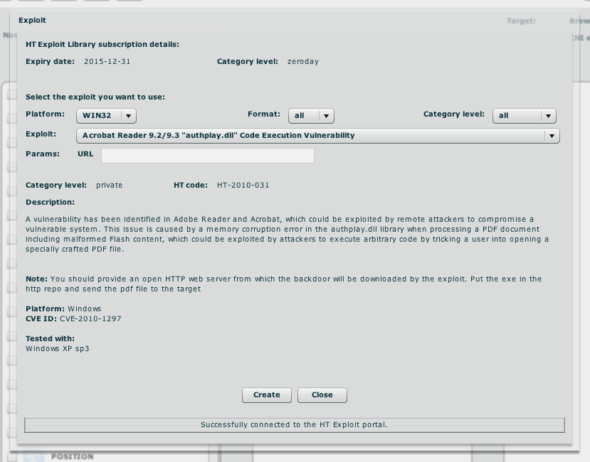
Each time the operator access the Exploit Portal, the Console downloads the updated exploit list that allows for the creation of documents containing an RCS Agent.
Since exploits base their effectiveness upon software flaws, the list of available exploits may change at any time, therefore supported file formats may vary frequently.

Exploit Categories
Within the Exploit Portal exploits are organized in categories: each category specifies if whether the exploit is commonly available or exclusive to the Exploit Portal, and if the security hole it uses is publicly known or secret to everyone but HackingTeam.
As an example, for exploits categorized as public, the vulnerability they use is known and the raw exploit code is publicly available. This means that probably the effectiveness of this kind of exploit is not at its best, but they still work and probably the vulnerable application is still in wide use.
The exploit portal uses four categories to organize the available exploits:
Category | Description
Social | This category of exploits do not rely on security holes, but on errors made by the human target in opening the document.  For example, an executable file can be concealed as a PDF by relying on the fact that Windows normally hides common file extensions: the target will see the usual file icon he’s used to see on real PDF files, thus making him believe that it’s safe to double click on it and open the document.
Public | For this category, the software flaw is known and the exploit code is publicly available on the Internet, tough the vulnerable version of the application is considered still widely adopted by a large user base.
Private | The exploit relies on a known vulnerability, but there is no public exploit code. No technical information is available on the vulnerability, so writing an exploit is a difficult task.
Zero-day | The exploit relies on a vulnerability not even known by the vendor of the application itself, and no exploit code is available. The latest version of the software is almost always vulnerable, thus making this exploit very effective even against users that update their installed applications frequently.
This categorization permits you to have a wide selection of usable exploits, targeting different applications and file formats. Therefore, depending on the specific scenario you’re confronting with, you may want to preserve private or zero-day exploits as last resorts, first using the more expendable social and public exploits.
The Exploit Portal always contain at least three zero-day level exploits.

