Remote Control System Installation
Delivery Assessment Procedure

Important Notice
HT s.r.l. shall bear no responsibility or liability to a client or to any person or entity with respect to liability, loss or damage caused or alleged to be caused directly or indirectly by any HT s.r.l. product. This includes, but is not limited to, any interruption of service, loss of business or anticipatory profits or consequential damage resulting from the use or operation of any HT products. Information in this document is subject to change without notice and does not represent a commitment on the part of HT s.r.l.
The systems described in this document are furnished under a license agreement or non-disclosure agreement.
All information included in this document, such as text, graphics, photos, logos and images, is the exclusive property of HT s.r.l. and protected by international copyright laws. Permission is granted to view and photocopy (or print) materials from this document for personal, non-commercial use only. Any other copying, distribution, retransmission or modification of the information in this document, whether in electronic or hard copy form, without the express prior written permission of HT s.r.l., is strictly prohibited. In the event of any permitted copying, redistribution or publication of copyrighted material, no changes in, or deletion of, author attribution, trademark legend or copyright notice shall be made.

All contents of this document are: Copyright © 2011 HT s.r.l. All rights reserved.

Table of Contents

1 General 1-4
1.1 RCS Modules 1-4
1.2 Architecture 1-5
1.3 Testing Scenario 1-5
1.4 Reference platforms 1-6
2 Functional tests 2-7
2.1 Collectors 2-7
2.1.1 Procedure 2-7
2.1.2 Results 2-7
2.2 Backdoor creation and configuration 2-8
2.2.1 Procedure 2-8
2.2.2 Results 2-8
2.3 Build installation vectors 2-9
2.3.1 Procedure 2-9
2.3.2 Results 2-10
2.4 Target lifecycle 2-11
2.4.1 Procedure 2-11
2.4.2 Results 2-11
2.5 Injection Proxy 2-12
2.5.1 Procedure 2-12
2.5.2 Results 2-12

General
This document details the compliancy test suite required for assessing the functional compliance of the Customer’s installation of HackingTeam Remote Control System software.
The provided suite of tests is intended to be used while delivering the solution at the Customer’s Site. The detailed tests shall be carried out by HackingTeam’s Representatives in the presence of Customer’s representatives.
All the tests are going to be performed on modules and platforms enabled by the RCS license provided to the Customer (refer to paragraphs 1.1 and 1.4 for a complete list of modules and platforms).
All the tests are going to be performed during or after the installation process. On successful completion of the acceptance procedure the Customer shall sign the enclosed Acceptance Certificate.
The Signature Date will be considered as the Service Delivery Date for any future use or reference.

RCS Modules
The following naming conventions will be used during all the tests to avoid any ambiguity or misunderstanding. Please get familiar with these naming conventions prior to reading the rest of the document. Most of the names are specific of the RCS product.
Target Any installation of RCS on intercepted devices.
Backdoor The RCS software installed on target for the purpose of interception and control.
Console The GUI used to administer all the installation.
Backend The server that contains the database, comprising any external storage.
Frontend Any set of one or more servers directly connected to the Internet and accepting connections from the RCS targets.
Anonymizer Any set of one or more servers spread over the internet used to re-route connections coming from the Targets.
Injection Proxy The appliance used for performing on-the-fly melting of executables while downloaded from the Internet.
Mediation Node A Bluetooth device used to collect evidences from Windows Mobile targets.
Remote Mobile Installation A module used to perform installation of RCS on mobile devices by sending them a special SMS.

Architecture
Depicted in Figure 1 is a drawing representing a typical installation of RCS, following our best practices. The actual installation may differ due to customizations made for the Customer.
The tests shall be performed following the guidelines of traffic and connections depicted here, according to the Customer’s actual installation.
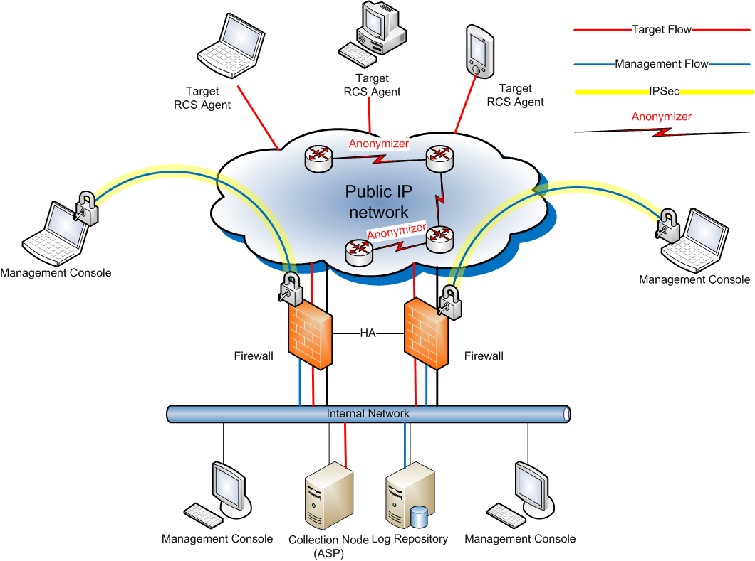
Figure 1 - General architecture

Testing Scenario
A full installation of the Remote Control System is required for performing the tests.
A HackingTeam Representative shall perform the installation for the Customer and verify the minimal set of functionality required for RCS to operate:
- Check network connectivity among components.
- Check network connectivity to the Frontend from the Internet.
- Check all the components status using the Monitor panel of the Console.
Please refrain from asking to perform any of the activity concerning this procedure in an actual investigation environment. Only designed test systems will be used.

Reference platforms
During the tests for all the platforms, the following versions will be used as reference:
Operating System | Reference Version
Microsoft Windows | 7 64bit
MacOS X | 10.6 (Snow Leopard)
iOS (Apple iPhone) | 4.0
Windows Mobile | 6.5
BlackBerry | 6.0
Symbian | S60 (5th Edition)
Android | 2.3

All the hardware used as Targets during the tests will be provided by HackingTeam.

Functional tests
Functional tests include testing of all the product’s features. During the tests some activities are required to be performed upon installation in order to setup minimum functionality for the RCS system to be used.
The purpose of this set of tests is to assess proper functionality of the Customer’s RCS installation. Tests are divided into Units, each concerning a specific functionality of the system.
Each Unit specifies a procedure that shall be strictly followed by HackingTeam and Customer Representatives. The Units must be carried out in the order listed to guarantee all assumptions to be in place and verified as needed during the tests.
The Customer should consider these activities as a first setup of the RCS installation by HackingTeam Representatives, following our company best practices: this is to guarantee a flawless testing experience and usage of the system thereafter.
The activities, groups, targets and backdoors created during tests may be deleted after tests completion, leaving the Customer’s with a clean RCS installation.

Collectors
This Unit verifies that each Collector (Frontend and Anonymizers if available) is reachable from the Internet, and when contacted by any system other than a valid backdoor, correctly redirects to a decoy website (i.e. Google), to prevent disclosure of its intended purpose.

Procedure
The activity and tests required for this unit may be performed on any system connected to the Internet that can reach the public addresses of the Collectors (Frontends and Anonymizers)
Please follow the steps listed below to complete the procedure:
- Open a web browser.
- For each Collector, direct the browser to the URL composed as follows http://<IP address of the Collector under test>
- Verify that the browser replies with the default web site (Google).

Results
Please fill the table below indicating for each expected outcome where it was verified.
 | Verified?
Collector replies with default web page. | N/A OK Error:

Backdoor creation and configuration
This Unit verifies that ‘tech’ users are able to create and configure backdoors for all the supported platforms. Configuration templates will be used during this step and all the tests carried out on the following Units.

Procedure
The activity and tests required for this unit will be performed on the Console, following the steps listed.
- Logon using the ‘tech’ user.
- Create a new backdoor of type DESKTOP.
- Create a new backdoor of type MOBILE.
- Load the DESKTOP backdoor in the Build Panel and then load the “[D] Test Configuration” template.
- Modify the synchronization server address according to the reachable Frontend address, then save the configuration.
- Load the MOBILE backdoor in the Build Panel, then load the “[M] Test Configuration” template and save the configuration.
- Modify the synchronization according to the connectivity method selected during step 1; modify the synchronization server address according to the reachable Frontend address; save the configuration.
Steps related to Desktop and Mobile should be performed only if at least one desktop and/or mobile platform is included in the license.

Results
Please fill the table below Indicating for each expected outcome where it was verified.
Desktop backdoor created and configured. | N/A OK Error:
Mobile backdoor created and configured. | N/A OK Error:

Build installation vectors
This Unit verifies that installation vectors can be built by ‘tech’ users, starting from the backdoor configurations created in the previous Unit.
The artefacts (products) of this Unit are needed during some of the following Units. Care should be taken in saving them to a proper place and keep them safe from deletion for the duration of the tests. Pay attention to modify the default names for each file in order to avoid any overwriting.
To create an installation vector for Symbian devices, the Customer needs to acquire a certificate for signing the vector. HT shall provide the Customer with the documentation needed to ease the procedure of issuing the certificate.
Installation vectors should be built only for platforms included in the Customer’s license.

Procedure
The activity and tests required for this unit will be performed on the Console, following the steps listed below:
- Logon using the ‘tech’ user.
- In the Build Panel, load the configuration for the DESKTOP backdoor.
- Create and save an EXE vector for installation on Windows targets.
- Create and save an EXE vector for installation on Mac targets.
- In the Build Panel, load the configuration for the MOBILE backdoor.
- Create and save an SD vector for installation on Windows Mobile targets.
- Create and save a Remote COD vector for installation on BlackBerry targets.
- Create and save a SIS vector for installation on Symbian targets.
- Create and save an APP vector for installation on iPhone targets.
- Create and save an APK vector for installation on Android targets.

Results
Please fill the table below indicating for each expected outcome where it was verified.
Executable file for Windows created. | N/A OK Error:
Executable file for Mac created. | N/A OK Error:
SD vector created. | N/A OK Error:
COD file created. | N/A OK Error:
SIS file created. | N/A OK Error:
APP file for iPhone created. | N/A OK Error:
APK file for Android created. | N/A OK Error:

Target lifecycle
This Unit verifies that following two assumptions:
- Proper installation can be performed on each of the available target platforms, using the vectors previously created.
- The RCS agent running on the each target platform is able to send collected evidences to the Frontend.
- The RCS agent can be removed from the target system by the console.

Procedure
The activity and tests required for this unit will be performed both on the Console and on each target system, following the steps listed below:
- Logon using the ‘viewer’ user.
- Start from a clean installation of the selected operating system.
- Verify internet connectivity to the Frontend (or the Anonymizer chain).
- Install RCS using the previously created infection vector (par.2.3.1) for the selected platform.
  - In case of Android installation, if disabled you’ll have to enable the option “Unknown sources” in Settings, Application before the installation.
  - In case of Android installation reboot the phone after installing the package.
- In case of mobile platforms, wait for the phone to go in standby mode.
- Using the dashboard, verify that synchronization is performed within 4 minutes from the installation.
- Verify that collected data reflects actual configuration of the RCS agent.
- Logon using the ‘tech’ user.
- Using the console, change the Status field of the backdoor to CLOSED.
- Wait the next synchronization for the uninstallation message to be delivered to the device.
- Logon using the ‘viewer’ user.
- No more synchronizations shall come from the CLOSED backdoor.

Results
Please fill the table below indicating for each expected outcome where it was verified.
First synchronization performed. | N/A OK Error:
Data received correctly. | N/A OK Error:
No synchronization is received from the closed backdoor. | N/A OK Error:

Injection Proxy
This Unit aims at testing the correct functionality of the Injection Proxy (IP) after installation.
A setup network is required and shall be configured by HackingTeam Representatives according to the available network environment at the Customer’s site.
Production test for the IP can be carried out only when the IP is deployed in the production environment (i.e. ISP).
To guarantee proper functionality of the IP once deployed, the following tests can be performed to assess proper network functionality.

Procedure
On the RCS Console:
- Login in console with the 'tech' user.
- In the Monitor panel, verify the IP is shown with a green icon and no errors are reported.

On the root prompt of the appliance:
- Place the IPA In a switched environment
- Connect monitor and USB keyboard to the IP if needed.
- Login as 'root'.
- Start tcpdump with the following command: tcpdump -ni dag0 (or the corresponding network interface)
- Verify that expected traffic is shown.
- Close tcpdump by pressing Ctrl-C.
- Logout with 'exit'.

Results
Please fill the table below indicating for each expected outcome where it was verified.
Green Icon in monitor. | N/A OK Error:
Traffic seen by tcpdump. | N/A OK Error:

Delivery Acceptance Certificate
Issued by the Customer to HackingTeam

The following items (being either the Licensed Software or a part of the Licensed Software) have been accepted for the purposes of this Agreement.
(please list below the accepted items)

Other conditions attached to the Certificate of Acceptance.
(specify here if there are any conditions attached to the Certificate of Acceptance)

 | Customer Representative |  | Customer Representative
 | ^{Full name} |  | ^{Full name}
 | ^{Title} |  | ^{Title}
 | ^{Signature} |  | ^{Signature}
 | ^{Date} |  | ^{Date}
HackingTeam Representative
Full Name and signature

