RCS User Manual

Summary
1 Installation 4
1.1 Log Repository (RCSDB) 4
1.2 RCS Server (ASP) 6
1.3 Offline Installer environment (RCSPE) 7
1.4 Configuration Manager (HCM4) 8
1.5 RCS Advanced Log Viewer (VR) 9
2 Users Administration 10
2.1 Add new users 12
2.2 Modify user's details 12
2.3 Remove a user 13
2.4 Types of privileges 13
2.5 Other web features 14
3 Configuration Module (HCM4) 16
3.1 Creation of the infection executable (Melting tool) 16
3.2 Offline Media installation tool 19
3.3 Wizard tool 21
4 New Off-line installer 22
4.1 RCS Installation 23
4.2 RCS Uninstall 25
5 RCS Advanced Log Viewer 26
5.1 Authentication 27
5.2 Log selection and drill down operations 29
5.3 Priority Change 33
5.4 Contextual Search 34
5.4.1 KeyLog 38
5.4.2 SnapShots 39
5.4.3 Web URL 40
5.4.4 Voip 41
5.4.5 Print 42
5.4.6 Passwords 43
5.4.7 ClipBoard 44
5.4.8 File Captured 45
5.4.9 File Opened 46
5.4.10 File Uploaded / File Downloaded 47
5.5 Contents visualization 48
5.5.1 KeyLog 48
5.5.2 SnapShots 49
5.5.3 Web URL 50
5.5.4 VOIP Calls 51
5.5.5 Print 52
5.5.6 Passwords 52
5.5.7 ClipBoards 53
5.5.8 File Opened 54
5.5.9 File Captured / File Uploaded / File Downloaded 54
6 Appendix 55
6.1 Management Console 55
6.1.1 Plugin folder 55
6.1.2 Vector folder 55
6.1.3 BUILD folder 56
6.2 Server RCS 57
6.2.1 Decoy web page 57
6.2.2 Asp service Log file 57

Installation
These are the steps to perform in order to install the RCS environment.
Each component can be installed separately on different machines, or all together.
The operating system on all the machines involved in the installation process must be Microsoft Windows Server 2003 (32 bit).

Log Repository (RCSDB)
Log Repository is the package that implements data storage for RCS agents, configurations (current and old) and RCS system user informations (users, groups, access privileges, etc.).
Its logic is composed by a relational database, which is accessed using an application-level layer used by others RCS components (management console, ASP server, Report viewer).
This layer is implemented by PHP scripts running on Apache 2 webserver. The RDBMS for the storage is MySQL 5.
The Log Repository packages requires both these services up and running. Apache webserver must use TCP port 80 and port 4443 (for TLS connections).
Services are configured to start at every Windows reboot: if you want to change their properties, or manually start and stop the daemons, you can use the Windows management console (“services.msc”) and modify the “Apache2.2” or “MySQL5.0” service settings.
In the Apache log files you can find all the activity regarding Log Repository access.
The setup is performed using a Windows Setup executable: the process installs all you need to run the repository, creates the database and configures the users needed by the application. The passwords for the “DB admin” and the “APPLICATION admin” will be asked during the installation setup.
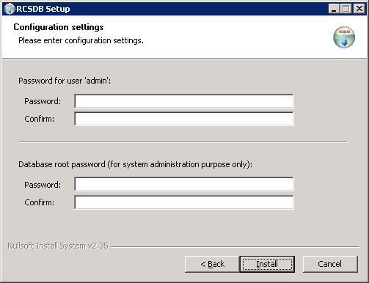
Figure 1 - Log repository installation

The “DB admin” user should be used only to perform maintenance on the DB. The “APPLICATION admin” user will be used to login into the system by the various applications, so it must be configured during their installation.
After the installation you've to execute two installer RCSCORE and RCSCERT. These installers will put into the database the required information (unique per each installation) needed to create the RCS Agents.

N.B. The “APPLICATION” credential could be modified at any time using the user administration panel (see Users Administration: RCS Admin Panel).
Each user/password change must be kept consistent with the RCS Server informations (see the following paragraph)

RCS Server (ASP)
Log transfer from RCS Agents, new configuration changes and plugin activation is performed by RCS Server.
This module is a normal Windows service, that has the target to handle agents connections.
The service is configured to start at every Windows reboot: if you want to change its properties, or manually start and stop the daemon, you can use the Windows management console (“services.msc”) and modify the “ASP Server: Service version 4.0.1” service settings.
In order to run properly, the server must have the ability to receive HTTPS connections from RCS agents (tcp port 443).
During install, you must enter the IP address of the Log repository and the credentials to login (user and password for user “root” – see the paragraph about Log Repository for default credentials).

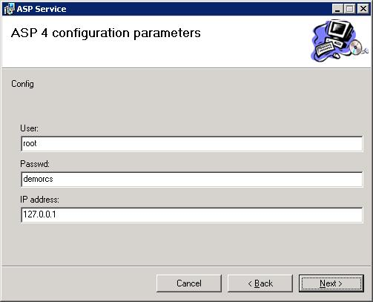
Figure 2 - RCS Server configuration

Every time you change the credentials (the default install creates “root/demorcs”), the service must be removed from the host and re-installed with the correct data.
If you want to check the right behavior of RCS Server, you just need to open the log file (“%systemroot%\TEMP\AspService-report.log”): here you can find all the informations about startup and all the errors occurred during the execution.
After the installation process, you need to reboot the machine in order to start the service.

Offline Installer environment (RCSPE)
This package contains the files used by the configuration manager to create the offline RCS installer (CD or USB key).
The installer is a Windows Setup executables, and must be run before trying to create any offline installation build.
This package must be installed on the same machine where HCM will be installed.

Configuration Manager (HCM4)
The Configuration Manager is used to create RCS Agents, build executables and CD/USB infection vectors.
The installer is a Windows Setup executable, and all default values are acceptable for the default installation (select Next at each step of the installation process).
The first time you use HCM, you've to configure the IP address of the Log Repository using the “Conf” button in the toolbar before login to the the application.

Figure 3: Toolbar

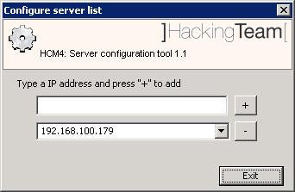Figure 4: Configuration dialog box

RCS Advanced Log Viewer (VR)
The RCS Advanced Log Viewer is used to browse logs captured by RCS clients and stored into the Log Repository.
The installer is a Windows Setup executable, and all default values are acceptable for the default installation (select Next at each step of the installation process).
When prompted for IP Address, insert the Log Repository’s IP address.

Users Administration
A web interface allows the creation and administration of RCS users. To access the service just point the browser to this address: http://<server_address>/web/admin/.
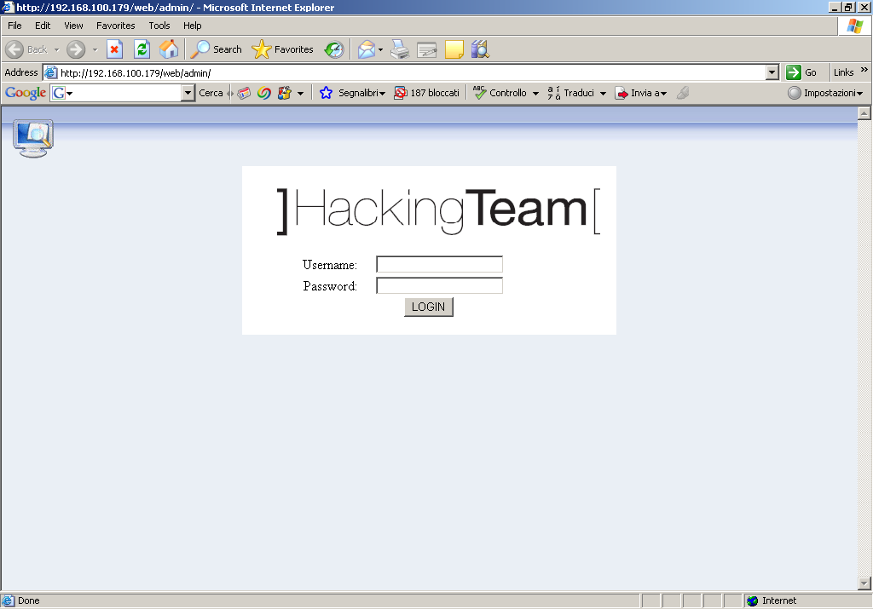
Figure 5 - Login screen

A login screen will then ask the operator for valid credentials.
After logging-in a page like this will be shown:
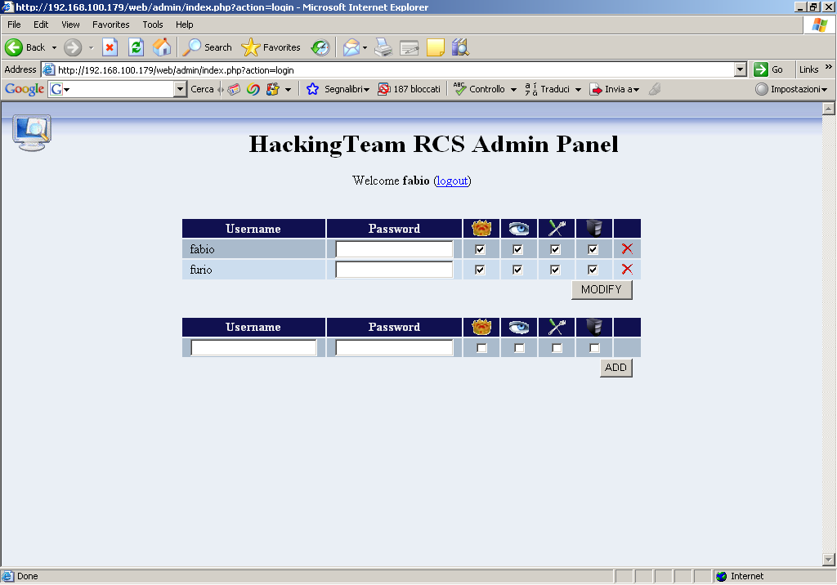
Figure 6 - Administration panel

In the upper part of the screen will be shown a list of all users, and relative rights, added to RCS system (user list). In the lower part will be shown a form used to insert new users into the database (insertion form).

Add new users
To create a new user just fill the insertion form with the username that will be assigned to this new user, his password and his rights (cfr. Types of privileges), then click ADD.

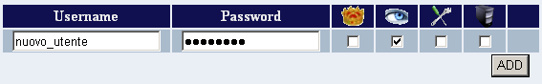
Figure 7 - Creation of a new user

Modify user's details
After adding a new user it will be possible to modify his password and privileges:
- Password change: in the user list fill the form with the password that will be assigned to the user (leaving blank the lines of those users that don't need a new password) then click the Modify button.
In the following image the password for user “fabio”, but not “furio”, is gonna be changed.
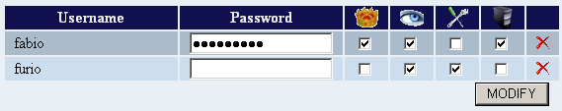
Figure 8 - Password change

- privileges adjustment: change the status of the tick box inside the user list to assign or revoke the privilege for the user. After clicking the MODIFY button the user will have only those privileges for which the tick box has been set.

Remove a user
To remove a user just click the button inside the user list. It is not needed to click the Modify button.

Types of privileges
Each RCS user will have one or more of the following privileges:
- ADMIN: Only users with this privilege will be able to login in the administration panel. These users will be the only allowed to create new users and to assign/revoke other user's privileges.
- VIEWER: Users with this privilege will be able to login in the RCS Web Log Viewer (cfr. documentation) and view the backdoors' logs.
- TECHNICIAN: Users with this privilege will be able to login in the backdoor's creation and configuration element (cfr. documentation).
- SERVER: This privilege is required by the listening system (cfr. documentation) to access the insertion functions in the database.

Other web features
It is possible to access the web log viewer pointing the browser to http://<server_address>/web/viewer. Logs generated from operators (backdoor creation, configuration change etc...) can be viewed at: http://<server_address>/web/trace.
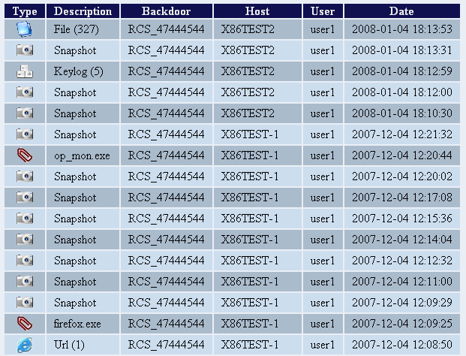
Figure 9 – Web Logs

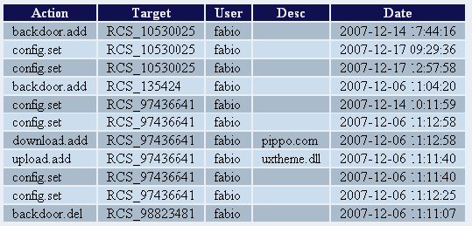
Figure 10 – Operator’s log

Configuration Module (HCM4)

The main changes from the previous version are three:
- Melting tool
- Offline Media installation tool
- Wizard tool
- Microphone Agent

These new procedures enable you to create the configurations needed by the RCS agent and create the executable or the media for the installation on the target machine. The melting tool is used to hide the RCS agent inside an already existent executable (maintaining the original functionalities), the offline media installation tool is used to create a bootable CD-ROM or USB pen drive to install the RCS agent if you have physical access to the target machine, the wizard tool is a repository of configurations used to perform standard data collections from the target machine.

Creation of the infection executable (Melting tool)
Once you have configured the RCS agent, you can create the executable (with .exe extension) that is used to infect the target PC.
The procedure (called ‘melting’) enables you to create an executable starting from whichever executable file you want. This file should be a windows executable (should be in ‘PE format’, not compressed and not packed). The melting tool transform the original file adding the functionalities of the RCS agent and installs it silently once executed. The resulting file maintain the original functionalities of the starting file.
The new executable, once launched on the target PC, installs silently the RCS agent and then executes the original file. This way the user is not aware of anything.
The components of the RCS agent are crypted by a polymorphic engine, which introduces anti-reversing and anti-debugging feature to the RCS core.

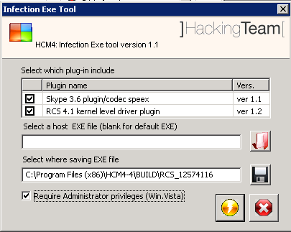
Figure 11 - Melting tool

The right button on the left of the HCM4 “Configuration Module” invokes the melting tool. 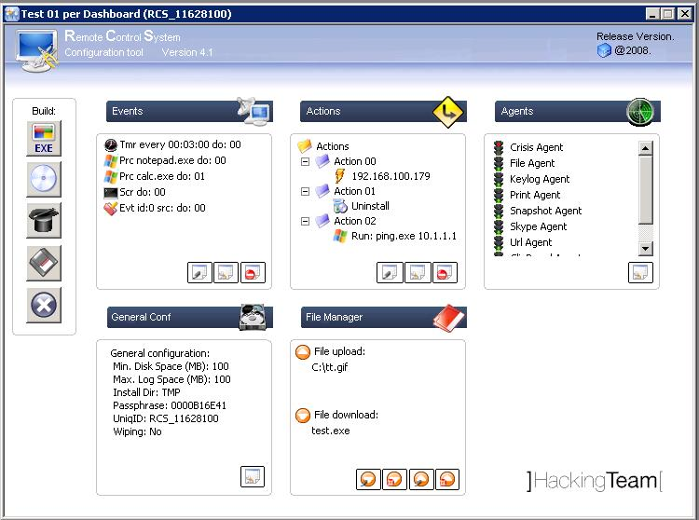
The procedure requires a starting executable and a target directory where the final executable will be saved (the name of the executable will be identical to the original one).
If the starting executable is not specified, a neutral executable will be used. This executable has no functionalities and its aim is to install the RCS agent silently.
The default destination directory will be the path of the HCM4 install dir + “BUILD\<Uniq_ID>”. In this case the executable will be called <Uniq_id>.exe (ex: “RCS_5577758.EXE”).
Before generate the setup file it’s even possible to choose which plug-in (additional components
that implement some features of the RCS agent) embed during the melting.
The console automatically adds a plug-in based on the agent configurations: for example, if the Skype interception is active by default or there is a configuration in event / action 'that makes it active, the plug-in is automatically entered.

NOTE:
Plug-ins can be installed dynamically even after the installation of the RCS agent: simply insert the plug-in (taken by the appropriate sub-folder [see Appendix]) in the queue of upload files. At the first synchronization will be transferred to the target PC and will be available at the end of sync.

NOTE 2:
The “Require Administrator Privileges” flag is used to modify the host program’s manifest in order to request, upon running, the highest allowed privileges for the user (program’s icon will be visualized with the UAC shield).
This flag has to be checked if the program is going to be run on Windows Vista operating system, and the target user is a member of the Administrators group. In every other case (non-admin user, WindowsXP system, etc.) the flag doesn’t need to be checked (even though it doesn’t compromise program’s functionality).
Anyhow, some program’s manifest can’t be modified; In this case, if the flag is checked, HCM4 will pop up an error message, suggesting to change the host program.
This flag’s state affects the build even if it’s used with the injection proxy tool.

Offline Media installation tool
Through the management console it is possible to create the media for the offline installation: "bootable cdrom" and "bootable usb pen drive."
These tools enable the installation of the RCS agent when it is possible to have physical access to the target PC: using this media you should insert the cdrom or usb pen drive to target PC turned off, power on the system and boot from one of these devices. The system will start from the media and a simple installation procedure is displayed.
Pressing the appropriate button from the HCM4 “Configuration Module” launches the creation of the media.
Before being added to the media, the components of the RCS agent are crypted by a polymorphic engine that introduces anti-reversing and anti-debugging feature to the RCS core.
It is possible to choose which plug-in (additional components that implement some features for the RCS agent) embed in the media.
The tool automatically adds plug-ins according to the agent configurations: for example if the Skype module is active by default or there is a configuration in event / action 'that makes it active, the plug-in is automatically entered.
For the creation of cdrom you need to set the file name "ISO" and its destination while for the USB memory stick (once inserted in the PC) you must select the letter (eg "D:" , "Z:" etc.) on which the USB device is mapped. To generate the media, simply press the corresponding button.
The procedure of creating "bootable CD" creates an ISO9660 image, you can then burn it with a standard software burner.

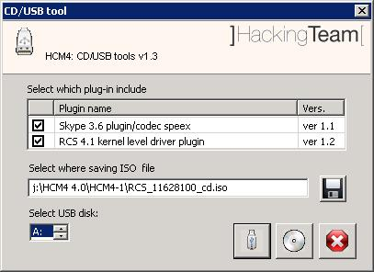
Figure 12 - Media installation tool

NOTE:
The USB pen should be “prepared” as described in the “RCS-UsbSetup-procedure-0-2.doc “ before being used for the offline installation.
Plug-ins can be installed dynamically even after the installation of the RCS agent: simply insert the plug-in (taken by the appropriate sub-folder [see Appendix]) in the queue of upload files. At the first synchronization will be transferred to the target PC and will be available at the end of sync.

Wizard tool
Using the button you will launch the wizard tool. Thru this tool you can access to a repository of standard configurations. The Actions and Events items will be filled with the necessary information based on the choices you made in the wizard tool. The repository contains pre-configurations for the most common task to be executed on the target machines such as:
- Documents sent to the printer
- Web activity
- Skype calls
- Keylog of the pressed keys
- Windows clipboard activity
- Saved account informations (usernames and passwords)

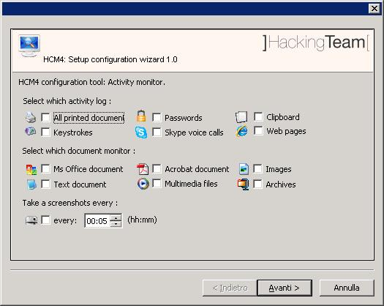
Figure 13 - Wizard tool

Microphone Agent
The microphone agent can be configured as any other agent in HCM4.
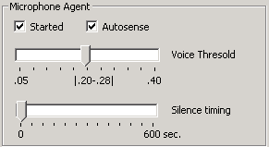
These are the parameters that can be tuned:
- Autosense: If this flag is checked, the agent will try to modify audio mixer settings (mute/unmute, line selection and volume) in order to optimize audio capture, avoiding low or clipping sound recording.
- Voice Threshold: Microphone agent tries to record only human voices, avoiding background noise. Voice analysis function produces an output value: if the value is in this range, then the captured chunk is recorded. Suggested range is 0.2-0.28. Higher values better recognizes some female voices but record more background noise.
- Silence Timing: This value represents the maximum amount of seconds of silence that the agent will record. If the agent captures only silence for “silence time” seconds, the recording is interrupted. In any conversation there can be some moments of silence: if this value is too low, only the “active” part of the conversation will be recorded, suppressing the silence. On the other hand, if the slider is set to the highest value, then silence will not be suppressed, and the audio capture will result in a unique continuous recording.

New Off-line installer
The offline installation tool (it can be either a Cd-Rom or a USB-Dongle) allows the installation of RCS tool on each computer where physical access is possible. Installation takes place booting the computer with the infection media, therefor loading the operative system of the target computer is not necessary. Moreover this same media can be used to uninstall RCS tool from those computers that were previously infected.
N.B. Each infection media is associated, in a unique way, to a single backdoor generated by the configuration module. A specific infection media will only be capable of uninstalling the backdoor it's been associated to, even though the backdoor was installed on-line (.exe melting, injection proxy), or offline by the means of the same infection media.
Installation and removal of a RCS Backdoor happens in three simple steps described below.

RCS Installation
After booting the target pc with the infection media, a window like the one in figure will be automatically shown:
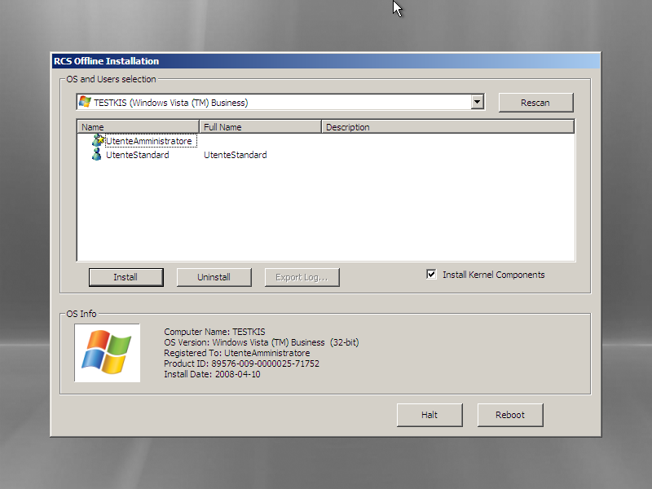
Figure 14 – Offline installation tool

This window has, in the upper part, a dropdown list containing all the operating systems installed on the target computer that were recognized by RCS; in the lower part there's a list of all informations gathered from selected operating system (OS Info). The icon on the lower left is shown in colors if the selected operating system is supported by RCS, otherwise the icon will be shown in black and white, and it won't be possible to install RCS on that OS.
Select from the dropdown list the OS to infect with a RCS backdoor.

N.B. If the target device is a removable media, and it's not shown in the dropdown list, it may be necessary to click the Rescan button to force a new scan of all attached devices.

In the middle part of the window the list of all users for the selected OS will be shown. For each user there will be shown the system name, the real name and in case a description. Below is a list of icons that identify each user:
-  Standard User
-  Administrator
-  Domain User
If the icon is shown in colors the user is active, otherwise the user has been disabled from the system administrator.

Beside the icons just shown there may be another icon used to represent the status of RCS for that particular user:
-  Correct RCS installation for this user
-  Corrupted (or not working) installation of RCS for this user

Select one or more users to infect with RCS, then click the Install button. A message will be shown to warn about the completion of installation process.

From now on it is possible to power off or restart the target computer clicking Halt or Reboot button.

RCS Uninstall
The uninstallation procedure is specular to the one already seen above. After selecting one or more users infected by RCS, it's enough to click on the Uninstall button. A message will be shown to warn about the completion of uninstallation process. From now on it is possible to power off or restart the target computer clicking Halt or Reboot button.

RCS Advanced Log Viewer
The Graphical User Interface can be used to view the logs contained in the database. The logs are organized in a structured manner so as to keep all informations concerning the provenance and the conditions in which they were acquired on the monitored system in particular they have the following fields common to all types of log:
- BACKDOOR: unique id of the backdoor
- REMOTE USER: username of the remote target
- REMOTE IP: the ip address of the target
- REMOTE HOST: hostname of the target machine
- LOG TYPE: type of the acquired log
- ACQUISITION DATE: date of the log on the target machine
- RECEPTION DATE: date of the reception of the log on the database machine

Each log can be associated with a PRIORITY:
- Not interesting (GRAY)
- Default (WHITE)
- Low interest (GREEN)
- Medium interest (YELLOW)
- Hi interest (RED)

Authentication
The first thing you have to do is the authentication to the system. You have to insert the username and password into the following form:

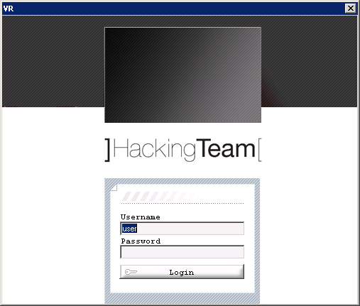
Figure 15 – Authentication

Once successfully authenticated you will be presented with the main screen:

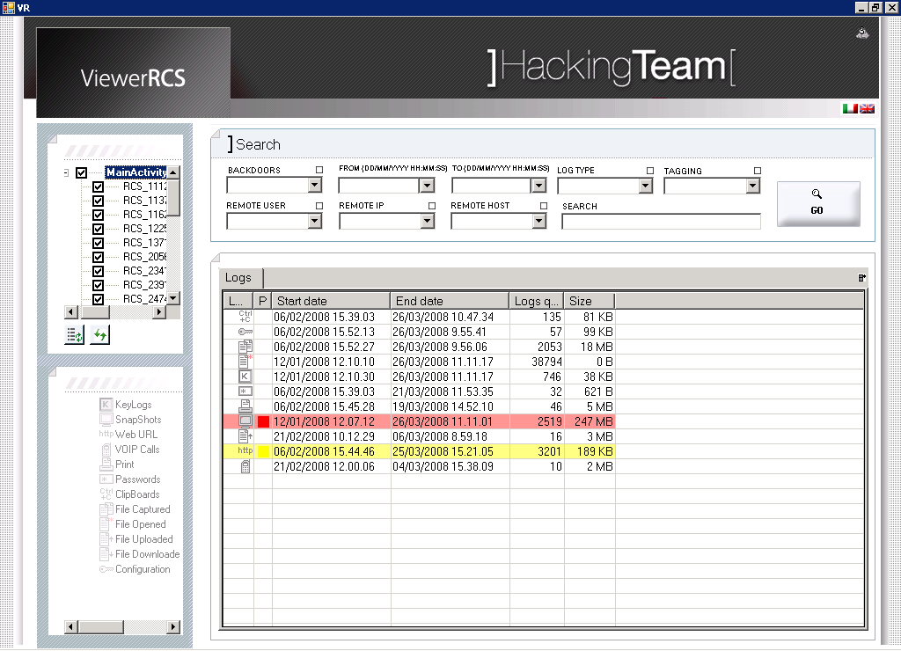
Figure 16 - Advanced viewer

In the left column there is a list of available backdoor (those generated logs into the system), you can select those on which you want to see data. All backdoor are grouped under "MainActivity", which can be used to make a selection with all the backdoor present.
Within this area are also two buttons: one on the left to update the list of backdoor available, while the second updates the data contained in the search fields outlined below.
Under the area for the backdoor selection there is the console for the various log types, as outlined in the section devoted to visualizing specific types of logs.
In the area in the upper right there are buttons to change the language (currently supported languages are English and Italian), and a key to reset the session, resetting all parameters to their default value.

At the top of this there is the mask of advanced search that allows you to refine the search and make the operations of selection to focus the attention on interesting data. Once you have made your selections, pressing the "GO" button will show the results in the underlying application, allowing further elaboration.

Log selection and drill down operations
The principle underlying the organization of the data is the aggregation.
Initially the results will be provided in aggregate, providing information summaries of elements that can be united with each other (such as the quantity of logs a particular type or their top priority).
The research must be drilled down in order to restrict the amount of data on which you want to focus the interest; to do this you must act on research areas with the following paradigm:
- if the search is interesting, we need to select all items for which you want to have information (possibly using the button "select all")
- if the field is not interesting, do not select any item in the list
- for the fields “from” and “to” specify the time interval of research: any logs present with a date of acquisition outside this range will not appear in search results
- for the free search ("SEARCH"), insert the words that you want to find in the content of the log (you can use regular expressions)

For example, if you select two computers name in the search field and the type of log "VOIP", two row will be displayed in the results, the first row will contain all the calls made by a user, while the second those made by the other.
In the absence of selection of users, only one line will be returned containing the sum of total calls made by the two users (and therefore the “REMOTE USER” field will not be present because it is not uniquely defined for this aggregate view).

All logs in the general view are therefore aggregates, and do not represent
individual log: to get them you must drill down the research in the forms provided by the application.

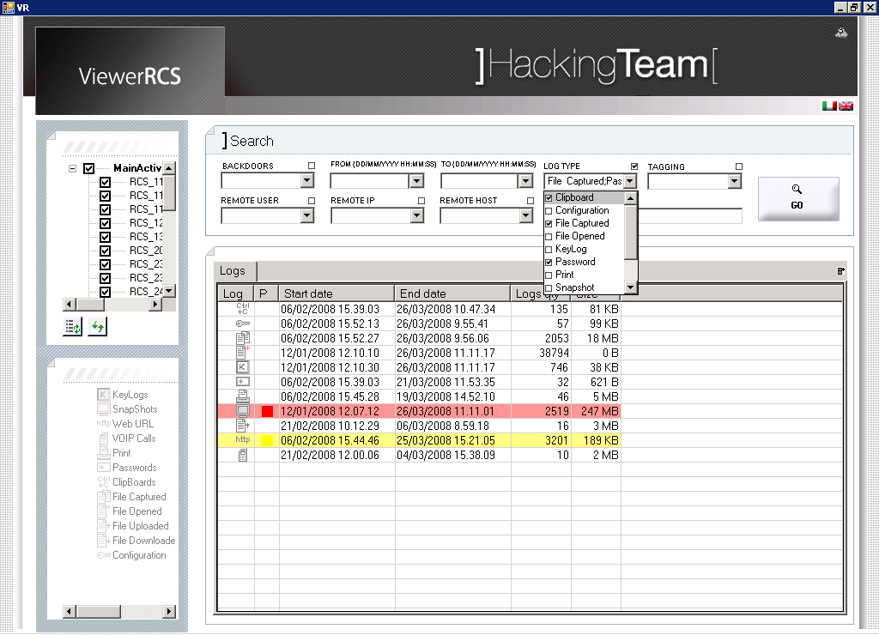
Figure 17 – Aggregated data

Once the research has been made, the results will be presented in an aggregated form that reflects the parameters used:
1. if a field was not considered interesting (no element selected during the research), the logs are not divided according to that parameter
2. if a field was considered interesting, the logs will be grouped and will be presented into lines one per selection item, aggregating logs based on the contents of that field
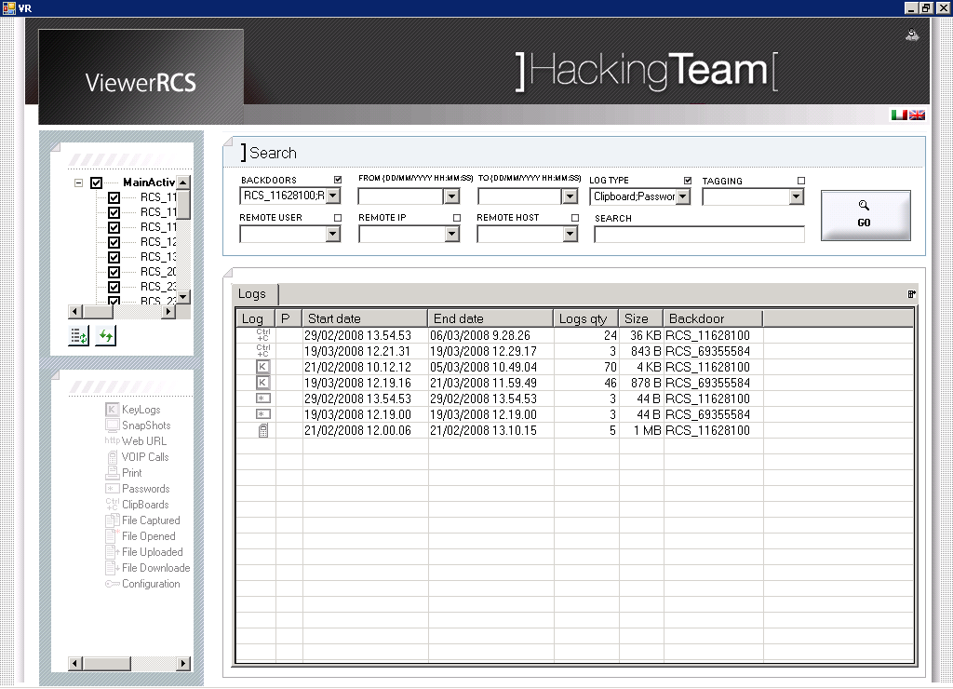
Figure 18 – data drill down

The number of displayed rows is variable and is dependent on how was the selection for the research.
The results can be sorted within the grid acting on the column, which also allow a rearrangement of vertical fields.
To view additional columns or to hide columns that do not interest you can act on the side button in order to customize the display.

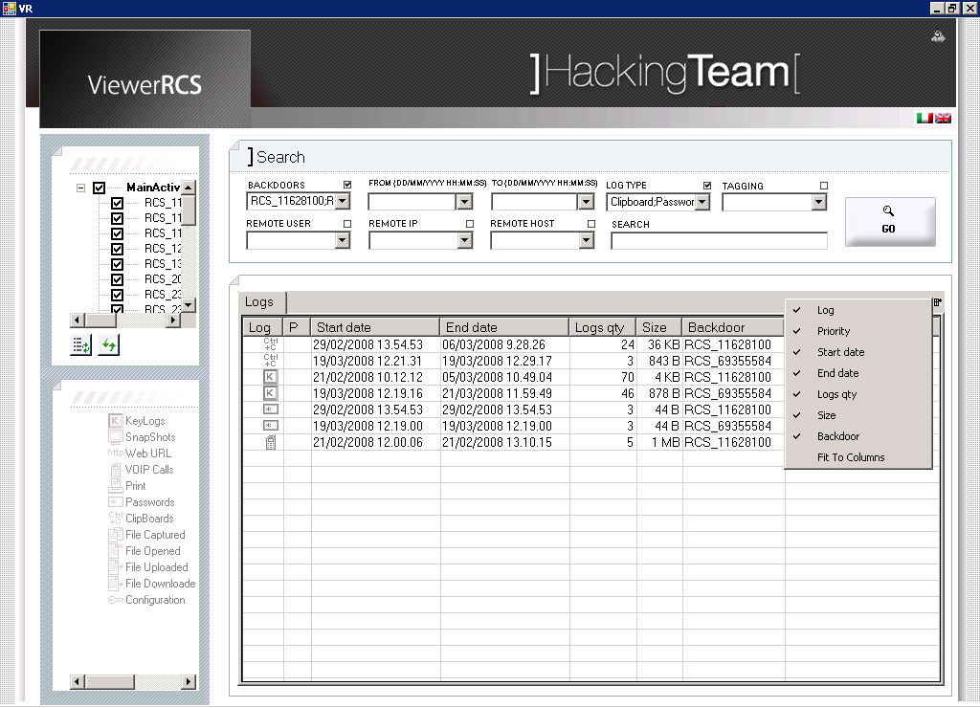
Figure 19 – Field selection

Priority Change
It is possible to set a priority on the join by selecting a log and right clicking on the row. The color shown into the row represents the log with the highest priority in the join. It must be taken into account that changing the priority on the join changes the priority of every single log that's part of the joing itself, independently from its original priority.
Setting the priority on a single log is possible from a subsequent visualization grid.

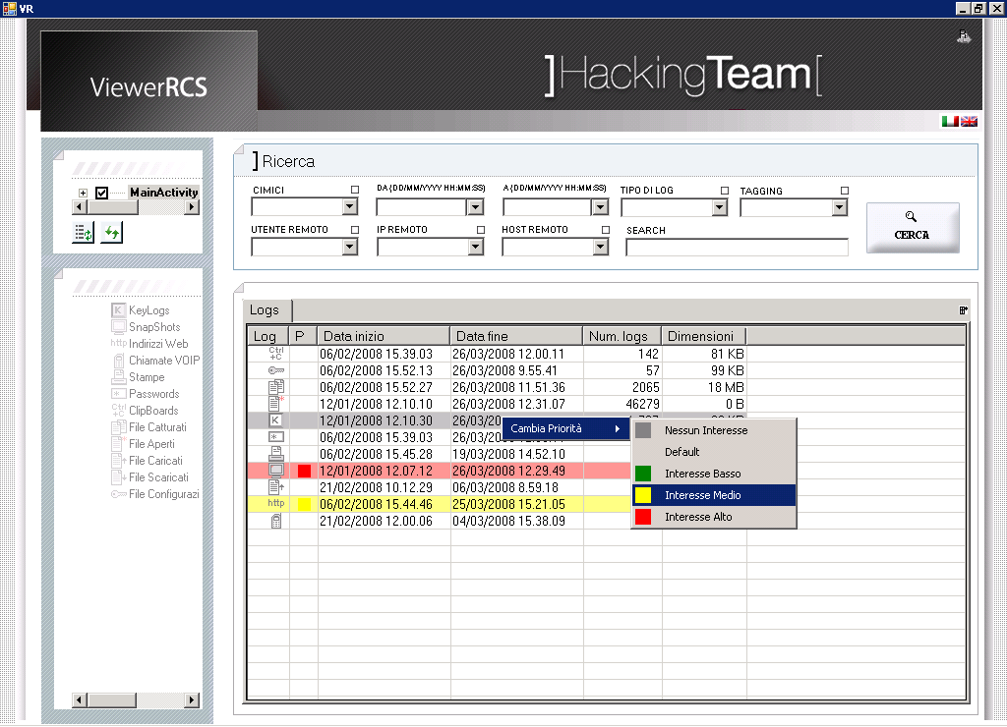
Figure 20 - Priority Change

Contextual Search
To access the contextual search for log types it is possible to double-click on a row in the tab “Logs” or select a log type from the lower left panel.

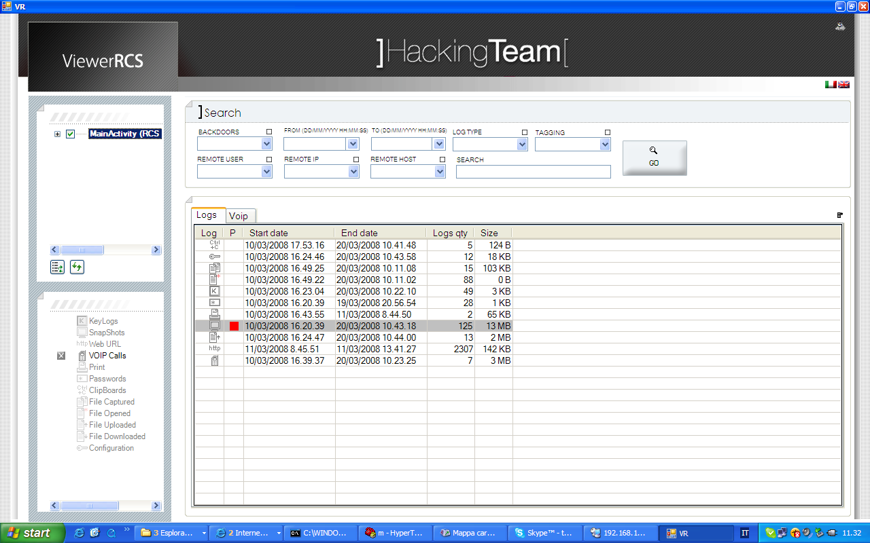
Figure 21 - Contextual search

After that a new tab for selected log type will be opened and all the data corresponding to search parameters will be shown.

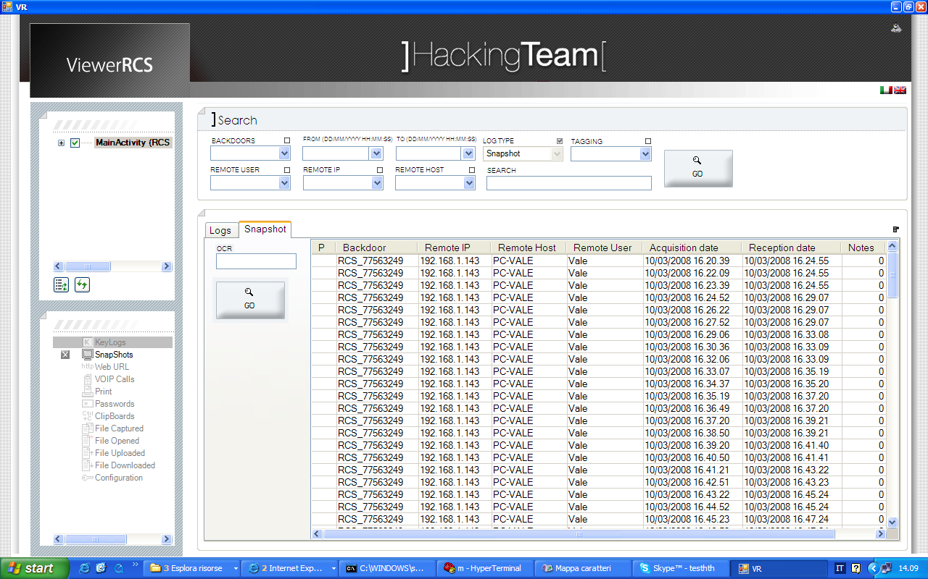
Figure 22 - Second level tab

On each contextual search tab it's possible to use the generic search parameters, and additionally some other parameters that are specific to each log type.
Contextual search frames follows the same “Select and break up” paradigm already shown in the “Logs” general search tab.

As seen in the tab “Logs”, in secondary search tabs too is possible to change the priority of one or more rows through the contextual menu.

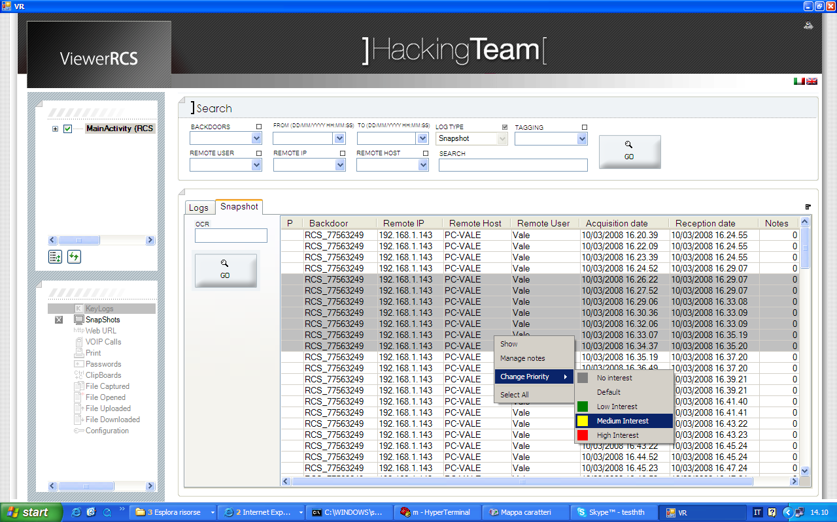
Figure 23 - Priority Change

To close a contextual search tab the user has to select the icon in lower left panel.

After refining the search by means of parameters, specific to each log, it's possible to visualize the content of the log selecting one or more rows in the grid and using the “Show” entry in the contextual menu.

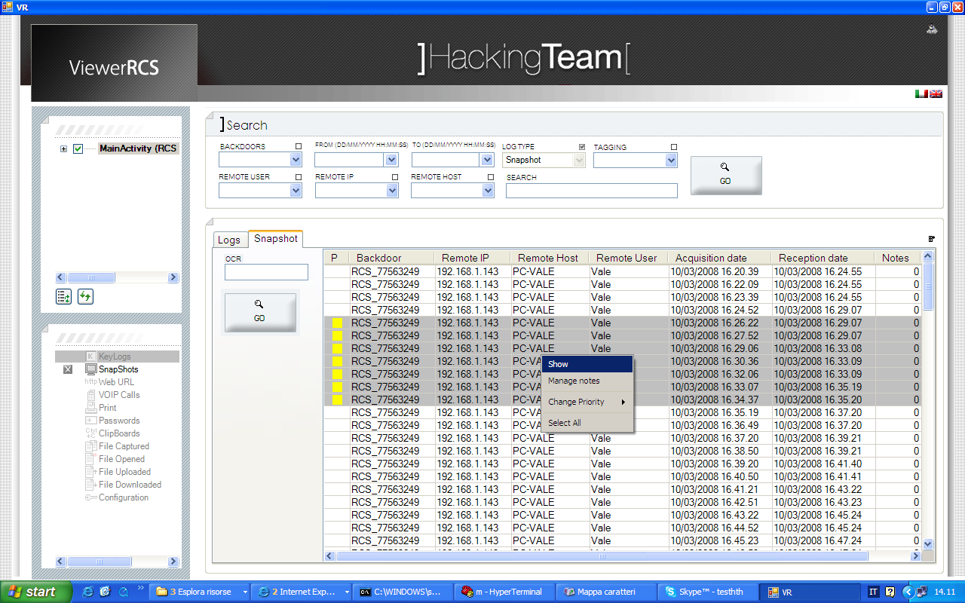
Figure 24 - Log visualization

The way logs are visualized it's different from each data type they represent (cfr. “Content Visualization”). Hereafter follows a list of each parameter specific to each kind of log.

KeyLog
“KeyLog” tab shows the entries in the grid keeping the same level of “join” chosen in the “Logs” general search tab. Each row will show, in addition to those fields for which the log was “broke up” before, even these columns:
- Logs qty: the number of entries contained in the join
- Size: the sum, in bytes, of each entry contained in the join

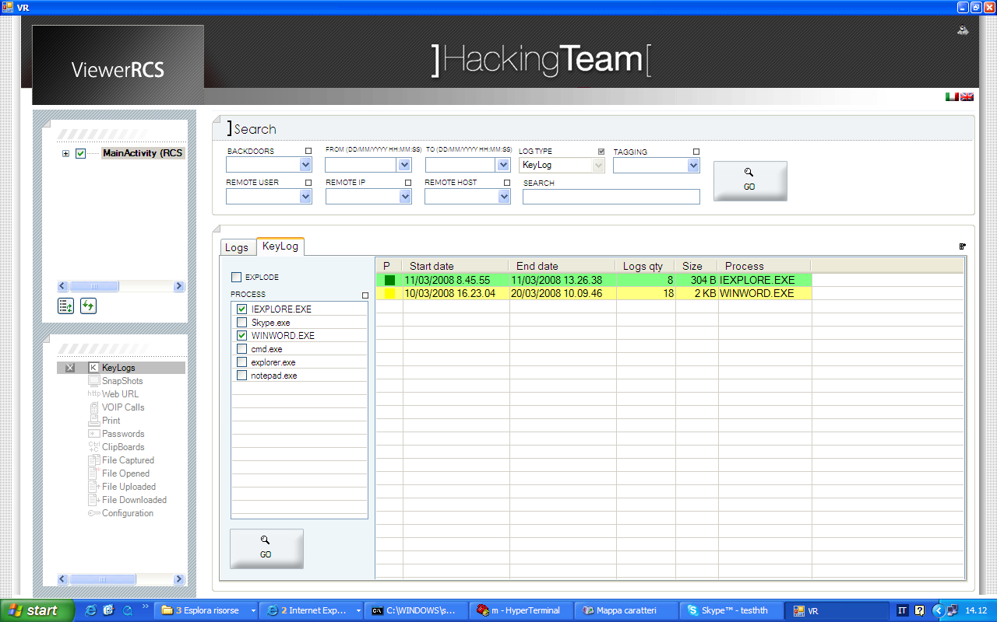
Figure 25 - Keylog

“KeyLog” tab has two specific search elements:
- “EXPLODE”: this checkbox, if enabled, allows to view each entry one by one, thus eliminating any previous join.

- List view “PROCESS”: this list view contains the names of each process in which there has been some keylogging activity. It is possible to select one or more processes (or all of them selecting the checkbox on the upper right part of the screen), this action has the same “select and break up” effect discussed before. If a selection has been done inside the list view, the “Process” column will be automatically shown in the logs grid.

SnapShots
Each row in the “SnapShots” tabs represents a bitmap.
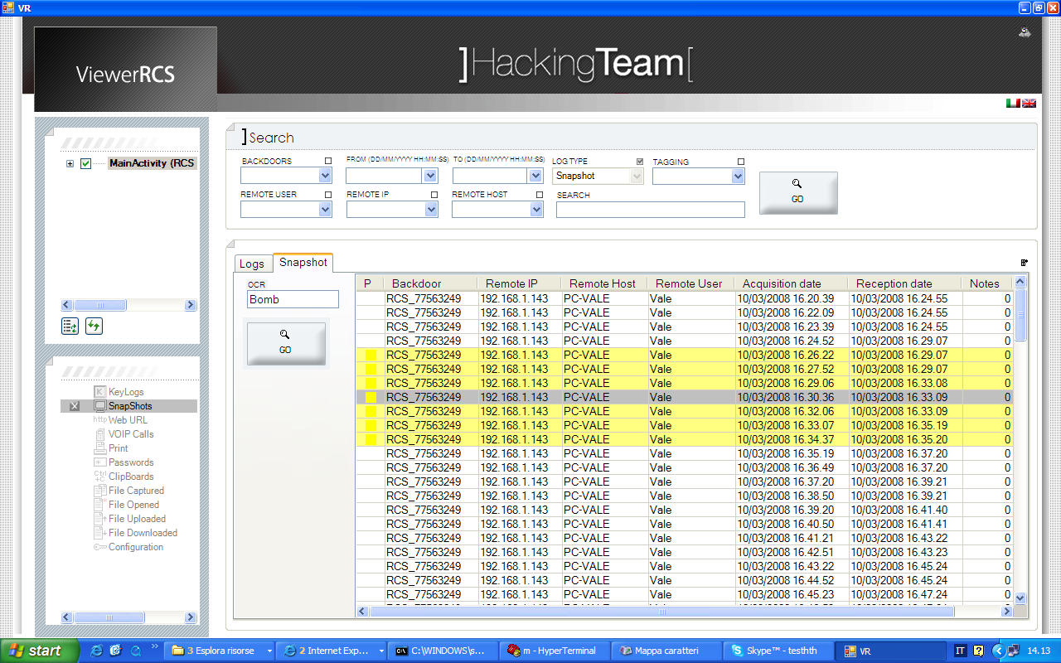
Figure 26 - Snapshots

The specific search parameter for this kind of log is::
- OCR: allows to make a textual search inside the bitmap by the means of an automatic text recognition system. A search can even be accomplished using the “regular expressions” paradigm.

Web URL
“Web URL” tab shows the entries in the grid keeping the same level of “join” chosen in the “Logs” general search tab. Each row will contain, in addition to the fields it was “broke up”, the following columns:
- Logs qty: the number of entries contained in the join
- Page qty: the number of visited pages contained in the join
- Size: the sum, in bytes, of each entry contained in the join

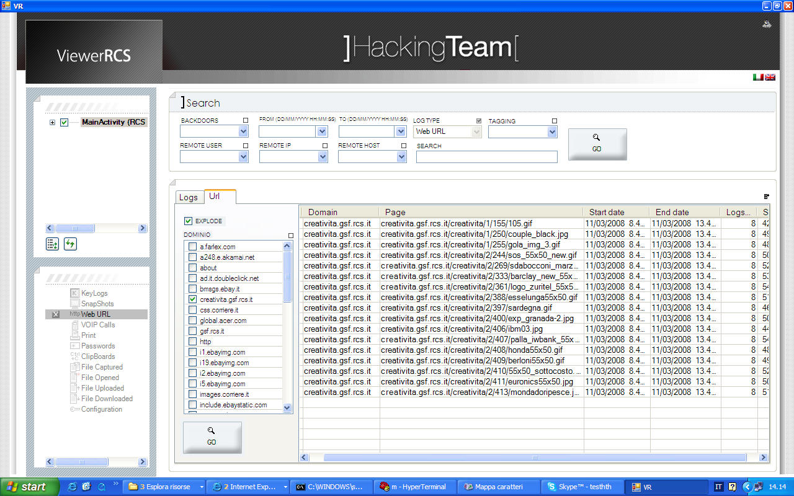
Figure 27 - Web Url
“Web URL” has two specific search parameters:
- “EXPLODE”: allows to show each entry in the grid, one by one, removing the join per domain and per page. Each row will represent a single visited page and the columns “Domain” and “Page” will be added to the view. Column “Logs qty” will represent the number of times each page has been viewed.

- List view “DOMINIO”: This view contains the name of each domain visited. It is possible to select one or more domains (even all of them selecting the upper right checkbox), this action has the same effect of “Select and break up” discussed before. If at least one selection has been done in the list view, the column “Domain” will be automatically shown in the log grid.

Voip
“Voip” tab shows the entries in the grid keeping the same level of “join” chosen in the “Logs” general search tab. Each row will contain, in addition to the fields it was “broke up”, the following columns:
- Logs qty: the number of entries contained in the join
- Duration: total duration of the calls contained in the join

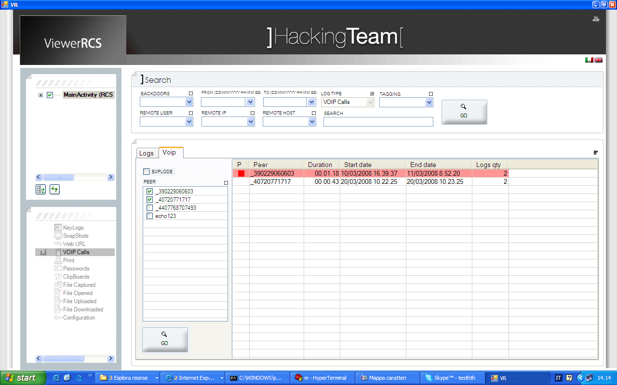
Figura 28 - Voip

“Voip” tab has two specific search parameters:
- “EXPLODE”: allows to show each entry in the grid, one by one, removing the join per domain and per page.

- List view “PEER”: this list view contains the names of all speakers. It is possible to select one or more peers (even all of them selecting the upper right checkbox), this action has the same effect of “Select and break up” discussed before. If at least one selection has been done in the list view, the column “Peer” will be automatically shown in the log grid.

Print
Each “Print” tab represents a bitmap. Each row will contain a column named “Job name” that represents the name of the printing job that made up the bitmap.

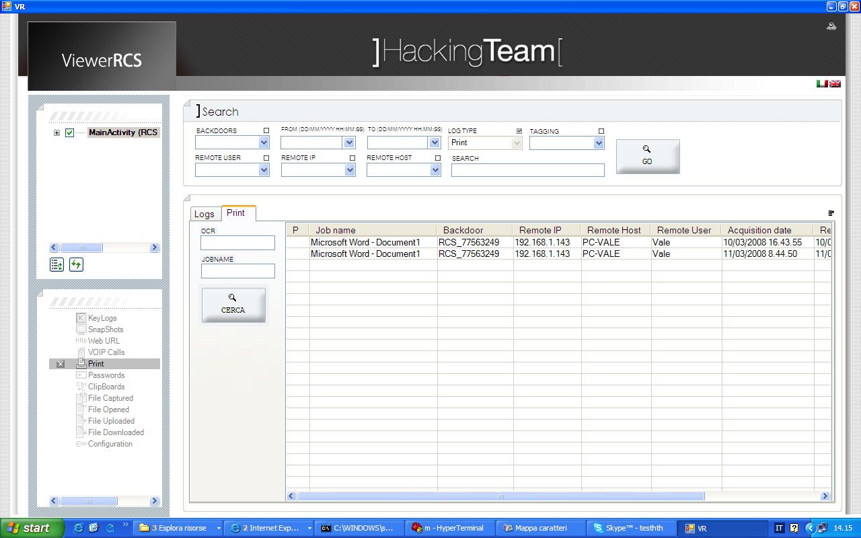
Figure 29 - Print

These are the specific parameters for this kind of log:
- OCR: allows to search for a particular text string in the bitmap using an automatic pattern recognition system. The search can also be accomplished using the “regular expressions” paradigm.

- JOBNAME: allows a textual search in the “Job name” field.

Passwords
“Passwords” tab shows the entries in the grid keeping the same level of “join” chosen in the “Logs” general search tab. Each row will contain, in addition to the fields it was “broke up”, the following columns:
- Logs qty: the number of entries contained in the join
- Size: the sum, in bytes, of each entry contained in the join

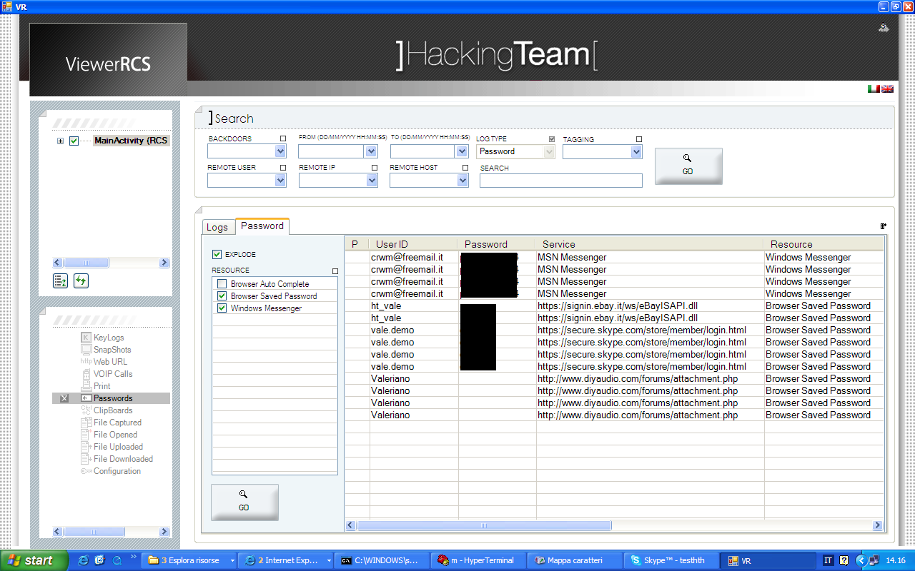
Figure 30 - Passwords

“Passwords” tab has two specific search parameters:
- “EXPLODE”: allows to show each entry in the grid, one by one, removing the join per domain and per page.

- List view “RESOURCE”: The list view contains all passwords categories (i.e.: MSN, FTP, Mail, etc...). It is possible to select one or more Resources (even all of them selecting the upper right checkbox) this action has the same effect of “Select and break up” discussed before. If at least one selection has been done in the list view, the column “Resource” will be automatically shown in the log grid.

ClipBoard
“ClipBoard” tab shows the entries in the grid keeping the same level of “join” chosen in the “Logs” general search tab. Each row will contain, in addition to the fields it was “broke up”, the following columns:
- Logs qty: the number of entries contained in the join
- Size: the sum, in bytes, of each entry contained in the join

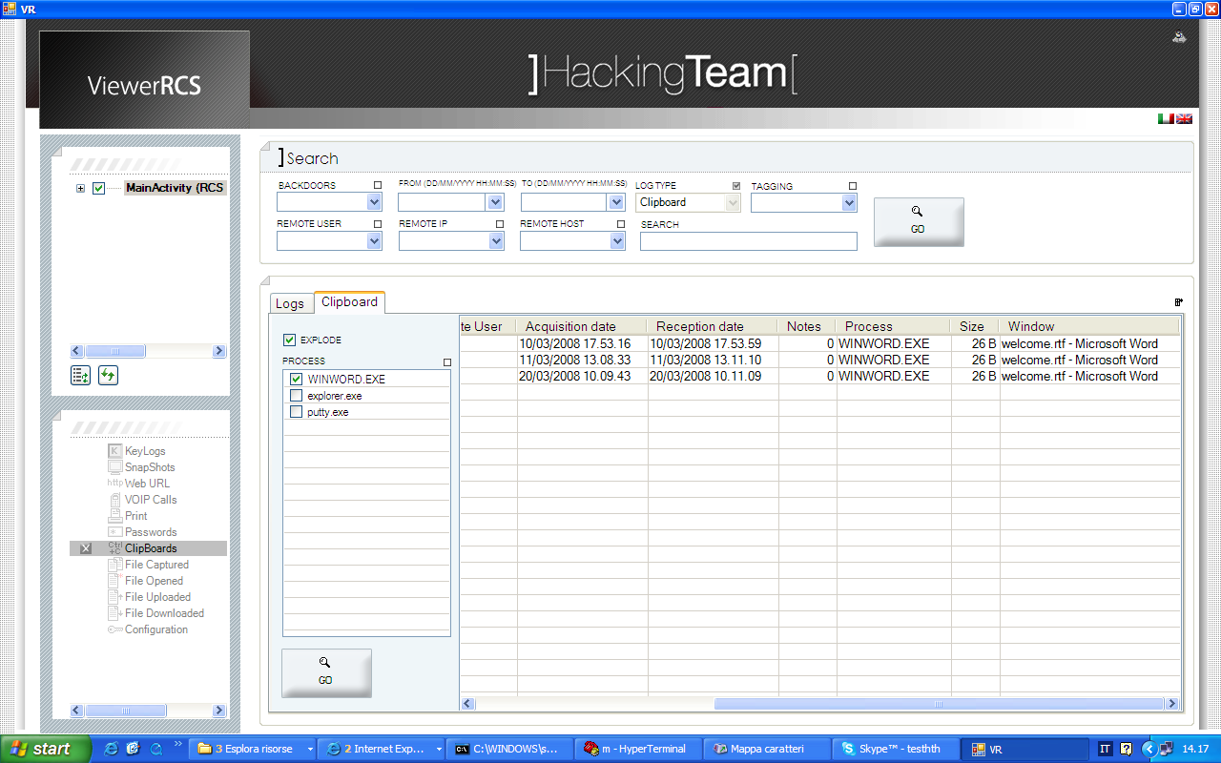
Figure 31 Clipboard

“ClipBoard” tab has two specific search parameters:
- “EXPLODE”: allows to show each entry in the grid, one by one, removing the join per domain and per page.

- List view “PROCESS”: This list view contains the name of all processes on which it was at least one keylogging activity. It is possible to select one or more processes (even all of them selecting the upper right checkbox) this action has the same effect of “Select and break up” discussed before. If at least one selection has been done in the list view, the column “Process” will be automatically shown in the log grid.

File Captured
Each row in “File Captured” tab represents a file that was captured, identified by the column “File name”.
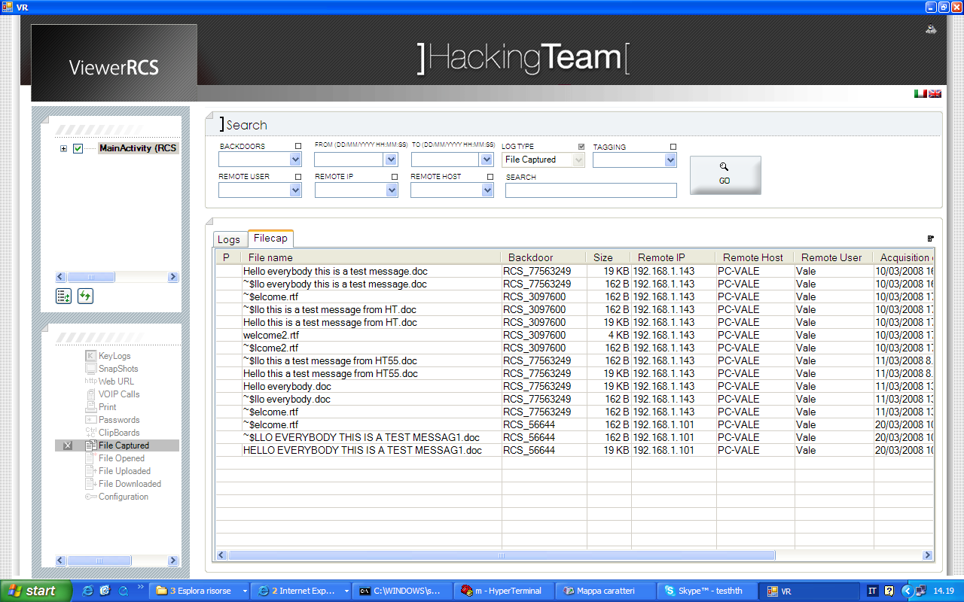
Figure 32 - Captured files

File Opened
“File Opened” tab shows the entries in the grid keeping the same level of “join” chosen in the “Logs” general search tab. Each row will contain, in addition to the fields it was “broke up”, the following columns:
- Logs qty: the number of entries contained in the join
- Filename count: number of different files contained in the join

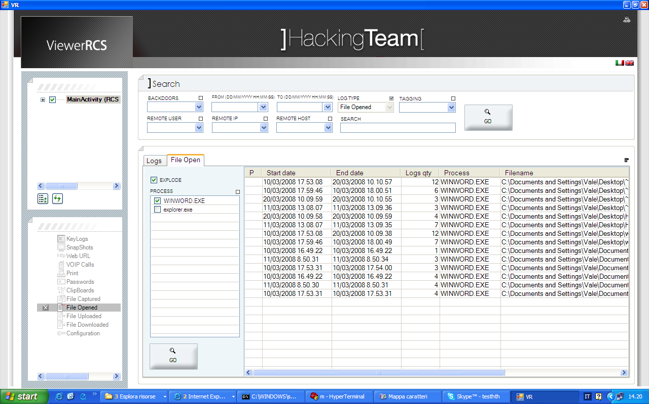
Figure 33 - Opened Files

Il tab “File Opened” presenta due elementi peculiari di ricerca:
- “EXPLODE”: allows to show each entry in the grid, one by one, removing the join per domain and per page.

- List view “PROCESS”: This list view contains the name of all processes that opened at least one file shown in the grid. It is possible to select one or more processes (even all of them selecting the upper right checkbox) this action has the same effect of “Select and break up” discussed before. If at least one selection has been done in the list view, the column “Process” will be automatically shown in the log grid.

File Uploaded / File Downloaded
“File Uplaoded” and “File Downloaded” tab shows all files that have been sent or received from the target computer. Each file is identified by the columns “File Name” and “Size”.
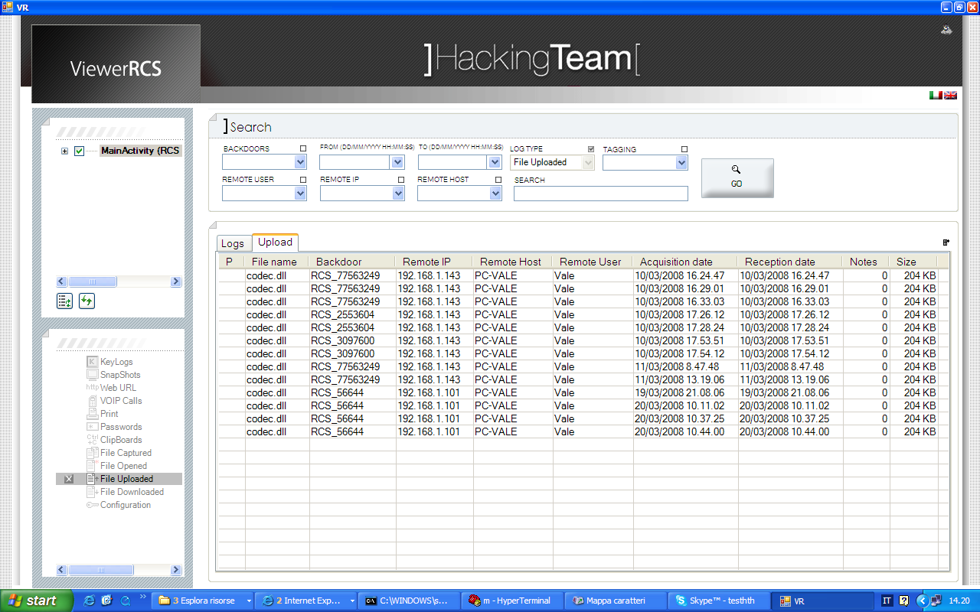
Figure 34 – Files Download/Upload

Contents visualization
You can select one or more rows from the secondary search screens, than you can view the content using the “Show” voice in the contextual menu.
The visualization modes changes depending on the type of log:

KeyLog
In the upper side of the screen will be displayed summary informations about every single entry. Informations about the selected entry will be visible in the lower side of the screen. Every entry includes captured keys, the date of the interception, the process name in which keys were pressed and the name of the foreground window in that moment.

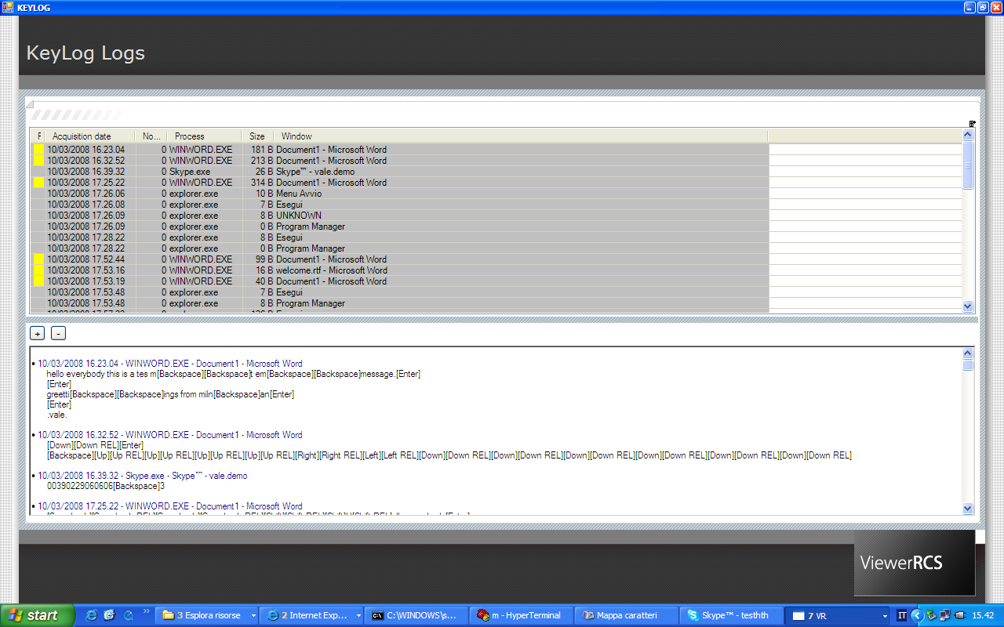
Figura 35 - Keylogs

Selecting entries in the upper side of the screen you can modify the priority of every log and change the concerning notes (through contextual menu).

SnapShots
The selected pictures will be displayed in a film strip mode. The previews of every bitmap previously selected appear in the lower side of the screen. The upper side displays the current bitmap and some information.
It is also visible an area which displays the notes relating to the current image.

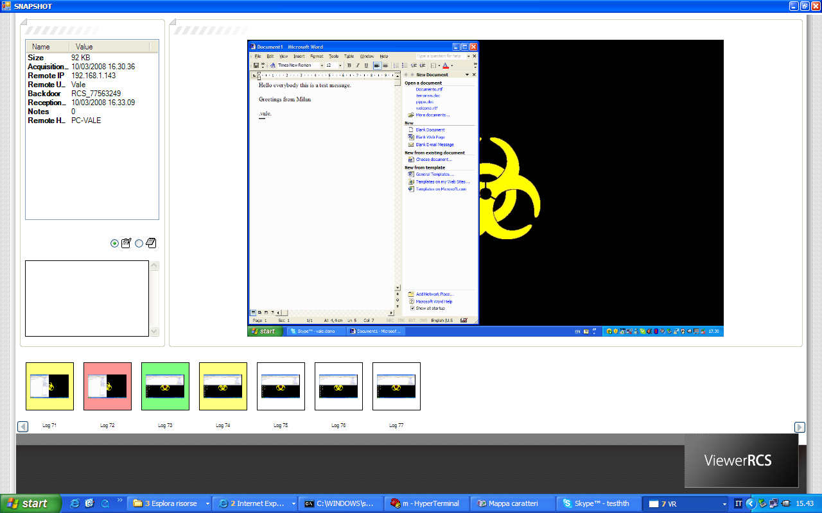
Figura 36 - Screenshot

If you click on one thumbnail, the image will be visualized in the upper side.
The contextual menu on thumbnails allows you to change its priorities and inherit notes.
With a double click over the image in the upper side it is possible switch to slide show mode. In this mode, there are two keys to move within the slide show ( < and > ) and two keys for zoom in and zoom out over the image ( + and -).
Web URL
A table presents all URL entries that have been previously selected.
For each row there is domain information, the page visited, the parameters of GET command and the date on which the URL was visited.

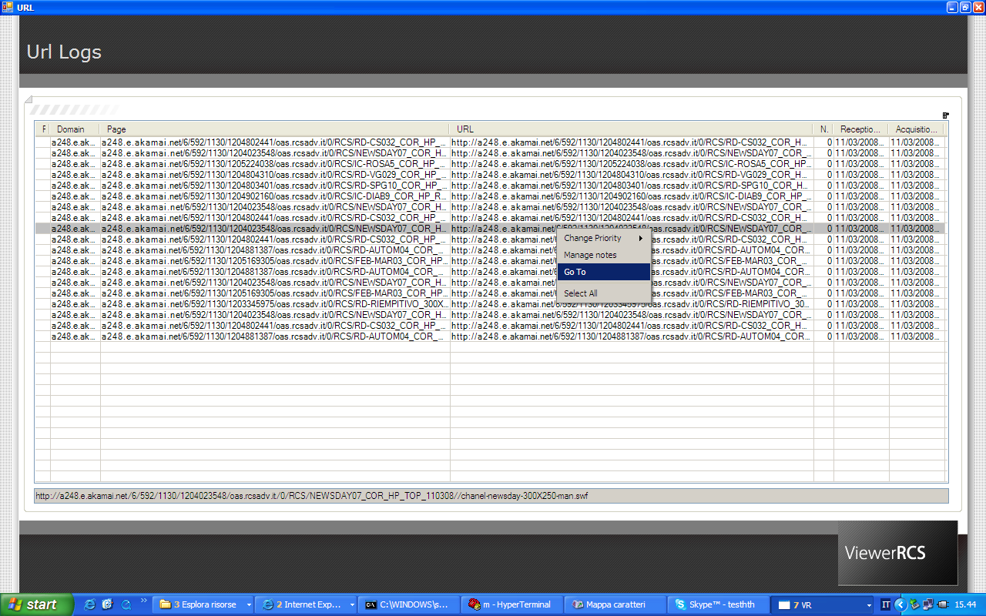
Figura 37 - Url

VOIP Calls
By selecting one of the entries in the lower side of the screen, it will be played. In the uppper side you can see data and notes about the selected phone call, the waveform channels and same buttons to execute the playback of the file ( respectively play, pause and stop)

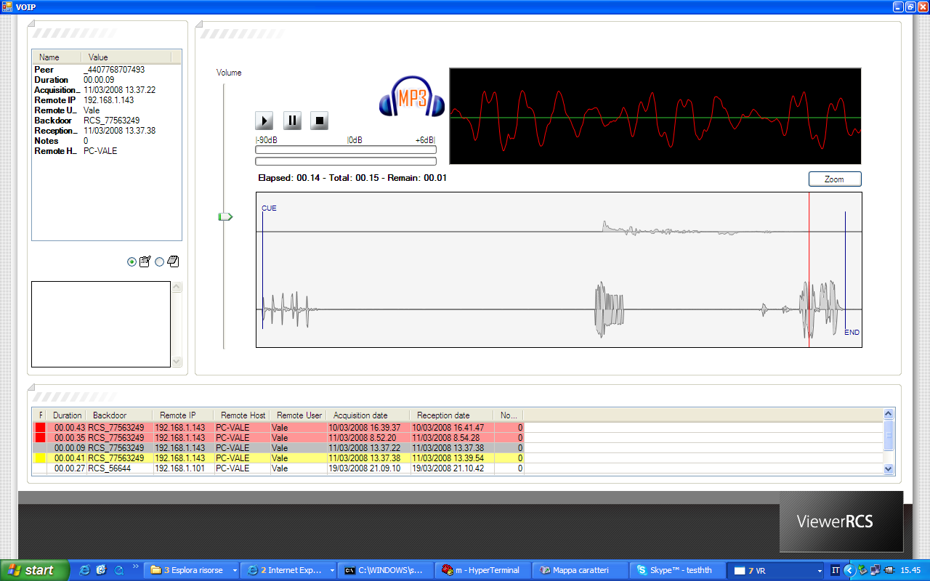
Figura 38 - VoIP calls

Selecting the entries in the lower side of the screen you can modify the priority and inherit the notes by using the contextual menu.

Print
The selected pictures will be displayed in a film strip mode. The previews of every bitmap previously selected appear in the lower side of the screen. The upper side displays the current bitmap and some information.
It is also visible an area which displays the notes relating to the current image.
If you click on one thumbnail, the image will be visualized in the upper side.
The contextual menu on thumbnails allows you to change its priorities and inherit notes
With a double click over the image in the upper side it is possible switch to slide show mode. In this mode, there are two keys to move within the slide show ( < and > ) and two keys for zoom in and zoom out over the image ( + and -).

Passwords
The visualization of the passwords is the same in the contextual search screen.

ClipBoards
In the upper side of the screen are displayed rows filled with data of every entry. The selected entry (all selected by default) will be displayed in the lower side of the sceen. Each entry contains, in addition to the body of clipboard, the date on which it was intercepted, the process in which the clipboard was taken, and the name of the window at that time was in the foreground.

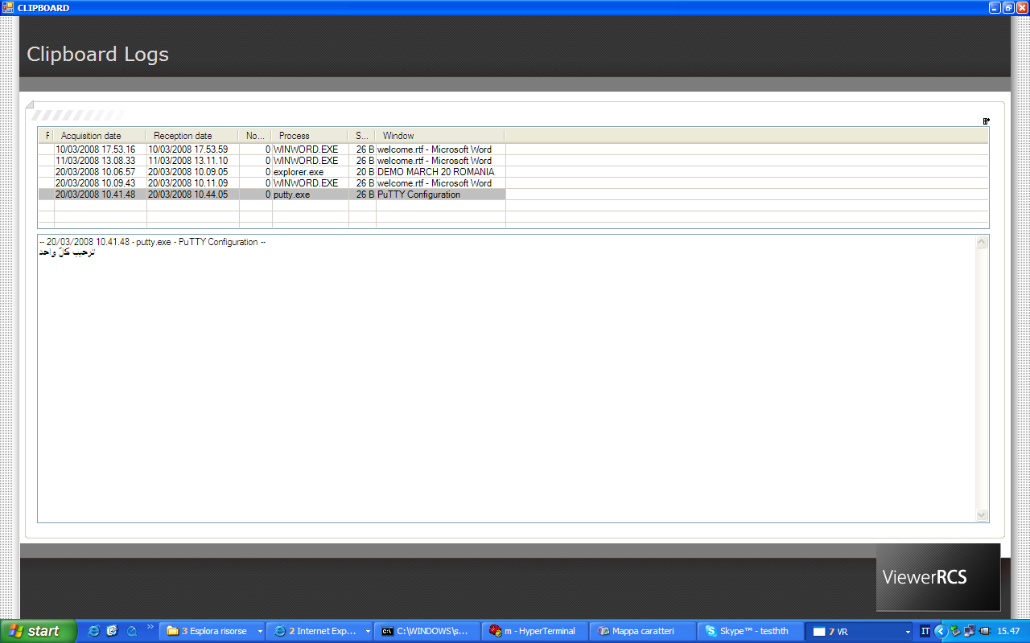
Figura 39 – Clipboard

Selecting entries in the upper side of the screen you can modify the priority of every log and inherit the concerning notes (through contextual menu).

File Opened
All accesses that were made to the files will be displayed through a grid. Each line represents an access and contains, in addition to the file name, the process that has opened, the size that the file had at that time and flags (r=Read w=Write d=Delete).

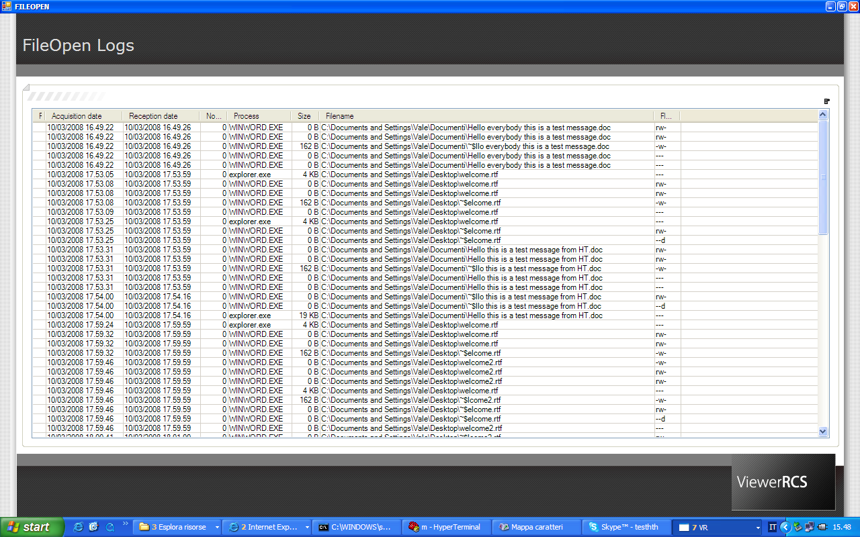
Figura 40 - File opened

File Captured / File Uploaded / File Downloaded
These three types of logs have no voice "Show" in the contextual menu of the secondary research tab. In its place there is the "Download file" that allows you to download the selected files.

Appendix

Management Console
The installation folder of HCM4 contains some subfolder used to store plugins and additional elements to the program.

Plugin folder
The "Plugin" folder contains a plugin system used by RCS (agent and console). The avaiable plugins are:
- RCS kernel level driver: file name is “MSDrv01.sys” and is stored in folder “Driver”.
- Skype 3.6 plugin: file name is “codec.dll” and is stored in subfolder “Skype”
The “Skype” plugin can be installed later even with the agent activated: just take the file in the folder "Skype" and add it to queue Upload.

Vector folder
“Vector” folder (placed in the subfolder "FILES" of the installation folder HCM4) contains neutral executable used by the RCS system to create "exe" installers.
- “neutral” executable: file name is “Foosrc.cap”; this “exe” file is a program that does not open any window and has no functionality.

BUILD folder
“BUILD” folder is the default folder in which the Trojans are created unless otherwise undergoing building.
In addition to executable files and possibly the iso CD installation offline, it also contains all the agents' resources, clouded and randomised.
The file "RCSDEF" contains informations used by the offline software installation and by injection proxy to perform the installation of agent on target PC.
The typical format of this file is the following:
- HCORE=<scrambled_name> : DLL core obfuscated name
- HCONF=<scrambled_name> : configuration obfuscated name
- HEXT1=<scrambled_name>: first plugin obfuscated name (kernel level driver)
- HDIR=<scrambled_name>: installation directory obfuscated name
- HREG=<scrambled_name>: registry key obfuscated name

From this folder you can take agents' elements in a format used by JProxy.

Server RCS
ASP service installation folder (default "C: \ Windows") contains some files that are used for the operation of the service.

Decoy web page
“DDPH.html” file (stored in “c:\windows” folder) is a static HTML page that is sent when a client that is connected to the service is not an agent RCS recognized as "genuine". This feature allows the "decoy" of the connections that attempts at unauthorized access.
You can modify this file to implement a custom redirect page.

Asp service Log file
The file "AspService-report.log" (stored in "c: \ windows \ temp") contains messages written from the server RCS during its working operations.
The state of service and any error messages are contained in this file.
In the event of RCS server malfunctioning or to verify the status of the service you can refer to this document.
At the start of the service this file should contain the following typical messages:
12/03/2008 15:24:49 Asp Server [1928]: Backend access successful
12/03/2008 15:24:49 Asp Server [2208]: ASP_init cert fixed
12/03/2008 15:24:49 Asp Server [2208]: ASP_init signature fixed
12/03/2008 15:24:49 Asp Server [2208]: Asp server working Directory: C:\WINDOWS\TEMP
12/03/2008 15:24:50 Asp Server [1928]: Listening ….
[…]
[…]

The user that will be used to access the administration panel needs the “ADMIN” privilege (cfr. Types of privileges)
Only if the audio driver allows it.
For the sake of brevity only the CD-Rom will be referred in the documentation, but the very same considerations will apply to USB dongle too.

