RCS Console User Manual
INDEX

General concepts 3
Activity, Target and Backdoor 3
Getting started 4
THE CONSOLE VIEW 6
Users 6
Privileges 9
Groups 10
Activities 14
Blotter 18
Target 19
Backdoors 21
 Summary 23
  Voip, Mic 25
  Webcam, Snapshot 27
 Keylog 29
 Url 30
 Chat 31
 Print 32
 Clipboard 34
 Password 34
 Fileopen 35
 Filecap 35
  Download, Upload 36
THE DASHBOARD VIEW 37
Activities balloon 38
Targets balloon 38
Backdoors baloon 39
AUDIT 39
HOWTO 40
Create an activity 40
Create a target 42
Create a backdoor 43
View and search log 44
Export log 45
Create an user 46
Create a group 48
Assign privileges to users 50
Create and manage blotter 51

General concepts

Activity, Target and Backdoor
RCSConsole is the gui to manage and browse data collected on the RCSServer. Data is gathered on the server that is captured by several backdoors configured to point to that server.
A single backdoor is a software tool that is injected on a target device to collect several kind of information in order to conduct an investigation.
A target device can be a personal computer, a laptop, a mobile phone or whatever other device that is supported by RCS.
Several backdoors can then be related to the same target of investigation. Targets in turn can be grouped in “Activities”.
A single Activity represent an “investigation”.
Backdoor can be configured to collect several kind of information, i.e. it has different agents enabled.
Each agent is responsible of collecting a single kind of information.

Getting started
When RCSConsole starts the initial logon screen is displayed:

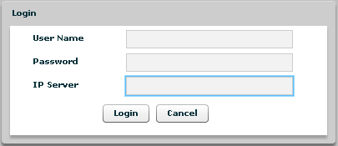
1

You need to logon to an RCSServer in order to have access to any data and to the rest of the application.
To logon you need to specify the following information:
- Your username
- Your password
- The RCSServer address URL. The URL must be preceded by protocol specification (http:// or https://). Encrypted channel (https) is active on port 4443. Eg: https://192.168.0.1:4443
and press the “Login” button.
If you fail to logon the application shows an error message:

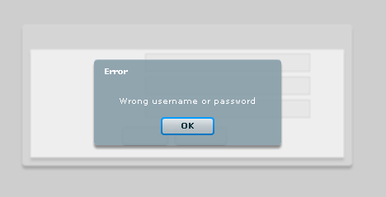
2
press “OK” button to close this window and return to initial logon screen.
After login successfully the application shows this windows:

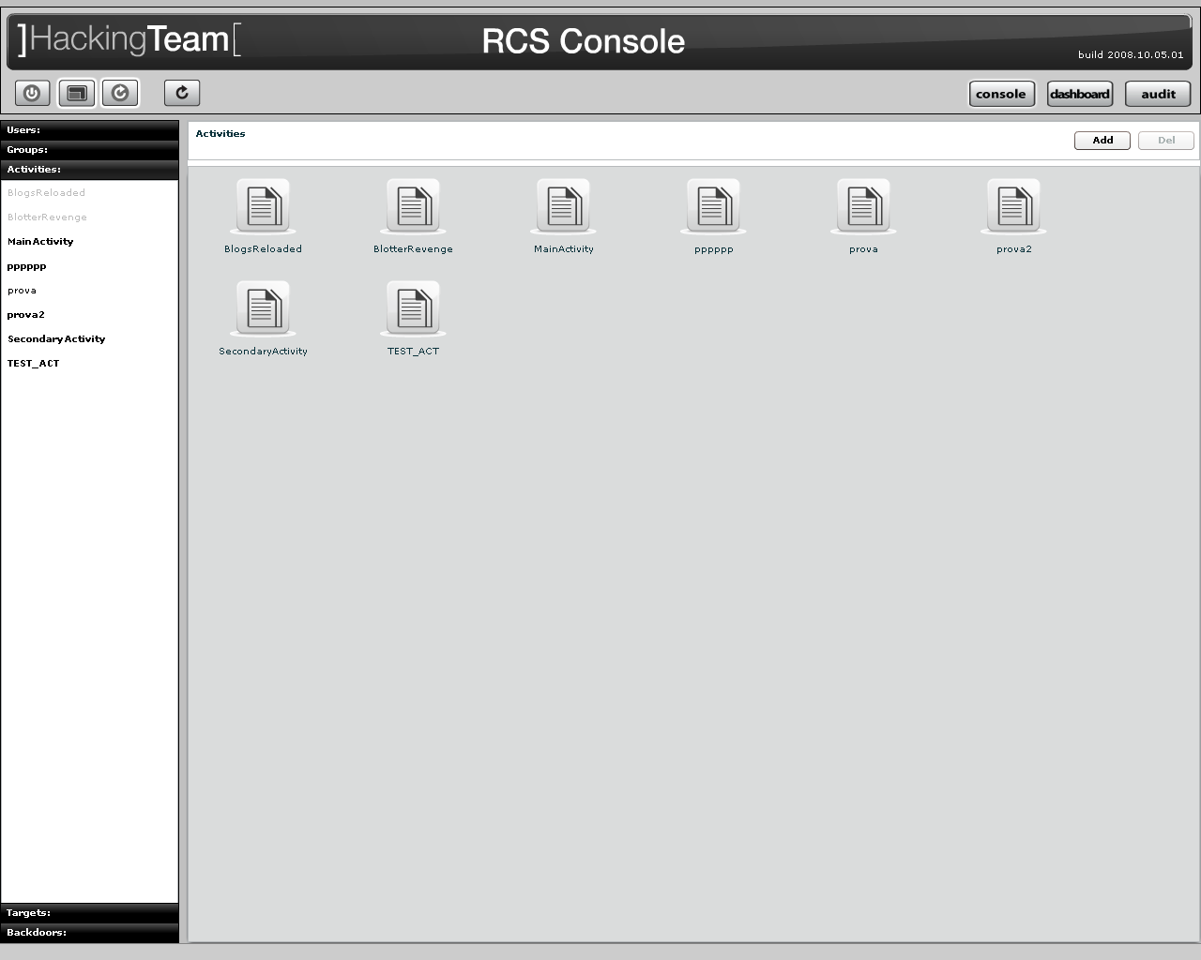
3

At the top on the right you see the current version, highlighted in red in next figure, and buttons to change modality: console, dashboard and audit; the default selected modality is console.

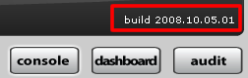
4

Selected button has a white border.

At the top on the left you can see four buttons:

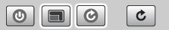
5

- Logout: to close application;

- Fullscreen: to switch between fullscreen and resized window;

- Automatic Refresh: to enable or disable automatic refresh;

- Refresh: to start manual refresh.

A white border appears around the selected button.

The view below the header is the same for any modality, splitted in two parts:
- on the left the object browser menu, let you navigate through all the resources accessible on the server,
- on the right the content/detail viewer

THE CONSOLE VIEW
The console view let you browse through any object that your profile has access to and to manage and edit them.

6

Users
Users Menu is available only for users with Admn privileges.

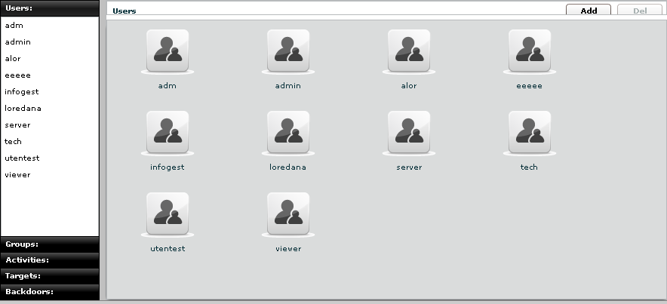
7
You can view a list of all users on the left under the tab “Users” and also on the right pane when you click on the Users tab title.

At this point you can:
- Add new user: click “Add” button on the right at the top of the icons-list:
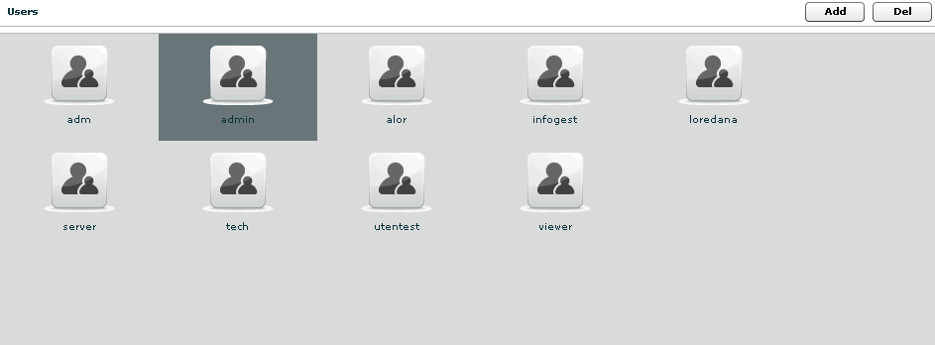
8
then fill fields and assign privileges:

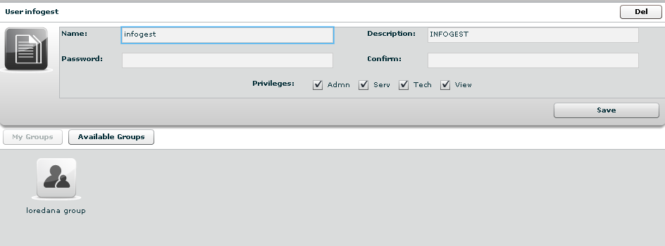
9
click “Save” button to save data.

- select an user, either by:
  - clicking on the user in menu-list:

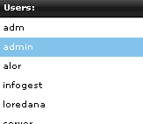
10
  - or double clicking on user's icon in icons-list:
11

- Edit an user: after selecting an user at the top of the window you can edit fields and save them clicking “Save” button.
At the bottom, you can view all groups the selected user belongs to:
12

you can see group’s details by double clicking group’s icon.
You can remove a group from selected user: select the group to remove and then click on the “-“ button or click on the “Remove Group” button below.

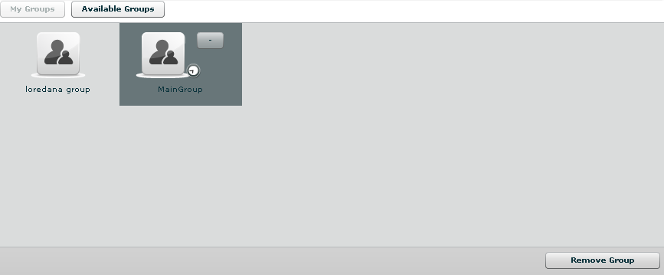
13

Clicking on “Available Groups” button you can view all groups available to be added to the selected user:

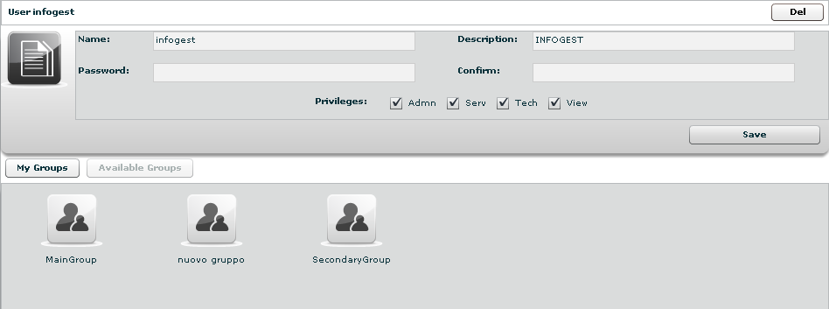
14
you can see group’s details by double clicking group’s icon.
To add a group to the selected user, select a group with a single click:
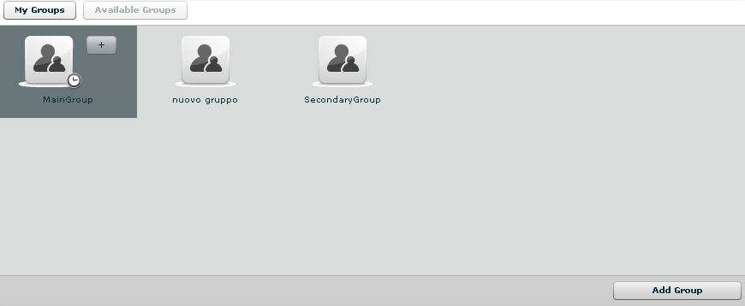
15

then either by:
- click “Add Group” button on the left at the bottom of the window;
- click “+” button next the group’s icon.

- Delete an user: after selecting an user, “Del” button on the top of list of icons is enabled, press the button to delete the user:
16
you must confirm the action to proceed:

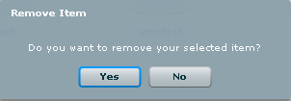
17
click “Yes” to confirm or “No” to exit.

Privileges

- Admn: this is the super user. It is the only one that can create users, groups, activity and targets;

- Serv: reserved role for the server components that require access to XML-RPC methods;
- Tech: this role can create, modify and reconfigure backdoors associated with a target, however the target can only be modified and created by ADMIN;
- View: this role is assigned to users that can only view the logs. It cannot modify backdoors, targets or activity. It can create and modify notes and blotters.

Groups

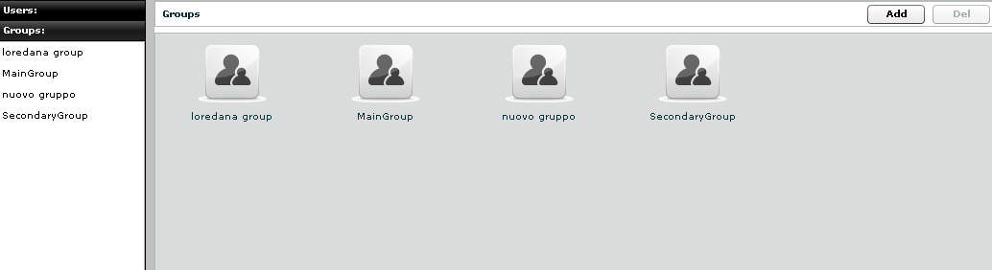
18

You can view a list of all groups on the left under the tab “Groups” and also on the right pane when you click on the Groups tab title.

At this point you can:
- Add new group: click “Add” button on the right at the top of the icons-list:
19
then fill fields:
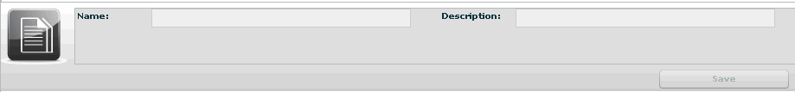
20
click “Save” button to save data.

- Select a group: either by:

  - clicking on the group in menu-list:
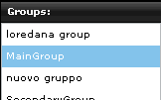
21

  - or double clicking on group's icon in icons-list:
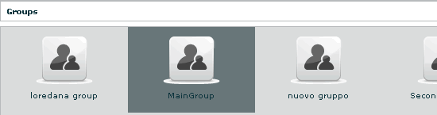
22

- Edit a group: after selecting a group: at the top of the window you can edit fields and save them clicking “Save” button.
At the bottom, you can view all users the selected group belongs to:

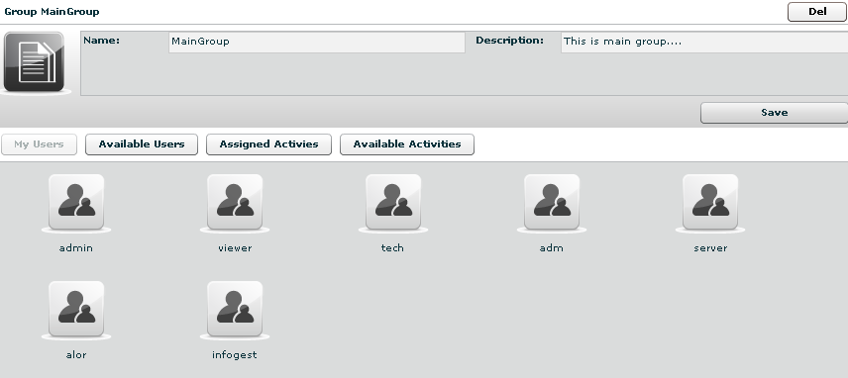
23
you can see user’s details by double clicking user’s icon.
You can remove a user from selected group: select the user to remove and then click on the “-“ button or click on the “Remove User” button below.

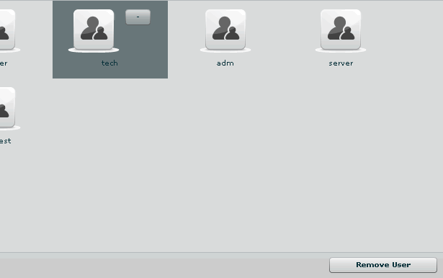
24

Clicking on “Available Users” button you can view all users available to be added to the selected group:

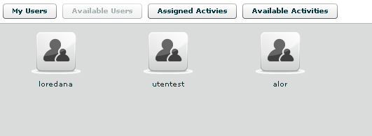
25

you can see user’s details by double clicking user’s icon.
To add a user to the selected group, select a user with a single click:

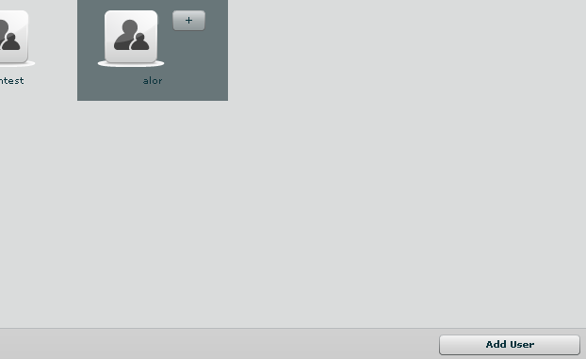
26

then either by:
- click “Add User” button on the left at the bottom of the window;
- click “+” button next the user’s icon.

Clicking on “Assigned Activities” button you can view all assigned activities to the selected group:

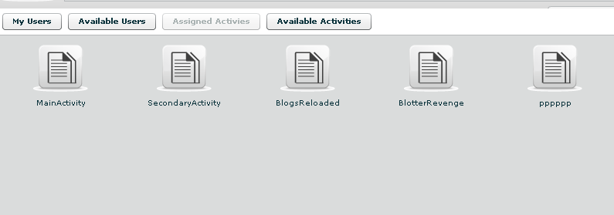
27

you can see activity’s details by double clicking activity’s icon.
You can remove an activity from the selected group: select the activity to remove and click on the “-“ button or click on the “Remove Activity” button below.

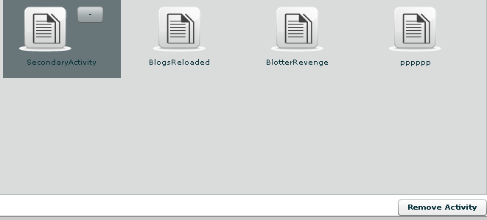
28

Clicking on “Available Activity” bottom you can view all activities available to be added to the selected group:

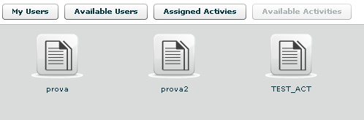
29

you can see activity’s details by double clicking activity’s icon.
To add an activity to the selected group, select an activity with a single click:

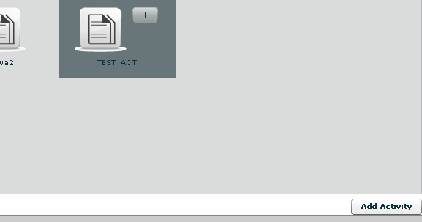
30
then either by:
- click “Add Activity” button on the left at the bottom of the window;
- click “+” button next the icon’s activity.

- Delete a group: after selecting a group, “Del” button on the top of list of icons is enabled, press the button to delete the group:

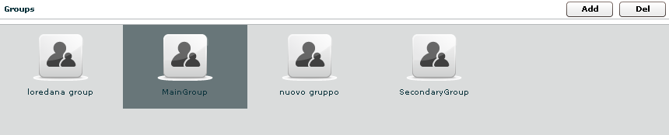
31
you must confirm the action to proceed:
32
click “Yes” to confirm or “No” to exit.

Activities

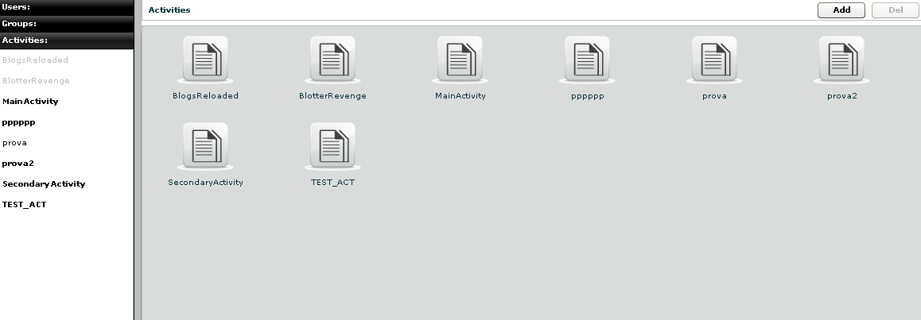
33

You can view a list of all activities on the left under the tab “Activities” and also on the right pane when you click on the Activities tab title.

At this point you can:

- Add new activity: click “Add” button on the right at the top of the icons-list:
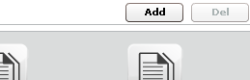
34

then fill fields and select “Status” OPEN:

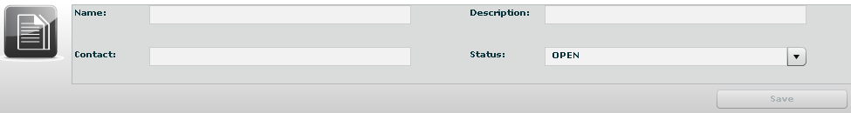
35

Click “Save” button to save data.

- select an activity, either by:
- click on the activity in menu-list:
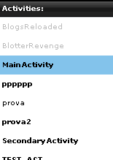
36
- or double clicking on activity's icon in icons-list:
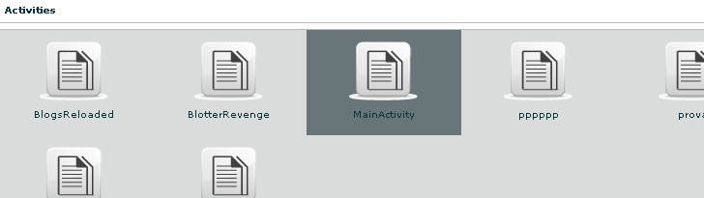
37

- Delete an activity: after selecting an activity, “Del” button on the top of list of icons is enabled, press the button to delete the activity:

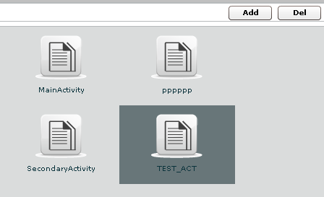
38

you must confirm the action to proceed:

39

click “Yes” to confirm or “No” to exit.
NOTE: Deleting an Activity, will delete recursively all of its targets, backdoors and logs.

- Close an activity: Select Status CLOSE and press the SAVE button. Closing an activity is an irreversible operation that should only be used in the appropriate case.
All the backdoors related to a closed activity will be automatically uninstalled upon the next synchronization.

- Edit an activity: after selecting an activity at the top of the window you can edit fields and save them clicking “Save” button.

At the bottom, you can view all targets the selected activity belongs to:
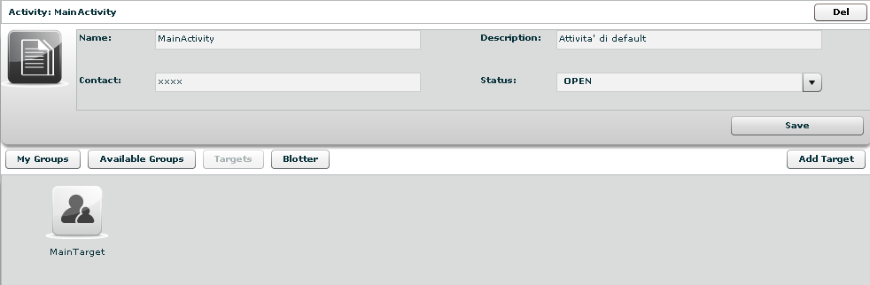
40

you can see target’s details by double clicking target’s icon.
To add a new target to the selected activity, click “Add Target” button on the right:

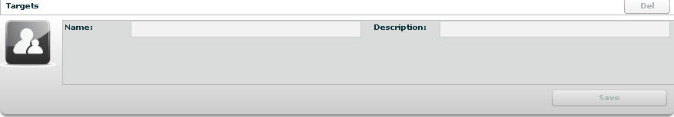
41

then fill fields and click “Save” button to save data.

Clicking on “My Groups” button you can view all groups the selected activity belongs to:

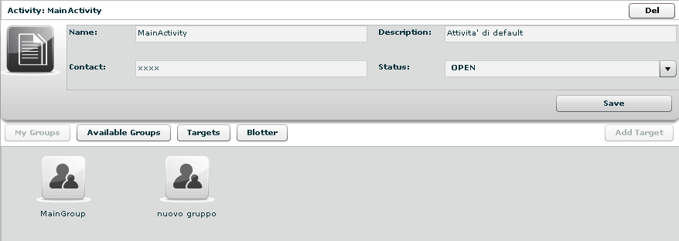
42

you can see group’s details by double clicking group’s icon.
You can remove a group from selected activity: select the group to remove and then click on the “-“ button or click on the “Remove Group” button below.

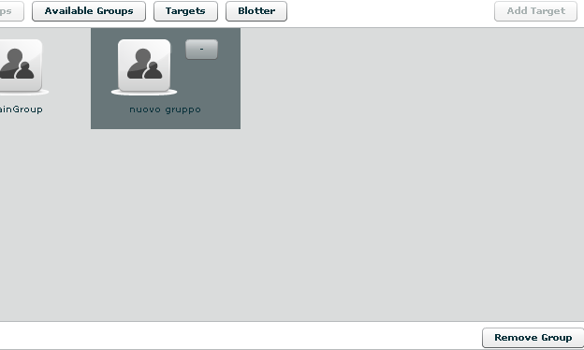
43

Clicking on “Available Groups” button you can view all groups available to be added to the selected activity:

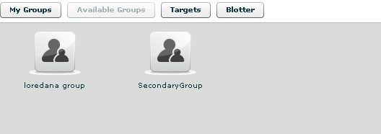
44

you can see group’s details by double clicking group’s icon.
To add a group to the selected activity, select a group with a single click:

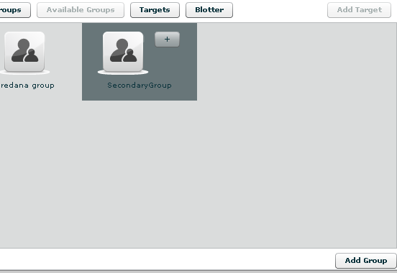
45

then either by:
- click “Add Group” button on the left at the bottom of the window;
- click “+” button next the group’s icon

Clicking “Blotter” button you can view a list of blotter.

Blotter
Blotter shows a list of preferential logs as a table:

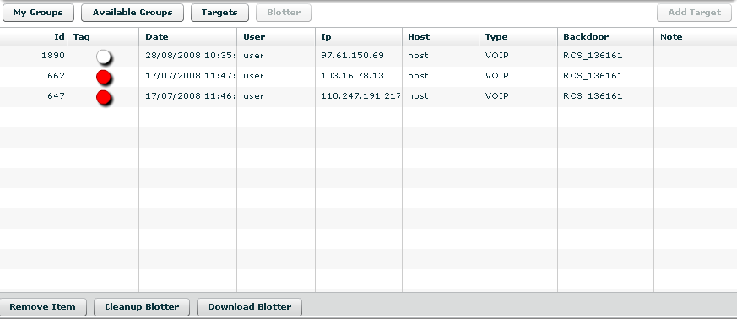
46

Double click mouse on detail’s row to view log’s detail.
If you want to remove a row, select it with a single click:

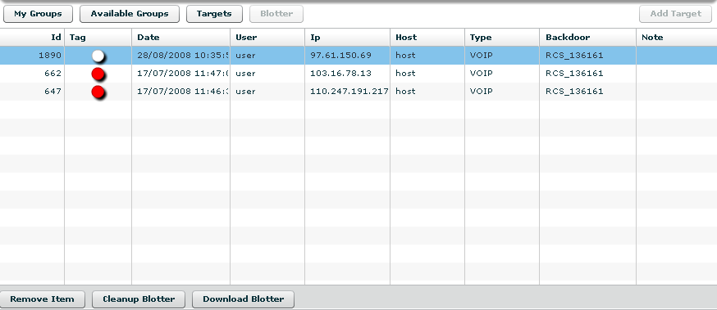
47

then click “Remove Item” button:

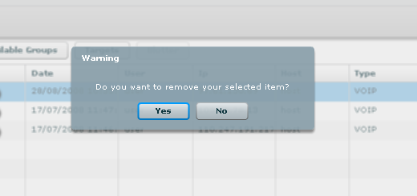
48

click “Yes” to confirm or “No” to exit.

Click “Cleanup Blotter” button to clear blotter.
Click “Download Blotter” button to download a blotter report as a compressed file (.zip).

Target

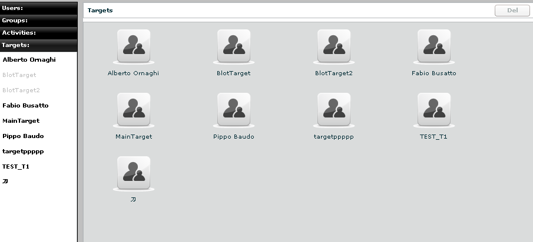
49

You can view a list of all targets on the left under the tab “Targets” and also on the right pane when you click on the Targets tab title.

At this point you can:
- select an user, either by:
  - clicking on the target in menu-list:

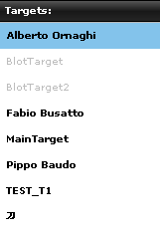
50

  - or double clicking on target's icon in icons-list:

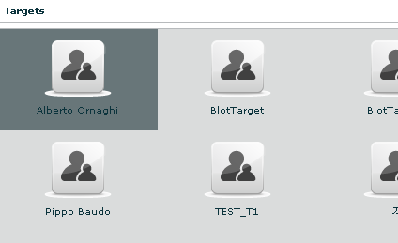
51
- Edit a target: after selecting a target at the top of the window you can edit fields and save them clicking “Save” button.
At the bottom, you can view all backdoors the selected target belongs to:

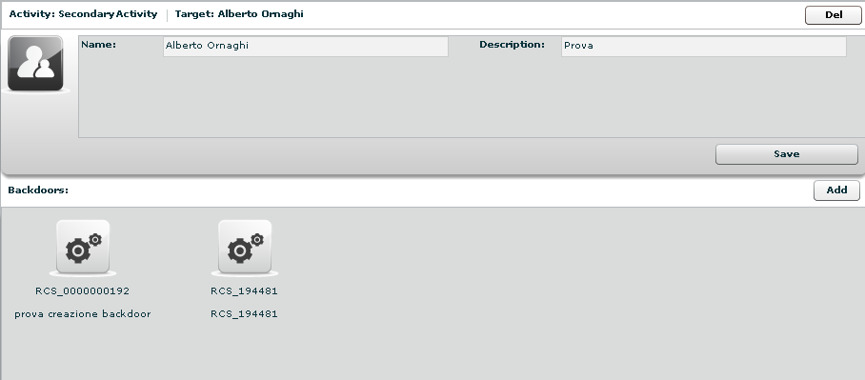
52

you can see backdoor’s details by double clicking backdoor’s icon.
To add a new backdoor to the selected target clicking “Add” button on the right:

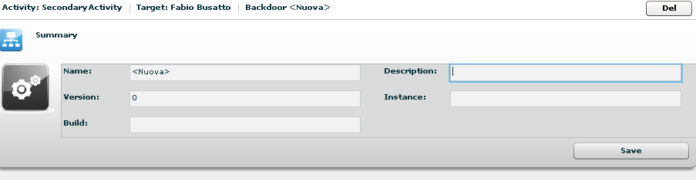
53

fill field “Description” and click “Save” button to save data.
You can view the activity’s target clicking on the link upper details of selected target:

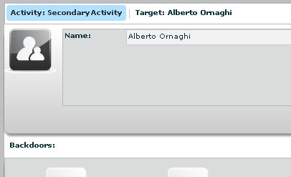
54

- Remove a target: after selecting a target, press “Del” button on the top of details of the selected target, you must confirm the action to proceed:

55

click “Yes” to confirm or “No” to exit.
NOTE: Deleting a Target will recursively delete all of its backdoors and logs.

Backdoors

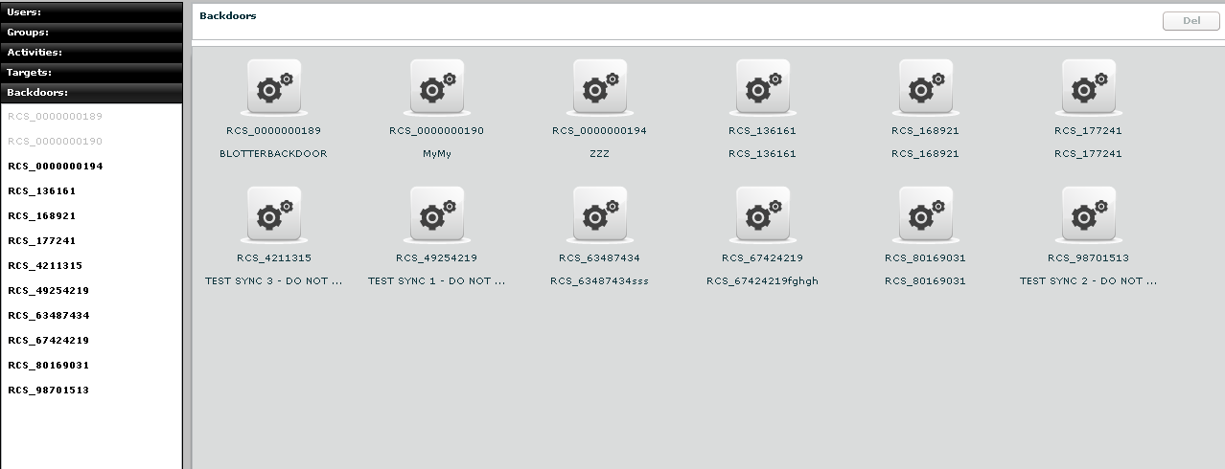
56

You can view a list of all backdoors on the left under the tab “Backdoors” and also on the right pane when you click on the Backdoors tab title.
Here you can see all the backdoor created within targets and all of their instances.
You can find different types of backdoors identified by different icons:
 All Windows 32 bit
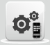 All Windows Mobile

NOTE:
Backdoor installed on different systems (or users) will create different instances. Each instance stands for an installation. First installation will have the name assigned to the backdoor when it was created. Further instances will have the same name followed by an incremental number between parentheses. Each instance can be configured separately.

At this point you can:
- select a backdoor, either by:
  - clicking on the backdoor in menu-list:

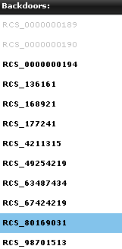
57

  - or double clicking on backdoor's icon in icons-list:

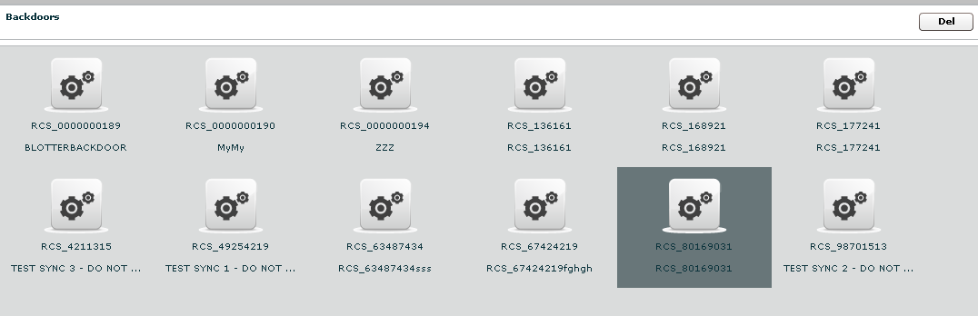
58

- Edit a backdoor, after selecting a backdoor, this is backdoor’s view with details summary icons:

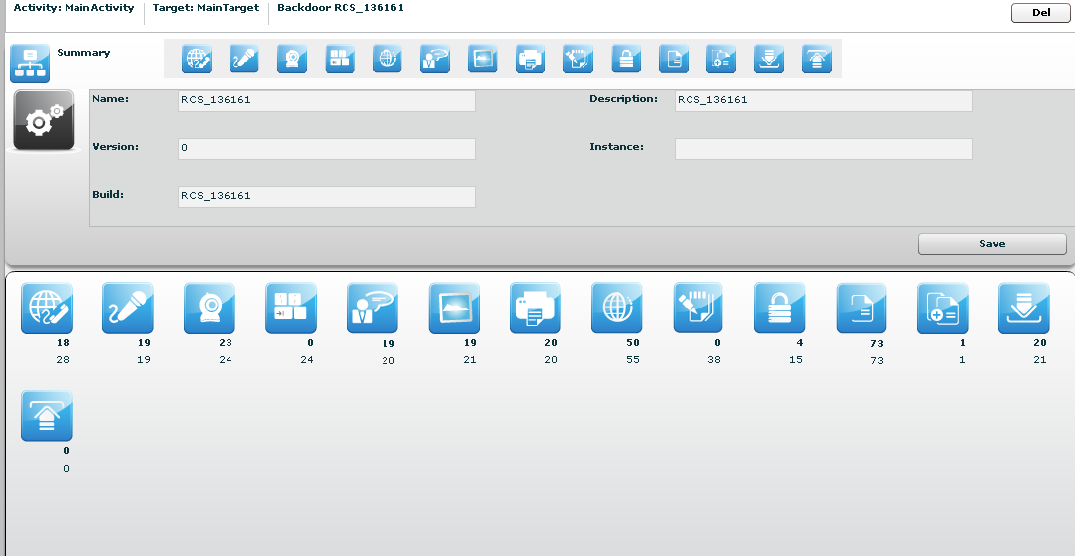
59

At the top, the link to open activity of selected backdoor:

60
and near the link to open target of selected backdoor:

61

under the links: on the left the summary icon and on the right a list of log’s detail’s icons; then you can edit field “Description” and save it clicking “Save” button.

To open a type of log click its detail icon, then summary icon and selected icon’s log
are replaced mutually:

62

- Delete a backdoor, after selecting a backdoor, press “Del” button at the top of details of the selected target, you must confirm the action to proceed:

63

click “Yes” to confirm or “No” to exit.
NOTE: Deleting a Backdoor will recursively delete all of its logs. Deleted backdoors will be automatically uninstalled from the target machine upon next synchronization.

Summary

Summary shows all icons to view all type of logs and a summary of all related statistics:

64

For each log there are two counters:
- in bold: count of recent logs;
- in normal: count of total logs.

You can select more than one backdoor at a time. In this case the counters will show cumulative values.

To open a type of log click its detail icon.

At the right-top of detail’s log’s table there are some buttons:

/ to show unread or all logs;
add selected log to blotter,
download, this button is enabled after selected one or more item;
to manage note of selected log: create a new note or modify or delete an existing note.

Note can be public and private:
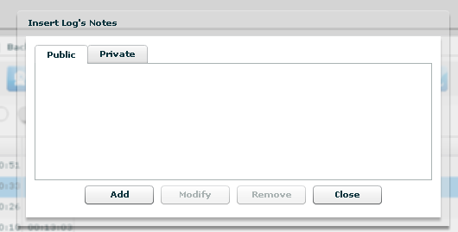
65

Then Tag Bar (priority), let you change priority of selected logs and is visible only when one or more row is selected.

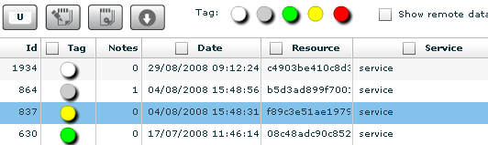
66

Tags in the Tag Bar are displayed in different colours from lower priority (white) to higher (red). Selected tag are displayed without a drop shadow.

You can change tag of selected row or rows just by clicking on new tag.

Right to the Tag Bar, there is a checkbox that let you show or hide remote data:
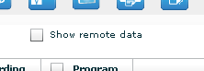
67
if you check it, remote data columns appear in the table; by default remote data are hidden.

It’s possible to filter table’s content: flag one or more checkbox in table’s header and specify your filter in the popup:

68

To remove filter, remove flag from its checkbox.

Under the table, you change number of logs showed, the default is 20:

69

and navigate the result pages with “<<” and “>>” buttons.

Multiple selection of Backdoors

You can select more than one backdoor at a time. In this case the counters will show cumulative values and the agents log view will show log detail originating from any of the selected backdoor.

To select more backdoors, in left pane under tab “Backdoors”, first select one backdoor, then press and hold the “Ctrl” button while selecting another backdoor and do the same for all backdoors you want to select.

One backdoor selected:

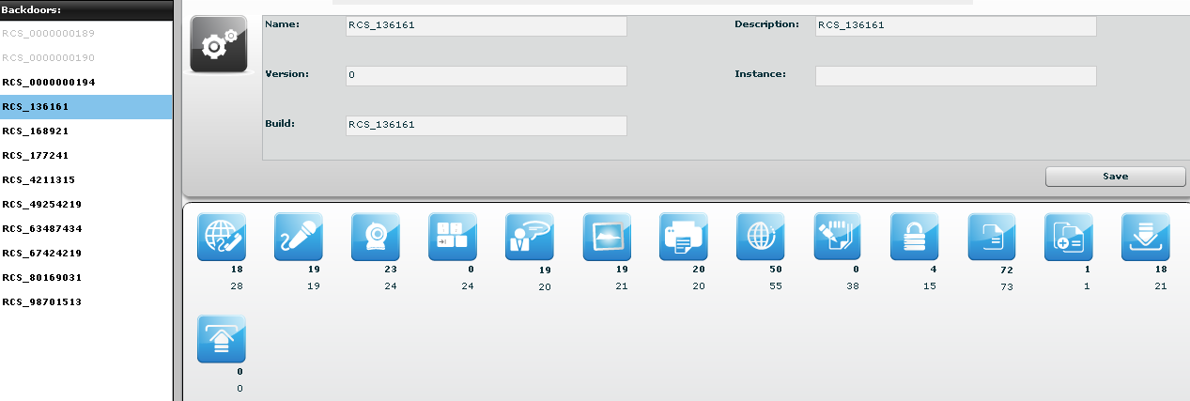
70

with more backdoors selected the counters show cumulative values for any type of log:

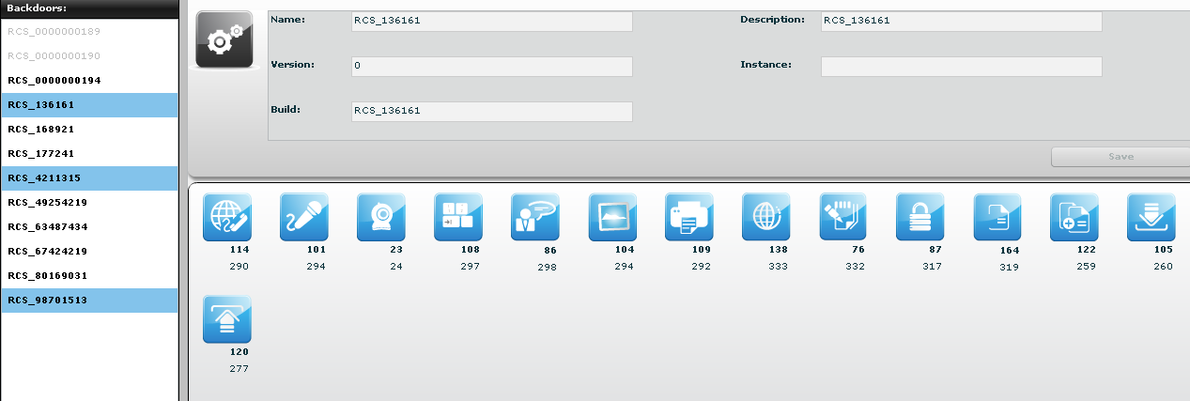
71

if you want to select consecutive backdoors, select first backdoor then press and hold “Shift” button while selecting the last backdoor:

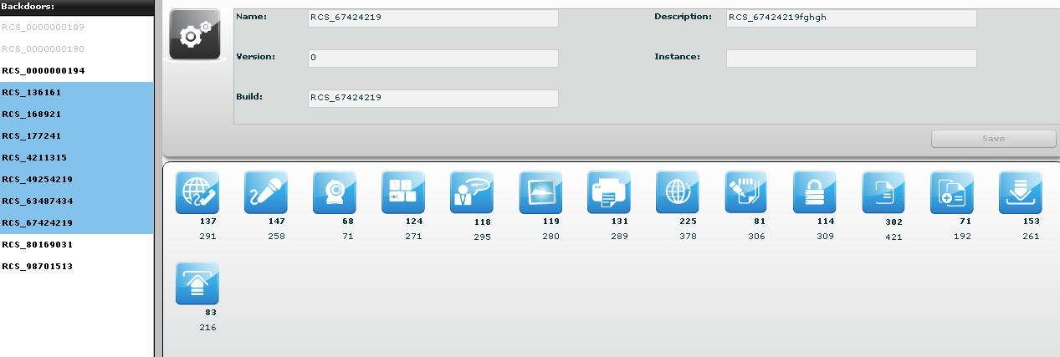
72
Voip, Mic
Select this agent view to show a list of all recordings of kind “call list”, “voip” or “mic”.
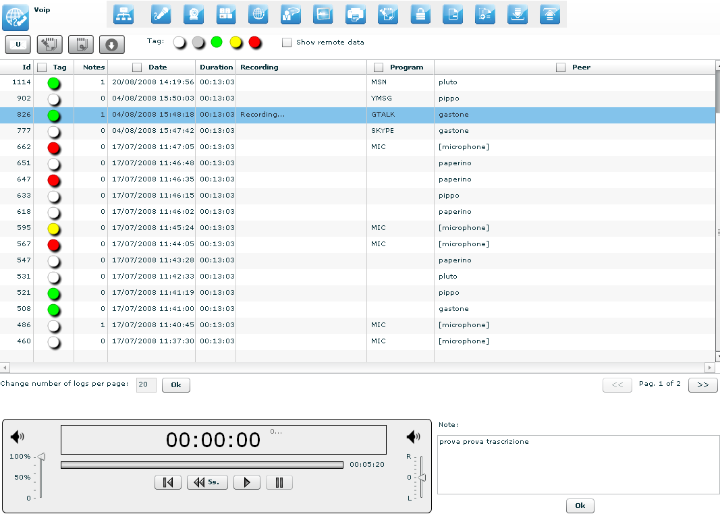
73

Double-clicking on a row a simple audio player is shown on the lower part of the view.
A public note editor is also shown at the right of the player.
Modify the note and press “Ok” button to save the changes.
These can be used to easily record any notes related to the listening recording.
The first time a row is selected or if the recording is still in place, the audio file need to be downloaded, a progress bar shown until finished:

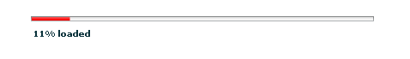
74

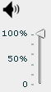 this control let you change the volume;

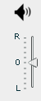 move this arrow to change balance, zero is default. For VOIP calls, left channel will contain the target’s “voice”, right channel will contain the peer’s “voice”.

There are four buttons to interact with the audio player:
to start player from begin;
to go back five seconds;
to play audio;
to pause audio.

The bar shows in red the portion of the audio already played:

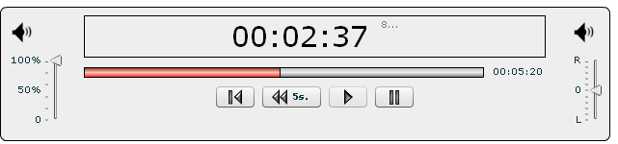
75

Webcam, Snapshot
Select this agent view to show a list of all captured images from webcam or snapshot backdoors.

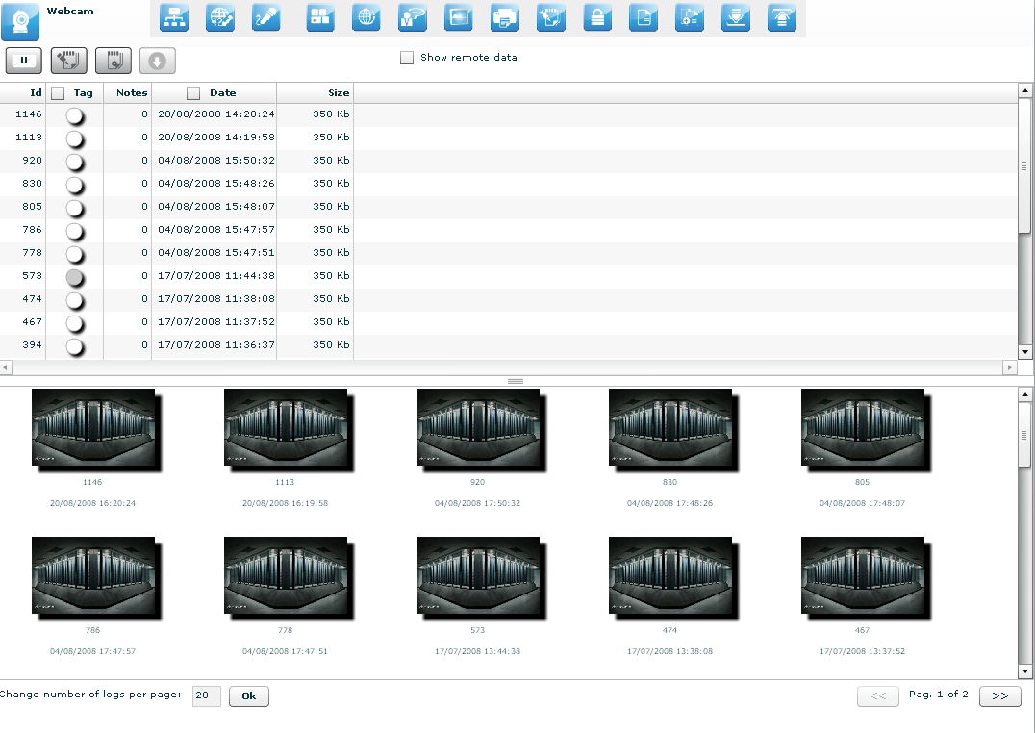
76

Under the table, there are frames of all webcam or snapshot’s logs. Double click on a frame to see more details:

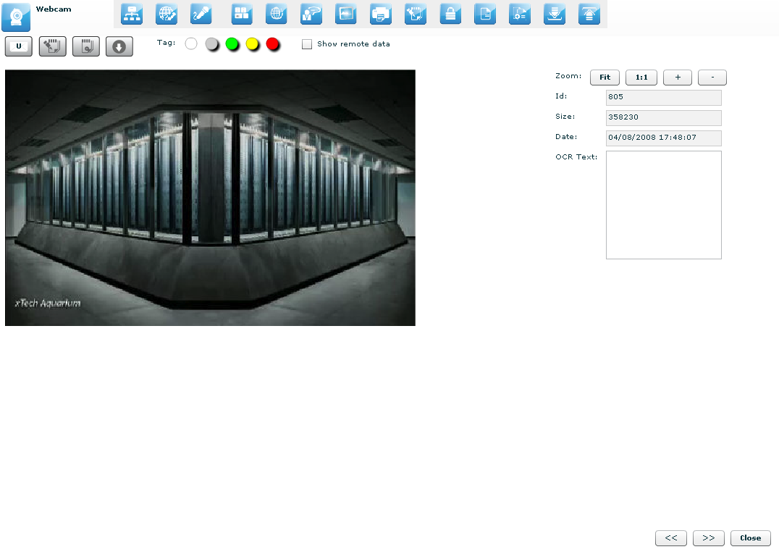
77

At the right of the page you can change zoom factor with four button:
“Fit” button to fit the image with the current view,
“1:1” button to see the image at the original size,
“+” button to increment zoom,
“-“ button to decrement zoom;

At the bottom of the page:
“<<” button to see previous frame,
“>>” button to see next frame,
“Close” button to return to the list of webcam or snapshot’s logs.

Keylog
This agent viewer let you browser through logs of kind “keylog”.

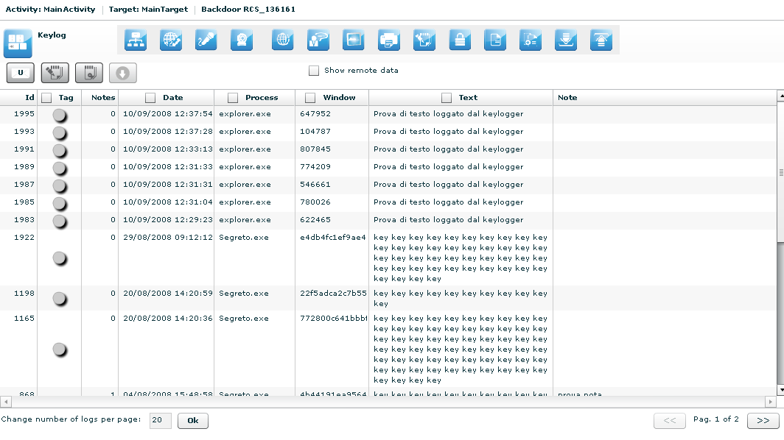
78

It is possible to edit public note directly by double clicking on the note filed of the selected row:

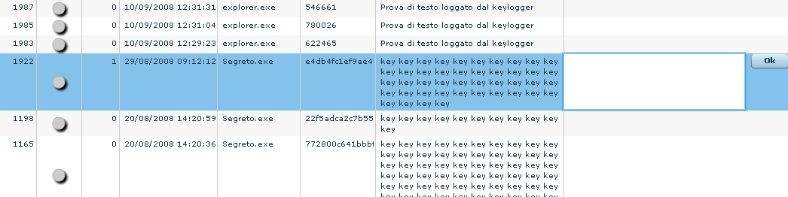
79
click “Ok” button to save data.

Url
This agent viewer let you browser through logs of kind “url”.

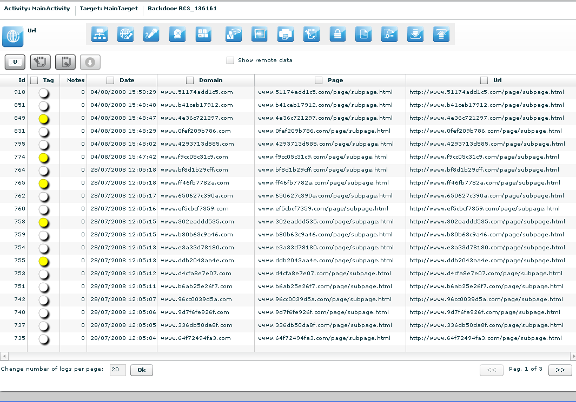
80

No other specialized function are available in this view other than the those commons to any agent viewer (download, add to blotter, etc.).

Chat
This agent viewer let you browser through logs of kind “chat”.

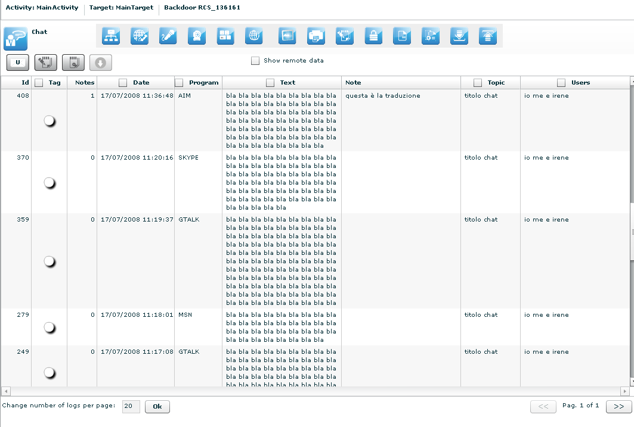
81

It is possible to write note also directly from the table: double click on the note field of the selected row:

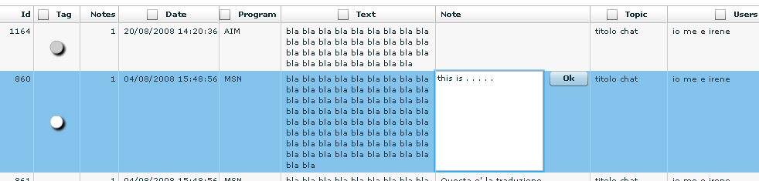
82
click “Ok” button to persist the changes on the server.

Print
This agent viewer let you browser through logs of kind “print”.

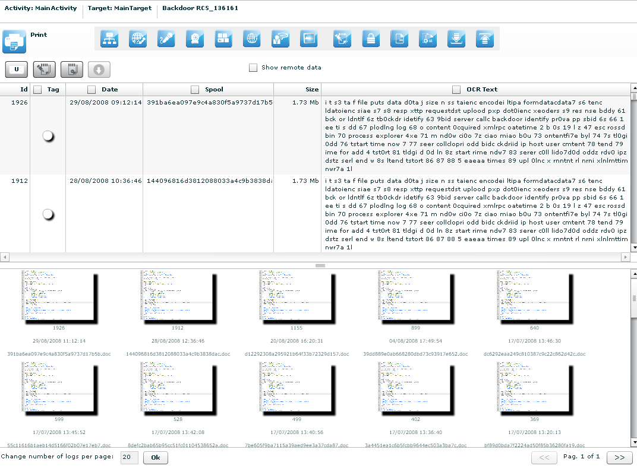
83

Under the table, there are previews of documents. Double click preview to see details:

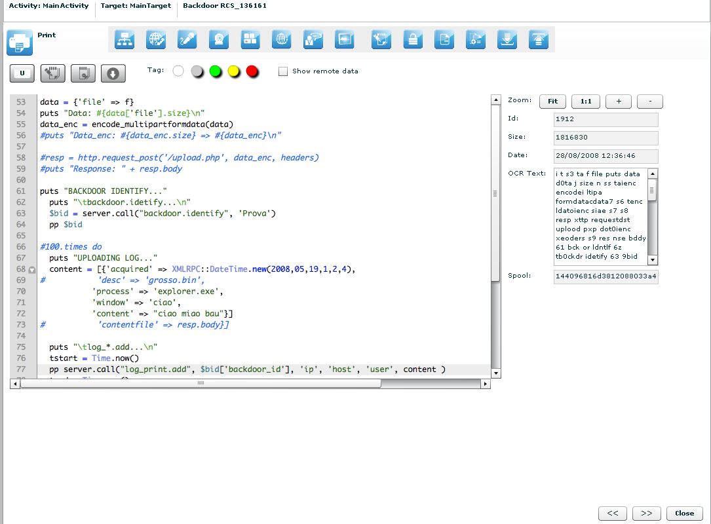
84

At the right of the page you can change zoom factor with four button:
“Fit” button to fit the image with the current view,
“1:1” button to see the image at the original size,
“+” button to increment zoom,
“-“ button to decrement zoom;

At the bottom of the page:
“<<” button to see previous frame,
“>>” button to see next frame,
“Close” button to return to the list of print’s logs.

Clipboard
This agent viewer let you browser through logs of kind “clipboard”.

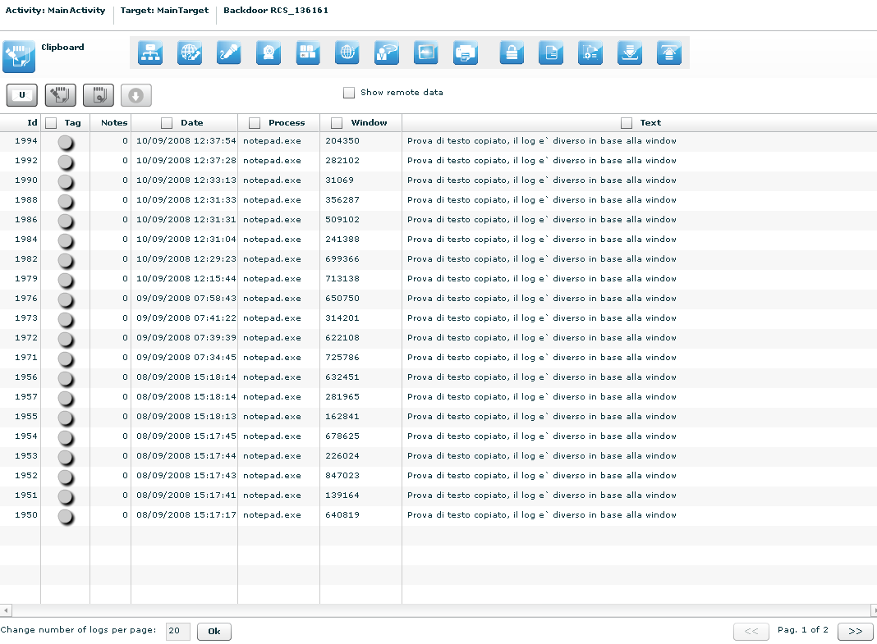
85
No other specialized function are available in this view other than the those commons to any agent viewer (download, add to blotter, etc.).

Password
This agent viewer let you browser through logs of kind “password”.

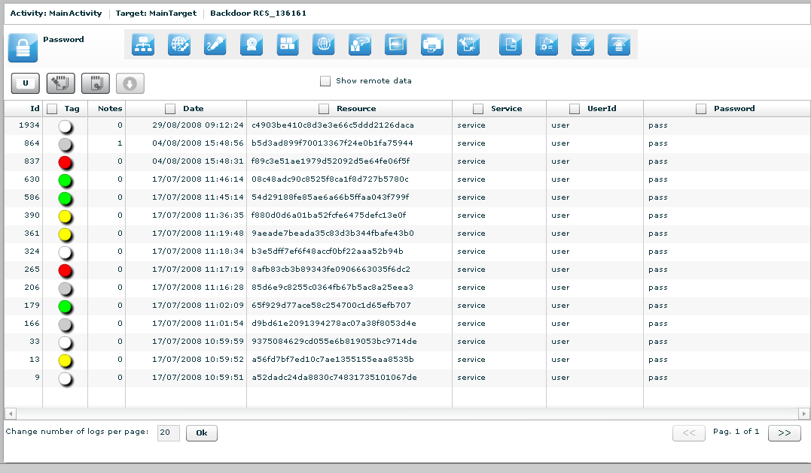
86

These are the main fields available in this view:
- Resource: The type of password (or browser auto complete)
- Service: The url or the server address where the account belongs
- UserId: The username of the account (or the name of the form field for browser autocomplete)
- Password: The password for the account (or a comma separated list of all possible form field’s values)

No other specialized function are available in this view other than the those commons to any agent viewer (download, add to blotter, etc.).

Fileopen
This agent viewer let you browser through logs of kind “fileopen”.

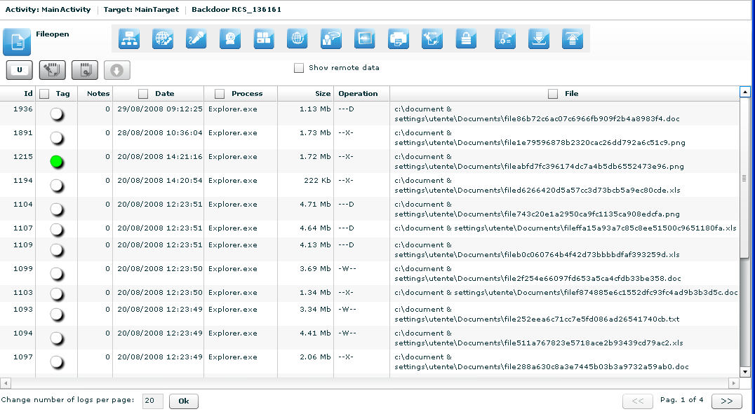
87
No other specialized function are available in this view other than the those commons to any agent viewer (download, add to blotter, etc.).

Filecap
This agent viewer let you browser through logs of kind “filecap”.

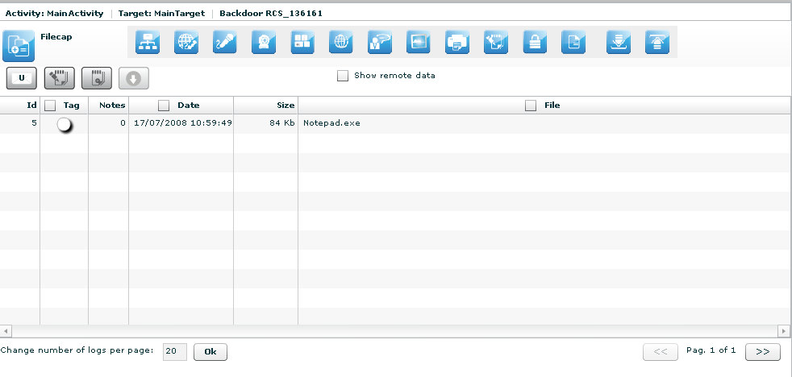
88

No other specialized function are available in this view other than the those commons to any agent viewer (download, add to blotter, etc.).

Download, Upload
This agent viewer let you browser through logs of kind “dowload” or “upload”.

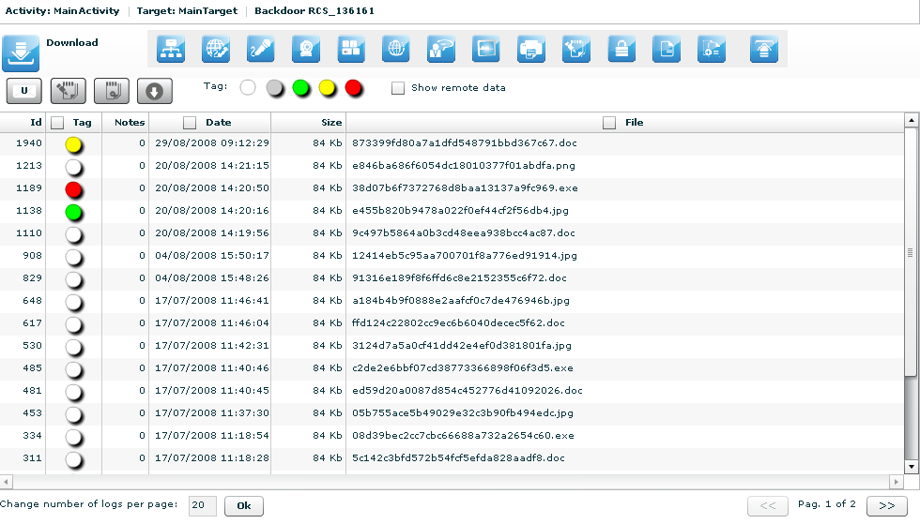
89

No other specialized function are available in this view other than the those commons to any agent viewer (download, add to blotter, etc.).

 Addressbook
This agent viewer let you browser through logs of kind “addressbook”.

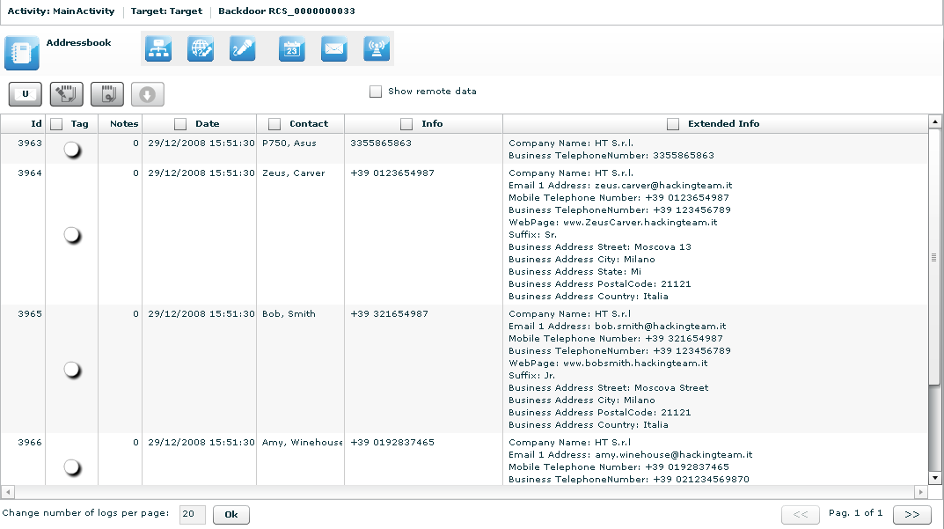
90

These are the main fields available in this view:
- Date: date and time.
- Contact: name and surname of the contact in the addressbook.
- Info: whether this field is filled it contains a mobile phone number or a home phone number.
- Extended Info: whether this field is filled it contains some informations like address, company name, address, webpage etc... of the contact.

No other specialized function are available in this view other than the those commons to any agent viewer (download, add to blotter, etc.).

 Calendar
This agent viewer let you browser through logs of kind “calendar”.

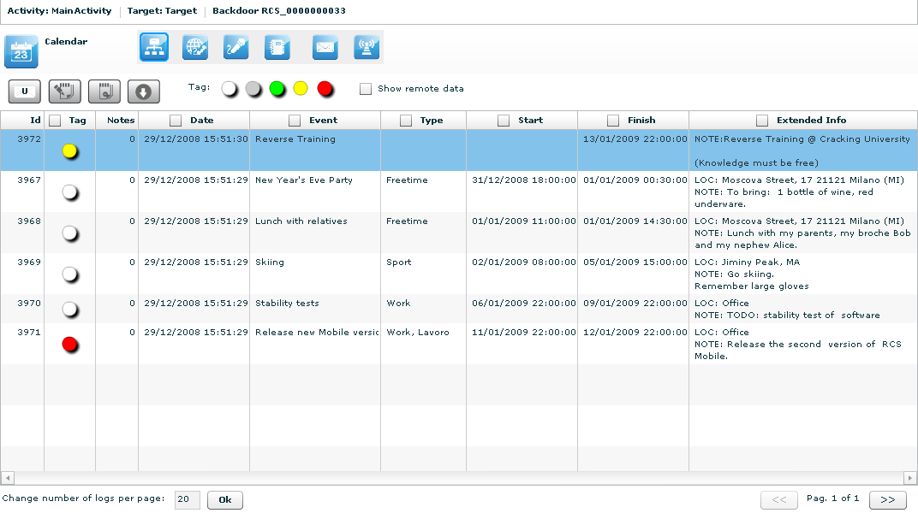
91
Every row of logs describes an appointment, event, meeting or task.

These are the main fields available in this view:
- Date: date and time;
- Event: object of the appointment;
- Type: type of the appointment (if specified);
- Start: date and time since appointment starts (some types of appointment doesn’t have a start time but only a Finish time);
- Stop: this field describes the date and time when the appointment finishes;
- Extended Info: in this field there may be
  - LOC: location where the appointment will take place;
  - NOTE: some notes about the appointment;
  - REC: recipients that take part in the meeting.

 Messages
This agent viewer let you browser through logs of kind “mail”, “sms” or “mms”.
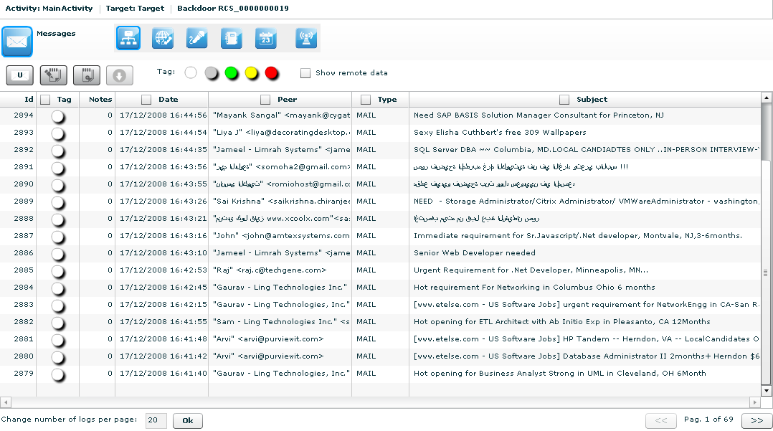
92
These are the main fields available in this view:
- Date: date and time;
- Peer: sender or receiver of the message;
- Type: type of the message, MAIL, SMS, MMS;
- Subject: part of the message body.
Double-clicking on a row will appears on the lower part of the view, the complete message body of the mail, MMS or SMS.

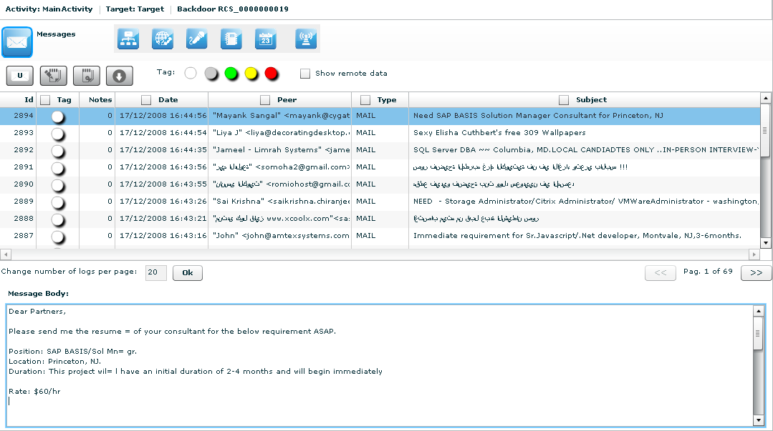
93

 Location
This agent viewer let you browser through logs of kind “gps” or “cell”.

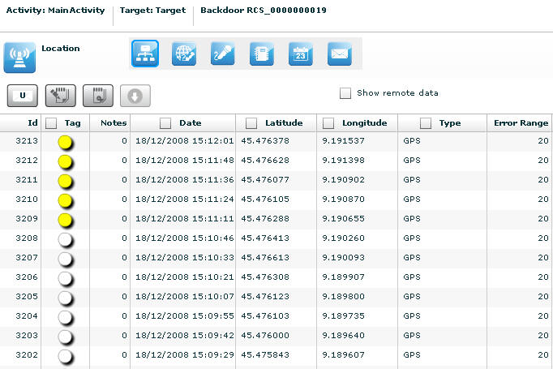
94

These are the main fields available in this view:
- Date: date and time;
- Latitude: latitude expressed in degree;
- Longitude: longitude expressed in degree;
- Type: gps or cell;
- Error range: possible errors in the position, expressed in meter.
Double-clicking on a row will appears on the lower part of the view a map that shows the geographical location that the log describes.

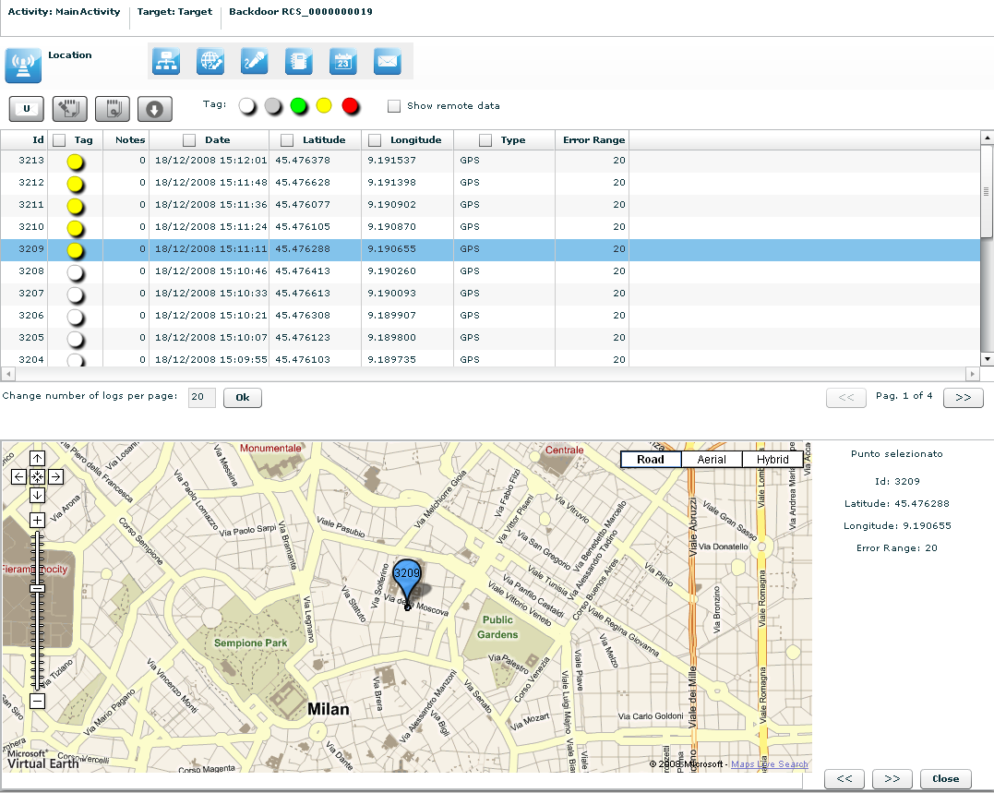
95
You can perform some operations on the map:
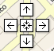 | move over all the map with the direction cross;

change the log view in the map moving right and left with arrows;

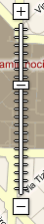 | zoom in and zoom out on the map image.

THE DASHBOARD VIEW
The dashboard let you highlight those activities or targets or backdoors to be monitored carefully.

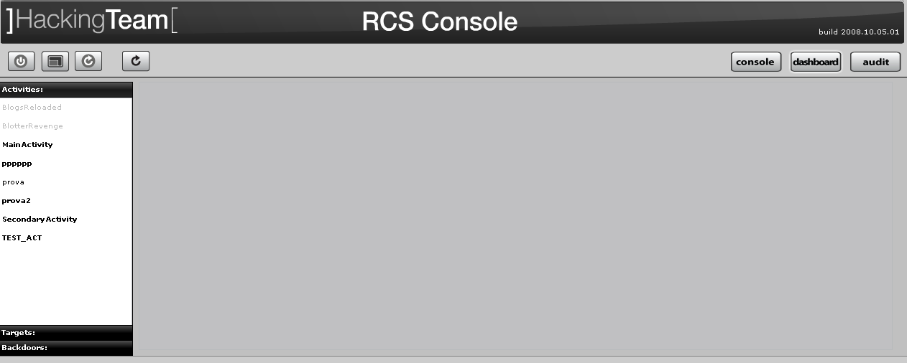
96

Just double click on an item in left menu or drag it to the centre of the screen and put it under observation: a corresponding “balloon” will appear on the watchboard.

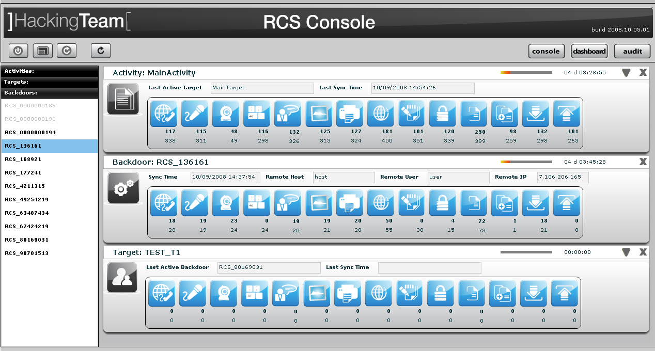
97

Selected items will be monitored contently (if automatic refresh is enabled) and newer (hottest) one will be placed on the top of the screen.
For all type of item: activities, targets, backdoors, there is a progress bar and a timer both showing the time elapsed from last received update:

98

to expand a balloon, only for activities, to see its targets, and for targets to see its backdoors;
to compress an expanded balloon;
to remove a balloon from the watchboard.

A balloon shows an icon for each kind of log. When new data arrives the corresponding icon will be highlighted until logs are viewed
To view the logs just click on its detail icon, then you will switch to the console view.
For every log two counter are showed:
- in bold: count of recent logs;
- in normal: count of total logs.

Activities balloon

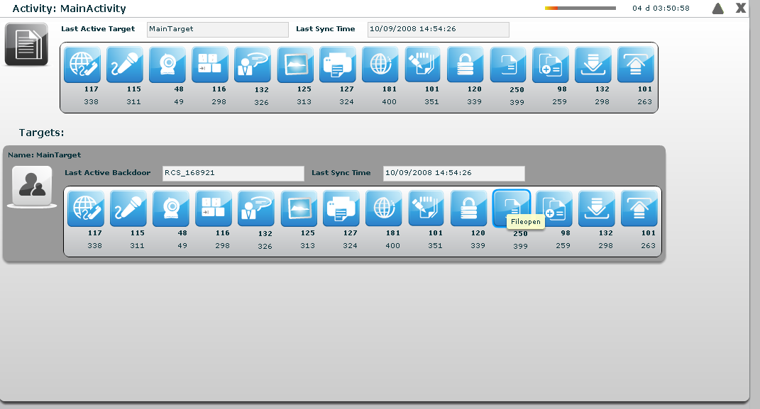
99

double click on target’s panel to see its details. The id of the last seen target and last sync time is showed. In expanded form last sync time, and seen backdoor for each target are also displayed.

Targets balloon

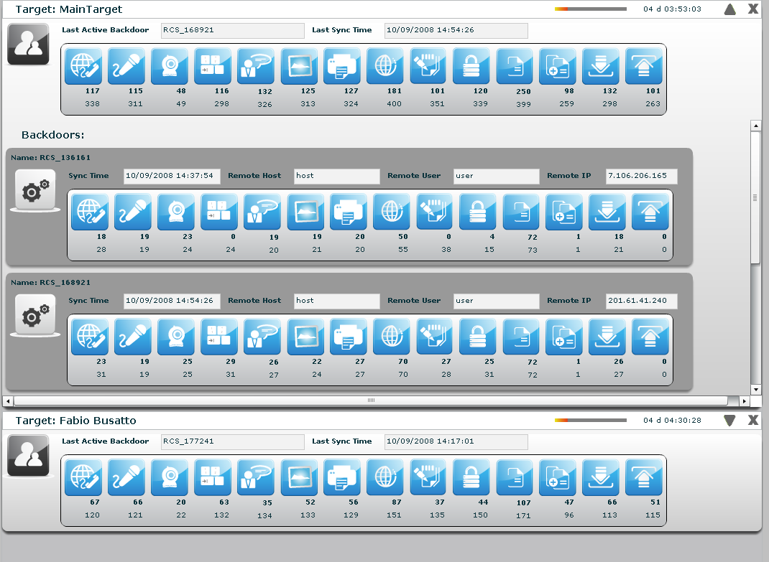
100

double click on one of backdoor’s panel to see its details. The id of the last seen backdoor and last sync time is showed. In expanded form last sync time, last remote host and user and last IP for each backdoor are also displayed.

Backdoors balloon

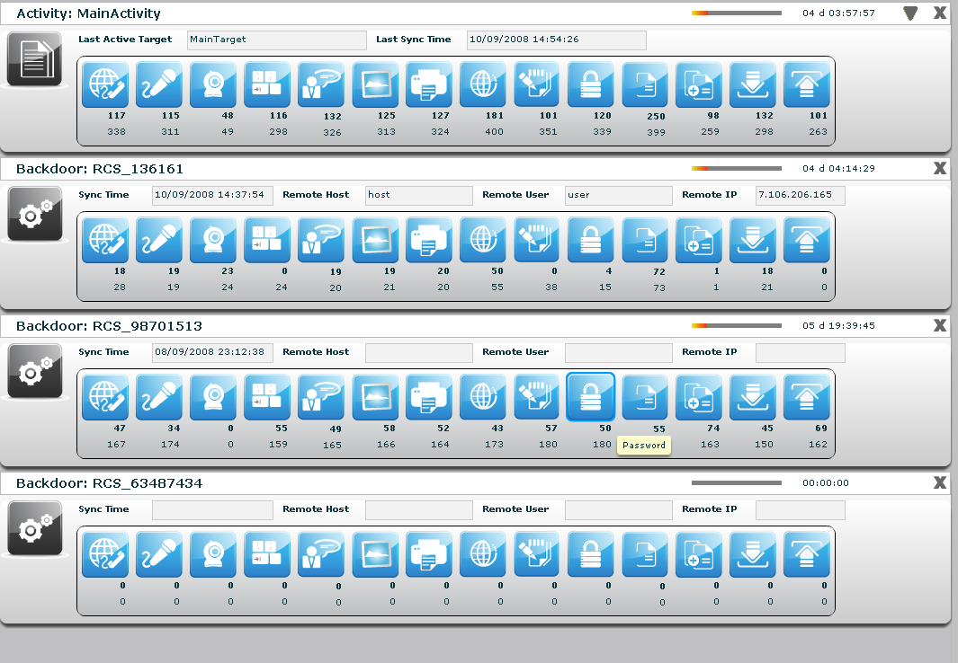
101

AUDIT

Available in next version.

HOWTO

Create an activity
You need to be logged with Admn profile. Start application and after successfully login, click “Add” button on left menu:

102
fill fields and select “Status” OPEN:

103
click “Save” button to save data.
Then “Available Groups” button is enabled, click it to choice one or more groups for this activity:
104

you can see group’s details by double clicking group’s icon.
An activity will only be available to users belonging to groups assigned to it. Thus, in order to give access to the newly created activity, its targets and its backdoors you need to assign groups to it.
Select group with a single click:
105
then either by:
- click “Add Group” button on the left at the bottom of the window;
- click “+” button next the group’s icon.

At this point you can add a new target clicking “Add Target” button on the right of the screen:

106
fill fields and click “Save” button to save data.

107

Create a target
You need to be logged with Admn profile. Start application and after successfully login, click tab “Activities” on left menu:

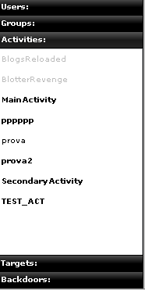
108

select an activity or create a new activity, then click “Add Target” button on the right of the screen to create a target:

109
fill fields and click “Save” button to save data.

110

Create a backdoor
You need to be logged with Tech profile. Start application and after successfully login, click tab “Targets” on left menu:

111
select a target then click “Add” button on the right to create a backdoor:

112

fill field “Description” and click “Save” button to save data:

113

View and search log
You need to be logged with Viewer profile. Start application and after successfully login you can either:
- the logs browsing throw targets/backdoors/activities in console view, or
- click “Dashboard” button to change modality and select and it from previously highlighted resource in the watchboard:

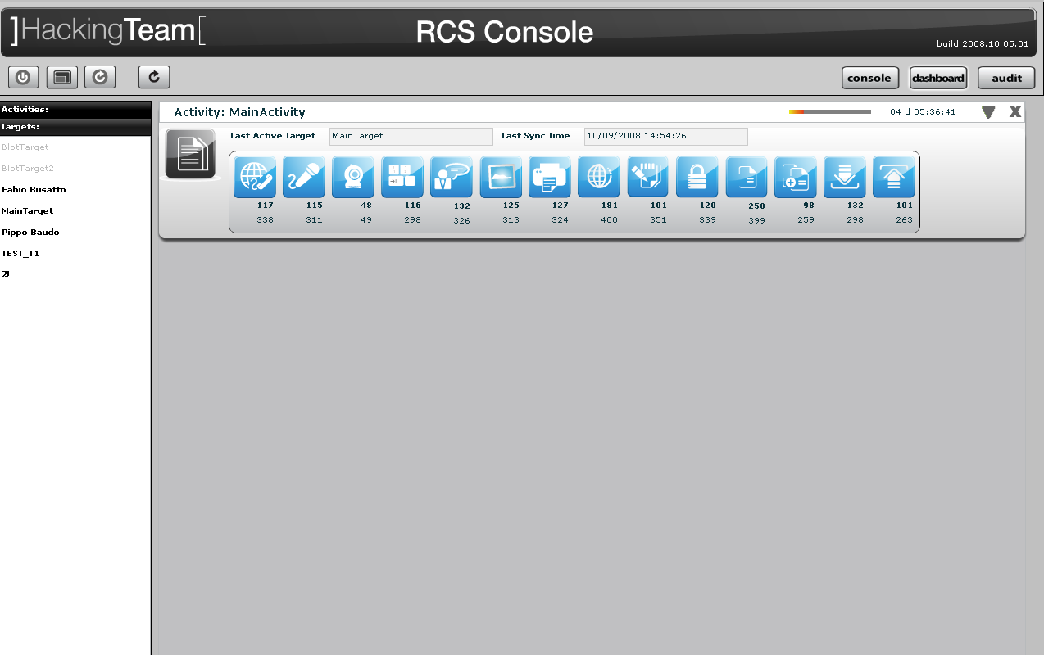
114

then click log’s icon to see log’s details.
In either way you will access the log details viewer where you can search and filter logs just by clicking on the column header. For example clicking on the date column header will let you specify time ranges for logs item.

Export log
You need to be logged with Viewer profile. Start application and after successfully login locate the logs you need to export either by browsing on the console view by selecting a log item in the dashboard view:

115

then select one or more log’s rows:

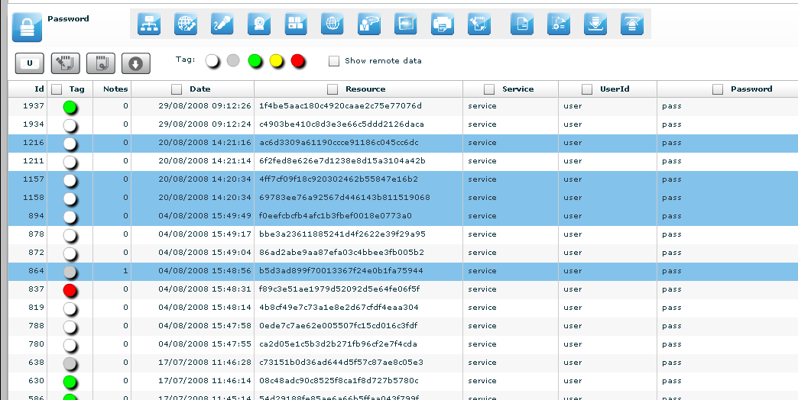
116

“Download” button is now enabled, click it to download selected logs.

Create an user
You need to be logged with Admn profile. Start application and after successfully login, click tab “Users” on left menu:

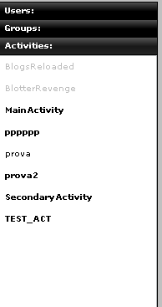
117

then click “Add” button on the right at the top of the icons-list:

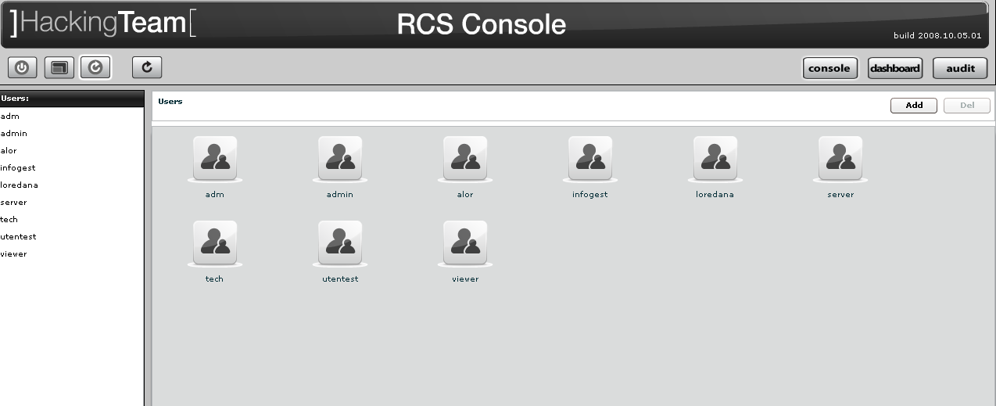
118
fill fields and assign privileges:

119

click “Save” button to save data.
At this point “Available Groups” button is enabled, click it to choice a group for this user:
120
you can see group’s details by double clicking group’s icon.
Select group with a single click:

121

then either by:
- click “Add Group” button on the left at the bottom of the window;
- click “+” button next the group’s icon.

Create a group
You need to be logged with Admn profile. Start Application and after successfully login, click tab “Groups” on left menu:

122

click “Add” button on the right at the top of the icons-list:

123
fill fields:

124
click “Save” button to save data.

Open new group:

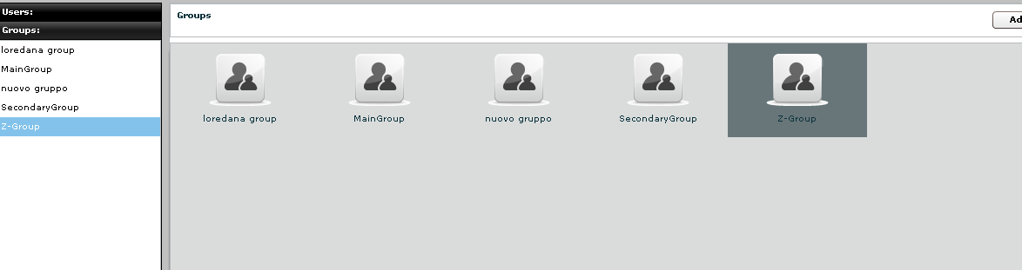
125
and to add a user to the new group, select user with a single click:

126

then either by:
- click “Add User” button on the left at the bottom of the window;
- click “+” button next the user’s icon.

Click “Available Activities” button to add activities

127

select activity with a single click:

128

then either by:
- click “Add Activity” button on the left at the bottom of the window;
- click “+” button next the icon’s activity.

Assign privileges to users
You need to be logged with Viewer profile. Start application and after successfully login, click tab “Users” on left menu:

129
and select an user:

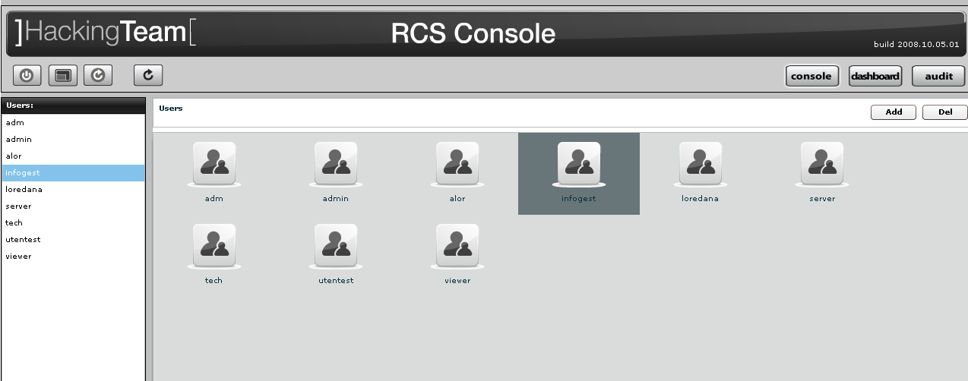
130
then flag checkbox of privilege you want to assign to selected user or unflag checkbox of privilege you want to remove to selected user:

131

- Admn: this is the super user. It is the only one that can create users, groups, activity and targets;
- Serv: reserved role for the server components that require access to XML-RPC methods;
- Tech: this role can create, modify and reconfigure backdoors associated with a target, however the target can only be modified and created by ADMIN;
- View: this role is assigned to users that can only view the logs. It cannot modify backdoors, targets or activity. It can create and modify notes and blotters.

Create and manage blotter
You need to be logged with Viewer profile. Start application and after successfully login, select an activity:

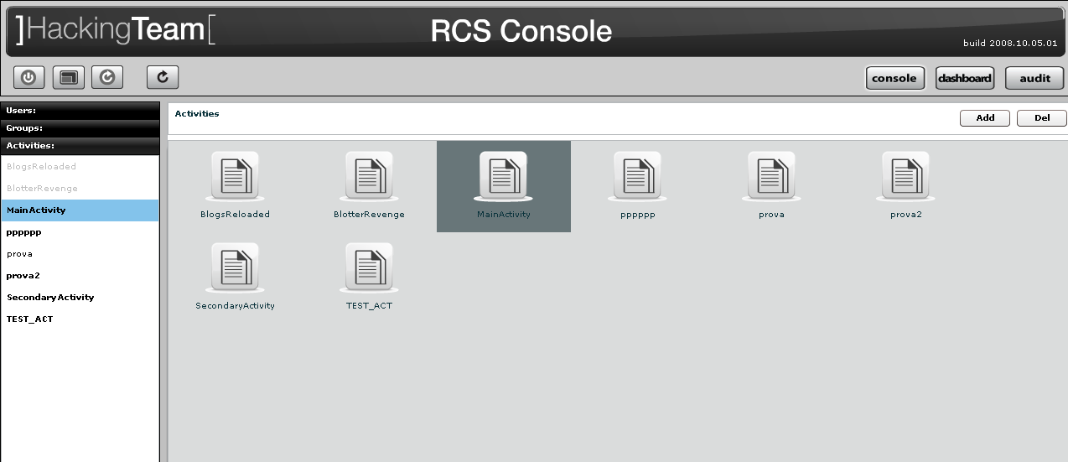
132

then click “Blotter” button:

133

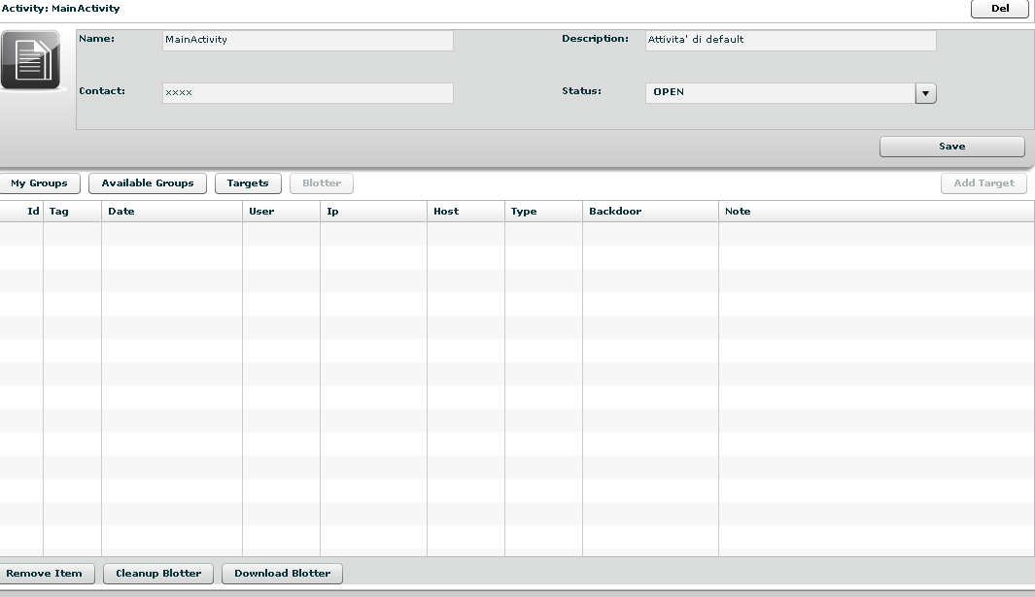
134

To add log to blotter, first browse and locate the log items to be added, then select one or more log’s rows:

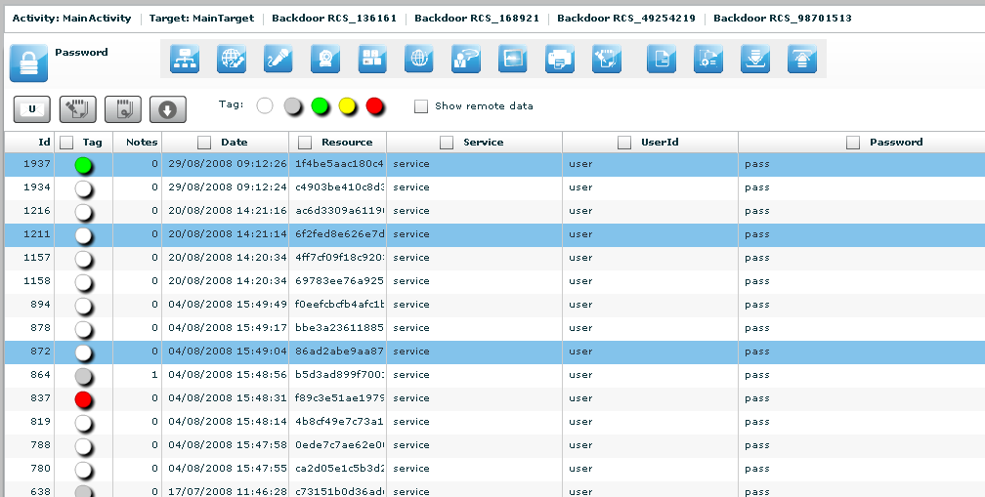
135

finally click this button to add selected logs to blotter.
Note: logs can be added only when logs from a single activity are currently displayed.

Return to activity to view blotter:

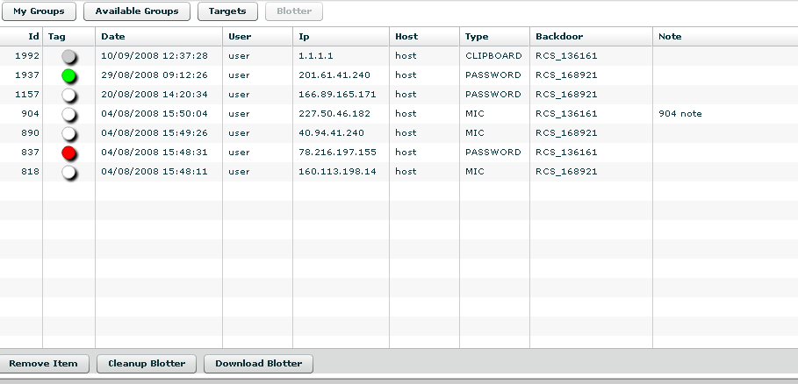
136

Double click mouse on detail’s row to view log’s detail
If you want to remove a row, select it with a single click:

137

then click “Remove Item” button:

138

click “Yes” to confirm or “No” to exit.

Click “Cleanup Blotter” button to clear blotter.
Click “Download Blotter” button to download a blotter as a compressed file (.zip)

Ask you RCSServer administrator if you don’t know the server address URL or your username and password.

