Remote Control System
Da Vinci

Integration with third party evidence analyzers

Ver 8.3.0
Configuration:
To configure the RCS system to export the evidence to a third party solution, you must configure a connector. Under the “System > Connectors” section you will find all the rules configured in the system.
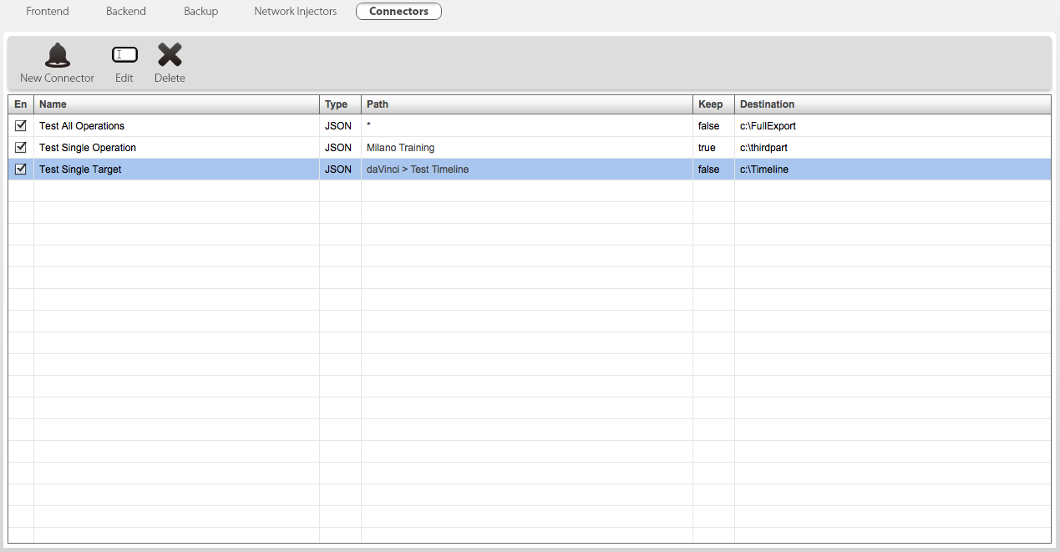
It is possible to have different rules for different operations or targets. When you create a new rule a form like this will appear:
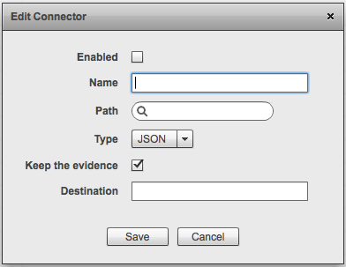
Each rule is composed by:
Name: Customizable name for the rule
Path: The operation or target that has to be exported, you can leave it blank to export all the operations
Type: The export type. Currently supported only JSON
Keep the evidence: Controls whether the evidence is stored in the RCS DB or not. If you want to save disk space and you will not use the RCS console to analyze the evidence, you can safely uncheck it.
Destination: The destination directory of the export

Directory structure:
Each exported evidence is stored in a hierarchical structure on the filesystem. The first level is represented by the operation, the second level is the target, the third level is the agent.
Every directory is made up of the name of the object plus the global unique id. Example:
operation-4f86902a2afb6512a7000033
-> target-4f86902a2afb6512a700006f
-> agent-4fd1a76d2afb65a3cc000039
The evidence are saved inside the agent directory and the name of the file is the unique id of the evidence (the same as the _id inside the json format).
For each evidence the connector create one or two files with the same name. The file with extension “.json” is always created and represents the metadata of the evidence. If the evidence has a binary content (es: screenshot, camera, call, etc) another file with the same name is created but the extension will be “.bin”. If the “_bin_size” field in the “data” hash of the json file is present, it is a confirmation that the corresponding bin file has been created as well. The bin file contains the raw binary data of the evidence.

JSON Common fields:
Every exported evidence has a common json structure. The common structure is made up of 9 fields:
NAME | TYPE | DESCRIPTION
_id | Global unique id | A unique id that identifies the evidence itself
da | Unix timestamp | Date of acquisition of the evidence (on the target device) UTC
dr | Unix timestamp | Date of reception of the evidence (on the collector) UTC
aid | Global unique id | Unique id of the agent which generated the evidence
tid | Global unique id | Unique id of the target which generated the evidence
oid | Global unique id | Unique id of the operation containing the target
agent | string | Name of the agent
target | string | Name of the target
operation | string | Name of the operation
type | string | The type of the evidence
rel | integer | The relevance of the evidence (0 to 4)
blo | boolean | Always false in exported evidence
note | string | Always empty (“”) in exported evidence
data | hash | The metadata of the evidence, differs based on “type”.

Example:
{
"_id": { "$oid" : "4FD9AFD02AFB6514F7000002" },
"da": 1339658104,
"dr": 1339658250,
"aid": "4fd1a76d2afb65a3cc000039",
"type": "file",
"rel": 0,
"blo": false,
"data": { },
"note": ""
}

JSON Specific fields:
For each evidence the field “data” may have different fields based on the “type” of the evidence. There may be other fields that are not relevant to the export itself but they can be present. The input parser of the third party solution that import the evidence should be resistant to the addition or deletion of the fields in the exported structure.
ADDRESSBOOK:
FIELD | TYPE | DESCRIPTION
name | string | The name of the contact
contact | string | The email address
info | string | Extended info about the contact
program | string | The program where the contact was taken from
type | string | The kind of the contact
handle | string | The unique identifier for that digital identity

APPLICATION:
FIELD | TYPE | DESCRIPTION
program | string | The name of the application
action | string | ‘start’ or ‘stop’
desc | string | Description of the application

CALENDAR:
FIELD | TYPE | DESCRIPTION
event | string | The name of the event
begin | unix timestamp | Beginning date of the event
end | unix timestamp | Ending date of the event
Info | string | extended info about the event

CALL LIST:
FIELD | TYPE | DESCRIPTION
from | string | The caller
from_display | string | The name of the caller
rcpt | string | The callee
rcpt_display | string | The name of the callee
program | string | The program from which the call was recorded
incoming | integer | Flag to know if the call is incoming or not (0 or 1)
duration | integer | Duration of the conversation (in seconds)

CALL:
FIELD | TYPE | DESCRIPTION
peer | string | The peer of the call
program | string | The program from which the call was recorded
status | string | The status of the call (should always be empty)
duration | integer | Duration of the conversation (in seconds)

CAMERA:
FIELD | TYPE | DESCRIPTION
- | - | -

CHAT:
FIELD | TYPE | DESCRIPTION
program | string | Name of the program used for the chat
incoming | integer | Flag to know if the chat message is incoming or not (0 or 1)
from | string | The caller
from_display | string | The name of the caller
rcpt | string | The callee
rcpt_display | string | The name of the callee
content | string | The content of the chat

CLIPBOARD:
FIELD | TYPE | DESCRIPTION
program | string | The program that created the clipboard snippet
window | string | Title of the window of the program
content | string | The content of the clipboard

COMMAND:
FIELD | TYPE | DESCRIPTION
command | string | The executed command
content | string | The output of the executed command

DEVICE:
FIELD | TYPE | DESCRIPTION
content | string | Information about the target device

FILE:
FIELD | TYPE | DESCRIPTION
type | string | ‘open’ or ‘captured’
program | string | The name of the program that opened the file
path | string | The full path of the file
size | integer | Size of the file (in bytes)
access | integer | Access mask

FILESYSTEM:
FIELD | TYPE | DESCRIPTION
path | string | Path of the filesystem entry
size | integer | Size of the file
attr | integer | 0 = file, 1 = empty directory, 3 = directory

INFO:
FIELD | TYPE | DESCRIPTION
content | string | The content of the info log

KEYLOG:
FIELD | TYPE | DESCRIPTION
program | string | The name of the program from which the keys are recorded
window | string | The title of the window
content | string | The recorded keystrokes

MESSAGE:
FIELD | TYPE | DESCRIPTION
type | string | ‘mail’, ‘sms’ or ‘mms’
program | string | The program used to send or receive the message
from | string | The sender of the message
rcpt | string | The receiver of the message
cc | string | Carbon Copy
subject | string | Subject of the message
body | string | Body of the message
incoming | integer | Flag to know if the message is incoming or not (0 or 1)
attach | integer | Number of attachments

MIC:
FIELD | TYPE | DESCRIPTION
duration | integer | Duration of the recording (in seconds)

MOUSE:
FIELD | TYPE | DESCRIPTION
program | string | Name of the program
window | string | Title of the window
x | integer | Absolute x coordinate
y | integer | Absolute y coordinate
resolution | string | Screen resolution

PASSWORD:
FIELD | TYPE | DESCRIPTION
program | string | The program used to store the credentials
service | string | The service name
user | string | Username
pass | string | Password

POSITION:
FIELD | TYPE | DESCRIPTION
type | string | Type of the source: ‘WIFI, ‘GPS, ‘GSM, ‘CDMA’
latitude | float | Latitude
longitude | float | Longitude
wifi | array | Array of hash, each composed by:  mac string The mac address of the wifi node  sig integer Current signal strength measured in dBm  bssid string SSID
cell | hash | Hash composed of:  mcc integer Mobile Country Code (MCC for GSM and CDMA)  mnc / sid integer Mobile Network Code (MNC for GSM, SID for CDMA)  lac / nid integer Location Area Code (LAC for GSM, NID for CDMA)  cid / bid integer Unique identifier of the cell. (CID for GSM, BID for CDMA)  db integer Radio signal strength measured in dBm.  adv integer Represents the distance from the cell tower.  age integer The number of milliseconds since this cell was primary.

PRINT:
FIELD | TYPE | DESCRIPTION
spool | string | Spool name (typically the file name)

SCREENSHOT:
FIELD | TYPE | DESCRIPTION
program | string | Foreground program name
window | string | Foreground window title

URL:
FIELD | TYPE | DESCRIPTION
program | string | The name of the browser
url | string | The visited URL
title | string | Window title of the URL page
keywords | string | List of keywords searched on search engines

BIN formats:
The format of the “.bin” file depends on the type of the evidence:
screenshot | Jpeg image
mouse | Jpeg image
camera | Jpeg image
print | Jpeg image
call | Mp3 audio
mic | Mp3 audio
mail | Eml message
file | The original format of the file (can be extracted from the ‘path’ field in the json metadata)

