Remote Control System V7.0.0

Administration Manual

Summary
Remote Control System 1
Summary 2
1 Introduction 4
1.1 Offensive security technology 4
1.2 Functionality 4
1.3 Stealth 5
2 General Architecture 5
2.1 RCS Agent 6
2.2 Admin Station (RCS Console) 6
2.3 Collection Node (ASP) 7
2.3.1 Anonymizers Chain 7
2.4 Mobile Collection Node (RSSM) 7
2.5 Log Repository (RCS DB) 8
2.6 Infection Media 8
2.7 Injection proxy 8
3 RCS Installation 9
3.1 Log repository 9
3.1.1 RCSDB 9
3.2 Collection node 18
3.2.1 RCSASP 18
3.3 Admin station 23
3.3.1 RCSConsole 23
3.3.2 OS Configuration 25
3.4 Anonymizers chain 26
3.4.1 RCSAnon 26
4 Usage 27
4.1 Functionality Flow 27
4.1.1 Group Creation 27
4.1.2 User Creation 28
4.1.3 Activity creation 28
4.1.4 Target Creation 28
4.1.5 Backdoor Creation 29
4.1.6 Backdoor Configuration 29
4.1.7 Infection Vector Creation 29
4.1.8 Installation on target machine 30
4.1.9 Evidence Visualization 31
4.1.10 End of Activities 31
4.2 Admin Station (RCS Console) 31
4.3 Mobile Server Admin 32
4.3.1 Service configuration 32
4.3.2 Data synchronization 33
4.3.3 Service logging visualization 35
4.4 Off-line installer 36
4.4.1 RCS Installation 37
4.4.2 RCS Uninstall 39
4.4.3 Log Export 39
4.5 Injection Proxy 40
4.5.1 Installing the environment 40
4.5.2 Importing a backdoor 41
4.5.3 Selecting the targets 41
4.5.4 Diverting the Internet Traffic 42
5 Troubleshooting 43
5.1 Log Format 43
5.1.1 ASP 43
5.1.2 DB 44
5.2 Activity Trace 44
6 Internals 45
6.1 ASP Decoy Page 45
7 Disaster Recovery 45
7.1 Backup 45
7.2 Recovery 46
7.2.1 ASP 46
7.2.2 DB 46
7.3 Dongle malfunction 46
7.4 Disgrunted employee 47

Introduction

Offensive security technology
Remote Control System (RCS) is an investigation support tool that performs active and passive interception of data and information related to the activities of the user of a controlled system.
RCS can create, configure, and install a software agent that is in turn able to scan, remaining undetected, all activities and operations executed out on a target computer or mobile phone and to gather all data and information generated by the system.
The software agent is guaranteed to remain operational even when no internet connection is available: the agent will continue gathering information and will be able to act autonomously, following the logic pattern programmed during the configuration process. All gathered data will be uploaded to the control room whenever possible.
This feature grants extreme flexibility and allows for data interception in the most adverse conditions.

Functionality
RCS allows you to intercept, monitor and gather a large number of information on all the activities carried out on a PC or a Mobile Phone, like:

- Websites visited;
- Filed opened/modified/deleted;
- Keys pressed;
- Documents and images printed;
- VoIP phone calls (Skype, WindowsLiveMessenger, YahooMessenger, etc);
- Programs executed;
- Audio surveillance;
- Webcam capture;
- Screen capture;
- Instant Messaging and Chat (Skype, WindowsLiveMessenger, YahooMessenger, etc);
- Clipboard;
- Passwords (i.e.: e-mail account, WindowsLive account, etc);
- Sent and received e-mails;
- Mobile phone calls;
- GPS Position;
- Address book and contacts

Stealth
A fundamental feature of RCS is the stealth system of the software agent: once “installed” on the target, all resources used by the agent will be hidden, rendering it invisible to the most widely spread protection systems and virtually impossible to detect using conventional tools.
Its logic of operation was designed to mimic the user’s behaviour, a feature that makes it all the more difficult to detect its activities and tell them apart from those of the user.

General Architecture
The following diagram explains the main logic components of the RCS system. In the following paragraphs we’ll go through all the necessary information to fully understand the role and the functionality of each key element in the infrastructure.

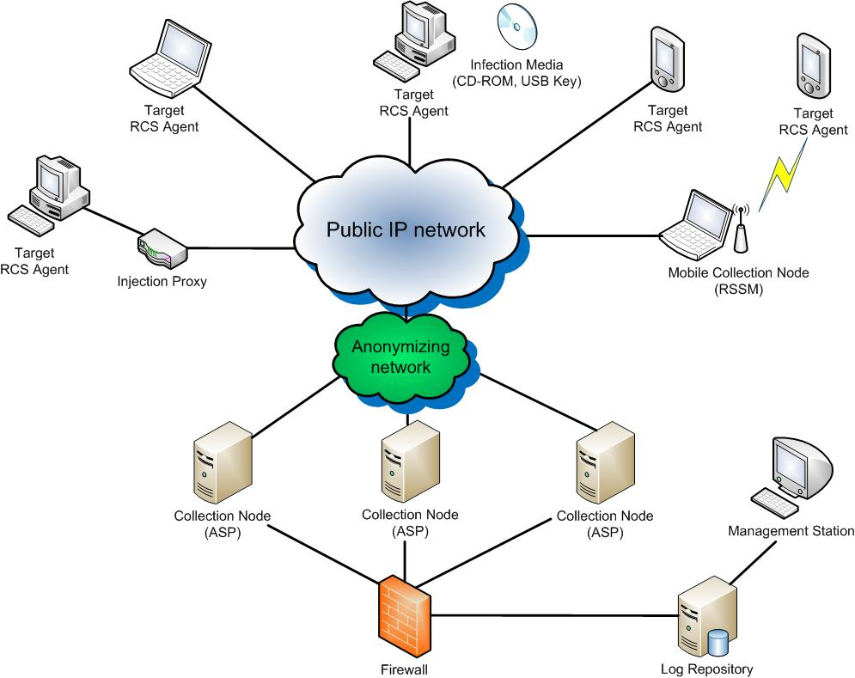

RCS Aschitecture

RCS Agent
All surveillance functionalities are implemented in a small software module (RCS agent). Once installed on the target PC, the agent will perform all necessary operations to gather evidences without being detected.
The RCS agent was designed with modularity and flexibility in mind: all features and functionalities of the agent can be profiled, added, removed or updated according your needs, even during the course of operations.
The functionality paradigm is based on the concept of event/action: the agent is able to monitor the user’s activities and, when a certain “event” occurs, react following the “actions” programmed during the set-up process. Thanks to its innovative design, the agent will be able to work autonomously, according to the logic patters programmed during configuration.
All information gathered is stored locally on the target PC in an encrypted repository, hidden to the system. Based on the agent’s configuration (programmed by the operator) all gathered data are sent back to the operator through a ciphered connection and removed safely once the upload is complete. The connections are strongly encrypted and mutually authenticated.
The uploading system of the evidences is perfectly able to work in complex network infrastructures (enterprise), in the presence of firewalls, proxies with domain authentication, etc., mimicking the behaviour of a normal user browsing the web.
Thanks to its modus operandi, the RCS agent is able to work in the most extreme conditions.

Admin Station (RCSConsole)
This component is the main user interface of the RCS system.
Using the Admin Station, the operator will be able to:
- Manage users and groups of the RCS system;
- Manage all investigation activities and targets;
- Configure and deploy the RCS agents
- Create digital and physical vectors of installation;
- Browse and search the logs database;
- Monitor the state of the RCS agents;
- Check all data and information concerning the system;
Access to the functions mentioned above is regulated by the privileges assigned to the operator. It is so possible to create different profiles:
- Administrators;
- Operatives;
- Evidence Inspectors;

Collection Node (ASP)
ASP is the reference point for the RCS agents. Through this service it is possible to receive the logs gathered by the agents, and to upload new configurations and plug-ins.
Once the authenticity of the RCS client has been verified, ASP will work as an intermediary towards the DB: this means that it will be possible to link any number of ASPs (even when they are located in different networks) to a single central log repository. The agent will be able to upload its logs and receive the new configurations (stored on the DB) regardless of what ASP server it established contact with.
ASP is the only component in the infrastructure that needs to be visible from the internet: the use of a firewall to profile access to the service is strongly recommended.
ASP also implements security devices such as decoying to another website, in case of attempted access to the service by any client different from an actual RCS agent.

Anonymizers Chain
Each ASP Server can be hidden behind an anonymizers chain. Anonymizers act as proxies for the RCS protocol and can be placed anywhere in the internet avoid exposing real ASP's IP address. Anonymizers can be used in cascade, thus creating an "anonymizer chain". Each chain can be built and reconfigured on-the-fly by RCS Console.

Mobile Collection Node (RSSM)
RSSM is the component that accepts connections from Mobile RCS installations, using point-to-point proximity protocols (BlueTooth). Thus it will be possible to retrieve logs from a Mobile RCS Agent, and send new configurations, without forcing it to establish a payment internet connection to the ASP server. Data are stored encrypted on the RSSM device, and it is possible to synchronize them to the ASP server later, using a standard internet connection.

Log Repository (RCSDB)
The RCSDB is the storage component of all logs gathered by the agents, of all current and previous configurations, and of all information used in managing the access to the RCS system (users, groups, profiles, etc.)
On a logical level, the RCSDB is composed of a relational database, whose access is managed and regulated by an application logic that allows the other components (ASP, etc.) to access all data and information.
The system was designed to protect the content and the integrity of sensitive information (the data gathered by the agents) and to implement all those security devices needed to prevent the adulteration of all gathered information.

Infection Media
The RCS system is also able to install agents through hardware devices (CD-ROM, USB Key), should direct access to the target machine be impossible. Such devices can execute the infection even if the PC is protected by OS or BIOS password.
Through the infection media, it is also possible to export logs (in the scenario of a target machine that is never connected to the internet) or remove the agent.

Injection proxy
Injection proxy is a hardware/software system that can inject and modify the data generated during a web session. In different attack scenarios, the system is able to infect, safely and undetected, any Windows executable downloaded from the web on a target PC. When the unknowing user executes the downloaded file, the injected code will silently install the RCS agent.
A description of all possible attack scenarios is provided in the respective paragraph.

RCS Installation
In order to function correctly, the system needs several components.
These components must be installed as described below, exactly in this order.

Log repository
Collection nodes and Admin stations must reach Log repository’s TCP port 4443 (encrypted).

RCSDB
The RCSDB package contains all the necessary software for data storage.
The operating system required is Microsoft Windows Server 2003 x64 or 2008 x64.
The installation file is called RCSDB-<serial>.exe and must be launched using the following procedure. The destination directory will be C:\RCSDB and cannot be changed. If an external storage is used to store DB data, it has to be mapped onto that path before the installation.

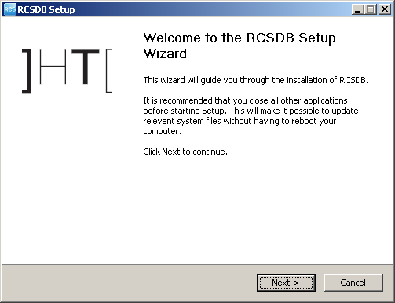
- click on 'Next'
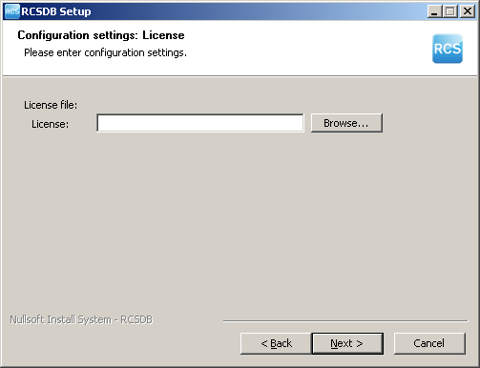
- insert the path of the license file
- click on 'Next'
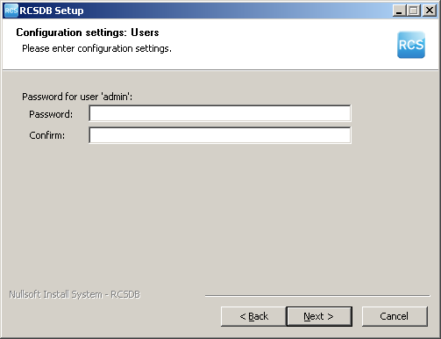
- insert the password for the ‘admin’ user that will be used to create and configure the system through the RCSConsole
- click on 'Next'
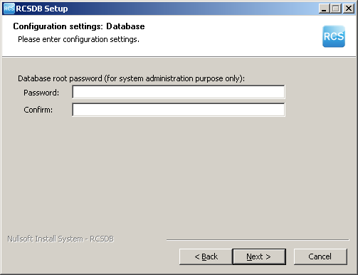
- insert the password that will be used to administer the database
- click on 'Next'
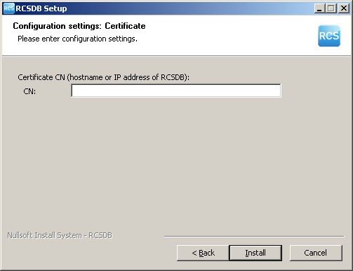
- insert the hostname of the server
- click on 'Install'
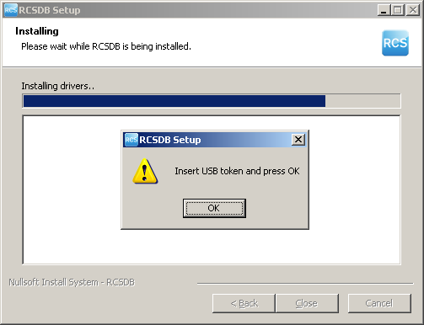
- insert the USB token into a free USB port, wait for the system to recognize it and click on 'OK'
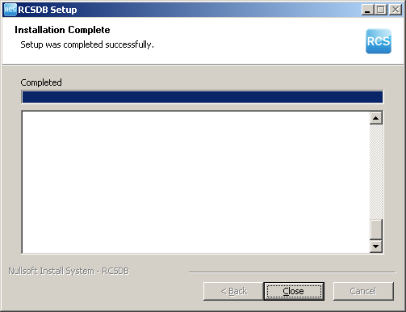
- wait for the installation process to complete
- make sure that no error occurred during the process
- click on 'Close'

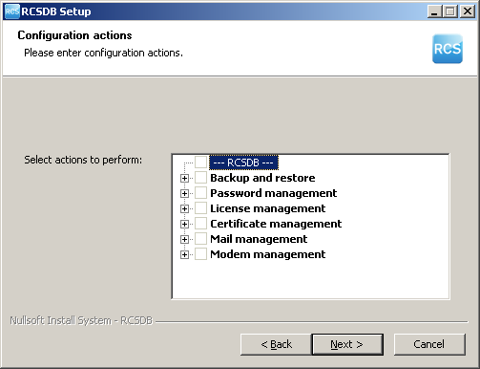
Selecting “Change” in “Add or Remove Programs” you can reconfigure the following parameters:
- Backup and restore (create a backup and restore a previously created dump)
- Password management (restore ‘admin’ account and change database root password)
- License management (change license file)
- Certificate management (replace RCSDB certificate file)
- Mail management (modify mail delivery settings)
- Modem management (modify modem settings)

Collection node
Collection nodes must be reached by RCS Desktop Agents on TCP port 443. RCS Mobile Agents use TCP port 80 instead.

RCSASP
The RCSASP package contains all the necessary software for data reception.
The operating system required is Microsoft Windows Server 2003 or 2008.
The installation file is called RCSASP-<serial>.exe and must be launched using the following procedure.

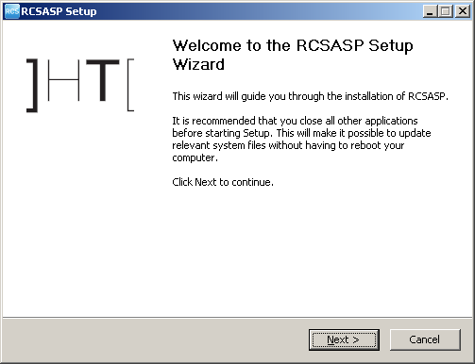
- click on 'Next'
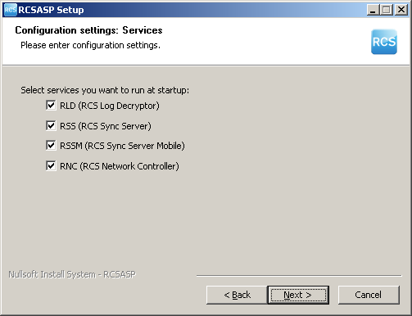
- select the components to be installed. For common installations, it is suggested to install all the components. Note: If more than one collection node are in use, RNC must be installed only on one of them (more instances of the service may create conflicts).
- click on 'Next'
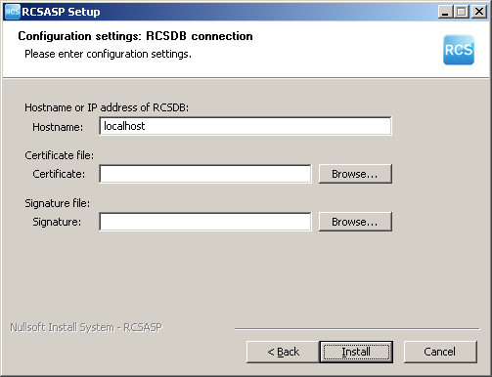
- modify the server address using the host or ip address to interact with
- insert the path of the certificate file (“RCSDB-export” on the Desktop of the server where RCSDB is installed)
- insert the path of the signature file (“RCSDB-export” on the Desktop of the server where RCSDB is installed)
- click on 'Next'
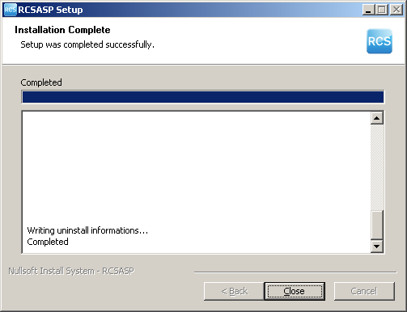
- wait for the installation process to complete
- click on 'Close'
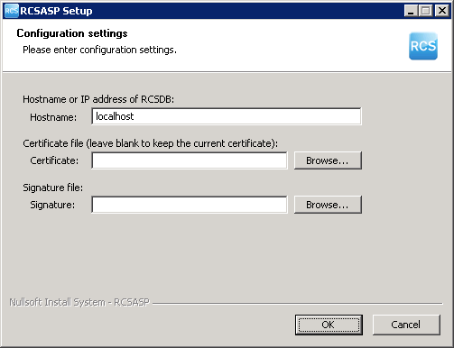
Selecting “Change” in “Add or Remove Programs” you can reconfigure the following parameters:
- the hostname for RCSDB
- certificate file
- signature file

Admin station
Admin station doesn’t act as a server, so it doesn’t need open TCP ports.

RCSConsole
The RCSConsole package contains all the necessary software to launch the console of the RCS system.
The Adobe AIR work environment is required (available on http://www.adobe.com/).
The installation file is called RCSConsole-<serial>.air and must be launched using the following procedure.

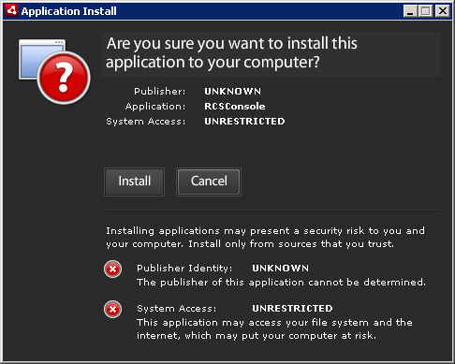
- click on 'Install'
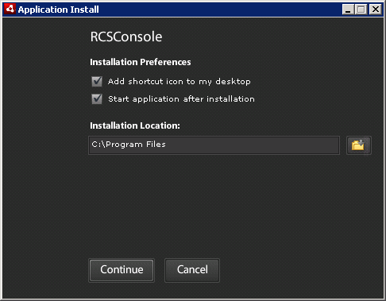
- uncheck 'Start application after installation'
- click on 'Continue'

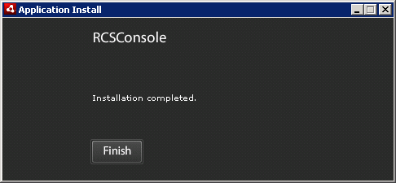
- wait for the installation process to complete
- click on 'Finish'

OS Configuration
In order to properly visualize all the evidences, it’s strongly suggested to install Arial Unicode MS font. This will enable the visualization of all unicode and special characters (eg: arrows, backspace, etc.).

Anonymizers chain
Each node of the anonymizers chain must be reached by RCS Agents on TCP ports 80 and 443. TCP port 4444 must be reachable by the RNC Service (Collection Node).

RCSAnon
The RCSAnon package contains all the necessary software for installing one or more node of the anonymizers chain.
The operating system required is Linux. In order to install RCSAnon, copy the file rcsanon-<serial>.sh on the target machine and run the following command (Note: root privileges are required):

#sh rcsanon-xxxxxxxxxx.sh

/ \
| rcsanon installer |
\ /

Checking rm.. /usr/bin/rm
Checking tar.. /usr/bin/tar
Checking tail.. /usr/bin/tail
Checking unzip.. /usr/bin/unzip
Checking killall.. /bin/killall

Installing.. ok

Checking rcsanon.. ok
Checking rcsnet.. ok

Installation complete!
----------------------
Remember to copy authentication files in /opt/rcsanon/etc/
Remember to run /opt/rcsanon/sbin/rcsanon and /opt/rcsanon/sbin/rcsnet

After command completion, copy ca.pem and network.sig (from the “RCSDB-export” directory on the Desktop of the server where RCSDB is installed) into /opt/rcsanon/etc folder.
To automatically run RCSAnon (/opt/rcsanon/sbin/rcsanon and /opt/rcsanon/sbin/rcsnet), please refer to the manual of the specific linux distribution in use.
NOTE: When upgrading the package, please stop both RCSAnon daemons before running the new installer.

Usage

Functionality Flow
We are going to explain in detail the correct functionality flow of the RCS system.
The flow should be followed exactly as detailed below, and customized according to the needs of the case. Each step can be performed using the RCS Console.
The functionality flow is composed of the following steps:
- Group creation;
- User creation;
- Activity creation;
- Target creation;
- Backdoor creation;
- Backdoor configuration;
- Infection vector creation;
- Evidence visualization;
- End of activities.

Group Creation
This process involves the creation of the groups that will be used in the following steps.
ADMIN-level privileges are needed to execute this step.
We recommend the creation of a different group for each group of people dealing with the same activities, creating a new group for every new activity. By assigning the same user to different groups it will be possible to handle existing users (linked to physical persons) in different activities including them in the relative group.

User Creation
This process involves the creation of the users that will be used in the following steps.
ADMIN-level privileges are needed to execute this step.
The users are one or more technicians (TECH-level privileges), taking care of backdoor configuration and of the creation of the infection vectors (executable, CD-Rom, USB, etc.), and one or more operators (VIEW-level privileges) tasked with monitoring the evidences once they are archived inside the system.
All users who need to interact with an activity (both newly created and already existing users) will have to be added to the groups designated to that activity.

Activity creation
This process involves the creation of the activities that will be used in the following steps.
ADMIN-level privileges are needed to execute this step.
An activity is a complete and complex analysis process that may involve one or more one or more subjects for monitoring. The activity must keep an OPEN state until all the evidence gathering operations are complete. Only then it will be possible to close the activity, thus preventing any further modification. The activity must be associated to the groups created to contain those users who will be able to interact with it.

Target Creation
This process involves the creation of the targets that will be used in the following steps.
ADMIN-level privileges are needed to execute this step.
A target is a single entity, part of a specific activity. However, it is possible to associate more than one backdoor to a single target (for instance, for the different devices used by the target).
The target is persistently linked to the activity for which it is created and cannot be re-associated to another activity. The target becomes non-modifiable once the relative activity is closed.

Backdoor Creation
This process involves the creation of the backdoors that will be used in the following steps.
TECH-level privileges are needed to execute this step.
A backdoor is a specific installation on a specific device used by the target it is associated to.
The backdoor is persistently linked to the target for which it is created and cannot be re-associated to another target. The backdoor is disabled automatically once the relative activity is closed.

Backdoor Configuration
This process involves the configuration of the backdoors that will be used in the following steps.
TECH-level privileges are needed to execute this step.
Once the backdoors have been created, it is necessary to configure them to execute the evidence gathering operations and to upload said evidences to the system.
Once the configuration process is complete, it is possible to save the configuration and modify it later using the same procedure.

Infection Vector Creation
This process involves the creation of the infection vectors that will be used in the following steps.
TECH-level privileges are needed to execute this step.
After a backdoor has been configured, it is time to choose among the different infection vectors that will be used to install the backdoor on the target system.
The creation and use of the vectors may vary according to the selected type. It is possible to create more than one infection vector for the same backdoor. Once installed on the target system, the backdoor will be independent from the infection vector used for the installation.

Installation on target machine
Once the creation of the infection vector is complete, it is possible to install the backdoor on the target system. The installation can take place in different ways:

- “Melted” executable/CAB/App: Just open the file on the target PC, Mac or mobile phone (either directly or through hacking or social engineering). The backdoor will be installed automatically, while no modification to the original executable/CAB/App will be visible to the user (see the RCS Console manual for further details).

- CD/USB Offline installation: It is possible to boot the target PC from one of these media (it is necessary to have physical access to the computer); the backdoor is installed automatically on the users selected from a list. If the computer cannot be booted (e.g., when the bios is protected by password), it will be possible to directly infect the hard disk linking it with the USB adapter to a laptop on which the Offline Installation CD is executed.

- Injection Proxy: This device can be used to infect the files downloaded by the user on the target PC (see chapter 4.5).

- Exploit library: RCS can be installed on a target device by running a client-side exploit (eg: malicious .pdf or .ppt files) containing RCS core code. This feature will be integrated in RCS Console in future releases.

- Installation on Windows Mobile Phones: Besides running the “melted” CAB, RCS can be installed on Windows Mobile phones by infecting their MMC (see the RCS Console manual for further details). Installation can also be performed through an already infected PC using the “Infection Agent” (see the RCS Console manual for further details).

- Installation on iPhone: RCS can be installed on iPhone by transferring and running the installation script on a “jailbroken” device (see the RCS Console manual for further details).

Evidence Visualization
This step involves the visualization of the evidence gathered.
VIEW-level privileges are needed to execute this step.
The visualization of the evidence allows an operator to have access to all the information received from the backdoors installed on the targets. It is possible to execute queries, save the evidence, create a summary, modify the priority and create public and private notes.

End of Activities
This process involves finalization of the activities executed.
ADMIN-level privileges are needed to execute this step.
Once the gathering of the evidences for a given activity is complete, it is possible to close the activity and render it un-modifiable. No new information about the targets will be received, and it will no longer be possible to modify the data associated to the activity. However, it will still be possible to execute all the operations described in the previous step - like the visualization and the creation of the summary.
Closing and activity is an irreversible operation that should only be used in the appropriate case.
All the backdoors related to a closed activity will be automatically uninstalled from the target machine upon next synchronization.

Admin Station (RCS Console)
RCS Console usage is described in a different document. Please refer to it for further informations.

Mobile Server Admin
RSSM service handles connections coming from Mobile RCS Agents, and is installed as a part of ASP package on the Collection Nodes. RSSM can also be installed as a standalone service to deploy Mobile Collection Nodes in order to retrieve logs from Mobile RCS Agents using point-to-point proximity connections (BlueTooth).
When running RSSM as a standalone Mobile Collection Node, the Mobile Server Admin GUI must be used in order to configure the service and interact with it.
After launching the MobileGUI (in the \RCSASP path) executable, the RSSM Admin GUI will be accessible from the system tray bar by this icon 

Service configuration
Before using the RSSM as a Mobile Collection Node, the service has to be configured. The basic configuration file must be imported from an ASP server running the RSSM component (be sure to install it on the Collection Node if you plan to handle data coming from mobile targets).
To export the configuration file, run the MobileGUI on the ASP server, switch to the Configuration tab and click “Export”. Copy the exported file on the Mobile Collection Node and run the MobileGUI. Switch to the Configuration panel, click “Import” and select the exported configuration file.
Now the configuration should be modified to activate the proper media.
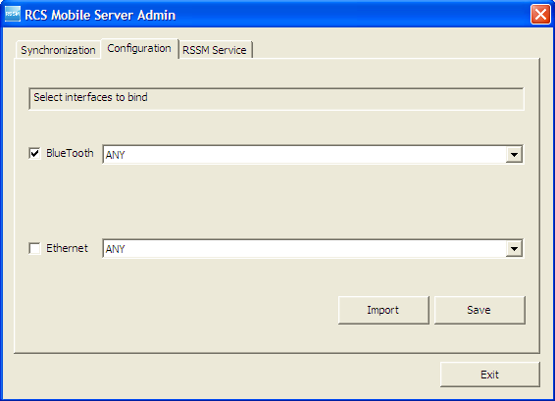

After saving the modified configuration, the service has to be restarted (switch to the RSSM Service tab). Under some circumstances the program will ask for a reboot.

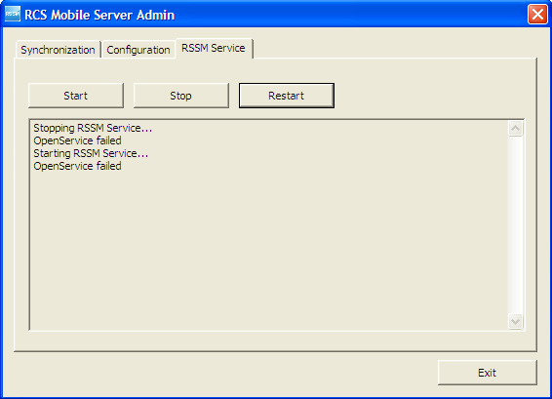

Now the Mobile Collection Node is ready to receive new connections from Mobile RCS Agents.

Data synchronization
Mobile Collection Node can synchronize its data with the Log Repository using a standard internet connection.

Synchronization process includes:
- Logs sending: All logs collected from Mobile Agents are sent to the Log Repository
- Configurations retrieving: New configurations, if available, are downloaded for all the backdoors that synchronized with that Mobile Collection Node at least once. The backdoors will receive the updated configuration files next time they synchronize with the Mobile Collection Node.
- Uninstalling: If a backdoor has to be uninstalled (eg: its activity was closed), the Mobile Collection Node will record its status (only for the backdoors that synchronized with that Mobile Collection Node at least once). The backdoor will receive the uninstall command next time it synchronizes with the Mobile Collection Node.

To perform a Synchronization run the MobileGUI and switch to the Synchronization tab.
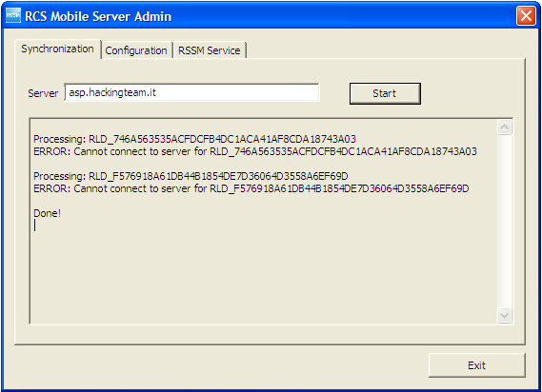

NOTE: The Server field must point to an ASP server running the RSSM service.

To start the synchronization press the “Start” button: the synchronization will occur every 3 minutes. The same button can be pressed again to stop the automatic process.

Service logging visualization
The service activities can be viewed by the MobileGui application using the “RSSM Log” tab. This window shows “online log” file placed in the “log” folder of the service home directory, and provide montironing of the current service activity.

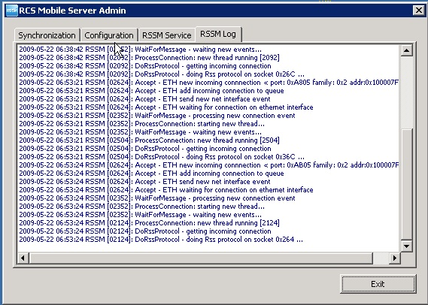

Off-line installer
The offline installation tool (it can be either a Cd-Rom or a USB-Dongle) allows the installation of RCS tools on a computer when physical access is possible. The installation takes place booting the computer from the infection media, so that loading the operative system of the target computer is not necessary. The same media can also be used to uninstall the RCS tool from the computers that were previously infected.
Note Each infection media is associated, in a unique way, to a single backdoor generated by the configuration module. A specific infection media will only be capable of uninstalling the backdoor it's been associated to (one of its instances), even though the backdoor was installed on-line (.exe melting, injection proxy), or offline by means of the same infection media.
The installation and the removal of a RCS Backdoor are executed in three simple steps, described below.

RCS Installation
After booting the target pc from the infection media, a window like the one in the image below will automatically appear on-screen:
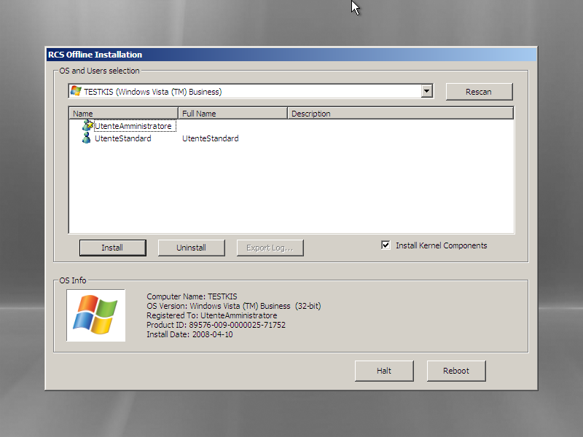
Offline installation tool

We can see, in the top section of the window, a dropdown list containing all the operating systems installed on the target computer that were recognized by RCS; in the lower section of the window, we can see a list of all information gathered from the selected operating system (OS Info). The icon on the lower left corner is shown in colors if the selected operating system is supported by RCS, otherwise the icon will be shown in black and white, and it won't be possible to install RCS on that OS.
Select from the dropdown list the OS to infect with a RCS backdoor.

Note If the target device is a removable media, and it's not shown in the dropdown list, it may be necessary to click the Rescan button to force a new scan of all the attached devices.

A list of all users for the selected OS can be seen in the middle section of the window. For each user it will be possible to see the system name, the real name and a description, when available. Below there’s a list of the icons that identify each user:
-  Standard User
-  Administrator
-  Domain User
If the icon is shown in colors the user is active, otherwise it means that the user has been disabled from the system administrator.

Besides the icons described above, there may be another icon used to represent the status of RCS for that particular user:
-  Correct RCS installation for this user;
-  Corrupted (or not working) installation of RCS for this user;

Select one or more users to infect with RCS, then click the Install button. A message will appear, warning about the finalization of the installation process.

From now on it will be possible to power off or restart the target computer clicking the Halt or the Reboot button.

RCS Uninstall
The uninstall procedure is specular to the one described above. After selecting one or more users infected by RCS, click on the Uninstall button. A message will appear on-screen, warning about the finalization of the uninstall process. From now on it will be possible to power off or restart the target computer clicking the Halt or the Reboot button.

Log Export
In the case of a target PC with no available internet connection, it is possible to export the logs via the offline installation tool. After selecting the user (or users) whose logs have to be exported, the operator will just have to press the Export Log button. An interface window will appear on-screen and it will be possible to select where to save the logs (it is advisable to use a removable media or the USB Key itself).
To Importing the logs into the DB, just copy the folder created during the export process (the name of the folder will be of the kind RLD_XXXXXX) in the \RCSASP\LOGREPO folder located in all Collection Nodes (ASP).

Injection Proxy
The on-line installation tool (Injection Proxy) allows you to install the RCS software on a system without needing physical access to the computer itself. In order for the installation to be successful it is necessary to be able to actively monitor the internet connection used by the target. The Injection software will thus be able to trace the HTTP connections established by the client, intercept incoming downloads, and inject all executables on-the-fly. When the user launched the downloaded file, the RCS software will be able to silently install itself on the computer.

In the following paragraphs, we will go through all the necessary steps to install, configure and activate the Injection Proxy.

Installing the environment
The softwer is provided in the form of a tar/gzip archive, ready to be installed on computers using Linux operating system. The installation process is composed of the following steps (admin privileges required):

- Uncompress the archive: tar –zxvf jproxy-bin.tar.gz
- Install the files: make –C jproxy-bin install
- Import the backdoors: (see following paragraphs)
- Select the targets: (see following paragraphs)
- Launch the program: /usr/local/bin/inject_proxy
- Divert the traffic: (see following paragraphs)

The logs of the infection activities are stored in the files:
- /var/log/jproxy_infect.log
- /tmp/infect_box

Importing a backdoor
The Injection Proxy system will infect with the RCS software the executables downloaded by the target. Once installed on the target system, RCS will begin to gather logs and to execute actions as specified during the configuration process.
The RCS configurations are created with the RCS Console (see relevant paragraph); it will be necessary to “import” the configurations created with this tool into the Injection Proxy.

In order to execute the Import you must:
- In the executable-creation panel of RCS Console (see RCS Console manual for further details) select the “Proxy” option.

- Copy the newly created directory into the file system of the linux machine where the Injection Proxy is located. The destination path can be chosen by the user.

- Associate the newly created folder, and the relative backdoor, to the desired target (see following paragraph).

Selecting the targets
The Injection Proxy system is able to import an arbitrary number of backdoors (and relative configurations) created by the RCS Console. It is necessary to provide the Injection System with the necessary information for it to choose which backdoor will be use to infect the files downloaded by a specific target client (you will have to provide the source IP address of the connections).

In order to make the association, you will have to edit the [Inject] section of the configuration file /etc/jproxy.conf. (see paragraph Error: Reference source not found).

Each line in this section identifies a target through a range of IP addresses; the character ‘*’ is used as a wildcard (e.g., 192.168.0.* identifies the range of addresses between 192.168.0.0 and 192.168.0.255).

Each line contains also the information that will be used by the Injection Proxy to execute the infection on a specific target:

- Backdoor Path: identifies the directory where the desired backdoor is located. A ‘*’ in this field assigns to the target the folder identified by the default_backdoor variable.

- Extension: identifies the extention (including the ‘.’) of file types that must eb infected. A ‘*’ in this field identifies the files indicated by the default_extension variable.

- Max file size: sets the maximum size (in bytes) that a file must have in order to be infected.

- Max infection: sets the maximum number of files that will be infected for a specific target.

Diverting the Internet Traffic
In order for the Injection Proxy to infect the downloaded files, it is necessary to divert the target’s HTTP traffic through the proxy itself. It is possible to redirect the traffic in several ways:
- Layer3: the traffic is redirected coming out of the target’s LAN, via appropriate modifications to the routing tables of the network system of the target’s internet provider.
- Layer2: the traffic is redirected before coming out of the LAN, via appropriate hacking techniques or modifications to the configurations of the Layer2 systems (switch).
- Layer1: the traffic is physically redirected through the proxy machine, bridging it to the target’s uplink cable.

Choosing how to redirect the traffic depends heavily on the context of use. For further information (routs set-up, bridging, etc.), please refer to the jproxy software manual.

Troubleshooting

Log Format
If a component of the system fails, it is possible to inspect the respective logs to point out the cause of the problem.
The critical components generating the logs are ASP and the DB.

ASP
ASP is divided into separate Windows services: RSS, RLD, RSSM and RNC.
RSS is responsible for managing the connections to the backdoors, while the RLD takes care of deciphering the logs and inserting the data in the DB. RSSM handles connections coming from mobile agents, and can also be used as a standalone mobile collection node. RNC is responsible for managing network elements (eg: anonymizers) updating their configurations and checking their status.
If no logs are received from any of the backdoors, it is necessary to make sure that these services are functioning correctly. It is possible to check their execution from the list of Windows’ services.
If the services are in execution, it is necessary to inspect the logs to point out what’s causing the problem.
Each one of these services creates a log called ASPService_RSS.log (for RSS), ASPService_RLD.log (for RLD) and AspService_RSSM.log (for RSSM) in the directory \\RCSASP
The format of the log files is the following:

date hour service [thread_id] : message

Example:

2008-10-23 07:29:35 RSS [02136]: StartAspHttps - INIT phase completed

If an error occurs, the message will explicitly contain the word ‘ERROR” followed by a short description of the error. If the error can be easily identified, solve the problem and reboot the service. If the issue still occurs, please contact tech support.
These files can also be used to monitor the normal activity of the services, because every key function writes inside the file what’s happening at any given time.

DB
The database is composed of 3 main elements: MySQL, Apache and PHP.
If the database is not reachable, it is necessary to check that mysql and apache are functioning correctly. These are both Windows services and can be re-booted with the standard procedure.
MYSQL records its activities inside the system’s logs.
Apache saves the logs in the file \\RCSDB\apache\logs\error.log. All the activities of the PHP layer are recorded here. All XML-RPC methods invoked are recorded in this file. N.B.: this file can reach considerable size with prolonged use of the product. It is advisable to monitor the space on the disk occupied by the database server.

Activity Trace
Every time an user performs a sensitive operation, such as creation of backdoors or targets, an audit log is generated. Those logs can be browsed by RCS Administrators (with ADMIN privilege) using the RCS Console (see RCS Console documentation).

Internals

ASP Decoy Page
“DDPH.html” file (stored in “C:\RCSASP” folder) is a static HTML page that is sent when a client connected to the ASP service is not a RCS agent recognized as "genuine" (eg: a web browser). This feature allows the administrator to hide the ASP service behind a “fake” web server.
You can modify this file to implement a custom web site’s home page.

Disaster Recovery
If a critical error occurs, it is possible to restore the correct functionality of the system following these procedures:

Backup
All the information are stored inside the database. It is necessary to plan some backup procedure for the data. In the case of critical error, it will be possible to restore the whole architecture starting from the data stored in the DB.
In order to backup all data in the DB correctly, create a dump file using the graphical interface in “Add or Remove Programs”.
If you want to create a batch job to create backups, you’ve to execute the following command:

mysqldump --verbose --hex-blob --quick --single-transaction
--extended-insert --complete-insert --result-file <outputfile>
-u root -p<password> rcs

All the data stored inside the DB will be saved in the specified file. The command will ask the root password used during the installation of the RCSDB package. It is also necessary to backup DB’s license file and configuration file. Both files are stored in the directory: \RCSDB\apache\htdocs\etc (RCSDB.lic and RCSDB.ini).
N.B.: It is always advisable to backup the whole computer where the database is installed: in case of malfunctioning, recovery time will be shorter than manually reinstalling all packages.

Recovery
In case of malfunctioning, it will be necessary to completely restore the failing component.

ASP
To restore the ASP server, simply reinstall the RCSASP package and provide the IP of the server and the access credentials. No data is stored on the ASP server; all you need is in the DB. This makes for a very fast and simple restore procedure.

DB
If a full backup of the DB computer is available, it is advisable to restore the backup. Otherwise, in order to restore the DB server, it will be necessary to reinstall the RCSDB package and restore the data.
Once the RCSDB package has been reinstalled, it is possible to import all data from the backup created previously using the graphical interface in “Add or Remove Programs”. Please note that, after restoring the data, RCS admin user’s password will be restored as well (it may be different from the password specified during the re-installation process).

We have now restored the DB to the exact moment of the backup. In order for the server to work correctly, besides the data of the DB, it will be necessary to restore also the DB’s license and configuration files. The RCSDB.lic and RCSDB.ini files must be restored in the directory \RCSDB\apache\htdocs\etc.
Once all data have been restored, it is possible to re-boot the services (mysql and apache) being careful to plug the USB-dongle in the server’s usb port.

Dongle malfunction
In the case of a USB-dongle malfunction, it will be necessary to replace the defective dongle with a new one and replace the license file. The license is univocally linked to the serial number of the dongle itself. Just replace the license file (RCSDB.lic) in \RCSDB\apache\htdocs\etc; replace the broken dongle with the new dongle linked to the new license and re-boot the DB services (apache e mysql).

Disgrunted employee
If you need to modify the password of an ‘admin’ account, you can restore it using the graphical interface in “Add or Remove Programs”.

If the ‘root’ user of the DB is compromised, it is possible to boot the MySQL server in ‘grantless’ mode and restore the ‘root’ user. In order to do this, you will have to follow this procedure:

- Stop the service:
net stop MySQL5.0

- Boot the service (mysqld) using the command:
C:\RCSDB\mysql\bin\mysqld-nt --skip-grant-table

- Connect to the database and modify the root user:
mysql -u root -e "UPDATE `user`
SET `Password` = PASSWORD('newpassword')
WHERE `Host` = 'localhost' AND `User` = 'root'" mysql

- Shut down the service:
mysqladmin shutdown

- Re-boot the service:
net start MySQL5.0

For the sake of brevity only the CD-Rom will be referred to in the documentation, although the very same considerations apply to a USB dongle too.
Please, refer to the program’s manual and online help for further information on the configuration and execution parameters.

