

GSM-Monitoring System Semi Active

Falcon E+

CONFIDENTIAL – Subject to change without prior notice!

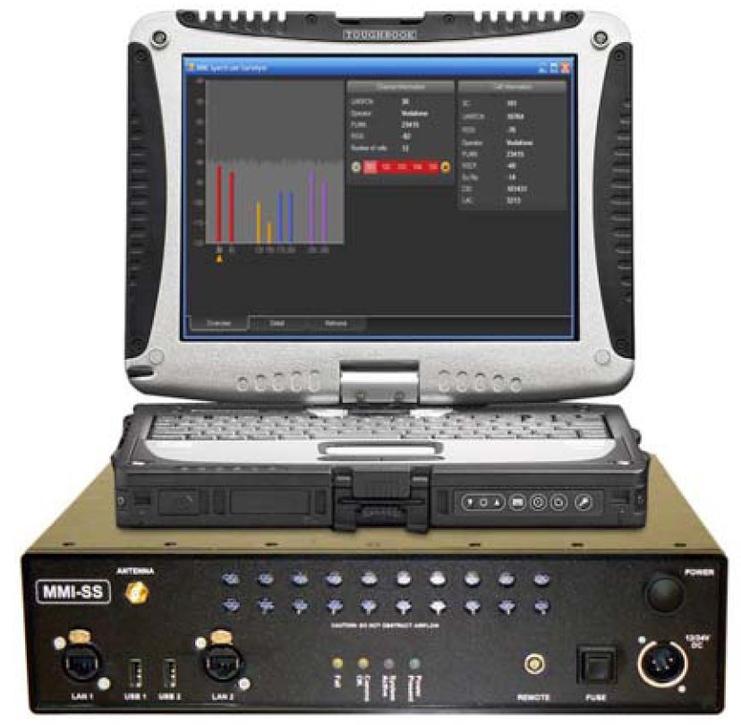

GSM-Monitoring System Semi Active – Falcon E+

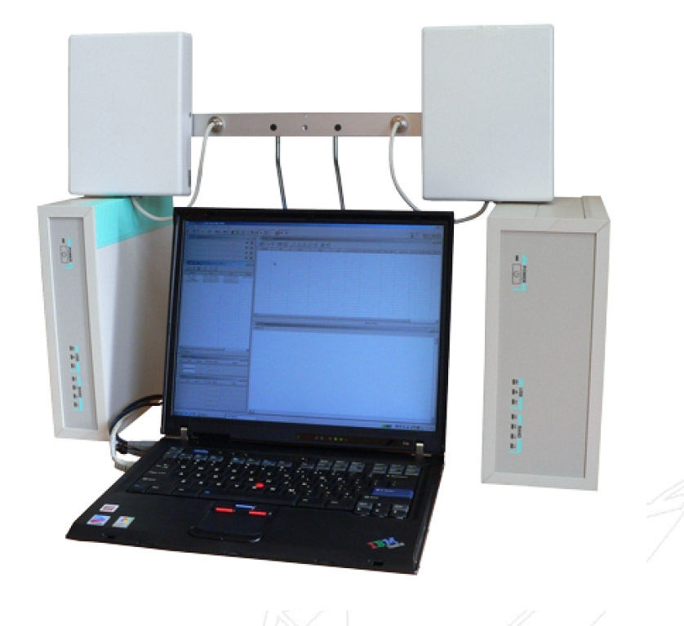

Description

The Falcon E+ system is designed and developed as a Semi Active OFF-THE-AIR-GSM-Monitoring system. The system provides the option of both stationary and mobile operation

The Falcon E+ system deciphers A5.1 and A5.2 ciphering algorithms online. The system does not require the service providers SIM for operation because uses cloning of the targets phone in real time. Therefore, all the calls made by the target are billed into its account

Main Features

- The system ensures monitoring of audio and data traffic within standard GSM 900/1800 networks (800/1900 on request) and deciphers A5.1 and A5.2 algorithms online

- Default configuration of the system – 8 or 12 reception channels (4 or 6 duplex channels, monitoring of both forward and reverse conversation channels)

- The system ensures registration of radio-electronic-conditions within the radio cells to be monitored (frequency and characteristics of BCCH-channels)

- The operator can select the required targets based on their IMSI or IMEI. Upon selecting the targets the system acts as a virtual base station (BTS) for these targets.

- When one of the targets initiates a call, the FALCON E+ system automatically calculates the ciphering key ant authentications parameters. These parameters are then cloned onto another mobile phone attached to the system (up to 4). The targets calls are now routed through the cloned mobile phone, maintaining the same encryption and target identity.

- The system contains a database (up to 1000 calling partners), operating in real-time, which can be accessed corresponding to the selected search criteria and parameters.

- Calling partners are identified according to the IMEISV, IMSI, TMSI, ISDN number (local and international number)

- Retrieving of target IMEI/IMSI for using targets mobile number and silent call

- Registration and storage of telephone conversations, call related information, network information and Short Message Service (SMS) to the system`s hard disk.

- The system ensures registration and storage as audio codec – types FR, EFR, HR.

- Playback of recordings may be carried out by the system itself

- Identification of SMS and DTMF data.

Scope of Delivery

- Main unit FALCON E+
- Control unit (Notebook)
- Virtual base station 900MHz and/or 1800MHz
- Duplexer 900MHz and/or 1800MHz
- GSM antenna (omni-directional)
- GSM antenna (directional 9dBi gain)
- Network-connecting cables
- Power supply cable 230VAC
- Power supply cable 12VDC
- User manual
- Transport case (2 pcs.)

Technical data

GSM900 GSM1800
Reception Channel 8 or 12 (4 or 6 Duplex channels
Target Numbers Up to 1000
Data entries Up to 100000
Identification Through IMSI, TIMSI, IMEI, Class mark,
Telephone Number, Distance
Monitoring Voice (A5.0, A5.1, A5.2),SMS, DTMF
Recording Audio codec type FR, EFR, HR
Playback Player software
Frequency Range of Down 935…..960 1805…..1880
Link BTS->MS MHZ MHZ
Frequency Range of Up-Link 890….915 1710….1785
MS->BTS MHZ MHz
Channel Spacing 200 kHz
Number of Channels 124 375
Frequency Deviation 45 MHz 95MHz
Frequency Stability ±0.03 ppm
Receiver Type Wide Range Receiver
Receiver Sensitivity - 105 dBm
Output power 10mW – 6W. (20W or 50W optional)
Operation Range up to 500 m in city
Assessment of coverage up to 550m
Accuracy
Antenna Impedance 50 Ω
Time of frequency Change < 500 μS
In Hopping mode
Dynamics Range >75 dB
Volume Range 25 dB
Demodulator GMSK, asynchrony
Decoder For Protocol A5.2
Speech Codex RPE/LTP:FR, EFR
Channel structure TDMA/FDMA
System Software Windows XP
Audio Format Standard Wave-Form
Interface TCP/IP
Remote Control via LAN, ADSL
Power supply 220 VAC, 50Hz
110 VAC, 60Hz
Operating Temperature + 5° C….40° C
Dimensions/Weight:
Box-900: 29x26x12,5 cm / 4,25 kg
Box-1800: 29x26x12,5 cm / 3,7 kg
Clone-Box 29x26x 8 cm / 1,75 kg

