EXHIBITION AGREEMENTS

TO BE HELD DURING

THE 82nd ICPO-INTERPOL GENERAL ASSEMBLY

From 21 October to 24 October 2013

ADMINISTRATIVE CONDITIONS

CONTRACTOR

CARTAGENA MAGICA BUSINESS GROUP SA
REGISTRO NACIONAL DE TURISMO 20747 – 23095 - 23160
Calle del Arsenal No. 10 – 32, Cartagena de Indias - Colombia
(+575) 6648760 – 6605831 cel: 318-6085391 info@cartagenamagica.com.co
www.cartagenamagica.com.co

Represented by

Mr Omar Moises CHAR MUVDI

THE EXHIBITION

The 82nd-INTERPOL General Assembly will be held at the Centro de Convenciones Cartagena de Indias Julio Cesar Turbay Ayala, Colombia from October 21 to October 24, 2013.

Exhibitors will have the unique opportunity to create mutually beneficial relationships with the 600 law-enforcement officers coming from all over the world.

If you are a provider of new technology and services for the Criminal Police, sign up for this event!! This is your chance to display your most innovative products and to promote contacts with active players and key decision-makers of the International Criminal Police community.

Requests for additional IT equipment, tailor made booth or other needs, must be sent to Cartagena Mágica.

A 60% deposit will be requested to all registered Exhibitors.

CONTRIBUTION TO THE 82nd ICPO-INTERPOL GENERAL ASSEMBLY

(Net Prices + VAT 16%)

I/ YELLOW BOOTH_____________________________$ 26 200 USD + VAT 16%

- One 18m² booth – (6mts x 3mts)
- Full page advertisement on the exhibitor guide
- Publication of Exhibitors’ logo and a 200-word exposé on the ICPO-INTERPOL public website (under ICPO conditions)

Important note: A maximum of 2 (two) yellow booths may be accommodated in the Exhibition area.
*Number of booths may change with respect to new arrangements

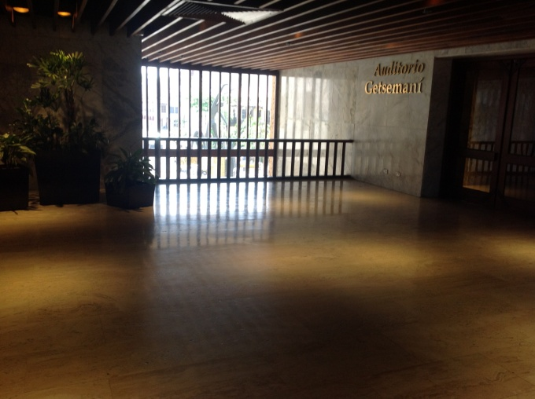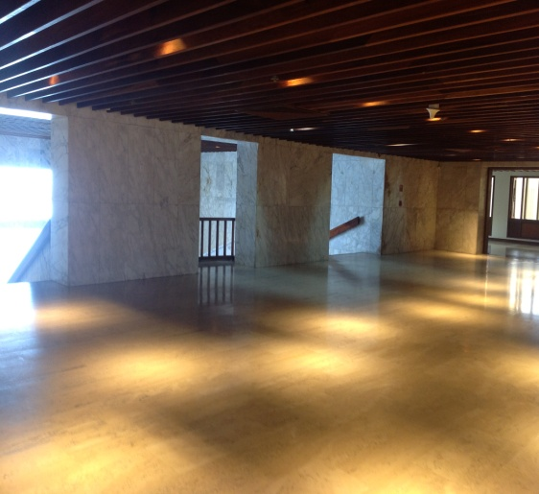
Yellow 6mts x 3mts – Booth 5 Yellow 6mts x 3mts – Booth 6

II/ / BLUE BOOTH __________________________$ 20 300 USD + VAT 16%

- One 12m² booth – (6mts x 2mts)
- Full page advertisement on the exhibitor guide
- Publication of Exhibitors’ logo and a 200-word exposé on the ICPO-INTERPOL public website (under ICPO-INTERPOL conditions)

Important note: A maximum of 3 (three) blue booths may be accommodated in the Exhibition area.
*Number of booths may change with respect to new arrangements

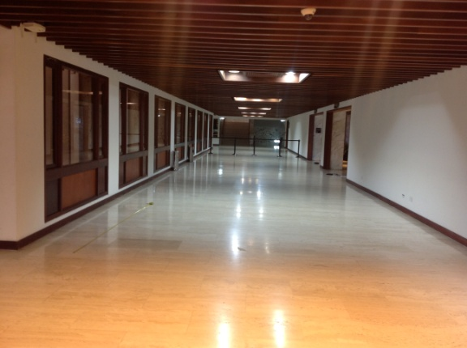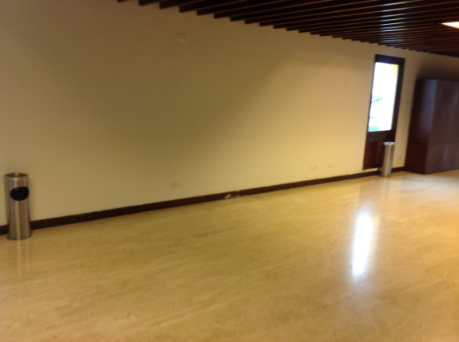
Blue 6mts x 2mts – Booth 9 Blue 6mts x2mts – Booth 15

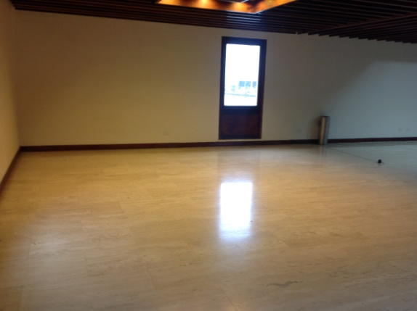
Blue 6mts x 2mts – Booth 12

III/ ORANGE BOOTH____________________________$ 14 400 USD + VAT 16%

- One orange 9m² booth – (4.5mts x 2mts) OR (3mts x 3 mts)
- Full page advertisement on the exhibitor guide
- Publication of Exhibitors’ logo and a 200-word exposé on the ICPO-INTERPOL public website (under ICPO-INTERPOL conditions)

Important note: A maximum of 6 (six) orange booths may be accommodated in the Exhibition area.
*Number of booths may change with respect to new arrangements

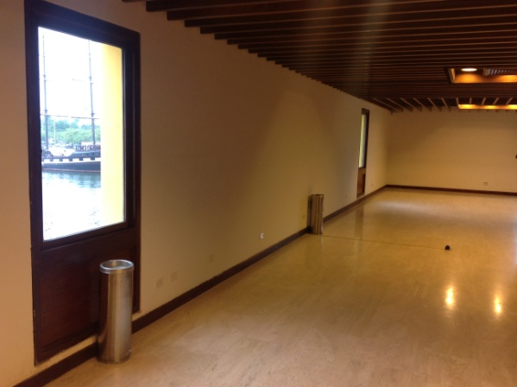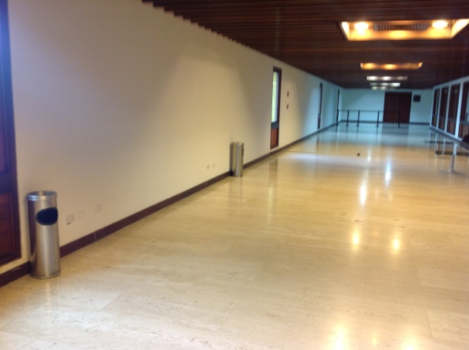
Orange 4.5 mts x 2 mts – Booth 16 Orange 4.5mts x 2 mts – Booths 18 -19

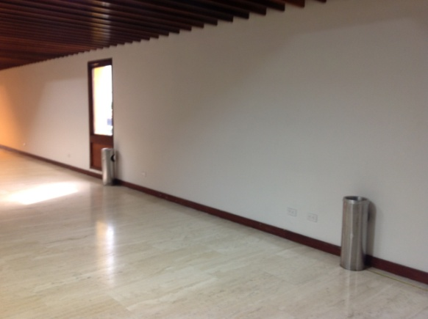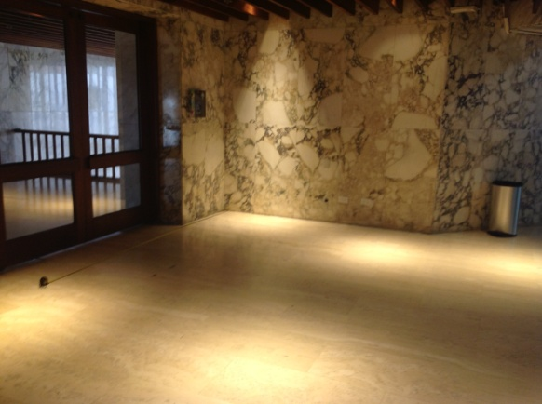

Orange 4.5 mts x 2 mts – Booth 20 Orange 3 mts x 3 mts – Booth 3

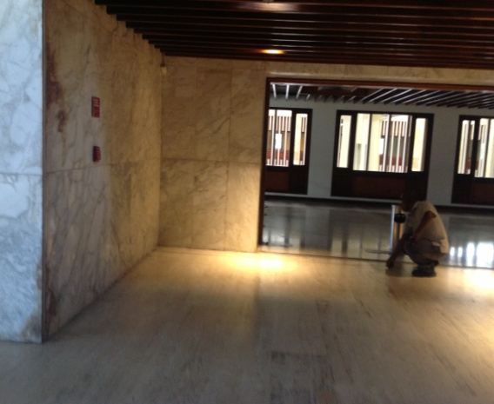

Orange 3mts x 3 mts – Booth 7

IV/ RED BOOTH____________________________$ 11 200 USD + VAT 16%

- One 6m² booth - 3mts x 2 mts
- Full page advertisement on the exhibitor guide
- Publication of Exhibitors’ logo and a 200-word exposé on the ICPO-INTERPOL public website (under ICPO-INTERPOL conditions)

Important note: A maximum of 3 (three) red booths may be accommodated in the Exhibition area.
*Number of booths may change with respect to new arrangements

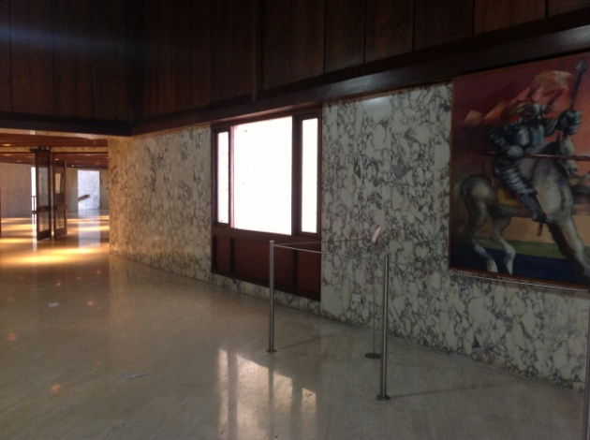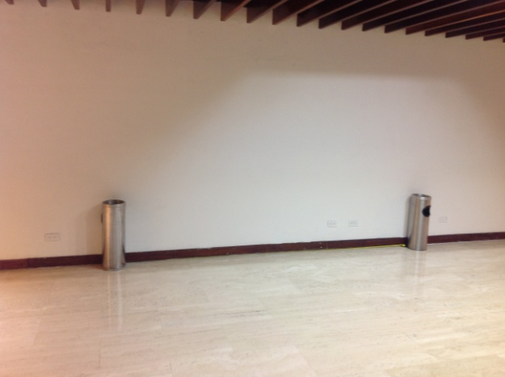
Red 3mts x 2mts – Booth 2 Red 3mts x 2mts – Booth 13

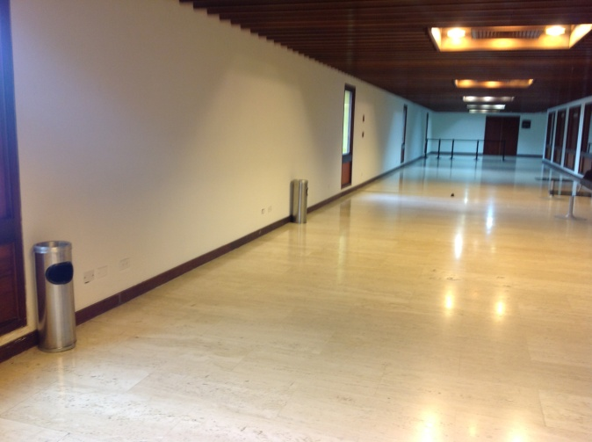
Red 3mts x 2mts – Booth 21

FULL DESCRIPTION AND IMAGE OF STANDARD BOOTH

See attached technical description.

EXHIBITION PACKAGES LAYOUT

See attached Exhibition Layout.

APPLICATIONS

In order to be valid, the booth reservation is to be made by MAIL copy by FAX on the BOOTH RESERVATION FORM enclosed and sent to Cartagena Mágica. 60% deposit of the total rental fee must be made at the order of Cartagena Mágica. The signature of the Booth Reservation Form and the deposit paid constitute a firm hire commitment and compel the subscriber to accept both the general conditions and the exhibition rules and regulations. No verbal or telephone agreement will commit Cartagena Mágica or ICPO-INTERPOL unless confirmed in writing.

The deposit shall be paid at the latest on 20 August 2013. The remaining rental fee is to be settled by at the latest on 20 September 2013. Non-payment by this stated deadline will lead to the cancellation of the right to use the booth, without reimbursement of the deposit paid.

Site allocations will be attributed following strict reservation order of arrival. Once locations have been attributed no change of location will be possible without ICPO-INTERPOL’s and Cartagena Mágica’s written agreement.

The exhibition floor plan presented in this document is non-contractual. It is subject to acceptance by ICPO-INTERPOL and the Centro de Convenciones Cartagena de Indias Julio Cesar Turbay Ayala. Cartagena Mágica reserves the right to change if deemed advisable, the location, size and layout of the surfaces requested by the exhibitor.

INSURANCE

The Company shall subscript with a reputable insurance company and provide a copy of:

- Its civil and professional liability policy covering any loss, damage or injury to any person or property whatsoever during or because of the Exhibition or any journey related to the Exhibition.

- An insurance policy to cover all its property and exhibiting products, which are not covered by Cartagena Mágica’s policy, including in particular the Booth.

PAYMENT

Payment of the deposit and last instalment in US Dollar shall be made:

By bank transfer to:
Cartagena Mágica Business Group S.A.

Bank Account details

Account No. 1

BANK | WACHOVIA BANK N.A.
CITY – COUNTRY | NEW YORK - USA
SWIFT CODE WACHOVIA BANK | PNBPUS3NNYC
ABA CODE WACHOVIA BANK | 026005092
BENEFICIARY BANK IN COLOMBIA | BANCO DAVIVIENDA S.A.
SWIFT CODE DAVIVIENDA | CAFECOBB
ACCOUNT IN DAVIVIENDA BANK | 2000192002710
BENEFICIARY COMPANY | CARTAGENA MAGICA BUSINESS GROUP SA
ACCOUNT NUMBER CARTAGENA MAGICA BUSINESS GROUP SA | 057069994879
ACCOUNT TYPE CARTAGENA MAGICA BUSINESS GROUP SA | CHECKING ACCOUNT
NIT CARTAGENA MAGICA BUSINESS GROUP SA | 900.322.434-1
CITY – COUNTRY | CARTAGENA - COLOMBIA

Account No. 2

BANK | CITIBANK
CITY – COUNTRY | NEW YORK - USA
SWIFT CODE | CITIUS33
ABA CODE | 021000089
BENEFICIARY BANK IN COLOMBIA | BANCO DAVIVIENDA S.A.
SWIFT CODE DAVIVIENDA | CAFECOBB
ACCOUNT IN DAVIVIENDA BANK | 36240428
BENEFICIARY COMPANY | CARTAGENA MAGICA BUSINESS GROUP SA
No. CUENTA CARTAGENA MAGICA BUSINESS GROUP SA | 057069994879
ACCOUNT TYPE CARTAGENA MAGICA BUSINESS GROUP SA | CHECKING ACCOUNT
NIT CARTAGENA MAGICA BUSINESS GROUP SA | 900.322.434-1
CITY – COUNTRY | CARTAGENA - COLOMBIA

The transfer must be made net of bank transfer fees, at the charge of the Exhibitor.

RULES AND REGULATIONS

These Rules and Regulations shall apply to the contractual arrangements between the Company and Cartagena Mágica and are accepted by the Company upon completion and signature of the booth reservation form.

DEFINITIONS

INTERPOL | Means the International Criminal Police Organization, an international organization governed by public international law benefiting from host agreement with the French Government.  INTERPOL is a third party to the Agreement.  Nothing in the present Agreement shall be construed as INTERPOL’s waiver of its immunity from jurisdiction Cartagena Mágica.
Contractor | Means Cartagena Mágica Business Group S.A., which has been entrusted by INTERPOL with the general logistics and management of the Exhibition.
Company | Means the company which signed the booth reservation form.
Exhibition | Means the Exhibition to be held during the 82nd ICPO-INTERPOL General Assembly.
Intellectual Property | Means patents, registered designs, applications of any of those rights, trade and business names and registered and unregistered trademarks and service marks, copyrights, know how, rights in designs and inventions and any rights of the same or similar effect or nature in each case in any jurisdiction.
Parties | The Contractor and the Company are known collectively as the Parties and individually as the Party.

AGREEMENT

The entire agreement between the Contractor and the Company hereafter referred to as the Agreement, include the booth reservation form and the Exhibition brochure (administrative conditions & rules and regulations).

No Agreement shall be made before INTERPOL’s approval (even if the Company already signed the booth reservation form). In case of the INTERPOL’s refusal, there will be no Agreement (even if the Company already signed the booth reservation form) and any deposit made by the Company will be refunded. Neither INTERPOL nor the Contractor shall be held liable for any other amounts or expenses.

PROVIDED SERVICES

By the Agreement, the Contractor provides to the Company the following services:

- Rent and use of a booth during the Exhibition and during assembling and dismantling.
- Information and coordination services during the assembling and dismantling of a booth and during the Exhibition.
- Rent of IT equipment without prejudice to the prices fixed by the Contractor, this service is considered as an additional service.

EXHIBITING FEES

The exhibiting fees for the services provided by the Contractor are defined in the booth reservation form and paid by the Company as follows:

Payment of the 60% deposit in USD should be made by, 20, August 2013. Last 40% in USD should be made by 20, September 2013.

Exhibiting fees must be transferred net of bank fees, at the charge of the Company. All payments shall be made by bank transfer, in accordance with the Administrative Conditions.

The Exhibition fees will not be reimbursed in case of cancellation of attendance to the Exhibition by the Company.

In the In the event of cancellation by the Company, the Exhibition Agreement will remain binding and the full amount of the Exhibition Fees will remain due. The Exhibition fees will not be reimbursed in case of cancellation of attendance to the Exhibition by the Company.

LOCAL AND SITE REGULATION

INTERPOL and the Contractor have the authority to demand removal / change or cancel participation of any structure which is not in accordance with the Exhibition rules and/or local and site regulations. The decision of INTERPOL will be final and binding.

ENTRY TO EXHIBITION

Access to the Exhibition will be possible only to regularly registered conference and Exhibition participants as well as accredited media.
The Company undertakes to provide the Contractor with a list of its staff to intervene on site at least 48 (forty-eight) hours prior to their arrival on the premises. The list shall give the identity of each person assigned and shall indicate whether the assignment of each person, for the execution of the Contract, is temporary or permanent.

MEDIA COVERAGE

Exhibitors who do not wish to be filmed or photographed by local or international media having access to the Exhibition, should expressly disclose this on the booth reservation form.

THE COMPANY’S OBLIGATIONS

During the continuance of the Agreement, the Company agrees with the Contractor:

- Arrival: the Company shall be solely responsible for the transportation of its material and products to the Exhibition and its storage without prejudice to any assistance that may be provided by the Contractor.

- Installation: to install at its own risk and cost the Company’s material and products during the permitted times.

- Repair : to maintain and keep in good and substantial order and condition the Booth during the Exhibition.

- Local and site regulations: the Company shall abide by the local and site regulations with respect to law and order, safety and security. INTERPOL and the Contractor will take appropriate action against those who do not comply with regulations.

- Fire precautions and equipment and gas installations: to comply with all requirements of the appropriate fire authority and the request and recommendations of INTERPOL and the Contractor in relation to fire precautions.

- Regulations: to comply with practices and procedures reasonably required by the Contractor for the management operational and security of the Exhibition.

- More generally, the Company agrees to comply with any restriction, regulation or policy imposed by INTERPOL and/or the Contractor if INTERPOL and/or Contractor consider the use of the Company’s Booth or advertising insert could be considered as being damaging to INTERPOL’s name or interests.

- Name and interests of INTERPOL: to respect INTERPOL’s image and name and not to do anything that is likely to prejudice INTERPOL’s reputation, image or interests.

- Exhibiting products: not to bring into the Exhibition exhibiting products not allowed by INTERPOL and/or Contractor.

- Alterations: not to make any alteration to the booth.

- At the end of the Exhibition, the Company shall return the booth in substantially the same condition as the Company found it.

- INTERPOL’s and Contractor’s Access: To allow INTERPOL, the Contractor and all persons authorized by them with all necessary materials to enter and work in the Booth to exercise any of INTERPOL rights under the Agreement.

- No Subletting: the Company is not permitted to assign, sublet or apportion the whole or any part of the Booth allotted to it.

- The contribution and the activity of the Company must be compatible with the principles, goals and activities of INTERPOL.

- The Company must answer requirements of morality, notoriety and reliability.

NON SOLICITATION

The Contractor and the Company shall refrain, except in the case of a prior written agreement, from directly or indirectly engaging an employee of the other Party assigned to providing the services covered by this Agreement, even if any such sollicitation is at the initiative of the said employee, and/or from taking that employee into its service under any status whatsoever.

The present Article shall apply throughout the implementation of this Agreement and for a period of two (2) years following its completion.

Should one of the Parties fail to respect this obligation, it undertakes to compensate the other Party by paying an indemnity equal to twelve (12) months' basic salary of the employee concerned.

CONFIDENTIALITY

The Company shall regard as strictly confidential and treat as such any knowledge, information and documents given and communicated by INTERPOL or the Contractor within the framework of the presents and relating to INTERPOL, whatever their nature and their media may be.

The Company undertakes not to reveal or let reveal directly or indirectly, entirely or partly, the aforementioned information to any third party.

The Company shall take all required measures, in particular with regard to its personnel, for the permanent and rigorous respect of this obligation. The Company undertakes not to use Confidential Information for any purpose other than the execution of this contract, and more particularly, shall not make any reference to INTERPOL in any publicity without prior and written acceptance of INTERPOL.

LIABILITY IN CASE OF CANCELLATION
Neither INTERPOL nor the Contractor may under any circumstances be held liable for any cancellation of the Event or any of the consequences of such a cancellation.

MANAGEMENT

The Company may announce, publicize and promote its participation in the Exhibition in a manner and form previously approved in writing by INTERPOL. INTERPOL will not have to motivate their refusal.

INTERPOL shall advertise the Company´s booth on all such media installed at the Exhibition and in other promotional material and brochures produced by or on behalf of INTERPOL in the sole discretion of INTERPOL.

INTELLECTUAL PROPERTY

The Company shall not without the prior consent of INTERPOL and the Contractor :

- use any Intellectual Property which belong to or are used by INTERPOL or the Contractor.
- or use any trademark licensed to or registered in the name of INTERPOL or Contractor.

The Company hereby grants INTERPOL and the Contractor a non-exclusive right to use and publish the Company’s name and trademarks in connection with the Exhibition and in any promotional document.
No party shall have or acquire any right, title or interest in any licensed material, intellectual property right, mask work, trade secret or know-how of the other party under this Agreement.

INSURANCE

The Company shall subscribe with a reputable insurance company and provide a copy of:

- Its civil and professional liability policy covering any loss, damage or injury to any person or property whatsoever during or because of the Exhibition or any journey related to the Exhibition.

- An insurance policy to cover all its property and exhibiting products, which are not covered by INTERPOL’s policy, including in particular the booth.

LIMITATION OF RESPONSIBILITY

Except in the case of negligence, INTERPOL and the Contractor assume no liability for damage to property of the Company, its agents, representatives, employees, invitees, guest or other persons.

The Company, and its insurance company, renounce to take recourse against INTERPOL and the Contractor and undertake to subscribe the insurance policies defined in the article INSURANCE.

Except in the case of negligence, no liability shall arise against or attach to INTERPOL or the Contractor in any circumstances whatsoever in respect of injury or damage to any person or company including (but not only) the Company and its employees and clients or to any property including (but not only) the booth or to the trade or business of any person or company or in respect of any economic or consequential loss and whether incurred directly or indirectly by reason of any statutory authority or any statutory undertaking to or in respect of any part of the Conference Centre.

The Company as well as its insurance company(ies) renounce to take any action against INTERPOL for any damage, loss or injury whatsoever incurred in relation with the present Agreement.

Besides, in no event shall INTERPOL be liable for any indirect, incidental, punitive, special or consequential damages, or damages for loss of profits, revenue or use incurred by the Company or any third party.

TERMINATION

If any part of the Exhibiting Fees or any other payment due under this Agreement is unpaid after becoming payable or if any obligation on the Company’s part shall not be performed, then the Contractor shall be entitled upon written notice to the Company to immediately terminate this Agreement, without prejudice to any claim by the Contractor in respect of any previous antecedent breach of any obligation.

In case of cancellation of the General Assembly and/or Exhibition decided by INTERPOL for any raison, the Agreement will be terminated at the date of the said decision and the Contractor will refund any deposits made by the Company as part of the Exhibiting Fee and any Exhibiting Fees already paid by the Company and will not be held liable for any other amounts or expenses incurred by the Company in other matters.

In case of earlier termination of the contract between the Contractor and INTERPOL for the Exhibition’s organisation, the Agreement between the Contractor and the Company will be automatically terminated and the Contractor will refund any deposits made by the Company as part of the Exhibiting Fees and any Exhibiting Fees already paid by the Company. Neither the Contractor nor INTERPOL shall be held liable for any other amounts or expenses incurred by the Company.

Without prejudice to their other rights, the Contractor shall be entitled upon written notice to the Company to immediately terminate the Agreement between the Contractor and the Company for any act or practice of the Company that is likely to prejudice INTERPOL’s reputation, image or interests. In this case, the Agreement between the Contractor and the Company will be automatically terminated and the Contractor will refund any deposits made by the Company as part of the Exhibiting Fees and any Exhibiting Fees already paid by the Company. Neither INTERPOL nor Contractor shall be held liable for any other amounts or expenses incurred by the Company.

In case of termination of the Agreement, any licenses eventually granted by either Party to the other hereunder shall immediately terminate.

FORCE MAJEURE

INTERPOL and the Contractor shall not be liable for any delay in performing or for failure to perform any obligations under the Agreement if the failure is caused by an Event of Force Majeure (outbreak of hostilities, riots, civil disturbance, acts of terrorism ; fire, explosion, flood, fog or bad weather ; power failure, failure of telecommunications lines, failure or breakdown of plan, machinery or vehicles ; theft, malicious damage, strike, lockout or industrial action of any kind, health measures).

Any such delay or failure shall not constitute a breach of the Agreement and the time for performance shall be extended by a period equivalent to that during which performance is so prevented.

If any Event of Force Majeure shall continue for a period of 30 (thirty) working days or more, then the Parties shall be entitled to terminate the Agreement forthwith upon written notice.

DISAGREEMENTS AND DISPUTES

Without prejudice to the rights of each party to request the competent judge to take urgent preventive measures, the Parties undertake to seek an amicable solution to any disputes concerning the execution of the Contract.

The party that believes that there is disagreement should notify the other party by registered mail with acknowledgement of receipt. After this letter, the Parties shall meet to try to find an amicable settlement to the disagreement in question.

The Company and the Contractor shall use their best efforts to negotiate in good faith and settle amicably any dispute, which may arise out of, or in relation to, this Agreement or a breach thereof. If any such dispute cannot be settled amicably between the parties hereto within one month of its arising, the matter shall be settled by arbitration. Such arbitration proceedings shall be conducted in Colombia and shall be governed by an Arbiter designed by the parties, or, in the event of conflict, that will elect the Arbiter from the members entered in the roll registered from no less than fifteen years and no more than twenty five years.

The decision of the arbitrator shall be binding on the parties.

The languages to be used in the arbitral proceedings shall be Spanish or English.

PROVISIONS GOVERNING THE TRANSACTION

The execution of the present Rules and Regulations is governed exclusively by the following documents, to the exclusion of any other commercial document:

The present Rules and Regulations, the Administrative Conditions and the Booth Reservation Form.

The Parties elect domicile at their respective registered offices indicated in the booth reservation form. All notifications must be sent to this address.

BOOTH RESERVATION FORM

82nd -INTERPOL GENERAL ASSEMBLY

From 21 October to 24 October, 2013

Please return this form to:
Cartagena Mágica Business Group SA

By e-mail: info@cartagenamagica.com.co

1/ COMPANY

Company name :

Address :

City/Zip: Country:

Contact Person:

Tel: Fax:

E-mail:

INVOICE DETAILS

Company name :

Address :

City/Zip: Country:

Vat Number:

2/ EXHIBITION MATERIAL

We propose exhibiting the following products:

3/ EXHIBITION PACKAGE

Preferred Booth Number | Package | Price  (Prices plus VAT) | Price Vat Included
 | YELLOW BOOTH | $ 26 200 USD + VAT 16% | $ 30 392 USD
 | BLUE BOOTH | $ 20 300 USD + VAT 16% | $ 23 548 USD
 | ORANGE BOOTH | $ 14 400 USD + VAT 16% | $ 16 704 USD
 | RED BOOTH | $ 11 200 USD + VAT 16% | $ 12 992 USD

PAYMENT: COST:.........$

Payment of the 60% deposit in US Dollar should be made By bank transfer to the order of
CARTAGENA MAGICA BUSINESS GROUP SA Business Group SA

The transfer must be made net of bank transfer fees, at the charge of the Company.

4/ RELEVANT ADDITIONAL INFORMATION

I will only require the empty space and build my own booth within the allocated space (dimensions and design subject to INTERPOL final approval).

____________________________________________________________________________

The Company is aware and agrees to the Rules and Regulations specified in the Administrative Conditions

Date Name Signature

