Remote Control System
Technical Requirements

Revision | Author (s) | Release Date
2.3.2 | FAE Team | 2014, July 24
2.3.3 | FAE Team | 2015, Jan 14
2.3.4 | FAE Team | 2015, Mar 12
2.3.5 | FAE Team | 2015, Apr 23
2.3.6 | FAE Team | 2015, May 04

Contents
1 Objectives 4
2 Environment 5
2.1 Requirements 5
2.2 Network Diagram 5
3 Hardware Requirements 6
3.1 RCS Master Node 6
3.2 RCS Shard 7
3.3 RCS Collector 8
3.4 RCS Anonymizer 9
3.5 RCS Console 10
3.6 Backup 11
3.7 Firewall 12
3.8 Switch 13
4 Network Configuration 14
4.1 VLANs Configuration on Switch 14
4.2 Firewall Switch Interconnection 15
4.3 Hardware Interconnection Schema 16
4.4 Firewall Rules Setup 17

Objectives
The present document details requirements needed for RCS installation.
The document includes:
- RCS architecture high level overview
- RCS hardware specifications
- RCS network configuration

Environment

Requirements
The following system requirements must be present:
- Rack cabinet
- KVM or separated items (monitor + USB keyboard + USB mouse)
- UPS and power strips to cover all production systems
- Network switch and Firewall as specified in the Hardware Requirements section
- Wired high-speed Internet connection with Static public IP Address; bandwidth of 4Mbit download/1 Mbit upload is recommended

Network Diagram

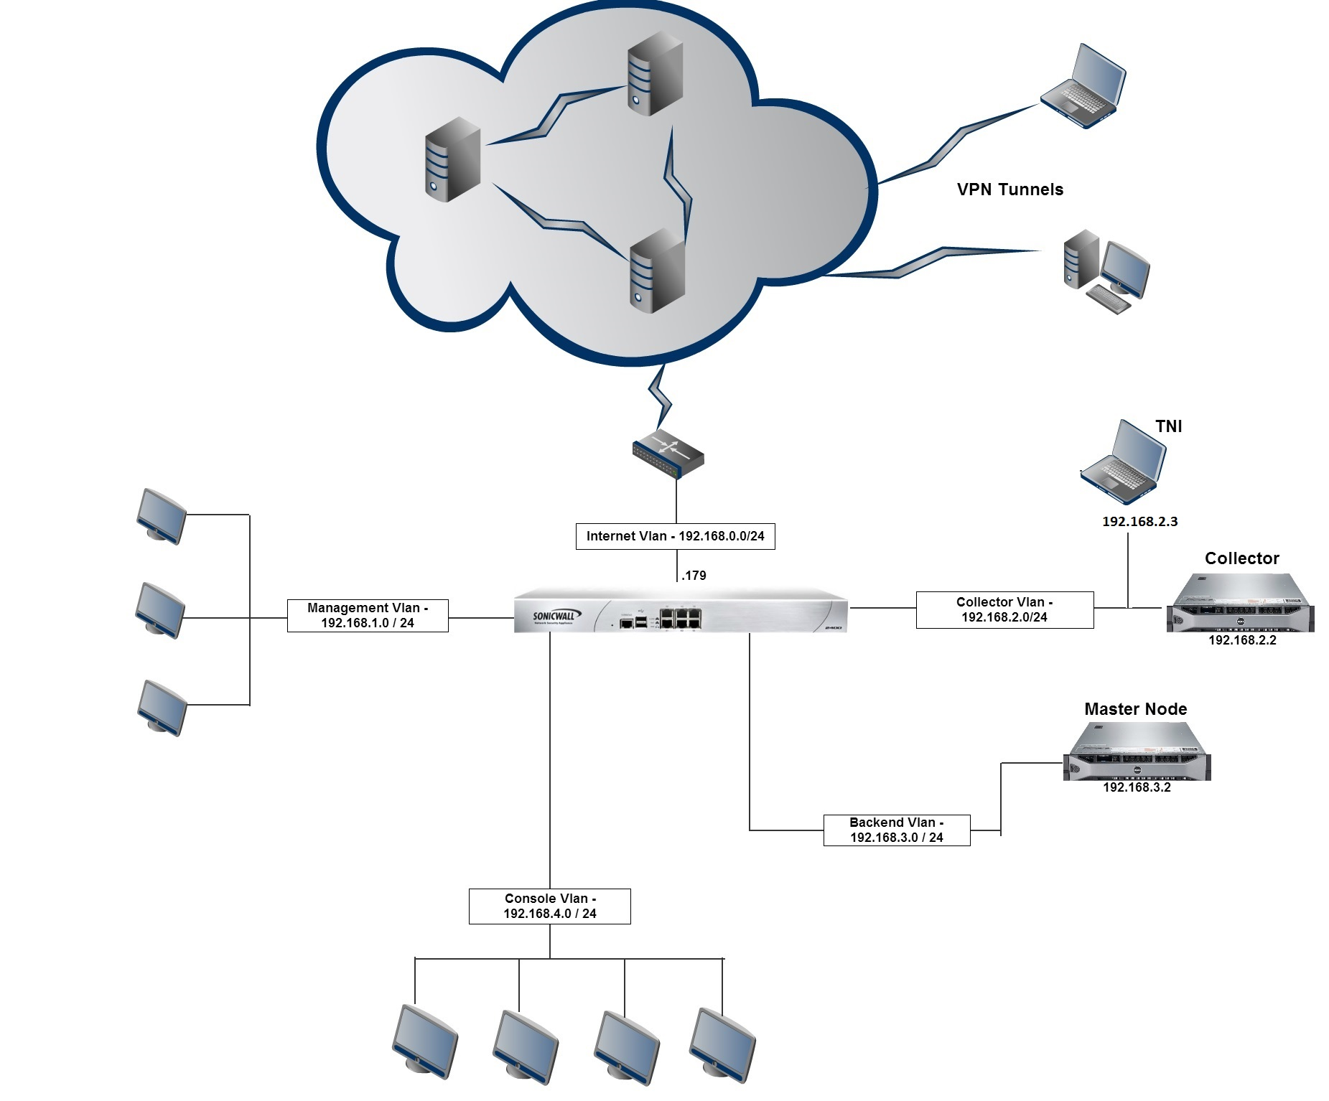

Hardware Requirements
Software and relative hardware quantities of Master Node, Shards, Collectors, Anonymizers and Consoles are indicated in the commercial offer. One backup unit, although strongly suggested, is optional.

RCS Master Node

System Requirements
The following must be present:
- 96 GB of RAM minimum
- 2 x 146GB SAS HD RAID1 (for O.S.)
- 4 x 600GB SAS HD RAID 10 (for data)
- Windows Server 2008 R2 SP1 Enterprise Edition 64 Bit (English)

Disk Configuration
The following table details how disks must be configured:
Qty | Disk | RAID | Partitioning | Notes
2 | 146 GB | RAID 1 | NTFS, single partition | Install O.S. here
4 | 600 GB | RAID 10 | NTFS, single partition | Mount as C:\RCS

Suggested Hardware Specifications
Below you can find a recommended hardware configuration for RCS Master Node.
Dell PowerEdge R720
CPU : Intel Xeon E5-2660 2.20Ghz, 20MB Cache
RAM : 12 x 8GB RDIMM, 1600Mhz
HD (OS) : 2 x 146GB SAS 6Gbps 15k 2.5” HD Hot Plug (RAID1)
HD (Data) : 4 x 600GB SAS 6Gbps 10k 2.5” HD Hot Plug (RAID10)
RAID : PERC H710p Integrated RAID Controller
Network : Broadcom 5720 QP 1Gb Network Card
Optical : 16X DVD+/-RW Drive SATA

Additional Configurations
Enable the NTP Synchronization towards the NTP server on the RCS Collector.

You would need at most one (1) Master Node unit.
Specific HBA card is required depending on the SAN or DAS selected.

RCS Shard
This is an optional module and can be skipped according to customer’s license.

System Requirements
The following must be present according to the purchased license:
- 96 GB of RAM minimum
- 2 x 146GB SAS HD RAID1 (for O.S.)
- 4 x 600GB SAS HD RAID 10 (for data)
- Windows Server 2008 R2 SP1 Enterprise Edition 64 Bit (English)

Disk Configuration
The following table details how disks must be configured:
Qty | Disk | RAID | Partitioning | Notes
2 | 146 GB | RAID 1 | NTFS, single partition | Install O.S. here
4 | 600 GB | RAID 10 | NTFS, single partition | Mount as C:\RCS

Suggested Hardware Specification
Below there is a recommended hardware configuration for RCS Shard.
Dell PowerEdge R720
CPU : Intel Xeon E5-2660 2.20Ghz, 20MB Cache
RAM : 12 x 8GB RDIMM, 1600Mhz
HD (OS) : 2 x 146GB SAS 6Gbps 15k 2.5” HD Hot Plug (RAID1)
HD (Data) : 4 x 600GB SAS 6Gbps 10k 2.5” HD Hot Plug (RAID10)
RAID : PERC H710p Integrated RAID Controller
Network : 2 x Broadcom 5720 QP 1Gb Network Card
Optical : 16X DVD+/-RW Drive SATA

Additional Configurations
Enable the NTP Synchronization towards the NTP server on the RCS Collector.

Refer to the commercial offer for the exact number of Shards you need.
In case of doubt please refer to your sales representative.

RCS Collector

System Requirements
The following must be present:
- 16 GB of RAM minimum
- 2 x 300GB SAS HD RAID1 (for O.S. and data)
- Windows Server 2008 R2 SP1 Standard Edition (or above) 64 Bit (English)

Disk Configuration
The following table details how disks must be configured:
Qty | Disk | RAID | Partitioning | Notes
2 | 300 GB | RAID 1 | NTFS, single partition | Install O.S. here

Suggested Hardware Specifications
Below you can find a recommended hardware configuration for RCS Collector.
Dell PowerEdge R210 II
CPU : Intel Xeon E3-1230 3.20Ghz, 8MB Cache
RAM : 2 x 8GB DDR3, 1333Mhz
HD (OS) : 2 x 300GB SAS 6Gbps 15k 2.5” HD Hot Plug (RAID1)
RAID : PERC H200 RAID Controller
Network : 2 x Broadcom 5720 QP 1Gb Network Card
Optical : 16X DVD+/-RW Drive SATA

Additional Configurations
Enable the NTP Synchronization towards the closest public NTP server.

Refer to the commercial offer for the exact number of Collectors you need.
In case of doubt please refer to your sales representative.

RCS Anonymizer

System Requirements
The following must be present:
- 256 MB of RAM minimum
- 10GB HD
- Linux CentOS 6 32 Bit
- Static public IP address
- 2 Mbit/s Internet connection

Due to company policies and to protect customer’s confidentiality requirements, Hacking Team is not allowed to provide accounts on VPS services.

Suggested VPS List
The following table list examples of possible VPS providers:
Name | Web site | Locations
Linode | http://www.linode.com | USA and many other locations
Host Europe | http://www.hosteurope.de | Germany and other locations

Refer to the commercial offer for the exact number of Anonymizers you need.
In case of doubt please refer to your sales representative.

RCS Console
A VPN connection is suggested when connecting to RCS Master Node from external network.

System Requirements
The following must be present:
- 8 GB of RAM minimum
- 320GB SATA HD
- Windows or OS X
- Display capable of 1280x800 pixel minimum resolution

Suggested Hardware Specifications
Below you can find a recommended hardware configuration for RCS Console.
Dell Latitude 15 – Series 3000
CPU : Intel Core i3-3120M 2.50Ghz, 3MB Cache
RAM : 8GB DDR3, 1600Mhz
HD : 1 x 320GB SATA 7.2k 2.5” HD
Video : Intel HD Graphics 4000
Network : 1 x 1Gb Network Card, 1 x Dell Wireless 1901 802.11 a/b/g/n
Optical : 8X DVD+/-RW Drive SATA

Additional Configurations
Adobe Air runtime must be installed on the system.

Refer to the commercial offer for the exact number of Consoles you need.
In case of doubt please refer to your sales representative.

Backup
The backup unit is a SAN (Storage Area Network) or a DAS (Direct-Attached Storage) device that is responsible for all RCS data backup.
Network share drives i.e. SMB, NFS are not supported.
A backup unit is strongly suggested.

System Requirements
The following must be present:

- 6 x 1TB SAS HD RAID6 (for data)

Disk Configuration
The following table details how disks must be configured:
Qty | Disk | RAID | Partitioning | Notes
6 | 1 TB | RAID 6 | NTFS, single partition | Mount as Z:\

Suggested Hardware Specifications
Below you can find a recommended hardware configuration for backup unit.
DELL PowerVault MD3200i
HD : 6 x 1TB SAS 6Gbps 7.2k HD Hot Plug

Firewall
Availability of the firewall is mandatory for the delivery.

System Requirements
The following must be present:
- Support for VPN connection client to site (SSL or IPSEC)
- Stateful throughput of 1 Gbps
- IMIX performance of 235 Mbps
- Maximum connections of 225000
- VPN throughput of 300 Mbps

The availability of a firewall with such characteristics dedicated to the RCS installation is compulsory for the completion of the installation.

Suggested Hardware Specifications
Below you can find a recommended hardware configuration for firewall.
SonicWall NSA 3600 Network Security Appliance
IPSEC VPN Connections Client to Site: Up to 1000
Firewall inspection throughput: 3.4 Gbps
IMIX Performance: 900 Mbps
Maximum Connections: 325000
VPN Throughput: 1.5 Gbps

Or

SonicWall NSA 2600 Network Security Appliance
IPSEC VPN Connections Client to Site: Up to 250
Firewall inspection throughput: 1.9 Gbps
IMIX Performance: 600 Mbps
Maximum Connections: 225000
VPN Throughput: 1.1 Gbps

Switch

System Requirements
The following must be present:
- 24 ports
- Support for 10/100/1000 Mbps

Suggested Hardware Specifications
Below you can find a recommended hardware configuration for the switch.
Dell PowerConnect 2800
Ports : 24 at least
Speed: 10/100/1000 Mbps

Network Configuration

VLANs Configuration on Switch
The RCS environment requires 5 VLANs on a switch.
These VLANs create different logical LAN for each RCS component and for devices management.
On the switch you can create there VLANs:
- Backend VLAN
- Collector VLAN
- Console VLAN
- Firewall Management VLAN
- Switch Management VLAN
The assigned ports on the switch for each VLAN could be 2 or more, depending on the architecture.

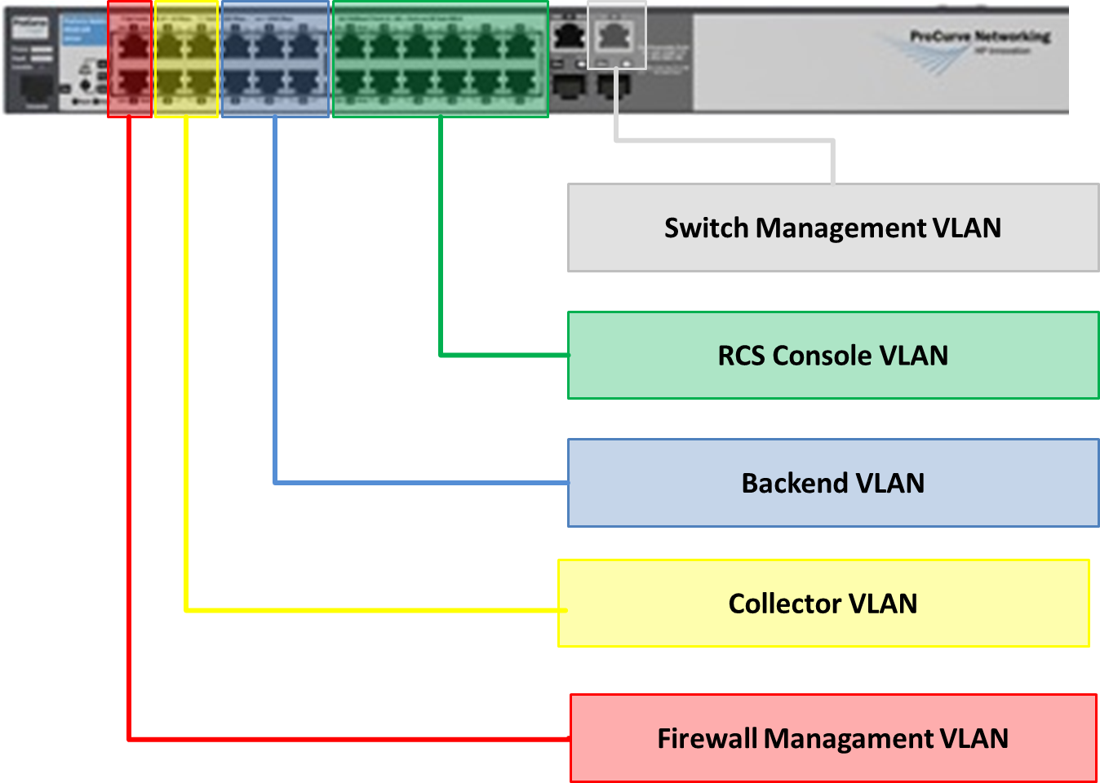

Firewall Switch Interconnection
The firewall is used to regulate communication between VLANs.
Five zones are configured on the firewall:
- Backend VLAN
- Collector VLAN
- Console VLAN
- Firewall Management VLAN
- External VLAN (Internet)
Zones on the firewall and VLANs on the switch must be connected according to the picture below.

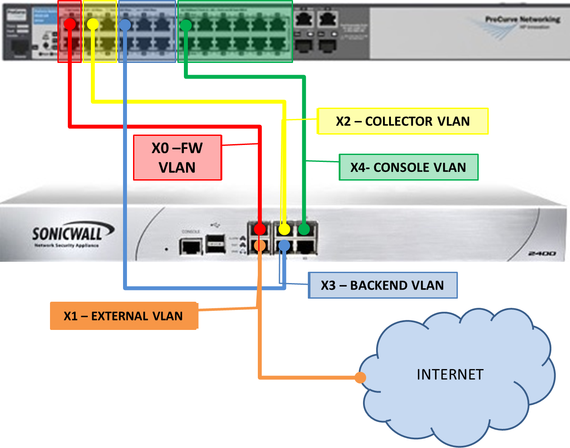

Hardware Interconnection Schema
Following is represented the whole system architecture with its interconnections. As described in the picture, final infrastructure may include additional RCS Collectors and RCS Shards.

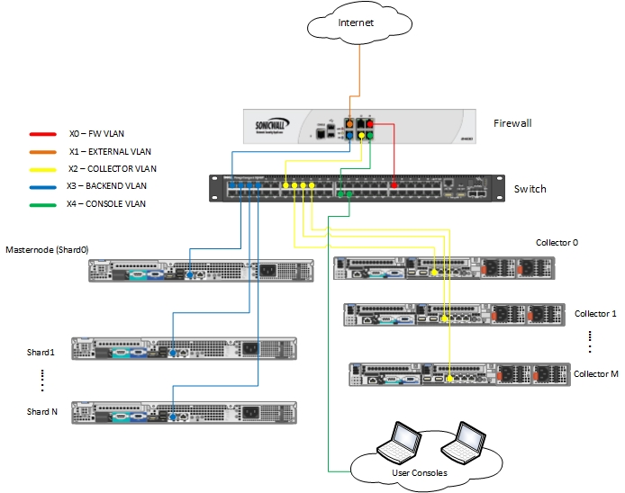

Firewall Rules Setup
The following rules must be implemented on the firewall to allow RCS works correctly.
Table’s colors reflect the colors used in previous pictures.
Source | Destination | Service | Protocol | Port
Backend | Any | DNS | UDP | 53
Backend | Any | NTP | UDP | 123
Backend | Collector | HTTP | TCP | 80
Console | Any | HTTPS | TCP | 443
Console | Any | HTTP | TCP | 80
Console | Any | DNS | UDP | 53
Console | Any | ICMP | ICMP
Console | Collector | RDP | TCP | 3389
Console | Backend | RDP | TCP | 3389
Console | Backend | HTTPS | TCP | 443
Console | Backend | TCP_444 | TCP | 444
Collector | Any | DNS | UDP | 53
Collector | Any | HTTP | TCP | 80
Collector | Any | HTTPS | TCP | 443
Collector | Any | NTP | UDP | 123
Collector | TNI | HTTPS | TCP | 443
Collector | Backend | HTTPS | TCP | 443
Collector | Backend | TCP_442 | TCP | 442
Anonymizer(s) | Collector | HTTP | TCP | 80

