DA: davidlim (MP) [davidlim@mpinetwork.com]

RE: INTERPOL announces new international security event ‒ INTERPOL World (Hacking Team)

venerdì 16/05/2014 05:26

Dear Lucia

I hope this email finds you well and I wanted to check if you are at a stage whereby you can confirm your participation in INTERPOL World?

Thank you and I do look forward to hearing from you soon.

Warmest Regards

**David Lim**

**Director of Sales**

**INTERPOL World Pte Ltd**

20 Kallang Avenue 2nd Floor Pico Creative Centre Singapore 339411

**T** +65 63896614     **F** +65 3896639    **E** [davidlim@mpinetwork.com](mailto:davidlim@mpinetwork.com)

**W** [www.interpol-world.com](http://www.interpol-world.com/)

[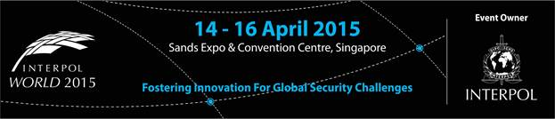](http://www.interpol-world.com/)