From: asiandefense [mailto:mail.buvqkthebvoxkihjhrk@online.ubmthailand.com]
Sent: Tuesday, July 22, 2014 12:58 PM
To: info
Subject: ‘Defense & Security 2015 – PRIMED FOR ACTION!’ 2-5 November 2015 at IMPACT Exhibition and Convention Center, Thailand.

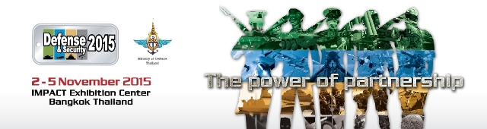
ENEW |  | 22 July2014
‘Defense & Security 2015 – PRIMED FOR ACTION!’
To promote Defense & Security 2015 the Defense & Security team has been making courtesy calls to top brass and high-ranking military officials and defense ministers around the world. Last week, Mr. M. Gandhi, the Managing Director of GML Exhibition(Thailand) Co., Ltd. - organizer of Defense & Security 2015 - made a courtesy visit to H.E. Lt. Gen. Wai Lwin, Union Minister for Defence, Republic of the Union of Myanmar, inviting him and high ranking delegations from Myanmar to visit the show next year in an official capacity.
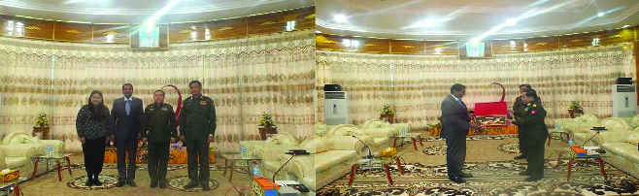
Earlier, the team also visited some of the leading defense companies in Beijing to promote show opportunities to Chinese exhibitors. All visits received positive feedback and interest in exhibiting was strong, especially from The State Administration for Science, Technology and Industry for National Defense (SASTIND), CETC, China Shipbuilding Industry Corporation , China Shipbuilding Trading Co., Ltd and China Precision Machinery Import-Export Corporation(CPMIEC). Most companies see positive business opportunities in Thailand and are eager to establish a foothold in the booming ASEAN region.
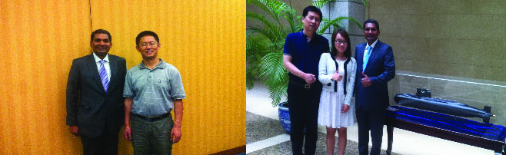
Defense & Security 2015 - Asia’s leading Tri-Service Asian Defense & Security Exhibition, Conference and Networking Event, has success in its cross-hairs. The 2015 show is shaping up to be one of the biggest and most dynamic military exhibitions ever held in the region. It will provide outstanding opportunities for international businesses in the D&S industry and enable global companies to enter ASEAN’s booming defense and security market.
Business Networking is also set to be outstanding with over 200 Official Delegations expected to attend from more than 25 countries , most of which will be represented by Defense Ministers, Chiefs of the Army, Navy and Air Force, and other high-ranking military officials and decision-makers. D&S has grown to become a must-exhibit event for any company in the industry.
With 60 % of DEFENSE & SECURITY 2015 space already booked or confirmed, you must act soon to get in on the action. Don’t let this special event pass you by.
Defense & Security 2015 will present a very special window of opportunity to the ASEAN procurement market… so SECURE YOUR PLACE AT THE SHOW TODAY!
Book online now at at : www.asiandefense.com or contact: + 662 642 6911 ext. 121, info@asiandefense.com

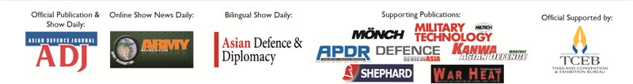
© Copyrights 2014. All rights reserved by GML Exhibition (Thailand) Co.,Ltd.

