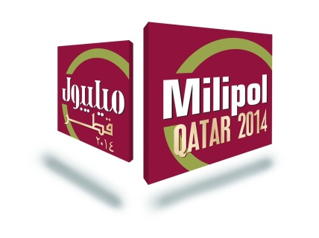

***Form 4 – Free invitation cards***

***Deadline: 15 September 2014***

**Company name : HT Srl**

**Booth number :**…………………

**Contact name** **:** Lucia Rana

**Address :**Via della Moscova, 13 - 20121 – Milan

**Country :** Italy

**Tel :** +39 0229060603

**Fax :**+39 0263118946

**E-mail** **:**…………......................................................................................................

MILIPOL QATAR is a trade exhibition. Admittance is only possible with an official invitation from an exhibitor or from the organiser.

Please note MILIPOL QATAR proposes you to send e-invitations that can be personalised with your logo, stand number and sent to your contacts data base. Free of charge (see form #3).

**Quantity of sets required:**

**Visitor invitation cards = 1 set x 125 cards**

**VIP invitation cards = 1 set x 50 cards**

***VISITOR and VIP INVITATION CARDS DELIVERY ADDRESS:***

MRS

First name: LUCIA

Last name: RANA

Telephone: +39 0229060603

E-mail: [lucia.rama@hackingteam.com](mailto:lucia.rama@hackingteam.com); [amministrazione@hackingteam.com](mailto:amministrazione@hackingteam.com)

Company name: HT Srl

Address: Via della Moscova, 13

Post Code: 20121

City: Milan

Country: Italy

**Please send back this form to:**

**emilie.darius@comexposium.com**

Comexposium Security

Immeuble Le Wilson – 70 avenue du Général De Gaulle - 92058 Paris la Défense Cedex – France

Tel : +33 (0)1 76 77 15 32