82nd INTERPOL General Assembly
October 21 – 24, 2013
Centro de Convenciones Cartagena de Indias Julio Cesar Turbay Ayala

GENERAL SCHEDULE

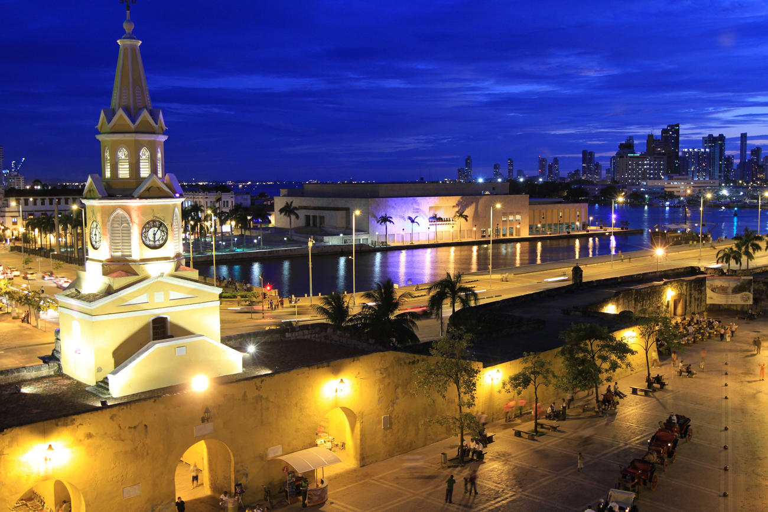

Welcome reception :
A welcome reception will be hosted by the Colombian authorities on Monday, 21 October. Full details including the exact time and venue will be communicated in due course.
General Assembly session dates: 21 to 24 October 2013
The General Assembly plenary session will be held in the Gran Salon Barahona.
Start time (opening ceremony) at 10.00 on Monday 21 October.
End of General Assembly session at lunch time on Thursday 24 October.
Note: Due to limited seating, Exhibitors will not be able to attend the opening ceremony.
Coffee Breaks (30 minutes):
Monday 21 October: morning and afternoon
Tuesday 22 October : morning and afternoon
Wednesday 23 October: morning and afternoon
Thursday 24 October: morning
Note: INTERPOL reserves the right to modify the general schedule at all times.
Gala dinner:
A Gala dinner will be hosted by the Colombian authorities on Wednesday 23 October. Full details including the exact time and venue will be communicated in due course.
Please note that attendance will be limited to 4 persons per exhibiting company.
Recognition Ceremony for Exhibitors:
Exhibitors are invited to attend a recognition ceremony during the plenary session to acknowledge their support to the INTERPOL General Assembly.
The ceremony will be held on Thursday 24 October, at the Plenary room in the Centro de Convenciones. Full details including the exact time will be communicated in due course.
Social programme
SET UP AND DISMANTLING SCHEDULE
Dates for set-up: 18 October, from 09.00 to 18.30 (tbc)
Saturday 19 October, from 09.00 to 12.00
Exhibition dates: 21 to 24 October, 2013
Dismantling: October 24, from 14.00 to 18.30 (tbc)

PROCEDURE FOR ONLINE PRE-REGISTRATION
Pre-registration
All members due to take part in the Exhibition held in the framework of the 82nd General Assembly in Cartagena, Colombia, MUST pre-register online at the following address:
https://www.regonline.co.uk/?eventID=1215920&rTypeID=716294
To pre-register, participants simply need to cut and paste the above link in the address bar of their internet browser and hit « enter ». They will be automatically directed to the online pre-registration form reserved for Exhibitors.
The following access code: exhib82ga62487 will be required to proceed with the pre-registration.
Please note that each Exhibitor could register a maximum of 8 persons and deadline is 20 September 2013.

Exhibitors passes give access to the following:
- Exhibition areas
- Lunch areas
- Coffee breaks (these will be served in the Exhibition area)
- Welcome Reception
- Gala dinner (maximum of 4 persons per exhibiting company)
- Recognition Ceremony for Exhibitors
- Social programme for Accompanying guests (for spouses or partners of participating exhibitors)
Please note that with the exception of the Recognition Ceremony for Exhibitors, Exhibitors are not admitted to the plenary conference hall.
SELECTED HOTELS
Should you wish to book accommodation at one of the selected hotels and benefit from the special conference room rates, please complete the required form (one form per room to be reserved) and send the duly completed form/s by e-mail or fax to the e-mail address or contact number specified on the form. Please not that deadline for Hotel bookings is 20 September 2013.
Capilla del Mar
Bocagrande, Carerra 1° N° 8-12
Cartagena de Indias (Colombia)
Website: www.capilladelmar.com

Hotel Caribe
Bocagrande, Carrera 1a, N° 287
Cartagena de Indias (Colombia)
Website: www.hotelcaribe.com

Holiday Inn Cartagena Morros
Anillo Vial. Carrera 9 N° 34 – 166
Cartagena de Indias (Colombia)
Website: www.holidayinn.com

